The Pavilion, Englefield Road, Theale, Reading, RG7 5AS

0118 9306592  
enquiries@thealeparishcouncil.gov.uk  
www.thealeparishcouncil.gov.uk

Grounds Maintenance Contract

2021–24

Tender Application Pack

Invitation to tender

Theale Parish Council (“the council”) invites tenders for the maintenance of its grounds in accordance with the conditions and specification included in this application pack.

This application pack is comprised of:

Section A General conditions  
Section B Work specification  
Section C Commercial information  
Section D Form of tender and declaration

Prospective contractors should ensure they are completely familiar with the nature and extent of the obligation to be accepted.

Any queries regarding the interpretation of any part of this application pack should be addressed to:

The Clerk  
Theale Parish Council  
The Pavilion  
Englefield Road  
Theale  
RG7 5AS

or via email: [enquiries@thealeparishcouncil.gov.uk](mailto:enquiries@thealeparishcouncil.gov.uk)

or via phone: 0118 930 6592

Prospective contractors should note that the council is not bound to accept the lowest, or any, tender. The council’s decision is final, and no correspondence will be entered into on the reasons why a tender has been rejected.

The successful tender and the council’s written acceptance shall form a binding agreement.

If having examined this tender application pack you wish to submit a tender, you should:

* + - 1. ensure you are familiar with the requirements of the contract
      2. complete sections C and D of this application pack and
      3. return the tender and any related documentation in an envelope marked “Tender for grounds maintenance” on the back to the address above.

The deadline for applications is **3pm on 5th March 2021**. Tenders received after the deadline will not be considered.

The council encourages prospective contractors to arrange a site visit with the clerk prior to submitting their tender.

Section A: General conditions

# Work to be done

The work to be done is described in the work specification.

All work specified is to be provided by the contractor within the annual sum.

All work shall be done in accordance with recognised horticultural standards.

The contractor shall ensure the employer’s property is protected against accidental or negligent damage likely to be inflicted whilst doing the work.

Any damage inflicted by the contractor shall be made safe immediately, reported to the council, and repaired to the satisfaction of the council as soon as possible at the cost of the contractor.

The contractor shall acquire the necessary permits needed to complete the work.

# Access and security

The contractor shall be given copies of keys for vehicle access gates (shown by solid yellow arrows in Maps 1 and 3 below).

The contractor must not leave any vehicle access gate open unattended.

# Waste

The contractor shall ensure all waste collected or produced, including grass clippings, is removed from the site and legally disposed of.

# Ground and weather conditions

The contractor shall make allowance for climatic variations which may impact the work specification.

Work shall not be done when ground conditions are such that puddling, deep rutting or similar detrimental effects may occur. The contractor shall inform the council immediately if ground conditions prevent cutting and as a result excessive grass growth occurs.

# Additional work

The council may request that the contractor do additional work not specified in the work specification. The contractor may provide a quotation which must be approved by the council. The council is not bound to accept the quotation and may arrange for another company to do the work.

# Health and Safety

The contractor shall ensure all employees are suitably qualified and provided with necessary Personal Protective Equipment.

The contractor shall ensure the work causes no damage or injury to desirable vegetation, animals, machines or other items of equipment. Any such damage or injury will be the responsibility of the contractor, who will rectify any damage and be liable for any compensation claims.

# Documentation

The contractor shall supply the council with copies of:

* + - 1. a relevant waste licence
      2. a public liability insurance certificate
      3. relevant Health & Safety policies and
      4. a sample proof of employee training.

# Contract length and termination

The contract will last for three years, from 1st April 2021 until 31st March 2024.

The council may terminate the contract immediately in the event of a serious breach of these conditions.

Should the contractor fail to deliver the services or terminate the contract before the end of the three-year period, the contractor will be required to pay the parish council for any increased direct costs that the parish council can reasonably prove it has incurred in obtaining replacement services. The replacement contractor will be chosen by the council.

# Invoicing and payment

The contractor shall issue monthly invoices to the council for work included in the specification.[1] Additional work requested shall be invoiced separately.

The council shall approve payments at its monthly meetings and transfer the sum by BACS soon after. Alternatively, a Direct Debit shall be instated and signed by the necessary signatories for the council’s bank.

The council will not be bound to pay an invoice until the specified work has been completed to the satisfaction of the council.

# Annual cost increase

The contractor will be permitted to increase the annual cost of the work for 2022–23 and 2023–4 by no more than 5% or the Retail Price Index (RPI) rate of inflation, whichever is lower.

The contractor shall notify the council of any increase permitted by 10.1 by 1st November before the beginning of the contract year at which the price increases.

# Key contact

The key contact at the council for all queries and invoices shall be the clerk. Contact details are as follows:

The Clerk  
Theale Parish Council  
The Pavilion  
Englefield Road  
Theale  
RG7 5AS

[enquiries@thealeparishcouncil.gov.uk](mailto:enquiries@thealeparishcouncil.gov.uk)  
0118 930 6592

Section B: Work specification

Quotation 1: North Street Playing Fields, recreation ground and the green at Roundhead Road

|  |  |  |
| --- | --- | --- |
| ACTIVITY | FREQUENCY | DATE |
| mow grass (including car park, shown in green)  strim perimeter (shown in red), fence lines and around buildings, bins, signs, benches, etc | 16 (fortnightly) | summer |
| cut shrubs to maintain access to entrances (shown as yellow arrows), benches, bins, etc | as necessary |  |

|  |  |  |
| --- | --- | --- |
| ACTIVITY | FREQUENCY | DATE |
| rough cut (area in blue) | 2 | May & September |

|  |  |  |
| --- | --- | --- |
| ACTIVITY | FREQUENCY | DATE |
| mow grass (except cricket square, area in green)  strim perimeter (red), fence lines and around buildings, bins, signs, benches, etc  strim skate park banks (area in purple)  strim around fence line of play area (area in purple)  **do not** strim or mow long grass deterrents under trees (orange stars) | 16 (fortnightly) | summer |
| cut shrubs impinging on play area (area in purple)  cut shrubs to maintain access to entrances (yellow arrows), benches, bins, etc | as necessary |  |
| remove fallen leaves in play area (area in purple) | as necessary | autumn |

|  |  |  |
| --- | --- | --- |
| ACTIVITY | FREQUENCY | DATE |
| cut hedges (yellow) | every other year | December 2022 |
| rough cut (area in blue) | 2 | May & September |

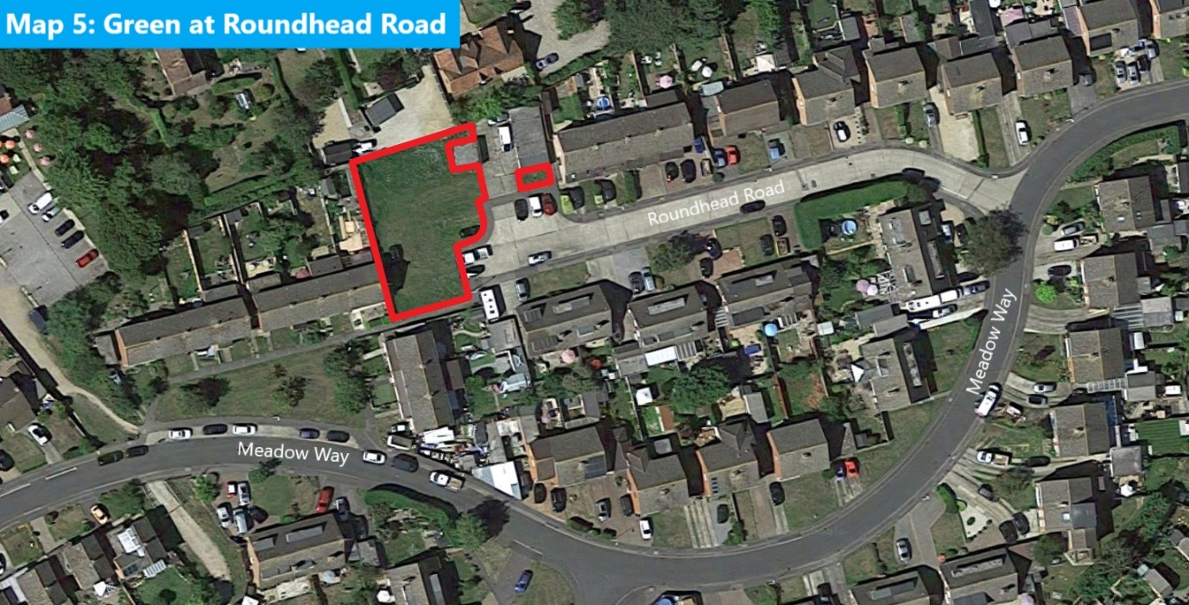

|  |  |  |
| --- | --- | --- |
| ACTIVITY | FREQUENCY | DATE |
| mow grass  strim perimeter (red) | 16 (fortnightly) | summer |

Quotation 2: North Street Playing Fields bund maintenance

|  |  |  |
| --- | --- | --- |
| ACTIVITY | FREQUENCY | DATE |
| maintain bund (area in yellow):   * spring cut & drop of the wildflower bund returning a couple of days later to clear clippings once seeds have fallen * summer cut & drop of the wildflower bund returning a couple of days later to clear clippings once seeds have fallen * autumn cut & drop of the wildflower bund returning a couple of days later to clear clippings once seeds have fallen | 6 | May, August & October |

Section C: Commercial information

|  |  |
| --- | --- |
| 1. COMMERCIAL IDENTITY | |
| Name of company submitting the tender | |
|  | |
| Contact name |  |
| Position in company |  |
| Registered office address |  |
| Telephone number |  |
| Email address |  |
| Website address |  |
| Registered company number |  |

|  |  |
| --- | --- |
| 1. INSURANCE DETAILS | |
| Please provide a copy of your company’s insurance certificates and provide the following information. | |
| Public liability insurance (limit of indemnity of at least £10,000,000) | |
| Insurer |  |
| Policy numbers |  |
| Expiry date |  |
| Limit of indemnity |  |
| Excess (if any) |  |
| Employers’ liability insurance (limit of indemnity of at least £5,000,000) | |
| Insurer |  |
| Policy numbers |  |
| Expiry date |  |
| Limit of indemnity |  |
| Excess (if any) |  |

|  |
| --- |
| 1. HEALTH & SAFETY |
| If the company employs more than 4 employees, please enclose a copy of an up-to-date Health and Safety policy. |
| Please supply the name and designation of the person responsible for the implementation of the company’s Health and Safety policy. |
|  |
| If the company employs fewer than 5 employees, please state how you ensure that your Health and Safety measures are practised within the company. |
|  |

|  |
| --- |
| 1. ENVIRONMENTAL SUSTAINABILITY |
| Please enclose a copy of any environmental management certification which the company holds. Otherwise, please detail how the company complies with environmental legislation. |
|  |

|  |
| --- |
| 1. TECHNICAL CAPABILITY |
| Please provide information of the company’s technical capability, expertise and experience over the past five years doing similar services under a formal contract to the public sector, in particular parish councils or other public bodies. |
|  |
| Please provide details (or a relevant policy) of your current training policy/procedures (including any Health and Safety training) and describe how you ensure that skills are maintained. |

|  |  |  |
| --- | --- | --- |
| 1. REFERENCES | | |
| Please provide details of two organisations—preferably parish councils or other public bodies—for which you have delivered similar services in the past 5 years that will be willing to provide a reference. Theale Parish Council will obtain two references. | | |
| Reference 1 | | |
| Organisation name |  | |
| Organisation address |  | |
| Contact name |  | |
| Phone number |  | |
| Email |  | |
| Website |  | |
| Contract start/end dates | start |  |
| end |  |
| Value of contract |  | |
| Brief description of contract including any use of sub-contractors |  | |
| Reference 2 | | |
| Organisation name |  | |
| Organisation address |  | |
| Contact name |  | |
| Phone number |  | |
| Email |  | |
| Website |  | |
| Contract start/end dates | start |  |
| end |  |
| Value of contract |  | |
| Brief description of contract including any use of sub-contractors |  | |

|  |
| --- |
| 1. TECHNICAL PROPOSAL |
| Please detail the format in which the company can receive service requests. |
|  |
| What arrangements will the company make for the removal and recycling of rubbish and debris accumulated during the supply of the services? |
|  |
| Please detail the checks the company will make to ensure that the services will be done by suitably trained and competent staff. |
|  |
| Please detail the company’s methodology for employing sub-contractors. If used, please state how the company ensures sub-contractors will comply fully with the conditions of the contract. |
|  |

Section D. Form of tender and declaration

|  |  |  |  |
| --- | --- | --- | --- |
| Please provide **two quotations** for the annual cost for 2021–22 to complete the work as listed in the work specification (Section B): | | | |
| Annual costs of all work as listed in the work specification (Section 2) under:  Quotation 1: North Street Playing fields, recreation ground and the green at Roundhead Road | 2021–22 | **£** | |
| Annual costs of all work as listed in the work specification (Section 2) under:  Quotation 1: North Street Playing fields, recreation ground and the green at Roundhead Road  **AND**  Quotation 2: North Street Playing Fields bund maintenance | 2021–22 | **£** | |
| Please detail any recommendations you would make regarding the work specification (Section B) with the respective additions/subtractions in cost. These might be activities in addition to or instead of elements of the work specification given. Please append a separate sheet if necessary. | | | |
|  | | |  |
| I certify that the information supplied is accurate to the best of my knowledge.  I understand that Theale Parish Council may contact anyone to verify this information, and that false or misleading information could result in the company’s exclusion for the select tender list.  I also understand that it is a criminal offence, punishable by imprisonment, to give or offer to give any gift or consideration whatsoever as an inducement or reward to any servant or member of a public body.  Signed _______________________________________________________  Position held _______________________________________________________  On behalf of _______________________________________________________  Date _______________________________________________________ | | | |

Before submitting this application form, please ensure you have:

* answered all questions
* enclosed relevant documents and
* completed the above declaration.

1. The council must approve all payment other than those by Direct Debit and standing order at its monthly council meetings, which usually take place on either the first or second Monday of the month. Once approved, payments are usually made within three working days.