Gerrards Cross Town Council

**South Lodge, East Common, Gerrards Cross SL9 7AD 01753 888018**

Jiya H Jilani

**Clerk Jiya H Jilani**

[**clerk@gerrardscross.gov.uk**](mailto:clerk@gerrardscross.gov.uk)

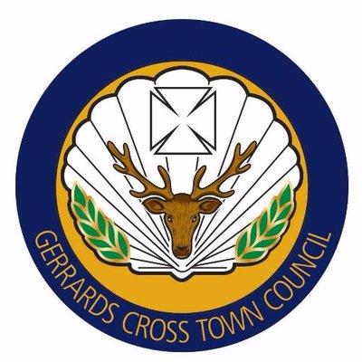

**GERRARDS CROSS TOWN COUNCIL**

**CONTRACT FOR STREET LIGHTING**

The contract for street lighting has been awarded to SparkX for the period of

1st April -31st March 2023.