

Fair share: options for water quality

V2 ( draft)

We are the Environment Agency. We protect and improve the environment.

Acting to reduce the impacts of a changing climate on people and wildlife is at the heart of everything we do.

We reduce the risks to people, properties and businesses from flooding and coastal erosion.

We protect and improve the quality of water, making sure there is enough for people, businesses, agriculture and the environment. Our work helps to ensure people can enjoy the water environment through angling and navigation.

We look after land quality, promote sustainable land management and help protect and enhance wildlife habitats. And we work closely with businesses to help them comply with environmental regulations.

We can’t do this alone. We work with government, local councils, businesses, civil society groups and communities to make our environment a better place for people and wildlife.

|  |  |
| --- | --- |
| Published by: |  |
| Environment Agency Horizon House, Deanery Road, Bristol BS1 5AH Email: enquiries@environment-agency.gov.uk [www.gov.uk/environment-agency](http://www.gov.uk/environment-agency)  © Environment Agency 2014  All rights reserved. This document may be reproduced with prior permission of the Environment Agency. | Further copies of this report are available  from our publications catalogue: [www.gov.uk/government/publications](http://www.gov.uk/government/publications)  or our National Customer Contact Centre:  T: 03708 506506  Email: [enquiries@environment-agency.gov.uk](mailto:enquiries@environment-agency.gov.uk). |

Contents

1. Introduction 4

2. Scope 4

3. Definitions and concepts 5

Basis of share 5

Environmental Quality Standards 5

Current concentration and pollutant share 5

Local and catchment share 5

Loads and concentrations 5

Point and diffuse sources 6

Average and peak catchment impact 6

4. Options for fair share 7

4.1. Calculation options for catchment fair share 7

4.2. Comparison of options 11

4.3 Catchment share comparisons – Thames and Wye basins 22

4.5 Evaluation 27

4.5 Implementation implications 28

5. Conclusion 29

1. Introduction

The purpose of this document is review 'fair share' concepts and options for water quality in the aquatic environment.

Our aspiration is that water quality should be good, or better than good, for the benefit of society and the environment. This, we hope to achieve through appropriate management of sources of pollution. 'Fair share' is pertinent to this because it helps us determine how much pollution reduction is required from various sources.

The notion of 'fair share' is that sources should be treated equitably. This is what is meant by 'fair'. The idea of 'share' is that the amount of source pollution reduction will, in some sense, be proportionate to a source's impact.

The aim of this document is to provide a precise articulation of this 'fair share' concept, in order that it may be applied in making decisions on pollution sources. As will become clear this is non-trivial.

It may seem strange that there are 'options' for fair share. Options arise because of differing interpretations on the meaning of equitability. It is not the purpose of this document to adjudicate on these, but rather to specify how they may be implemented and their consequences.

We note that the Environment Agency has historically adopted a fair share approach for site based pollution impacts. The departure now is to consider how we might apply fair share from a catchment, rather than single site, perspective.

We also note that fair share is implicit in the Water Framework Directive via the 'polluter pays' principle.

1. Scope

The scope is currently limited to phosphorus in rivers.

The reason for this is that phosphorus is the pollutant of chief concern in freshwater.

Having clarified the principles for one determinand, we consider that generalisation to other determinands will be easier.

1. Definitions and concepts

Basis of share

The presumption is that share is based on physical impact rather than cost or other attribute.

Here physical impact means concentrations in rivers.

Environmental Quality Standards

An environmental quality standard (EQS) is a concentration statistic, for example an annual mean or 95th percentile. Water quality is presumed unacceptable if the river concentration exceeds this statistic. For phosphorus the statistic is an annual mean.

The EQS provides a target to be achieved in the river.

Current concentration and pollutant share

The current concentration is the in-river concentration arising from all pollutant sources.

A pollutant share is its fraction of the current concentration.

Local and catchment share

The share that a pollutant has at a point in the catchment is known as the local share.

The impact from a pollutant source is not just local; it will impact at all points downstream from its entry, or discharge, point. Therefore its impact, and hence its share over the whole catchment needs to be quantified. This is considered further below.

Loads and concentrations

Above, share has been defined by concentration. This will correspond to a load share. However the load share may not be the same as the concentration share.

This is because of how concentration varies with flow for a pollutant source. For point sources, the concentration tends to vary inversely with flow so that the delivered load is constant with river flow. For diffuse inputs, the concentration may be constant or increase with flow. Thus the bulk of the load may be delivered under high flow conditions, but because of the accompanying dilution the impact on in-river concentration is less than if delivered under low flow conditions.

Therefore large diffuse loads will have less impact on river concentrations than equal point source loads. So share by load could be in the ratio 50:50, but share by concentration would be 25:75.

Share by load or concentration are equally valid, but must not be mixed. For example if the load share ratio is 50:50 this should not be taken to mean that the concentration ratio is 50:50.

Point and diffuse sources

So far we have referred to pollutant loads generally. When considering share the interest is to understand how much share a sector may have. For phosphorus issues, the primary sectors are water company (and to a much lesser extent, industry) discharges and diffuse agricultural and urban pollution.

For convenience these are grouped into collective point and diffuse sources, with the focus on determining their relative shares.

Average and peak catchment impact

The collective point sources and diffuse sources will each have their catchment averaged impact.

They will also have a peak catchment impact. For example, for point sources, peak impact will be at a specific location relating to a specific discharge. The notion of peak relates to the spatial rather than temporal variation, to which we are more accustomed.

(Diffuse impacts will also have peaks, but by inspection, these are generally less significant than point sources.)

These ideas of peak and average impact are developed below.

1. Options for fair share
   1. Calculation options for catchment fair share

For this discussion, refer to the figure below.

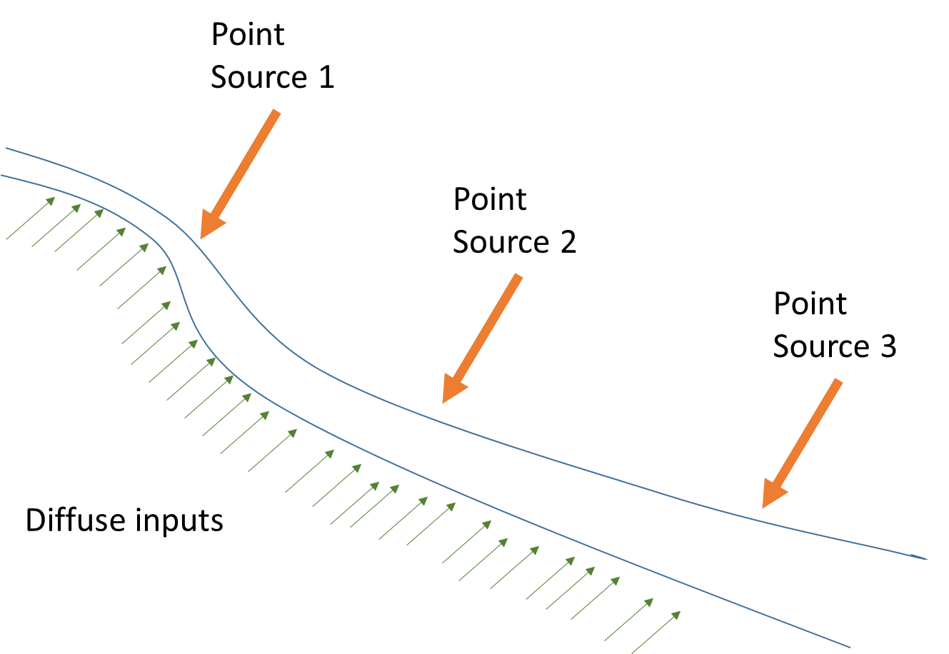

Figure 1 Example catchment

The figure shows a hypothetical, but realistic catchment, with three point source pollution sites. Diffuse inputs are also indicated.

Figures 2 shows the resultant concentration profiles down the catchment. These profiles are annual means.

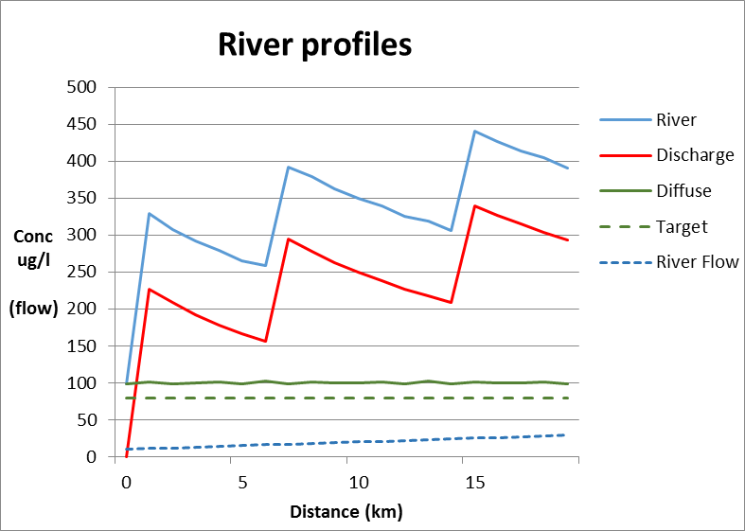

Figure 2. Profiles of river flow and concentrations

The following concentrations are profiled in the figure:

* Annual mean diffuse
* Annual mean point source
* Combined annual mean diffuse and point source
* Target (EQS)

Points to note are:

* The point source influences extend down the catchment, not just at point of impact
* The point source influences are ‘peaky’

We now consider the following options for calculation of point and diffuse share.

* + 1. Catchment average Impact

The catchment average impact for a sector (here we mean point or diffuse point source sector) is:

$$Sector impact=\frac{\sum_{x}{concentration} (x)}{\sum{x}}$$

Here $x$ represents a point in the catchment river system. The summation is over all points in the catchment.

$$point share=\frac{point sector impact}{\left(point sector impact+diffuse sector impact\right)}$$

$$diffuse share=\frac{diffuse sector impact}{\left(point sector impact+diffuse sector impact\right)}$$

$$target concentration \left(point\right)=point share*EQS$$

$$target concentration \left(diffuse\right)=diffuse share*EQS$$

Note that the relative point and diffuse catchment shares are the same before and after the implementation of target shares. Thus the approach is equitable.

These equations define what is meant by catchment average share and how it is quantified.

* + 1. Catchment peak impact

Point and diffuse sources differ in the way they impact on a catchment.

Diffuse sources are relatively homogeneous; this means that their resultant concentration within a catchment does not vary greatly. Point sources are different. They have a large impact at the point of discharge and diminish thereafter, mainly via dilution. (Of course if there are a good number of point sources, this effect will smear out.)

Option 1 may therefore be prejudicial to point sources: their reduced concentration impact as downstream distance increase is not credited.

Therefore rather than employing the catchment mean impact, as defined above, it may be more appropriate to somehow take account of the ‘peak’ impacts from discharges. Percentiles are a useful tool to do this. Here the percentile refers to the spatial profile of the (concentration) impact from all point sources operating in the catchment.

The highest percentile (eg 99th) will pick out that point source which has the greatest concentration at its discharge point, of all discharges. This would claim a high share of the catchment relative to the diffuse and would be unfair on the diffuse. A compromise percentile is the 85th, which would not unduly penalise the point or diffuse sources; nor would it skew the fair share apportionment because of a single point source. (For those point sources impacting at above the 85th percentile, they could either be controlled by emission limit, or an excess above target of 15% of the catchment could be tolerated.)

The advantage with using percentiles is that:

* they apply to all types of catchment, and so are relevant to catchments with a predominance of point sources at the top, bottom, elsewhere or evenly distributed
* all catchments are treated the same, and objectively.

The calculations are as for option 1, except that the point sector impact is now:

$$point sector impact=catchment point impact concentration(percentile)$$

As for 4.1.1, the relative point and diffuse catchment shares (as defined here) are the same before and after the implementation of target shares, and so the approach is equitable.

These equations define what is meant by the catchment peak share approach and how it is quantified.

(Because the diffuse and point sectors are uncorrelated, the diffuse mean is used to specify its impact, as above. The model output data could be analysed to check/modify this.)

* + 1. Local impact approach

The local impact uses the same equations as for the catchment average, but these are applied separately and only at the point of discharge.

$$Sector impact(at discharge point)=concentration (sector,at discharge point)$$

$$point share(at discharge point)=\frac{point sector impact}{\left(point sector impact+diffuse sector impact\right)}$$

$$diffuse share(at discharge point)=\frac{diffuse sector impact}{\left(point sector impact+diffuse sector impact\right)}$$

$$target concentration \left(point, at discharge point\right)=point share*EQS$$

$$target concentration (diffuse,at discharge point)=diffuse share*EQS$$

Note that the share is only defined at discharge points. The diffuse is ill defined between discharge points, but must meet its share at the discharge point.

As with the other approaches, the relative point and diffuse catchment shares (as defined here) are the same before and after the implementation of target shares.

These equations define what is meant by local impact approach to catchment share and how it is quantified.

* + 1. End of catchment approach

The end of catchment share allocations have been proposed as useful for characterising the catchment share allocation. This is a reasonable suggestion as the end of the catchment is responsive to all upstream influences and hence provides a type of catchment averaged view. A limitation is that the presence of a large discharge near the bottom of the catchment will result in a distorted view.

Therefore this option is similar to option 4.1.1 above, except that it based on one point rather than all points in the catchment.

* + 1. Other approaches

Other possibilities include using the monitoring points to calculate a catchment fair share. Again this is similar to option 4.1.1 except that only the monitoring points are used.

* 1. Comparison of options

4.2.1 Emission limit and diffuse impact comparisons

The catchment described in 4.1 is used to explore the consequences of the above options. The options are:

* Catchment averaging approach
* Peak catchment approach
* Local impact approach
* End of catchment approach

The consequences examined are:

* resulting point source emission limits
* point source shares
* diffuse target concentrations

Five cases are considered:

* Discharge impacts are similar down the catchment
* Large top of catchment discharge
* Large bottom of catchment discharge
* As (1), but rural catchment1
* As (1) but more urbanised catchment

1. .Analysis of national data suggests that for the 2009 baseline suggest that an ‘average catchment will have 75:25 point :diffuse concentration impact ratio, a rural catchment 60:40 and an urban catchment 90:10.)

The results are shown in figures 3 to 7.

Points to note are:

* Emission limits predictions are consistent and broadly similar across the methods.
* With the exception of rural catchments, the ‘percentile’ method tends to give less stringent emission limits than the average method.
* For rural catchments, the ‘local’ method gives less stringent emission limits and more stringent diffuse targets
* Diffuse target predictions are broadly similar with the following qualifications:
  + For the ‘local’ method the diffuse target concentrations vary across the catchment.
  + For the ‘local’ method the lowest downstream predicted diffuse target will apply at upstream locations. (As this is used in determining the emission limit and the presumption is that the net effect of all upstream diffuse sources is to conspire to give this concentration.)
  + Taking this into account the ‘local’ method tends to give tighter diffuse targets
* Distortion related to a large end of catchment discharge results in tighter emission limits under the ‘average’ method and tighter diffuse target under the others.

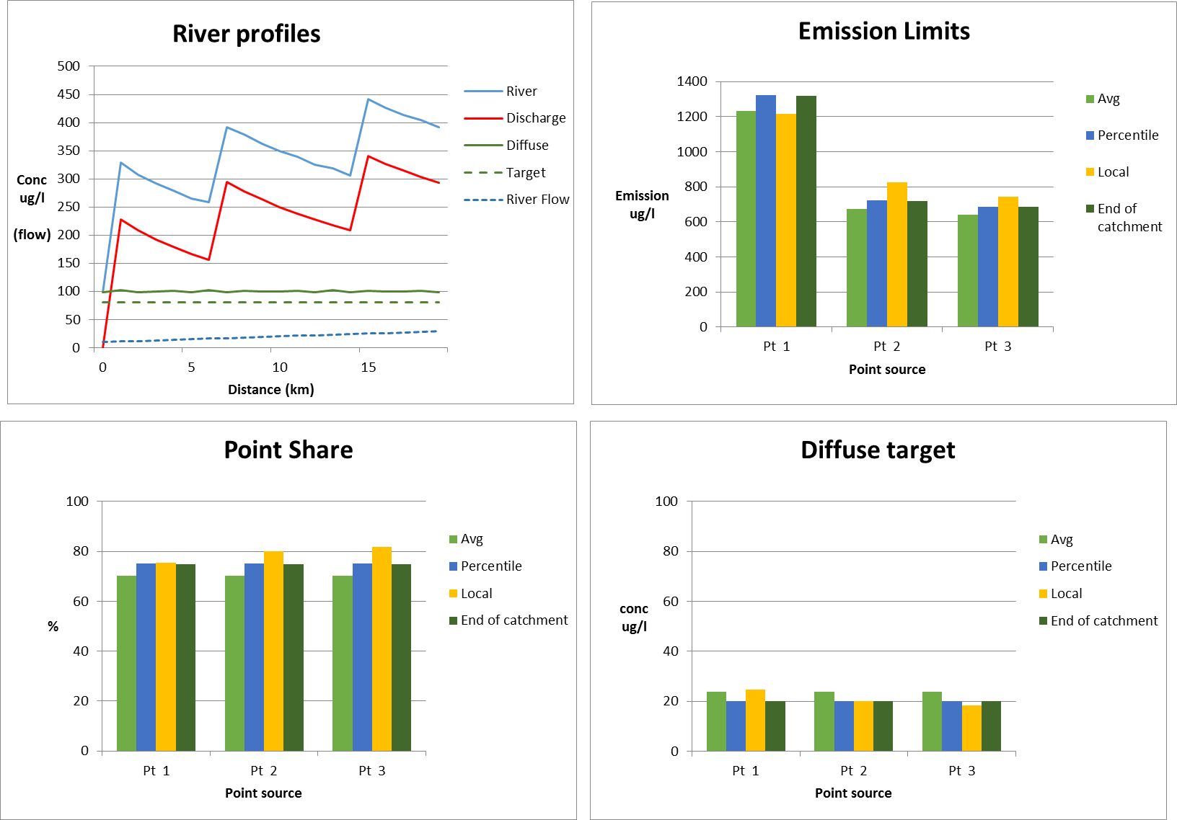

Figure 3 Base case

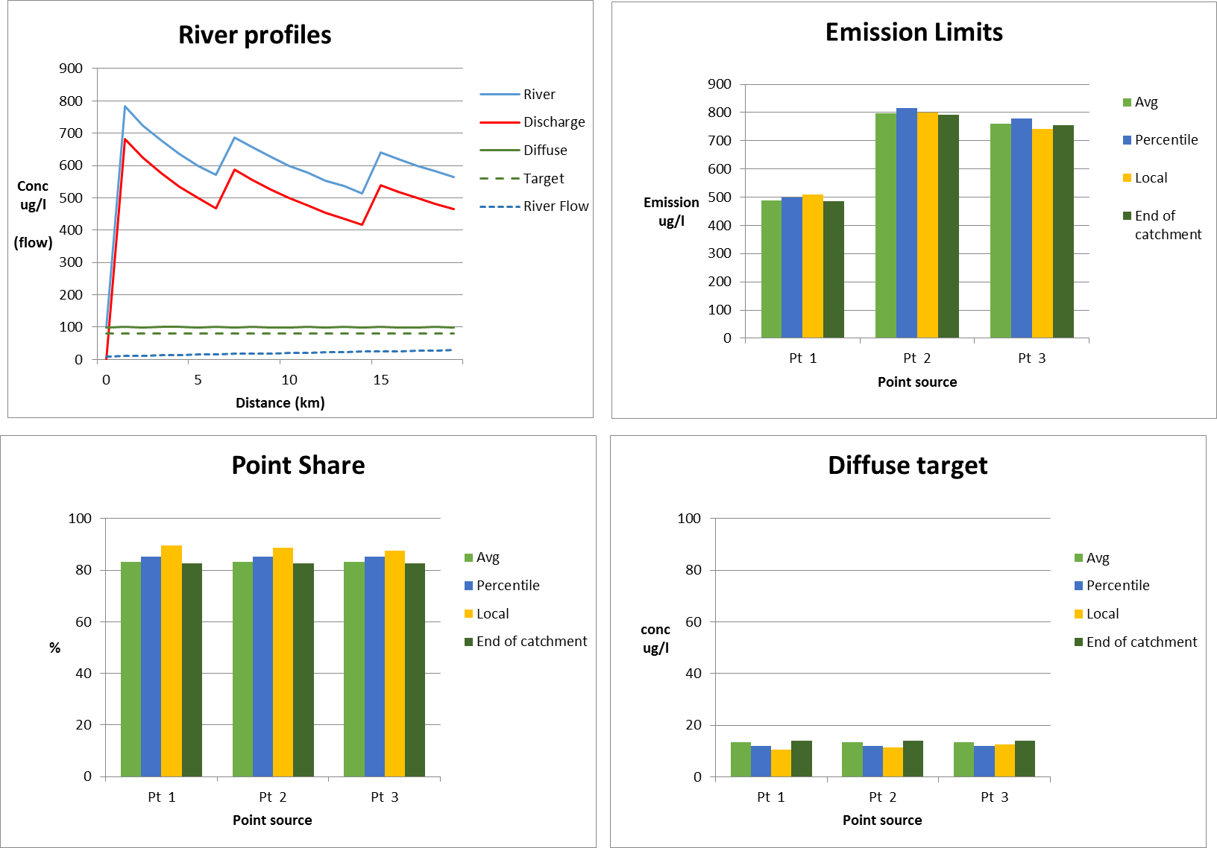

Figure 4. Large point source at top of catchment

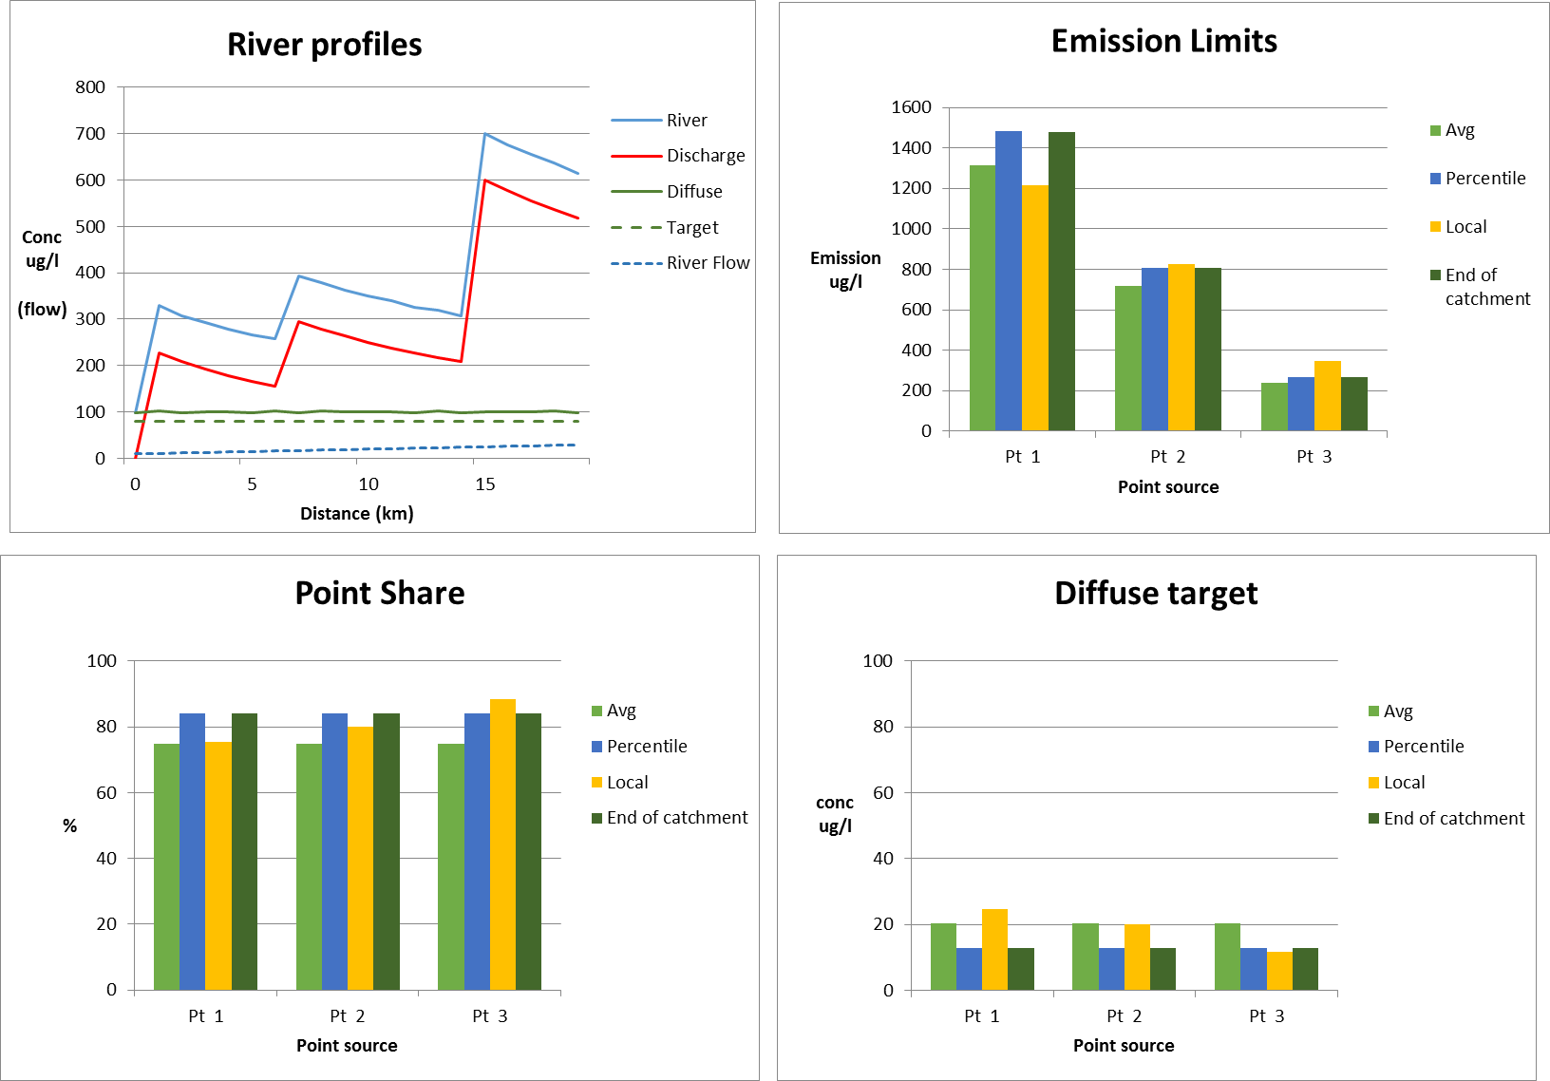

Figure 5. Large point source at end of catchment

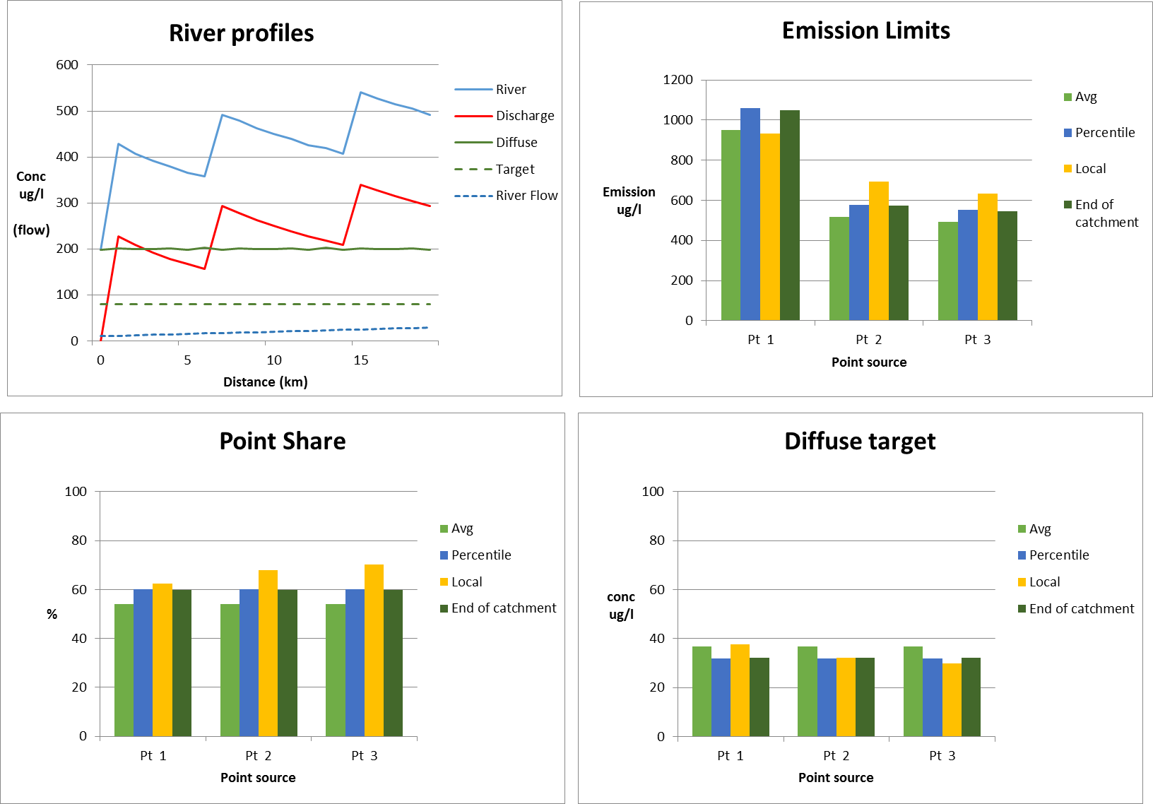

Figure 6. Rural catchment

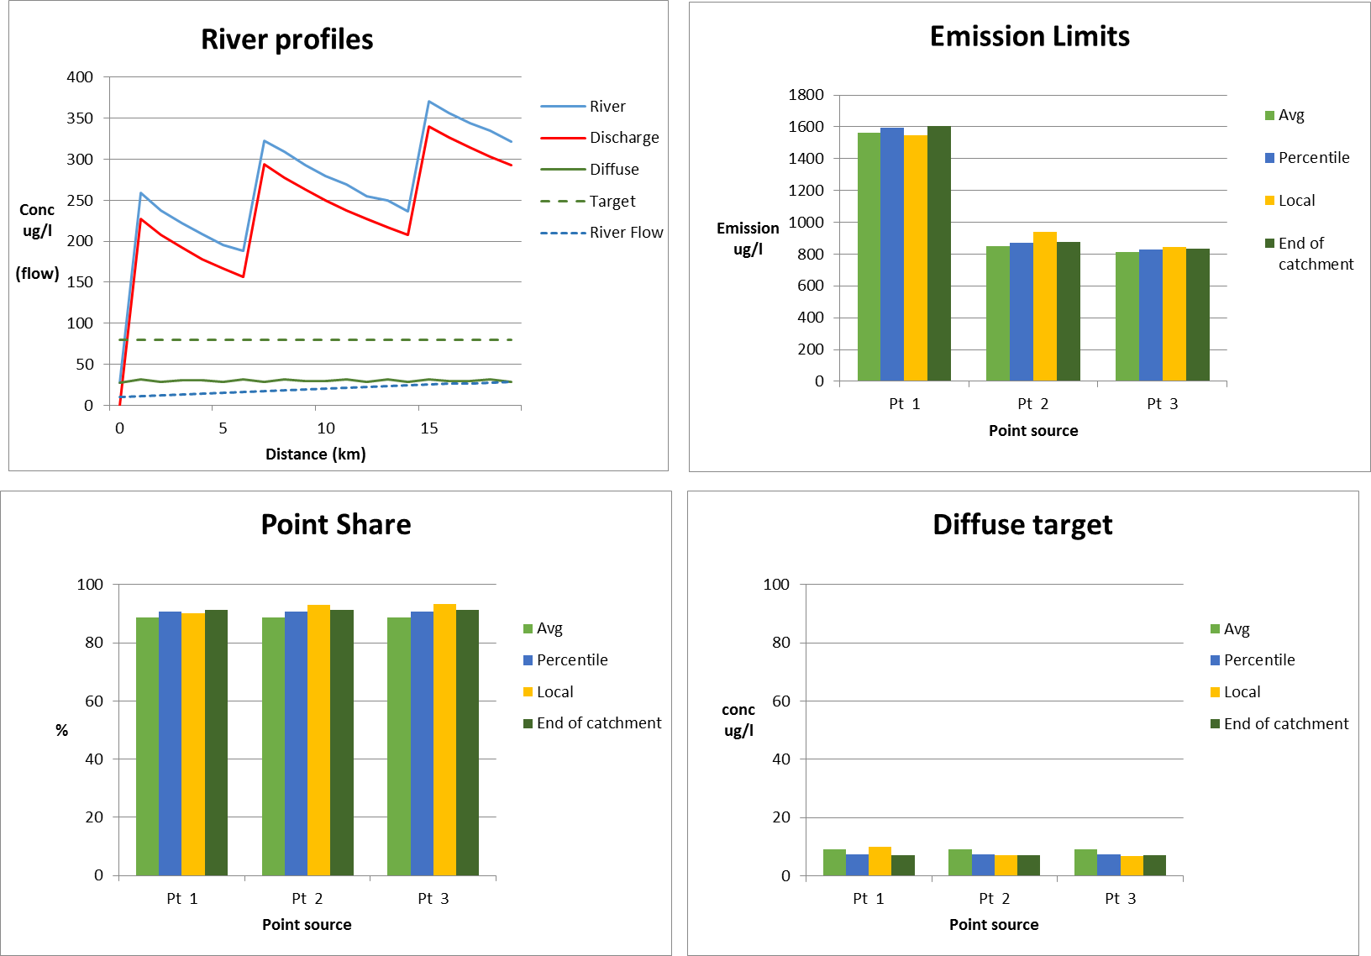

Figure 7. Urban catchment

4.2.2 Local approach versus catchment approaches

The local approach is compared here against the three catchment approaches, which all adopt a similar method, albeit with the percentage allocation of the EQS calculated in different ways. (i.e. catchment averaging, peak catchment and end of catchment).

A range of scenarios is examined to understand the likely outcomes in situations where the local source apportionment is different from the wider catchment. Two catchment case studies are presented:

1. Catchment 1 – Point source dominated *(point = 60% of load; diffuse = 40%)*
2. Catchment 2 – Diffuse source dominated *(point = 20%; diffuse = 80%)*

Within each of these two catchments, three localities are tested:

1. Locality 1 - Point source dominated *(point = 90%; diffuse = 10%)*
2. Locality 2 - Equal contribution of point & diffuse sources (p*oint = 50%; diffuse = 50%)*
3. Locality 3 - Diffuse source dominated *(point = 70%; diffuse = 30%)*

**Catchment 1 Point source dominated catchment *(point source = 60%)***

In catchment 1, point sources contribute 60% of the load. The P concentration at each locality is assumed to be 2-times higher than the EQS (P concentration = 0.20mg/l; EQS = 0.10g/l). The current load is 20kg/d; therefore halving the load to 10kg/d can be assumed to achieve the EQS.

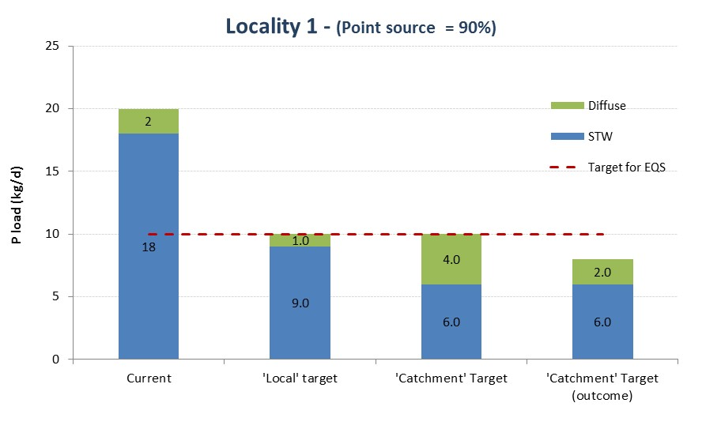

Figure 8 Locality 1 - Point source dominated

In locality 1 (figure 8), point sources currently contribute 90% of the impact at this point in the river. By adopting the ‘local impact’ approach, point sources are allocated 90% of the target. This is a 50% reduction in the current point load.

If the catchment approach is used, point sources are allocated only 60% of the target so would result in a 67% reduction in current load.

With the catchment approach, the diffuse sector is allocated 40% of the target, which is actually higher than the current contribution. In theory at least, it could double its load contribution here (from 2kg/d to 4kg/d). By squeezing the point sector into 60% of the target, the EQS target may be over-achieved as the diffuse won’t utilise its full allocation.

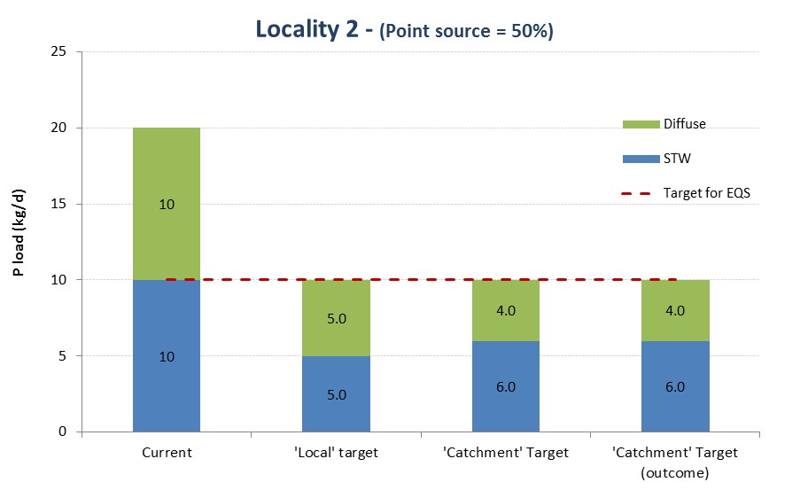

Figure 9 Locality 2 - Equal point & diffuse sources

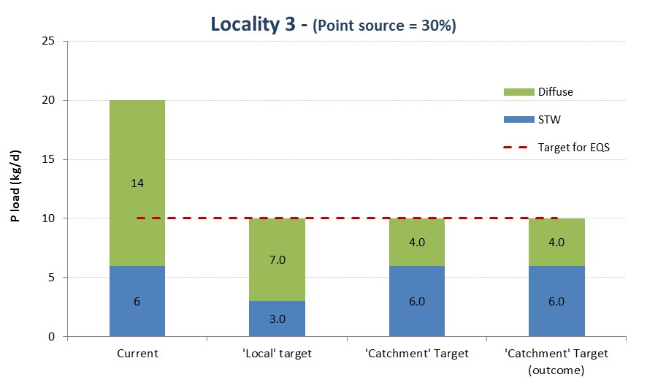

Figure 10 Locality 3 – Diffuse source dominated

In locality 3 (figure 10) point sources contribute only 30% of the current load but are allocated 60% of the target in the catchment approach. The point source does not have to make any improvement to achieve its share of the target.

Diffuse sources need to reduce 71% of the current load for the catchment approach compared to 50% for the local.

**Catchment 2 Diffuse source dominated catchment *(Diffuse source = 80%)***

In catchment 2, point sources contribute only 20% of the load. The P concentration at each locality is still assumed to be 2-times higher than the EQS, the same as catchment 1.

At locality 1 (figure 11), the same outcome occurs as in the catchment 1 example, although the over-achievement is exacerbated in a diffuse-dominated catchment as point sources are only allocated 20% of the target. Point sources need to remove 89% of the current load for the catchment approach compared to 50% using the local method.

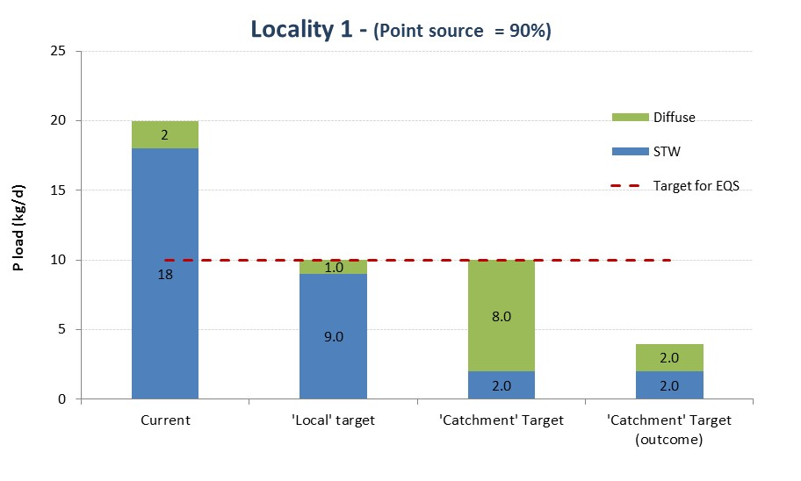

Figure 11 Locality 1 - Point source dominated

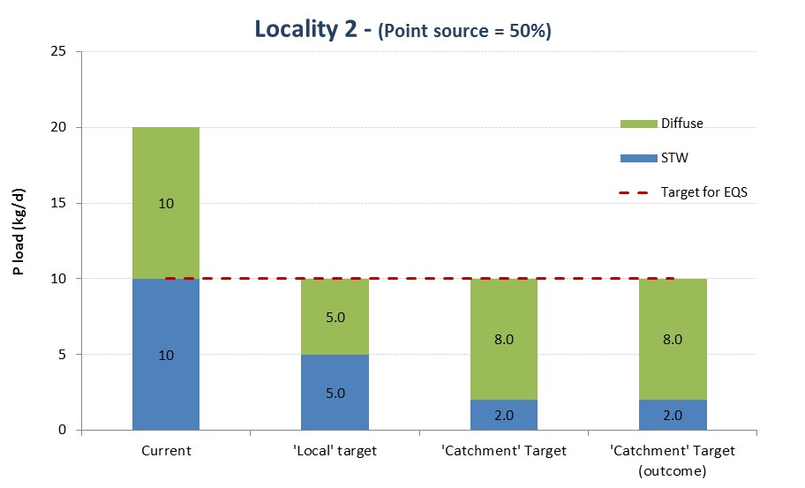

Figure 12 Locality 2 - Equal point & diffuse sources

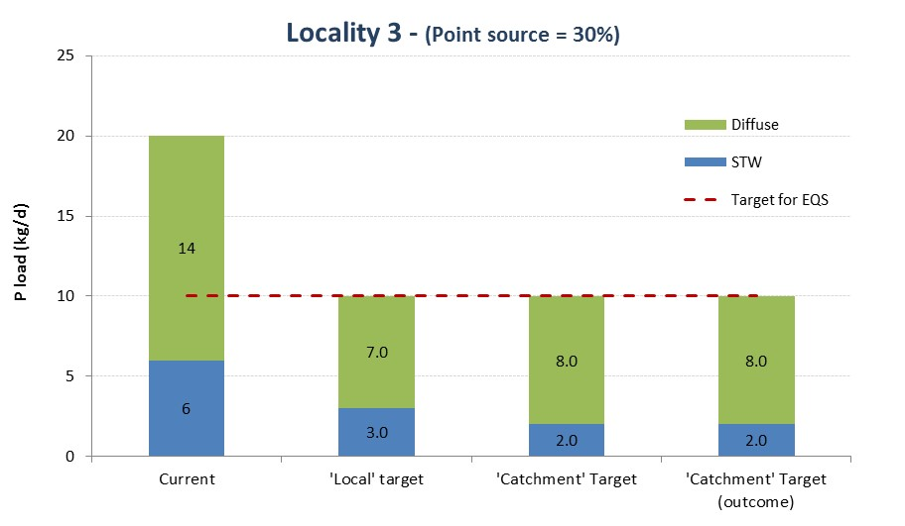

Figure 13 Locality 3 – Diffuse source dominated

Figure 14 extends the principle illustrated in the graphs above to a full range of local and catchment source apportionment. The values in the table are the percentage reduction in point sources using a catchment method. For comparison, the locally-derived improvement in our example is always 50%. The examples shown in figures 8 to 12 are highlighted in the matrix.

This matrix illustrates that the disparity between a catchment and local approach is exacerbated when the difference between local & catchment source apportionment is greatest.



Figure 14 Catchment method point source reduction (%) for range of local and catchment source apportionment

4.3 Catchment share comparisons – Thames and Wye basins

4.3.1 Introduction

The above examples are hypothetical. We now examine how the notions we have developed work out on actual catchments.

For this purpose we use the SAGIS-SIMCAT Thames and Wye model basins. The Thames catchments are predominantly, but not exclusively, point source dominated, whilst the Wye is conversely, rural.

The aim is to see how the share allocation varies under the different approaches.

4.3.2 Fair Share Options

All options are applied at operational catchment scale.

The options considered are:

1. Catchment averaging using all points (in the catchment)
2. Catchment 85th percentile using all points (in the catchment)
3. As (1) but at the sample points only
4. As (2) but at the sample points only
5. Catchment averaging at discharge points only
6. End of catchment (single value, hence only 1 result)

The ‘fair share ‘ metric is the percentage target for point (STW) sources. These metrics are calculated using calibrated SIMCAT models for the Thames and Wye.

Importantly options (3) and (4) do not depend on the validity of the quality model calibration. This is because the share metric is derived from the difference between the point impacts and the sample point concentration. (A flow calibrated SIMCAT model is needed, but this is easier to produce and more reliable than a flow and quality calibrated model.)

4.3.3 Results

The results are shown in the figures below.

These show the ‘fair share’ allocation by operational catchment for the above options.

Note that the ‘all points’ and ‘sample point’ estimates are more consistent than ‘end of catchment’ estimate.

And note that the discharges averages profiles are similar to the ‘all points’ profiles.

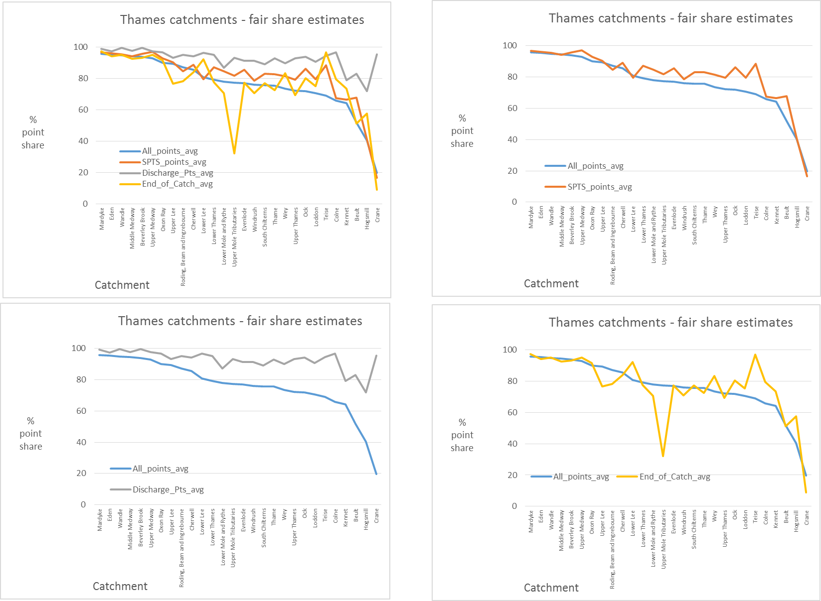

Figure 15. Thames catchments fair share estimates, all points and sample points – averaged.

Points to note:

* ‘All points’ and sample point profiles are similar. Disparities probably related to actual sampling point distributions in catchments.
* Discharge point profile gives more point share than the ‘all points’. This is to be expected because the point source impact is at maximum at discharge point.
* End of catchment similar to the ‘all points’. Disparities possibly related to bottom of catchment, or top of catchment STWs strongly influencing the estimate.

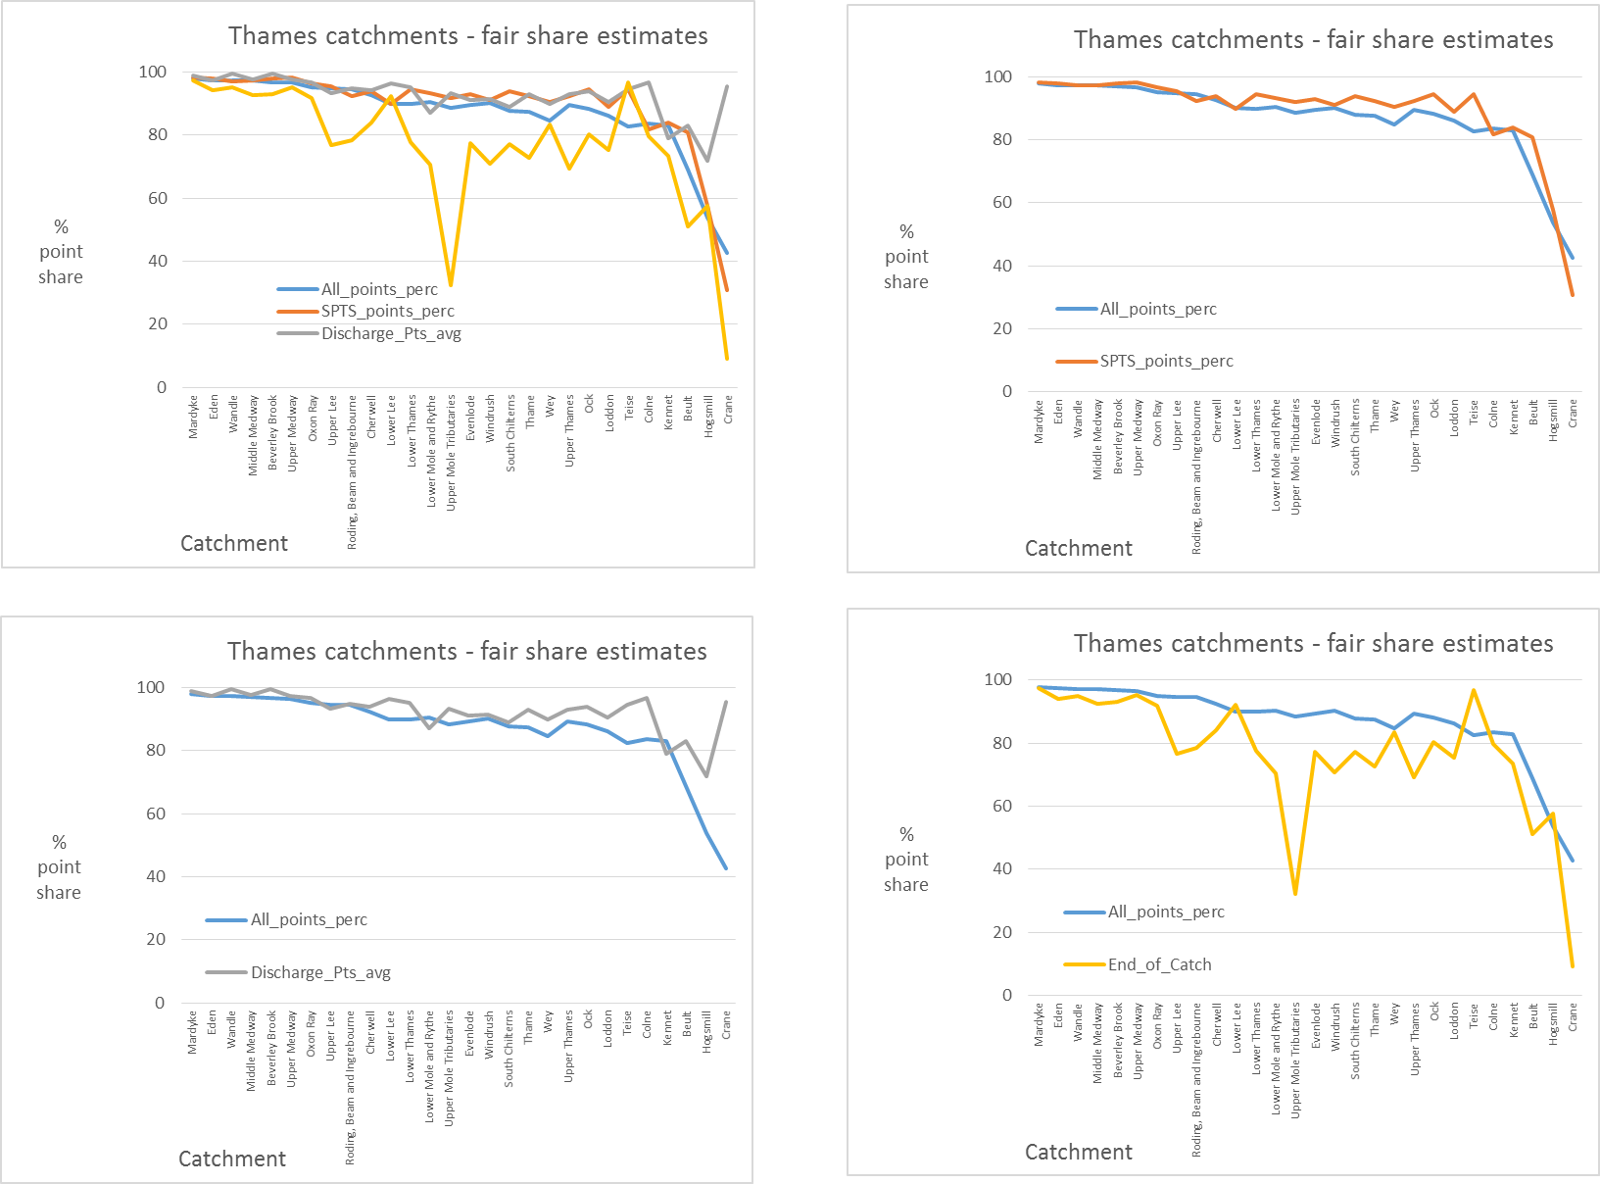

Figure 16. Thames catchments fair share estimates, all points and sample points – percentiles.

Points to note:

* ‘All points’ and sample point profiles are similar. Disparities probably related to actual sampling point distributions in catchments.
* Discharge point profile similar to the ‘all points’. This is to be expected as the ‘all points’ percentile will pick up the excursions relating to STW impact. The disparities for the Crane and Hogsmill catchments appears to be related to the influence of (relatively) large STWs towards the bottom of the catchment, with few other STWs. The discharge points method will be more strongly influenced by this than the all points method which is less sensitive to ‘extreme’ effects. (If a higher percentile than the 85th were used, then the disparity would decrease, at the expense of under-representing the rest of the catchment.)
* The end of catchment profile is lower than to the ‘all points’. This is because it is based on an averaging rather than percentiles.

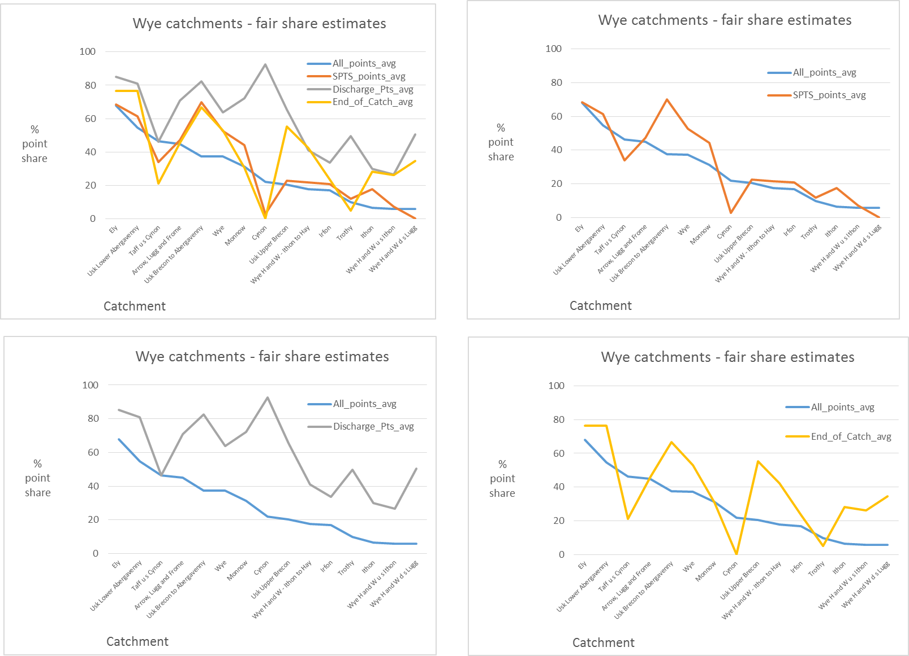

Figure 17. Wye catchments fair share estimates, all points and sample points – averaged.

Points to note:

* ‘All points’ and sample point profiles are similar. Disparities probably related to actual sampling point distributions in catchments.
* Discharge point profile gives more point share than the ‘all points’. This is to be expected because the point source impact is at maximum at discharge point.
* End of catchment is variable. Averaging across all catchments it is similar to the ‘all points’ results similar to the ‘all points’. Disparities possibly related to bottom of catchment, or top of catchment STWs strongly influencing the estimate.

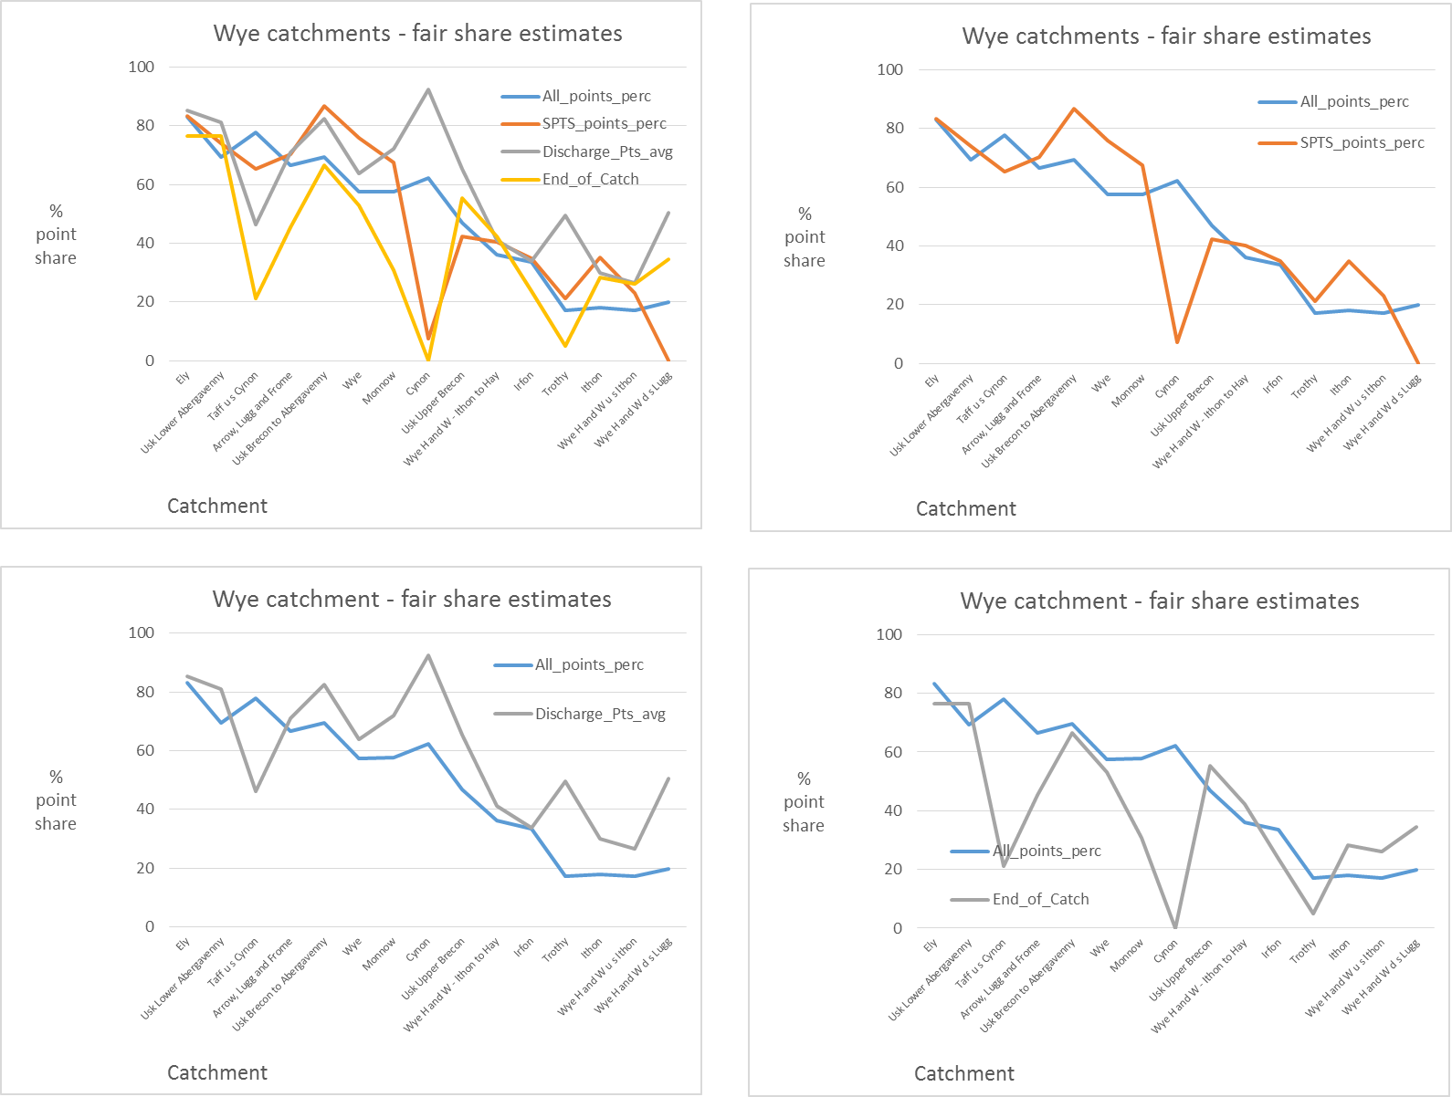 Figure 18. Wye catchments fair share estimates, all points and sample points – percentiles

Points to note:

* ‘All points’ and sample point profiles are similar. Disparities probably related to actual sampling point distributions in catchments.
* Discharge point profile similar to the ‘all points’. This is to be expected as the ‘all points’ percentile will pick up the excursions relating to STW impact. The disparities appear to be related to the influence of (relatively) large STWs towards the bottom of the catchment, with few other STWs. The discharge points method will be more strongly influenced by this than the all points method which is less sensitive to ‘extreme’ effects. (If a higher percentile than the 85th were used, then the disparity would decrease, at the expense of under-representing the rest of the catchment.)

The end of catchment profile is lower than to the ‘all points’. This is because it is based on an averaging rather than percentiles.

4.5 Evaluation

A number of approaches have been considered above.

These fall into two groups:

* Global – single value for whole catchment - share allocation
* Local share allocation.

The global approaches considered are:

* Catchment average – all points
* Catchment average – sample points
* Catchment average – end of catchment
* Catchment percentile – all points
* Catchment percentile – sample points
* Catchment – discharge points.

**Global evaluation**

Of these the averaging approaches do not allow for the peak impacts from STWs and hence over limit the point source allocation. The end of catchment approach is more variable, as it can be distorted by top/bottom of catchment dominant STWs.

The percentile and discharge points approaches are broadly consistent. The variation between the all points and sample points approach relates to the sample point coverage. The use of (spatial) percentiles to encapsulate catchment characteristics is new. It is analogous to the use of our more familiar temporal percentiles to describe time varying concentrations. The 85th percentile has been chosen here because it is aligned with our previous condition that 15% of a waterbody may be outside compliance.

In short, for global representation, the choice comes down to either the percentile or discharge point approach. The percentile approach sense the whole catchment and thus appears to be fairer.

**Local Evaluation**

The local approach allows fine tuning and will make some discharges more attractive and some less attractive, when emission limits and costs are considered. It will also result in the diffuse (agricultural) share being variable across the catchment.

**Choices**

Our understanding of catchment based approaches is evolving. Whether the global or local share allocation method is preferable will depend on catchment characteristics and goals. It would be premature at this stage to recommend one or the other as we need to better understand how they pan out when applied to our various and variable catchments. This understanding will develop as PR19 progresses.

4.5 Implementation implications

All methods can be modelled, using the SAGIS SIMCAT system and the Catchment Optimiser.

For point sources, it is straightforward to identify improvements for any of the approaches. The SAGIS Optimiser tool already utilises the local impact method to identify an optimum programme of point source improvements for a catchment. This tool was used to identify schemes for several water companies in PR14 so is consistent with existing practice. Other water companies used various approaches, including end of catchment share allocation.

For PR14, water industry phosphorus load reductions were estimated for each catchment as part of the ‘managing uncertainty‘ process. In general, these were calculated by summing local values across the catchment, being careful not to double-count improvements in upstream reaches which have benefits as they travel down the catchment.

The Optimiser tool could be adapted to use for the catchment average, peak catchment or end of catchment approaches. These three methods are very similar in terms of their ease of being implemented; they all involve a sector utilising the same apportionment of the target across the whole catchment, it’s simply a matter of calculating the specific value.

For diffuse sources, the ‘local’ method is more involved because of the need to identify the minimum downstream diffuse target and consider how this might be applied back up stream.

With the diffuse target varying across a catchment under the ‘local’ method, it would be difficult to apply.

1. Conclusion

A framework for understanding and comparing fare share concepts has been developed. The results of the comparison have been presented.

A judgment now has to be made on which approach to endorse and any amendments needed.



www.gov.uk/environment-agency