

Volume Two (2)

Contract for:
The Supply and install Modular Unit
at Grove Place Toilet, for Falmouth Town Council

Applicant’s Offer
Selection Questionnaire /
Invitation to Tender

Closing time and date for return of submission:
12:00 (Noon) 09/12/2022

Name of Applicant:
Please return electronically to:

email
AndyMedlin@falmouthtowncouncil.com

This document must be completed and returned in the published format. Failure to comply with this instruction may result in your Submission being discounted.
Contents

Section 1 – General Notes 3
Section 2 – Selection Questionnaire 3
Section 3 The Specification 8
Section 4 Applicants Response to Tender 11
Section 5 Pricing Schedule 13
Price Validity Period 13
Contract Renewal 13
Certificates and Declarations 14
Pricing Schedule Declaration 14
Certificate of Undertaking and Absence of Collusion or Canvassing 15
Certificate of Confidentiality 16
Commercially Sensitive Information 16
Conflict of Interest 16

Section 1 – General Notes
- This document should be read in conjunction with the supporting information contained within Volume 1 “Invitation to Tender - Background Information, Instructions and Conditions of Tender” and associated documents also referenced.
- This document and associated documents will form the basis of the Applicants formal tender response. Care should be taken to ensure that it is completed accurately, and all information required to submit a compliant tender is done ahead of submitting any final response.

Section 2 – Selection Questionnaire
- The Council confirms that it will keep confidential and will not disclose to any third parties any information obtained from a named customer contact, other than to the Cabinet Office and/or contracting authorities defined by the regulations, or pursuant to an order of the court or demand made by any competent authority or body where the Council is under a legal or regulatory obligation to make such a disclosure.
- The Applicants attention is further drawn to supporting guidance and information as included in “Volume 1” document related to this procurement process.
Notes for completion
- The “Council” means the contracting Council, or anyone acting on behalf of the contracting Council, that is seeking to invite suitable candidates to participate in this procurement process.
- “You” / “Your” refers to the potential supplier completing this standard Selection Questionnaire i.e. the legal entity responsible for the information provided. The term “potential supplier” is intended to cover any economic operator as defined by the Public Contracts Regulations 2015 (referred to as the “regulations”) and could be a registered company; the lead contact for a group of economic operators; charitable organisation; Voluntary Community and Social Enterprise (VCSE); Special Purpose Vehicle; or other form of entity.
- Please ensure that all questions are completed in full, and in the format requested. If the question does not apply to you, please state ‘N/A’. Should you need to provide additional information in response to the questions, please submit a clearly identified annex.
- The Council recognises that arrangements set out in section 1.2 of the standard Selection Questionnaire, in relation to a group of economic operators (for example, a consortium) and/or use of sub-contractors, may be subject to change and will, therefore, not be finalised until a later date. The lead contact should notify the authority immediately of any change in the proposed arrangements and ensure a completed Part 1 and Part 2 is submitted for any new organisation relied on to meet the selection criteria. The Council will make a revised assessment of the submission based on the updated information.
- For Part 1 and Part 2 every organisation that is being relied on to meet the selection must complete and submit the self-declaration.

Part 1: Potential supplier information
Please answer the following questions in full. Note that every organisation that is being relied on to meet the selection must complete and submit the Part 1 and Part 2 self-declaration.
Section 1 | Potential supplier information
Question number | Question |  | Response
1.1(a) | Full name of the potential supplier  submitting the information
1.1(b) – (i) | Registered office address (if applicable)
1.1(b) – (ii) | Registered website address (if applicable)
1.1(c) | Please mark ‘X’ in the relevant box to indicate your trading status |  | - a public limited company
 |  |  | - a limited company
 |  |  | - a limited liability partnership
 |  |  | - other partnership
 |  |  | - sole trader
 |  |  | - other (please specify)
1.1(d) | Date of registration in country of origin
1.1(e) | Company registration number (if applicable)
1.1(f) | Charity registration number (if applicable)
1.1(g) | Head office DUNS number (if applicable)
1.1(h) | Registered VAT number
1.1(i) - (i) | If applicable, is your organisation registered with the appropriate professional or trade register(s) in the member state where it is established?
1.1(i) - (ii) | If you responded yes to 1.1(i) - (i), please provide the relevant details, including the registration number(s).
1.1(j) - (i) | Is it a legal requirement in the state where you are established for you to possess a particular authorisation, or be a member of a particular organisation in order to provide the services specified in this procurement?
1.1(j) - (ii) | If you responded yes to 1.1(j) - (i), please provide additional details of what is required and confirmation that you have complied with this.
1.1(k) | Trading name(s) that will be used if successful in this procurement
1.1(l) | Please mark ‘X’ in the relevant box to indicate whether any of the following classifications apply to you |  | - Voluntary, Community and Social Enterprise (VCSE)
 |  |  | - Small or Medium Enterprise (SME)
 |  |  | - Sheltered workshop
 |  |  | - Public service mutual
1.1(m) | Are you a Small, Medium or Micro Enterprise (SME)?
1.1(n) | Details of Persons of Significant Control (PSC), where appropriate (Please enter N/A if not applicable)
 | Name:
 | Date of birth:
 | Nationality:
 | Country, state or part of the UK where the PSC usually lives:
 | Service address:
 | The date they became a PSC in relation to the company (for existing companies the 06 April 2016 should be used):
 | Which conditions for being a PSC are met:
 | Over 25% up to (and including) 50%
 | More than 50% and less than 75%
 | 75% or more
1.1(o) | Details of immediate parent company (Please enter N/A if not applicable)
 | Full name of the immediate parent company:
 | Registered office address (if applicable):
 | Registration number (if applicable):
 | Head office DUNS number (if applicable):
 | Head office VAT number (if applicable):
1.1(p) | Details of ultimate parent company (Please enter N/A if not applicable)
 | Full name of the ultimate parent company:
 | Registered office address (if applicable):
 | Registration number (if applicable):
 | Head office DUNS number (if applicable):
 | Head office VAT number (if applicable):
Please note: A criminal record check for relevant convictions may be undertaken for the preferred suppliers and the Persons of Significant Control of them.
Please provide the following information about your approach to this procurement.
Section 1 | Bidding model
Number | Question |  | Response
1.2(a) - (i) | Are you bidding as the lead contact for a group of economic operators?  If yes, please provide details listed in questions 1.2(a) (ii), (a) (iii) and to 1.2(b) (i), (b) (ii), 1.3, Section 2 and 3.  If no, and you are a supporting bidder please provide the name of your group at 1.2(a) (ii) for reference purposes, and complete 1.3, Section 2 and 3. |  | Please indicate your answer by marking ‘X’ in the relevant box.
 |  |  | Yes |  | No
1.2(a) - (ii) | Name of group of economic operators (if applicable)
1.2(a) - (iii) | Proposed legal structure if the group of economic operators intends to form a named single legal entity prior to signing a contract, if awarded. If you do not propose to form a single legal entity, please explain the legal structure.
1.2(b) - (i) | Are you or, if applicable, the group of economic operators proposing to use sub-contractors? |  | Yes |  | No
1.2(b) - (ii) | If you responded yes to 1.2(b)-(i) please provide additional details for each sub-contractor in the following table: we may ask them to complete this form as well.
 | Name:
 | Registered address:
 | Trading status:
 | Company registration number:
 | Head Office DUNS number (if applicable):
 | Registered VAT number:
 | Type of organisation:
 | SME (Yes/No):
 | The role each sub-contractor will take in providing the works and /or supplies e.g. key deliverables:
 | The approximate % of contractual obligations assigned to each sub-contractor:
Contact details and declaration
I declare that to the best of my knowledge the answers submitted and information contained in this document are correct and accurate.
I declare that, upon request and without delay I will provide the certificates or documentary evidence referred to in this document.
I understand that the information will be used in the selection process to assess my organisation’s suitability to be invited to participate further in this procurement.
I understand that the Council may reject this submission in its entirety if there is a failure to answer all the relevant questions fully, or if false/misleading information or content is provided in any section.
I am aware of the consequences of serious misrepresentation.
Section 1 | Contact details and declaration
Number | Question |  | Response
1.3(a) | Contact name
1.3(b) | Name of organisation
1.3(c) | Role in organisation
1.3(d) | Phone number
1.3(e) | E-mail address
1.3(f) | Postal address
1.3(g) | Signature (electronic is acceptable)
1.3(h) | Date
Part 2: Selection questions
Section |  | Additional questions
2.1 |  | Insurance |  | Response
Please self-certify whether you already have, or can commit to obtain, prior to the commencement of the contract, the levels of insurance cover indicated below (Please indicate your answer by marking ‘X’ in the relevant box): |  |  |  | Yes |  | No
Employer’s (Compulsory) Liability Insurance = £5m
Public Liability Insurance = £10m
Product Liability Insurance = £2m

Section 3 The Specification
- The Council is seeking a Supplier for modular building to be supplied and installed at Grove Place, Falmouth with Works must be completed by 31 March 2023.
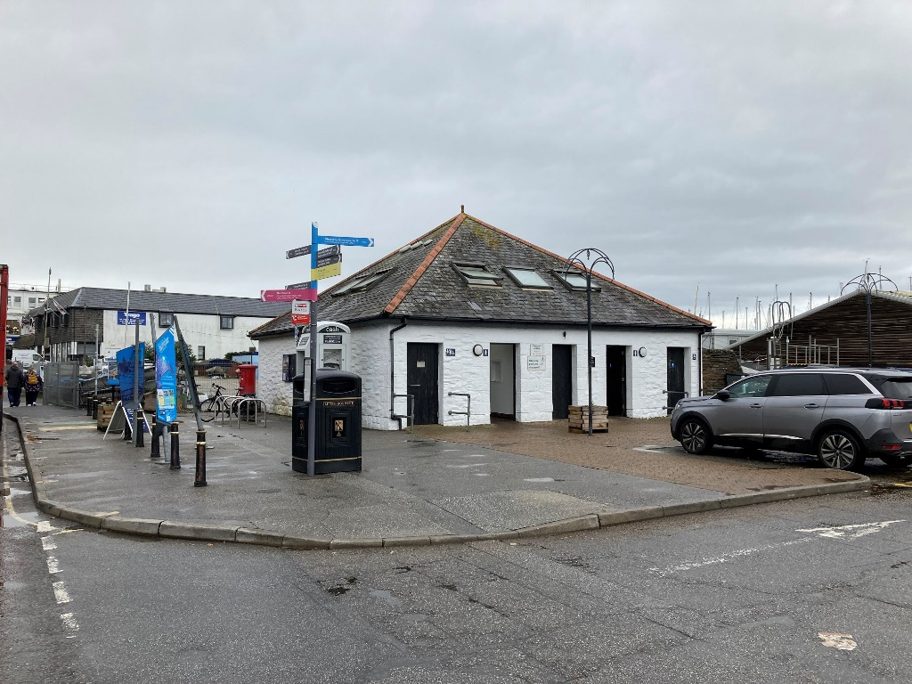
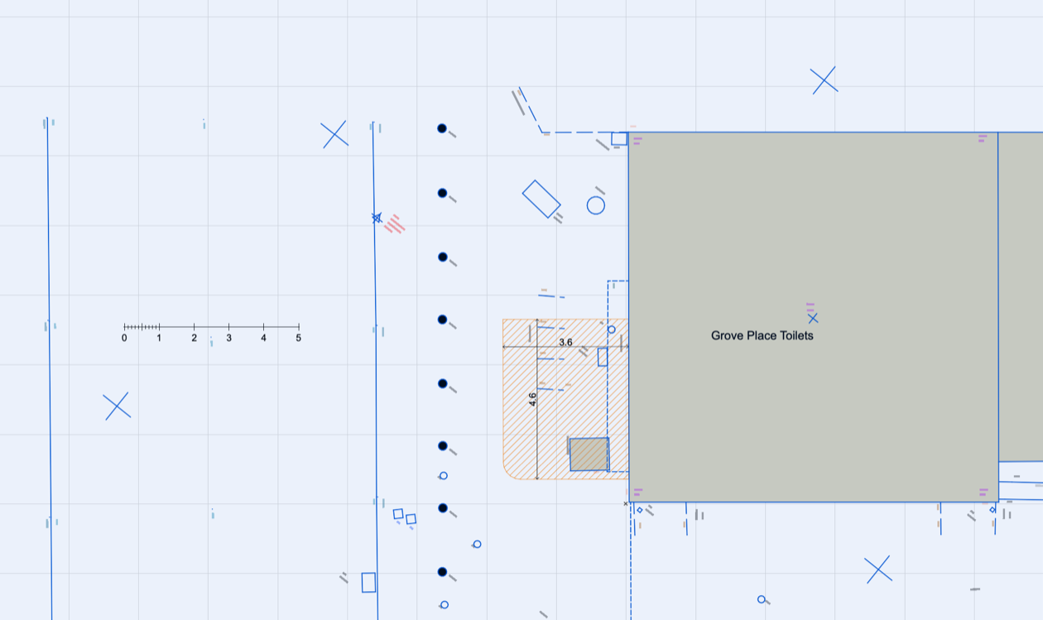
- All site service preparation and groundworks to be undertaken by the Council prior to installation. The specification for the Supplier to deliver against is as follows:
  - Supply, delivery and installation of modular change building to client prepared base – minimums size 4m x 3m. To meet BS8300 standards for guaranteed compliance
  - In house design and project management service
  - Modular unit fitted with all equipment and sanitary items to meet BS8300, including:
    - AirRise200 hoist unit on Slimline AirGlide360 track (or suitable equivalent). Hoist to have BatterySave advanced protection system for long lasting life. Critical Endstop to be used to ensure full safety when in use. Hoist to be compliant to: IEC 62366-1, Bs EN 12182, EN 1492-1+A1, EN 1492-1+A1 & EN 1492-1+A1.
    - Wall Mounted Changing Bench. To have removeable padded lying sections and curved lying section for extra patient comfort
    - Close coupled Peninsular toilet with easy access toilet seat
    - Height adjustable wash basin – integrated handholds and lever adjustment. All services to be enclosed in vanity cover and TMV3 tapset to be used to avoid any scalding
    - Wall Mounted Privacy screen – hygienic screen, on wheels to move around room and to fold back to wall when not in use. To have individual quick-release replaceable panels
    - Soap dispenser
    - Dropdown rails (one to include toilet roll holder)
    - Vertical grab rails
    - Wide paper roll dispenser
    - Full-length mirror
    - Paper towel dispenser
    - Hand dryer
    - General waste bin
    - Sanitary bin
    - Coat hooks
    - Colostomy bag shelf
  - Finish to match existing render paint to existing building
  - To have pitched antivandal roof with gable ends and slate tiles or similar
  - Corner of unit to be chamfered to allow easy pedestrian access around front of building
  - Supplied with external signage and lighting by door
  - Anti-slip flooring
  - Waterproof interior wall finish
  - Service connections provided in agreed location – electric, waste and water
  - Positioning, installation, testing, certifying, commissioning, handover and training
  - 10-year warranty on the building
  - 18-month warranty on specialist equipment:
  - 3 year service plan including statutory Lifting Operations and Lifting Equipment Regulations (LOLER)
  - Internal wall graphic option
  - Social media promotional launch
  - Obtaining formal accreditation and approval from Changing Places Consortium - https://www.changing-places.org/
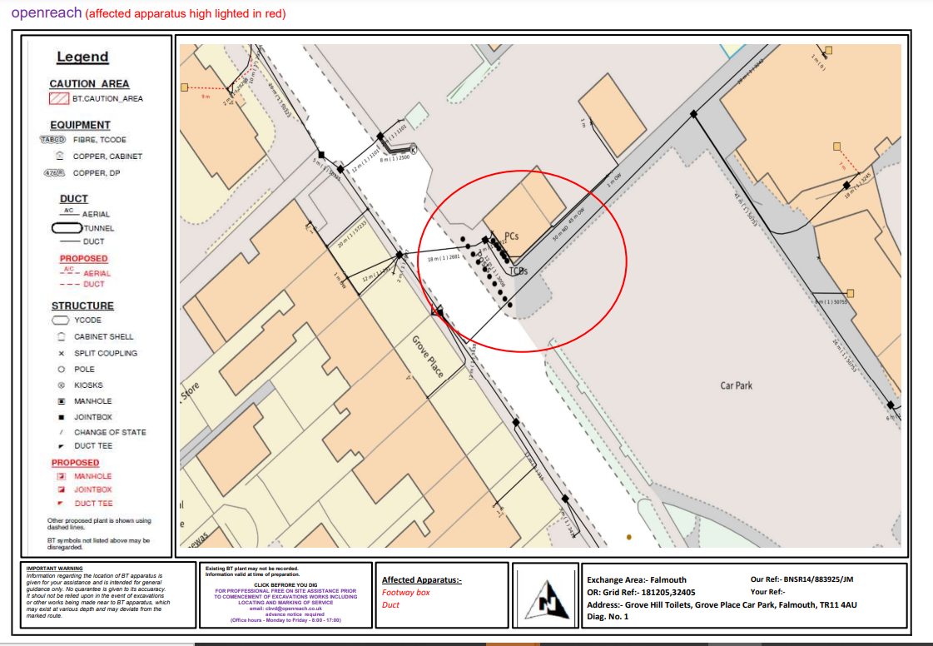

Section 4 Applicants Response to Tender
- Section 4 to be completed by all Applicants looking to submit a formal response to this Tender.
- The below are pass fail questions, and in the event that you answer “no” to any of the questions then we will not evaluate your tender any further and will not be able to contract with you.
Ref | PASS / FAIL QUESTIONS – Confirmation that Tender is submitted on the following understanding: | Please delete as appropriate
1 | You will contract with the Council under the JCT - Minor Works Sub-Contract with sub-contractor’s design (MWSub/D). | Yes / No
2 | You will be able to deliver the and hand over the modular building as complete to the Council by 31 March 2022 | Yes / No
Method Statement Responses:
- Please detail your response in regard to this specific Method Statement.
Method Statement Topic Areas – Supporting Proposal
Council requirements for the Applicant’s response to this Method Statement:
The Supplier is asked to produce a Supporting Statement which provides details on how the Supplier will deliver the outcomes required by the Council as set out in the supporting Specification.
WHAT DOES A STRONG RESPONSE LOOK LIKE?
A strong response by the Supplier would demonstrate that they have a credible modular solution that matches the outcomes set out in the Specification.
The proposal would include design and internal layouts of the modular unit and elevation.
The proposal would clearly set out requirements around the work required to be undertaken by the Council to enable the installation and how the Supplier would work proactively with the Council’s contractor
It would set out a clear plan as to the key dates and timeline to delivery and install in accordance with the deadline as required by the Council.
As strong proposal would also provide details on the quality controls which the Supplier would provide to ensure that both delivery and outcomes are to a high standard.
A strong response would clearly indicate an understanding of the requirements as set out within the Statement of Requirements and what is necessary to deliver high quality outcomes. It will clearly set out how each of the identified themes will be approached and met by the bidder.
A strong response would clearly set out a structured approach understanding and approach to ensure that the Contract is delivered in a timely orderly and professional manner.
A strong response would be clear on how the Supplier would work with both the Council and key stakeholders and other contractors, the approach they would adopt and the experience and credentials they have elsewhere which they would bring to this project to make it a success.
The proposal must also provide the details in relation to the costs for the supply and installation, including clarity on total costs and any exclusions.

Section 5 Pricing Schedule
- Applicants are required to provide a clear price for the supply and installation within the Bidders Supporting Proposal. All prices shall be stated in pounds sterling and exclusive of VAT. If there is no charge for an item, please state none. Any additional work will be based on further price proposal.
- Payments to be made on completion of satisfactory sign off on Milestones – in particular on the delivery and installation.

Price Validity Period
- As a minimum, all prices submitted must remain fixed and firm for six (6) months from date of Contract commencement. In support of this, please detail exactly how long your prices will remain fixed and firm for.
Price Review Proposals
- The Council does not expect the Applicant to implement any price increases throughout the life of this Contract.

Contract Renewal
- No Contract once awarded shall be renewed at a higher rate than agreed between the parties through this price review framework or through any other such agreement as submitted to and approved by the Authority in writing.

Certificates and Declarations

CONDITIONS OF TENDER
Reference number and Title of Contract: Shall be as per the Reference Number and Title of Contract as detailed on page one (1) of this Volume Two (2) Applicant’s Offer
1. | By submitting a Tender, Applicants are agreeing to be bound by the terms and conditions without further negotiation or amendment.  I/We fully accept the terms and conditions of contract for the provision of goods/works/services
2. | Having examined the tender documents for the provision of the above goods/works/services, we offer to provide the said goods/works/services in conformity, without qualification, therewith for the sum/sums enclosed at Schedule 5 of this Bid.
3. | The Authority does not bind itself to accept the lowest or any Tender, and reserves the right to accept a Tender either in whole or in part, for such item or items specified in the Invitation to Tender, and for such place or places of delivery as it thinks fit, each item and establishment being for this purpose considered as tendered for separately.
4. | I/We the undersigned DO HEREBY UNDERTAKE on the acceptance by the Authority of my/our Tender either in whole or in part, to supply (or perform the services), on such terms and conditions and in accordance with such specifications (if any), as are contained or incorporated in the Invitation to Tender. I/We agree and declare that the acceptance of this Tender by letter on behalf of the Authority, whether for the whole or part of the items included therein, will constitute a Contract for the supply of such items, I/We agree to enter into a further agreement for the due performance of the Contract, and I/We declare that I am/We are acting as the Delegated Authority for the purposes of signing off this Tender, and therefore, the Contract.

Pricing Schedule Declaration
I / We offer to supply the goods or services as per the pricing schedule above, in accordance with the Specification, terms and conditions and all other documents forming the Contract.

Certificate of Undertaking and Absence of Collusion or Canvassing
CERTIFICATE OF UNDERTAKING AND ABSENCE OF COLLUSION OR CANVASSING
The Applicant shall sign the below Certificate of Undertaking and Absence of Collusion clearly indicating whether they sign as a Consortium or Member of Consortium (Box A), or as a single body and/or individual (Box B) by striking through Box A or B, whichever does not apply.
Box A – Consortium
I/We the undersigned do hereby certify that:-
- the consortium’s tender is bona fide and intended to be competitive;
- the consortium has not entered into any agreement with any person outside the consortium with the aim of preventing Tenders being made or asked the amount of another Tender of the conditions or which the Tender is made;
- the consortium has not informed any person outside the consortium other than the person calling for the Tenders the amount or approximate amount of the Tender except where the disclosure in confidence of the approximate amount of the Tender was necessary to obtain insurance premium or other quotations necessarily required for the preparation of the Tender;
- the consortium has not caused or induced any person to enter into such an agreement as is mentioned in (b) above or to inform the consortium of the amount or the approximate amount of any rival Tender for the Contract.
- the consortium has not and will not canvass or solicit any Member, Officer or employee of the Authority in connection with the preparation, submission and evaluation of this Tender or award or proposed award of the Contract and that to the best of my knowledge and belief, no person employed by the consortium or acting on the consortium’s behalf has done or will do such an act.
- I/We further undertake that the consortium will not do any of the acts mentioned in (b), (c), (d) and (e) above before the hour and date specified for the return of the Tender.
Box B – Single Body and/or Individual
I/We the undersigned do hereby certify that:-
- My/our Tender is bona fide and intended to be competitive and I/we have not fixed or adjusted the amount of the Tender by or under in accordance with any agreement or arrangement with any other person;
- I/we have not indicated to any person other than the person calling for the Tender amount or approximate amount of the proposed Tender except where the disclosure in confidence of the approximate amount of the Tender was necessary to obtain insurance premium or other quotations necessarily required for the preparation of the Tender;
- I/we shall have not entered into any agreement or arrangement with any other person that they shall refrain from Tendering or asked the amount of any Tender to be submitted;
- I/we have not offered to pay or give any sum of money or valuable consideration directly or indirectly to any person for doing or having done or causing or having caused to be done in relation to any other Tender or proposed Tender for the said work any act or thing of the nature specified and described above.
- I/we hereby certify that I/we have not and will not canvass or solicit any Member, Officer or employee of the Authority in connection with the preparation, submission and evaluation of this Tender or award or proposed award of the Contract and that to the best of my knowledge and belief, no person employed by me/us or acting on my/our behalf has done or will do such an act.
- I/we further undertake that I/we will not do any of the acts mentioned in (b), (c) and (d) above before the hour and date specified for the return of the Tender.

Certificate of Confidentiality
CERTIFICATE OF CONFIDENTIALITY
I/we hereby agree with the Authority that I/we shall not at any time divulge or allow to be divulged to any person any information, confidential or otherwise, relating to information passed to me regarding this project.
It is appreciated by the parties that in the event of negotiations in respect of the proposed Contract being entered into between the Authority and my organisation that it may be necessary to share information with colleagues within my organisation. In this event this confidentiality clause may be waived to allow such information sharing to take place but not further or otherwise.

Commercially Sensitive Information
The Authority may be obliged to disclose information in or relating to this Bid following a request for information under the Freedom of Information Act (FOIA) or Environmental Information Regulations (EIR). Please outline in the table below items which you consider are confidential and genuinely commercially sensitive and which should not be disclosed in respect of your Bid. I declare that I wish the following information to be designated as Commercially Sensitive.
The reason(s) it is considered that this information should be exempt under Freedom of Information Act FOIA) or Environmental Information Regulations (EIR) is:

Conflict of Interest
CERTIFICATE OF CONFLICT OF INTEREST
I/we hereby notify the Authority that I/we consider the following declaration to be a conflict of interest (Applicant to insert details of the conflict of interest):

I/we hereby understand that in accordance with Article 24 of the Public Contract Regulations 2015 that the Authority is obliged to take appropriate measures to effectively prevent, identify and remedy conflicts of interest arising in the conduct of procurement procedures so as to avoid any distortion of competition and to ensure equal treatment of all economic operators.

Signatures

Signed*: | Date:
Name (in block capitals):

In the capacity of: (State official position, i.e. Director, Manager, etc.)

*(It must be clearly shown whether the Applicant is a limited company, statutory corporation, partnership or single individual, trading under his own or another name, and also if the signatory is not the actual Applicant, the capacity in which they sign or are employed).

