# Cambridgeshire County Council & Peterborough City Council

# Development of Accommodation with Care for Older People and Adults with Physical Disabilities PIN

**Introduction**

**Between 2021 and 2036, the number of people aged 65+ in Cambridgeshire and Peterborough is estimated to increase by 48% while the percentage of those over 85 is estimated to increase by 110%.**

**During the first half of 2021, Cambridgeshire County Council (CCC) and Peterborough City Council (PCC) will develop long term commissioning plans to ensure a sufficient supply of accommodation with care for older people and adults with physical disabilities to meet the forecasted increase in demand. By autumn/winter 2021, CCC and PCC hope to commence any subsequent procurement activity with a view to new developments being ready by 2026 or earlier.**

**CCC and PCC wish to engage with the wider market to communicate CCC and PCC's forecasted requirements; better understand market trends and opportunities in this sector; assess appetite for collaboration with LAs and other providers and understand market preferences for procurement.**

**The market engagement will comprise of 3 stages:**

* **Initial provider engagement opportunity – Ongoing**
* **Soft Market Testing exercise – market engagement event 16th March 2021**
* **Commissioning Planning Event to be held at the end of July 2021.**

**This Prior Information Notice (PIN) serves to inform the market of provider organisations in the field of accommodation based services for older people and adults with a physical disabilities.**

**Please note: this PIN is not an invitation to tender, or a request for formal expressions of interest. This notice does not form any part of an invitation to tender (ITT). Any future procurement, and subsequent contract award, will be undertaken in line with the requirements of the Public Contract Regulations 2015 and the Councils’ Contract Rules.**

**Background**

CCC and PCC have carried out a Needs Assessment to evaluate the future requirements for local authority funded accommodation for older people aged 65+ (including older people with mental health needs) and adults with physical disabilities aged 18+ within CCC and PCC local authority boundaries.

The Needs Assessment focused on the following settings:

* Residential and Nursing Care Homes
* Extra Care schemes
* Care Suites*.

Whilst the Needs Assessment primarily focused on local authority funded accommodation, it did consider potential self-funders and health funded demand. **The work did not include adults with learning disabilities, adults with specialist mental health needs aged 18-64 or live-in care.**

*tenancy based model of care

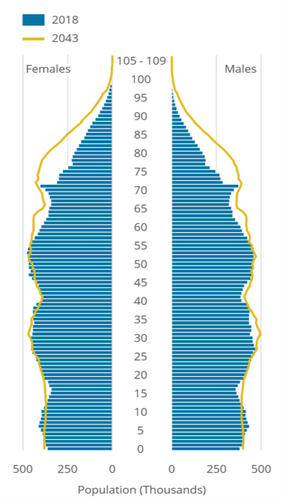**Introduction**

Nationally there will be an increase in the 65+ population. The chart opposite shows the national population change from 2018 to 2043. The increase in the 65+ population is largely due to the ageing of the Baby Boomers generation (people born from 1946 to 1964, during the post–World War II baby boom).

Between 2021 and 2036, the number of people aged 65+ in Cambridgeshire and Peterborough is estimated to increase by 48% while the percentage of those over 85 is estimated to increase by 110%.

The 18+ population across Cambridgeshire and Peterborough will increase by 8% from 2021 to 2036 from 538,730 to 580,850 people.

The Cambridgeshire and Peterborough population is forecasted to grow from over 800,000 in 2011 to just over one million in 2036. The growth rate of older people in Cambridgeshire and Peterborough aged between 65 and 84 is forecast to increase from 6% in 2021 to 14% and 13% in 2026 and 2031, higher than the growth rates for those aged 0 to 17 and 18 to 64. The growth rates of those aged 85+ are forecast to increase from an estimated 9% in 2021 to 32% by 2036.

Cambridgeshire and Peterborough’s older population of those aged 65+ will make up a greater proportion of communities across the two authorities.

**Provider Engagement**

This is an opportunity for care and support providers to influence the strategic direction for the future provision of accommodation based services for older people and adults with physical disabilities. At the online event on 16 March, there will be a presentation of CCC and PCC’s forecasted requirements and the intention is to exchange ideas about emerging models, innovations and methods of assessing demand for future developments. Following the event, the council will consider feedback and arrange to meet consultees for further discussion.

The event will be aimed at existing providers of Care Homes and Extra Care in Cambridgeshire and Peterborough as well as those interested in developing in the area, Registered Social Landlords and other interested investors.

**An online event will be held on the afternoon of 16 March 2021 (timing to be confirmed).** Please RSVP to [jane.heath@cambridgeshire.gov.uk](mailto:jane.heath@cambridgeshire.gov.uk) and we will send you an agenda and confirm the time. Include:

* Name of attende(s)
* Role(s)
* Company name
* Email address(es)