CHANGE CONTROL NOTICE (CCN)

Contract Title: | Contract for the Provision of Kainos (Workday) AMS, Smart Test & Smart Audit
Contract Reference: | CCS022A11 | Contract Change Number: | CCS022A11-3
Date CCN issued: | 31st October 2024 | Date Change Effective from: | 04th November 2024
Between: The Crown Commercial Service and Kainos Worksmart Ltd

- The Contract is varied as follows:

Time Extension; The buyer is utilising two options to extend by 12 months (2 years) as detailed in the original contract. The new end date will be 30th April 2027.
    - Change of Scope; CCS needs to integrate spend forecast data into Workday Adaptive Planning at the framework and lot level. The integration works will add a new dimension to the data source and script. This integration will include additional metadata related to Central Government/WPS and the Market sectors. Works will include the review of assumptions sheet and include the extra level of detail in.

Increase in contract value; as a result of the time extension and change of scope:

Uplift Value £434,226 (ex VAT)

New total contract value £1,100,846 (ex VAT)
- Words and expressions in this Change Control Notice shall have the meanings given to them in the Contract.
- The Contract, including any previous Contract changes, authorised in writing by both Parties, shall remain effective and unaltered except as amended by this Change Control Notice.

Change authorised to proceed by: (Buyer’s representative):
REDACTED TEXT under FOIA Section 40, Personal Information

REDACTED TEXT under FOIA Section 40, Personal Information
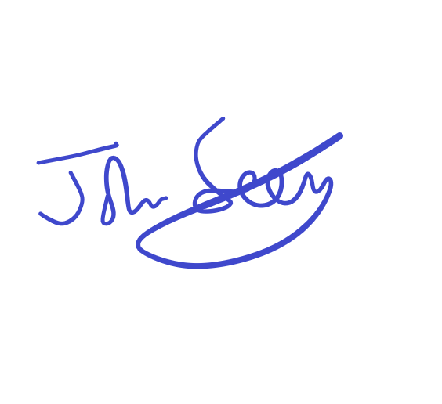
8/11/24

Signature Print Name and Job Title Date
13-11-2024
REDACTED TEXT under FOIA Section 40, Personal Information

REDACTED TEXT under FOIA Section 40, Personal Information

Authorised for and on behalf of the Supplier:

Signature Print Name and Job Title Date
13/12/24
REDACTED TEXT under FOIA Section 40, Personal Information

REDACTED TEXT under FOIA Section 40, Personal Information

Authorised for and on behalf of the Buyer:

Signature Print Name and Job Title Date

