FRAMEWORK SCHEDULE 4 – Annex 3

**ALTERNATIVE CLAUSES AND ADDITIONAL SCHEDULES FOR LOT 1**

|  |  |  |
| --- | --- | --- |
| **ALTERNATIVE CLAUSES** | | |
|  |  | Scots Law |
|  |  | Northern Ireland Law |
| **ADDITIONAL SCHEDULES** | | |
|  |  |  |
|  | S1 | Business Continuity and Disaster Recovery |
|  | S2 | Continuous Improvement |
|  | S3 | Supply Chain Visibility |

Unless there is a clear adjustment to an existing provision of the Contract, new definitions for the Schedule (Definitions) of the Call-Off Terms will have the effect of being inserted alphabetically into the table therein and associated schedules will have the effect of being inserted sequentially immediately after the Schedule (Definitions) of the Call-Off Terms.

**ADDITIONAL SCHEDULES**

**S1 BUSINESS CONTINUITY AND DISASTER RECOVERY – NOT APPLICABLE**

1. Definitions
   1. In this Schedule, the following definitions shall apply:

|  |  |
| --- | --- |
| "BCDR Plan" | 1. has the meaning given to it in Paragraph 2.1 of this Schedule; |
| "Business Continuity Plan" | 1. has the meaning given to it in Paragraph 2.2.2 of this Schedule; |
| "Disaster Recovery Plan" | 1. has the meaning given to it in Paragraph 2.2.3 of this Schedule; |
| "Related Supplier" | 1. any person who provides services to the Buyer which are related to the Services from time to time; |
| "Review Report" | 1. has the meaning given to it in Paragraph 6.3 of this Schedule; and |
| "Supplier's Proposals" | 1. has the meaning given to it in Paragraph 6.3 of this Schedule; |

1. BCDR Plan
   1. At least ninety (90) Working Days prior to the Commencement Date the Supplier shall prepare and deliver to the Buyer for the Buyer’s written approval a plan (a **“BCDR Plan”**), which shall detail the processes and arrangements that the Supplier shall follow to:
      1. ensure continuity of the business processes and operations supported by the Services following any failure or disruption of any element of the Services; and
      2. the recovery of the Services in the event of a Disaster
   2. The BCDR Plan shall be divided into three sections:
      1. Section 1 which shall set out general principles applicable to the BCDR Plan;
      2. Section 2 which shall relate to business continuity (the **"Business Continuity Plan"**); and
      3. Section 3 which shall relate to disaster recovery (the **"Disaster Recovery Plan"**).
   3. Following receipt of the draft BCDR Plan from the Supplier, the Parties shall use reasonable endeavours to agree the contents of the BCDR Plan. If the Parties are unable to agree the contents of the BCDR Plan within twenty (20) Working Days of its submission, then such Dispute shall be resolved in accordance with the Dispute Resolution Procedure.
2. General Principles of the BCDR Plan (Section 1)
   1. Section 1 of the BCDR Plan shall:
      1. set out how the business continuity and disaster recovery elements of the BCDR Plan link to each other;
      2. provide details of how the invocation of any element of the BCDR Plan may impact upon the provision of the Services and any goods and/or services provided to the Buyer by a Related Supplier;
      3. contain an obligation upon the Supplier to liaise with the Buyer and any Related Suppliers with respect to business continuity and disaster recovery;
      4. detail how the BCDR Plan interoperates with any overarching disaster recovery or business continuity plan of the Buyer and any of its other Related Supplier in each case as notified to the Supplier by the Buyer from time to time;
      5. contain a communication strategy including details of an incident and problem management service and advice and help desk facility which can be accessed via multiple channels;
      6. contain a risk analysis, including:
         1. failure or disruption scenarios and assessments of likely frequency of occurrence;
         2. identification of any single points of failure within the provision of the Services and processes for managing those risks;
         3. identification of risks arising from the interaction of the provision of the Services with the goods and/or services provided by a Related Supplier; and
         4. a business impact analysis of different anticipated failures or disruptions;
      7. provide for documentation of processes, including business processes, and procedures;
      8. set out key contact details for the Supplier (and any Sub-Contractors) and for the Buyer;
      9. identify the procedures for reverting to "normal service";
      10. set out method(s) of recovering or updating data collected (or which ought to have been collected) during a failure or disruption to minimise data loss;
      11. identify the responsibilities (if any) that the Buyer has agreed it will assume in the event of the invocation of the BCDR Plan; and
      12. provide for the provision of technical assistance to key contacts at the Buyer as required by the Buyer to inform decisions in support of the Buyer’s business continuity plans.
   2. The BCDR Plan shall be designed so as to ensure that:
      1. the Services are provided in accordance with this Contract at all times during and after the invocation of the BCDR Plan;
      2. the adverse impact of any Disaster is minimised as far as reasonably possible;
      3. it complies with the relevant provisions of ISO/IEC 27002; ISO22301/ISO22313 and all other industry standards from time to time in force; and
      4. it details a process for the management of disaster recovery testing.
   3. The BCDR Plan shall be upgradeable and sufficiently flexible to support any changes to the Services and the business operations supported by the provision of Services.
   4. The Supplier shall not be entitled to any increase in the Charges to the extent that a Disaster occurs as a consequence of any breach by the Supplier of this Contract.
3. Business Continuity (Section 2)
   1. The Business Continuity Plan shall set out the arrangements that are to be invoked to ensure that the business processes facilitated by the provision of Services remain supported and to ensure continuity of the business operations supported by the Services including:
      1. the alternative processes, options and responsibilities that may be adopted in the event of a failure in or disruption to the provision of the Services; and
      2. the steps to be taken by the Supplier upon resumption of the provision of the Services in order to address the effect of the failure or disruption.
   2. The Business Continuity Plan shall:
      1. address the various possible levels of failures of or disruptions to the provision of Services;
      2. set out the goods and/or services to be provided and the steps to be taken to remedy the different levels of failures of and disruption to the Services; and
      3. set out the circumstances in which the Business Continuity Plan is invoked.
4. Disaster Recovery (Section 3)
   1. The Disaster Recovery Plan (which shall be invoked only upon the occurrence of a Disaster) shall be designed to ensure that upon the occurrence of a Disaster the Supplier ensures continuity of the business operations of the Buyer supported by the Services following any Disaster or during any period of service failure or disruption with, as far as reasonably possible, minimal adverse impact.
   2. The Supplier's BCDR Plan shall include an approach to business continuity and disaster recovery that addresses the following:
      1. loss of access to the Buyer Premises;
      2. loss of utilities to the Buyer Premises;
      3. loss of the Supplier's helpdesk or CAFM system;
      4. loss of a Sub-Contractor;
      5. emergency notification and escalation process;
      6. contact lists;
      7. staff training and awareness;
      8. BCDR Plan testing;
      9. post implementation review process;
      10. details of how the Supplier shall ensure compliance with security standards ensuring that compliance is maintained for any period during which the Disaster Recovery Plan is invoked;
      11. access controls to any disaster recovery sites used by the Supplier in relation to its obligations pursuant to this Schedule; and
      12. testing and management arrangements.
5. Review and changing the BCDR Plan
   1. The Supplier shall review the BCDR Plan:
      1. on a regular basis and as a minimum once every six (6) months;
      2. within three (3) calendar months of the BCDR Plan (or any part) having been invoked pursuant to Paragraph 8; and
      3. where the Buyer requests in writing any additional reviews (over and above those provided for in Paragraphs 6.1.1 and 6.1.2 of this Schedule) whereupon the Supplier shall conduct such reviews in accordance with the Buyer’s written requirements. Prior to starting its review, the Supplier shall provide an accurate written estimate of the total costs payable by the Buyer for the Buyer’s approval. The costs of both Parties of any such additional reviews shall be met by the Buyer except that the Supplier shall not be entitled to charge the Buyer for any costs that it may incur above any estimate without the Buyer’s prior written approval.
   2. Each review of the BCDR Plan pursuant to Paragraph 6.1 shall assess its suitability having regard to any change to the Services or any underlying business processes and operations facilitated by or supported by the Services which have taken place since the later of the original approval of the BCDR Plan or the last review of the BCDR Plan, and shall also have regard to any occurrence of any event since that date (or the likelihood of any such event taking place in the foreseeable future) which may increase the likelihood of the need to invoke the BCDR Plan. The review shall be completed by the Supplier within such period as the Buyer shall reasonably require.
   3. The Supplier shall, within twenty (20) Working Days of the conclusion of each such review of the BCDR Plan, provide to the Buyer a report (a **"Review Report"**) setting out the Supplier's proposals (the **"Supplier's Proposals"**) for addressing any changes in the risk profile and its proposals for amendments to the BCDR Plan.
   4. Following receipt of the Review Report and the Supplier’s Proposals, the Parties shall use reasonable endeavours to agree the Review Report and the Supplier's Proposals. If the Parties are unable to agree Review Report and the Supplier's Proposals within twenty (20) Working Days of its submission, then such Dispute shall be resolved in accordance with the Dispute Resolution Procedure.
   5. The Supplier shall as soon as is reasonably practicable after receiving the approval of the Supplier's Proposals effect any change in its practices or procedures necessary so as to give effect to the Supplier's Proposals. Any such change shall be at the Supplier’s expense unless it can be reasonably shown that the changes are required because of a material change to the risk profile of the Services.
6. Testing the BCDR Plan
   1. The Supplier shall test the BCDR Plan:
      1. regularly and in any event not less than once in every Contract Year;
      2. in the event of any major reconfiguration of the Services; and
      3. at any time where the Buyer considers it necessary (acting in its sole discretion).
   2. If the Buyer requires an additional test of the BCDR Plan, it shall give the Supplier written notice and the Supplier shall conduct the test in accordance with the Buyer’s requirements and the relevant provisions of the BCDR Plan. The Supplier's costs of the additional test shall be borne by the Buyer unless the BCDR Plan fails the additional test in which case the Supplier's costs of that failed test shall be borne by the Supplier.
   3. The Supplier shall undertake and manage testing of the BCDR Plan in full consultation with and under the supervision of the Buyer and shall liaise with the Buyer in respect of the planning, performance, and review, of each test, and shall comply with the reasonable requirements of the Buyer.
   4. The Supplier shall ensure that any use by it or any Sub-Contractor of "live" data in such testing is first approved with the Buyer. Copies of live test data used in any such testing shall be (if so required by the Buyer) destroyed or returned to the Buyer on completion of the test.
   5. The Supplier shall, within twenty (20) Working Days of the conclusion of each test, provide to the Buyer a report setting out:
      1. the outcome of the test;
      2. any failures in the BCDR Plan (including the BCDR Plan's procedures) revealed by the test; and
      3. the Supplier's proposals for remedying any such failures.
   6. Following each test, the Supplier shall take all measures requested by the Buyer to remedy any failures in the BCDR Plan and such remedial activity and re-testing shall be completed by the Supplier, at its own cost, by the date reasonably required by the Buyer.
7. Invoking the BCDR Plan
   1. In the event of a complete loss of service or in the event of a Disaster, the Supplier shall immediately invoke the BCDR Plan (and shall inform the Buyer promptly of such invocation). In all other instances the Supplier shall invoke or test the BCDR Plan only with the prior consent of the Buyer.
8. Circumstances beyond your control
   1. The Supplier shall not be entitled to relief under Clause 33 (Force Majeure) if it would not have been impacted by the Force Majeure Event had it not failed to comply with its obligations under this Schedule.

**S2 CONTINUOUS IMPROVEMENT**

1. **Supplier’s Obligations**
   1. In addition to the Supplier’s general obligations as to continuous improvement in relation to the Services under Clauses 5.11 and 5.12 of this Contract, the Supplier shall produce at the start of each Contract Year a plan for improving the provision of Services and/or reducing the Charges (without adversely affecting the performance of this Contract) during that Contract Year (**"Continuous Improvement Plan"**) for the Buyer's approval. The Continuous Improvement Plan must include, as a minimum, proposals:
      1. identifying the emergence of relevant new and evolving technologies;
      2. changes in business processes of the Supplier or the Buyer and ways of working that would provide cost savings and/or enhanced benefits to the Buyer (such as methods of interaction, supply chain efficiencies, reduction in energy consumption and methods of sale);
      3. new or potential improvements to the provision of the Services including the quality, responsiveness, procedures, benchmarking methods, likely performance mechanisms and customer support services in relation to the Services; and
      4. measuring and reducing the sustainability impacts of the Supplier's operations and supply-chains relating to the Services, and identifying opportunities to assist the Buyer in meeting their sustainability objectives.
   2. The initial Continuous Improvement Plan for the first (1st) Contract Year shall be submitted by the Supplier to the Buyer for approval within six (6) Months following the Commencement Date, whichever is earlier.
   3. The Buyer shall notify the Supplier of its approval or rejection of the proposed Continuous Improvement Plan or any updates to it within twenty (20) Working Days of receipt. If it is rejected then the Supplier shall, within ten (10) Working Days of receipt of notice of rejection, submit a revised Continuous Improvement Plan reflecting the changes required. Once approved, it becomes the Continuous Improvement Plan for the purposes of this Contract.
   4. The Supplier must provide sufficient information with each suggested improvement to enable a decision on whether to implement it. The Supplier shall provide any further information as requested.
   5. If the Buyer wishes to incorporate any improvement into this Contract, it must request a Change in accordance with the Change Control Procedure and the Supplier must implement such Change at no additional cost to the Buyer.
   6. Once the first Continuous Improvement Plan has been approved in accordance with Paragraph 1.3:
      1. the Supplier shall use all reasonable endeavours to implement any agreed services in accordance with the Continuous Improvement Plan; and
      2. the Parties agree to meet as soon as reasonably possible following the start of each quarter (or as otherwise agreed between the Parties) to review the Supplier's progress against the Continuous Improvement Plan.
   7. The Supplier shall update the Continuous Improvement Plan as and when required but at least once every Contract Year (after the first (1st) Contract Year) in accordance with the procedure and timescales set out in Paragraph 1.1.
   8. All costs relating to the compilation or updating of the Continuous Improvement Plan and the costs arising from any improvement made pursuant to it and the costs of implementing any improvement, shall have no effect on and are included in the Charges.
   9. Should the Supplier's costs in providing the Services to the Buyer be reduced as a result of any changes implemented, all of the cost savings shall be passed on to the Buyer by way of a consequential and immediate reduction in the Charges for the Services.
   10. At any time during the Contract Period of this Contract, the Supplier may make a proposal for gainshare. If the Buyer deems gainshare to be applicable then the Supplier shall update the Continuous Improvement Plan so as to include details of the way in which the proposal shall be implemented in accordance with an agreed gainshare ratio.

**S3 SUPPLY CHAIN VISIBILITY – NOT APPLICABLE**

1. Definitions
   1. In this Schedule, the following definitions shall apply:

|  |  |
| --- | --- |
| **"Contracts Finder"** | the Government’s publishing portal for public sector procurement opportunities; |
| **"SME"** | an enterprise falling within the category of micro, small and medium sized enterprises defined by the Commission Recommendation of 6 May 2003 concerning the definition of micro, small and medium sized enterprises; |
| **“Supply Chain Information Report Template”** | the document at Annex 1 of this Schedule; and |
| **"VCSE"** | a non-governmental organisation that is value-driven and which principally reinvests its surpluses to further social, environmental or cultural objectives. |
|  |  |

1. Visibility of Sub-Contract Opportunities in the Supply Chain
   1. The Supplier shall:
      1. subject to Paragraph 2.3, advertise on Contracts Finder all Sub-Contract opportunities arising from or in connection with the provision of the Services above a minimum threshold of £25,000 that arise during the Contract Period;
      2. within 90 days of awarding a Sub-Contract to a Sub-Contractor, update the notice on Contract Finder with details of the successful Sub-Contractor;
      3. monitor the number, type and value of the Sub-Contract opportunities placed on Contracts Finder advertised and awarded in its supply chain during the Contract Period;
      4. provide reports on the information at Paragraph 2.1.3 to the Buyer in the format and frequency as reasonably specified by the Buyer; and
      5. promote Contracts Finder to its suppliers and encourage those organisations to register on Contracts Finder.
   2. Each advert referred to in Paragraph 2.1.1 of this Schedule shall provide a full and detailed description of the Sub-Contract opportunity with each of the mandatory fields being completed on Contracts Finder by the Supplier.
   3. The obligation on the Supplier set out at Paragraph 2.1 shall only apply in respect of Sub-Contract opportunities arising after the Commencement Date.
   4. Notwithstanding Paragraph 2.1, the Buyer may by giving its prior approval, agree that a Sub-Contract opportunity is not required to be advertised by the Supplier on Contracts Finder.
2. Visibility of Supply Chain Spend
   1. In addition to any other management information requirements set out in this Contract, the Supplier agrees and acknowledges that it shall, at no charge, provide timely, full, accurate and complete SME management information reports (the “**SME Management Information Reports**”) to the Buyer which incorporates the data described in the Supply Chain Information Report Template which is:
      1. the total contract revenue received directly on this Contract;
      2. the total value of sub-contracted revenues under this Contract (including revenues for non-SMEs/non-VCSEs); and
      3. the total value of sub-contracted revenues to SMEs and VCSEs.
   2. The SME Management Information Reports shall be provided by the Supplier in the correct format as required by the Supply Chain Information Report Template and any guidance issued by the Buyer from time to time. The Supplier agrees that it shall use the Supply Chain Information Report Template to provide the information detailed at Paragraph 3.1.1–3.1.3 and acknowledges that the template may be changed from time to time (including the data required and/or format) by the Buyer issuing a replacement version. The Buyer agrees to give at least thirty (30) days’ notice in writing of any such change and shall specify the date from which it must be used.
   3. The Supplier further agrees and acknowledges that it may not make any amendment to the Supply Chain Information Report Template without the prior approval of the Buyer.

**Annex 1**

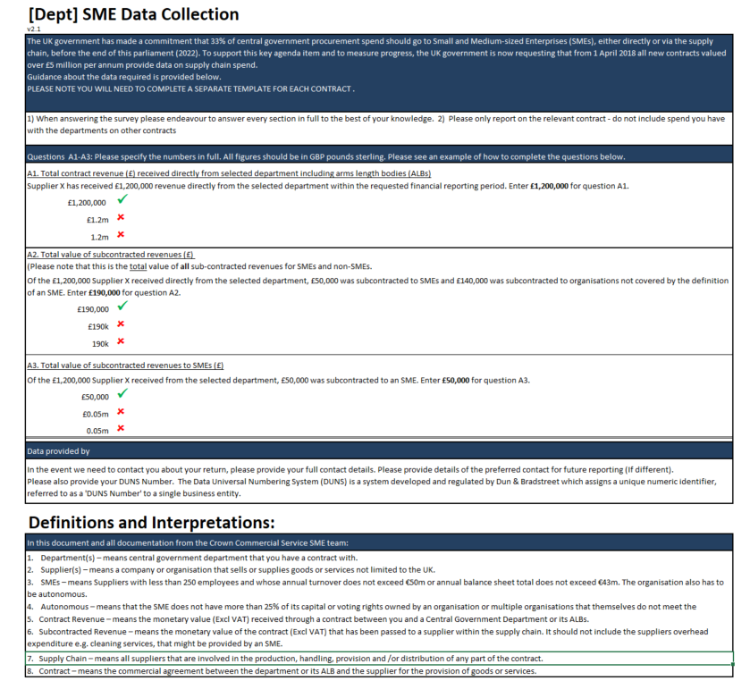**Supply Chain Information Report Template**

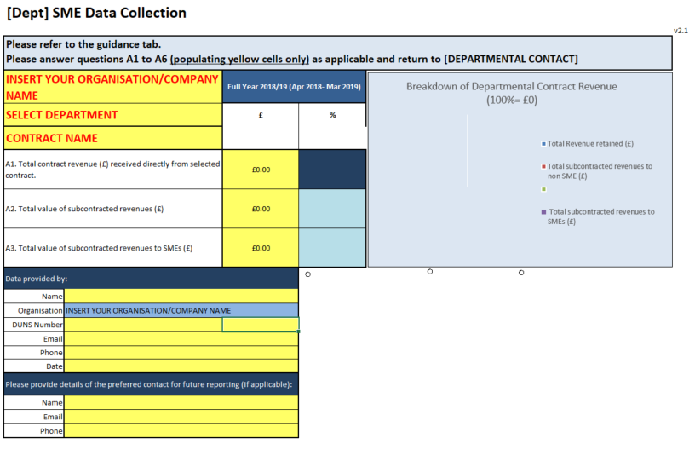

**ALTERNATIVE CLAUSES**

**SCOTS LAW – NOT APPLICABLE**

* + - 1. **Governing Law and Jurisdiction (Clause 37.1 and 37.4)**

1. Reference to “*laws of* *England and Wales*” in the original Clause 37.1 of the Contract (Governing Law, Jurisdiction and Dispute Resolution) shall be replaced with “*laws of* *Scotland*”.
2. Where legislation is expressly mentioned in the Contract, the adoption of Clause (a) shall have the effect of substituting the equivalent Scots legislation.
3. Reference to “the courts of England and Wales” in the original Clause 37.4 of the Contract (Governing Law, Jurisdiction and Dispute Resolution) shall be replaced with “the Court of Session”.
   * + 1. **Definitions (Working Day)**
4. Reference to “England and Wales” in the definition of Working Day shall be replaced with “Scotland”.
   * + 1. **Definitions (Insolvency Event)**
5. Reference to “Assignment” in the definition of Insolvency Event shall be replaced with “Assignation”.
   * + 1. **Definitions (Losses)**
6. Reference to “tort” in the definition of Losses shall be replaced with “delict”.

**NORTHERN IRELAND LAW – NOT APPLICABLE**

1. **Governing Law and Jurisdiction (Clause 37.1 and 37.4)**
2. Reference to “laws of England and Wales” in the original Clause 37.1 of the Contract (Governing Law, Jurisdiction and Dispute Resolution) shall be replaced with “laws of Northern Ireland”.
3. Where legislation is expressly mentioned in the Contract the adoption of Clause (a) shall have the effect of substituting the equivalent Northern Ireland legislation.
4. Reference to “the courts of England and Wales” in the original Clause 37.4 of the Contract (Governing Law, Jurisdiction and Dispute Resolution) shall be replaced with “the Courts of Northern Ireland”.
5. **Definitions (Working Day)**
6. Reference to “England and Wales” in the definition of Working Day shall be replaced with “Northern Ireland”.
7. **(Definitions) Insolvency Event**
8. Reference to “section 123 of the Insolvency Act 1986" in limb f) of the definition of Insolvency Event shall be replaced with “Article 103 of the Insolvency (NI) Order 1989”.