Clarifications:

**Q.1 – Please could you provide the addresses/locations of the buildings?**

The buildings are:

Civic 1 and Civic 2 – both at Civic Centre Victoria Avenue, Southend on Sea SS2 6ER

Civic 2 is adjacent to the car park to the

The Tickfield Centre, Tickfield Avenue, Southend on Sea SS2 6LL <http://www.southend.gov.uk/info/200453/southend_venues/742/southend_venues/2>

Civic 1 in red, Civic 2 in blue and Tickfield in green on the map extract below.

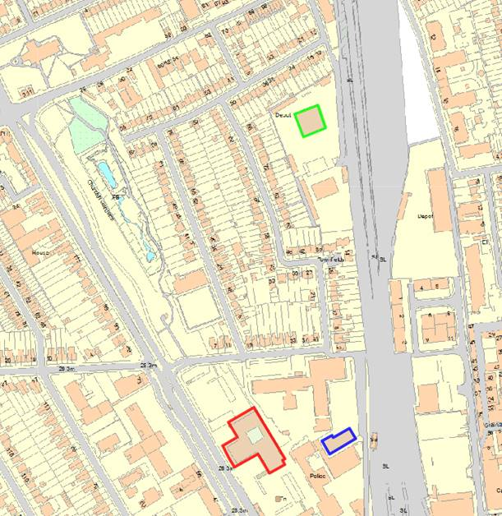

**Q.2 I was just wondering if the Council have already put aside the budget for this.**

We haven’t but it’s being driven by new CEx and director of finance who will make the budget available once a supplier and their cost is known following tender.

Q.3 It would be helpful to know the type of chairs currently used.

Current office chairs are Orangebox ARA EBA

Photographs below show part of a typical floor, meeting room and break-out area.

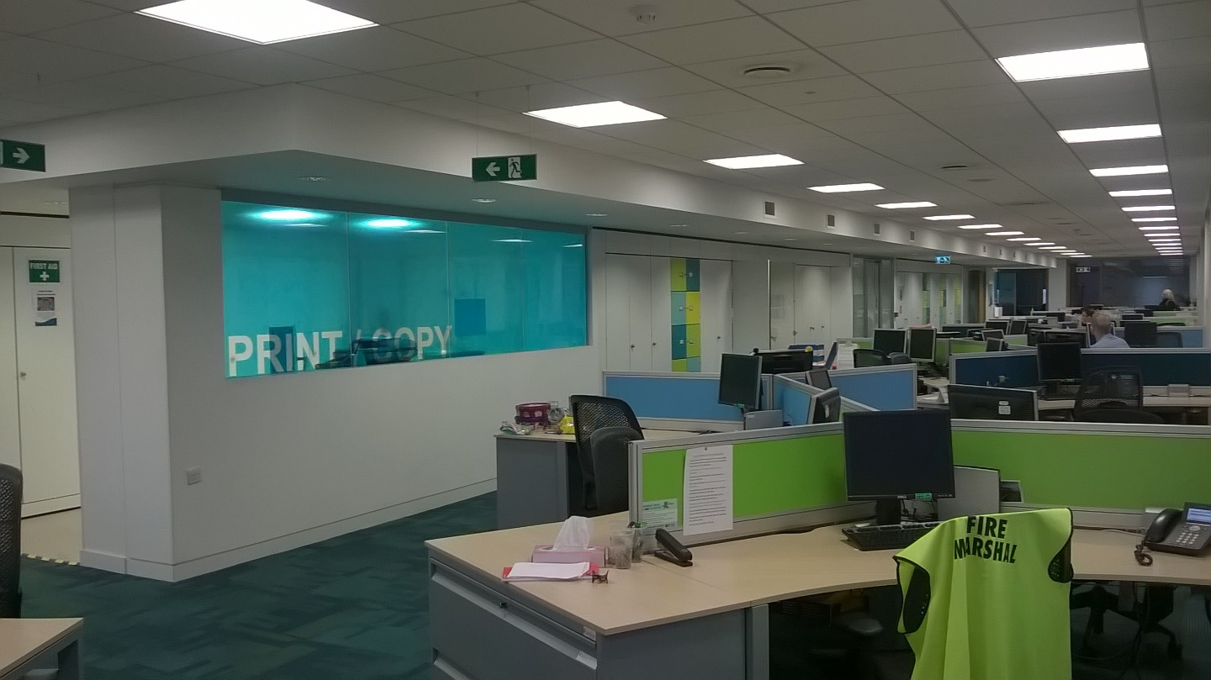

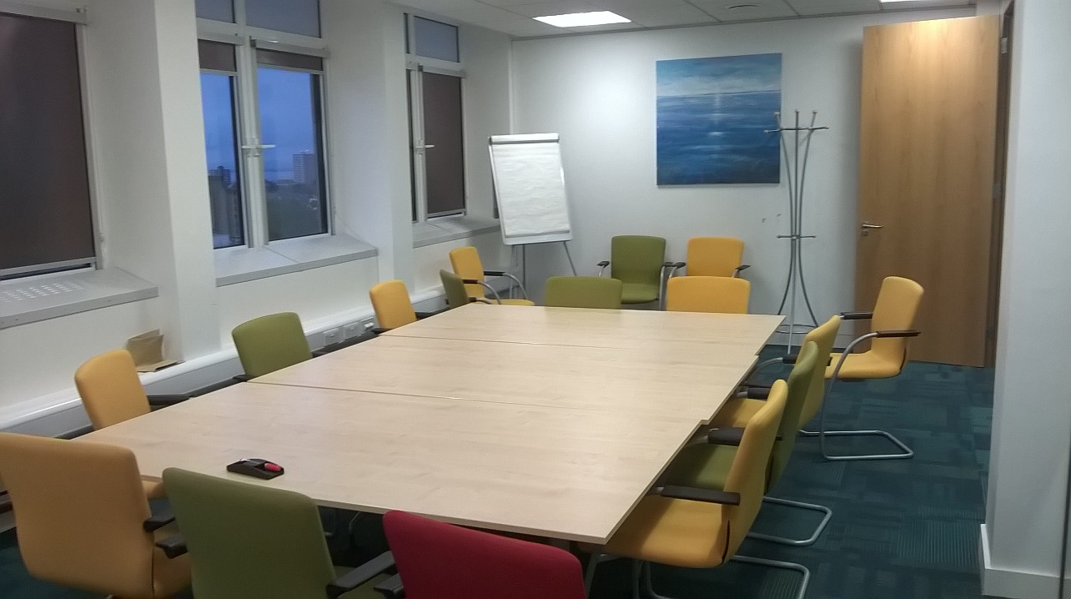

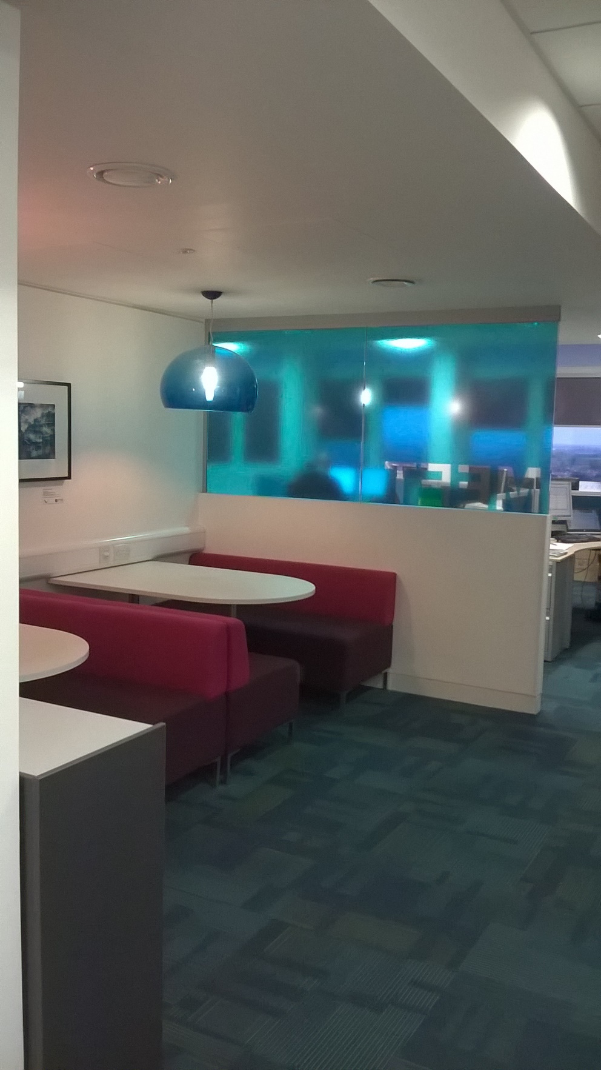

**Q.4 Do you have CAD data available for us to use for the IPMS element of the project?**

Yes, CAD plans are available and will be provided to the successful firm on appointment.