RenewEV Ltd.

Chippenham Town Council Net Zero Initiative:
Stanley Park Sports Ground

Solar PV System Specification

REVISION HISTORY
DATE | VERSION | DESCRIPTION | AUTHOR
03/10/2022 | 0 |  | J.Hurley
Table of Contents

1 Aim 2
2 Budget 2
3 Scope of supply 2
3.1 Removal and disposal of existing system – not applicable 2
3.2 New system 2
3.3 Assumptions/Parameters 3
3.4 Commissioning 3
3.5 Handover 4
3.6 Carbon/Supply Chain requirements 4
4 MCS and Industry Standards 4
5 Appendix 5
5.1 Drawings and documentation 5

Aim

The purpose of this specification document is to provide sufficient information to enable potential bidders to submit a full quotation to Chippenham Town Council for the design, supply, installation and commissioning of a Solar PV System at Stanley Park Sports Ground.
The intention of this project is to deliver cost savings and reduce the dependency on fossil fuels at Stanley Park, by displacing energy supplied by the grid with solar generated energy.
The CTC declared a climate emergency in 2019 and has set a target of decarbonising it’s estate by 2030. A key part of the strategy is reducing the energy usage of their buildings as well as switching to sustainable sources of energy.

Budget

£45,000 Ex vat

Scope of supply

Removal and disposal of existing system – not applicable

New system

The design, supply, installation and commissioning of a new solar photovoltaic system at Stanley Park, see figure 1 overleaf.

This includes:
- Providing a full PVSol report, or similar, detailing the proposed system design.
- Completing structural, mechanical and electrical surveys.
- Coordinating and managing all sub-contractors, such as scaffolders
- Providing a level 3 schedule, updating on progress where required.
- Supply and installation of a minimum 48kWp photovoltaic system making use of Tier 1 panels and a high quality inverter, (SMA or equivalent).
- MCS registration and G99 grid connection.
- Provision for remote monitoring.
- Making good all affected areas following the installation and commissioning.
- Handover pack and maintenance schedule

Assumptions/Parameters

Permitted development | 1m space between the roof edge and the solar panels.
Total roof area | ~900m2
South West facing pitch area | ~460m2
Roof inclination | 15º
Roof covering | Trapezoidal metal
Supply | 3 phase
Invertor location | To be wall mounted in the plant room. Refer to Appendix 1, Stanley Park Layout Drawing.
Distribution board | The existing distribution board has sufficient capacity to accommodate the new PV system.
Generation meter | To be supplied and installed.
Annual on-site consumption | ~96,000kWh. Refer to Appendix 1, SP HH data.

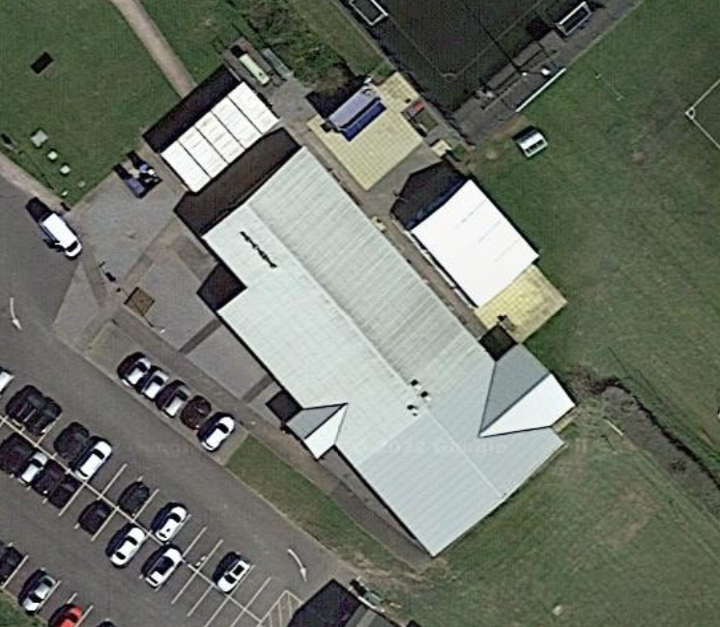
Figure 1 – Google Earth Image of Stanley Park

Commissioning

The installation must be tested and commissioned ready for occupation by 1st April 2023.

Handover

A handover pack and full customer training shall be provided following the commissioning of the new system. This shall include demonstration of all operational controls and ongoing maintenance scheduling. All warrantee registrations to be made and information to be provided for fittings, panels, inverter (s) and remote monitoring device (s). The installer shall be required to provide customer support for a minimum period of 24 months following the commissioning of the system.

Carbon/Supply Chain requirements

In line with ethical best practise, where possible, all equipment should be ethically sourced with minimal carbon footprint and not manufactured in forced labour camps.

MCS and Industry Standards

The design and installation shall be carried out by an MCS accredited installer to MCS standard MIS 3002.
The installation and commissioning of the new system must be completed by suitably qualified professionals to all other relevant industry standards.

Appendix

Drawings and documentation
- Stanley Park layout drawing
- Stanley Park HH data

