**Appendix B1: Description and Specification**

LOT 1

1. **Site identification**

|  |  |  |  |
| --- | --- | --- | --- |
| Site name | Archers Way | | |
| Site reference | A1 | Site Postcode | SP4 7YT |
| What3Words location | ///scouts.overlaid.amphibian | | |

Site photograph/s:

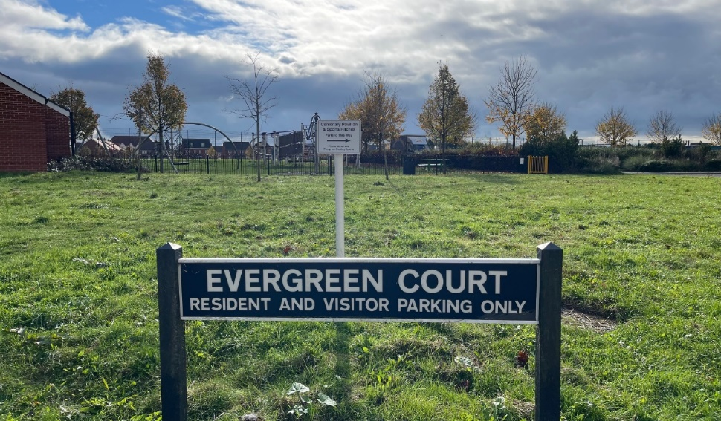

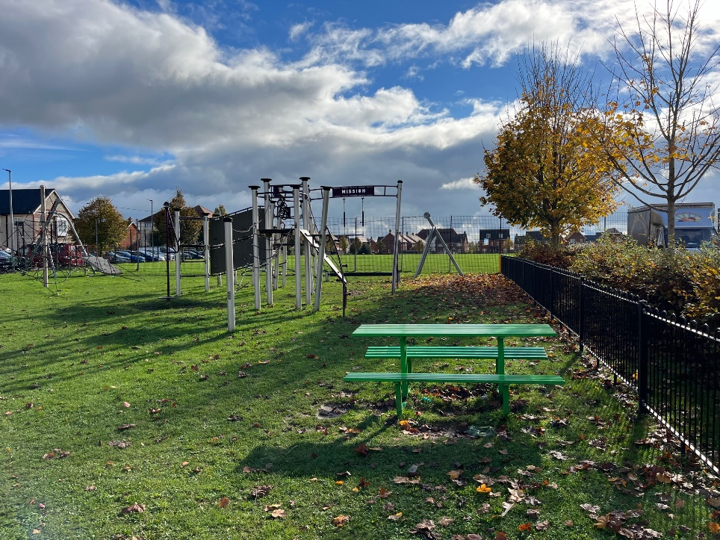

Site Video: <https://www.dropbox.com/scl/fi/cs7idvm4ll8h50map75j9/IMG_2106.MOV?rlkey=s9t87lu2kpznsrlirz3jx6p1k&st=rm8fy0f8&dl=0>

Site set-up:

Welfare (drinking water and a portable toilet) must be provided for the duration of the Works.

Heras Fencing must be established around the entire site for the duration of the Works, with sufficient CDM signage and double clipped.

Compound and Access Route: details on the tender submission should include any vehicle access route and contractor parking, proposed compound, and processes to mitigate any impact on the community such as vehicle movement, noise, or any other factors.

1. **Lot budget**

This Lot has an allocated maximum budget of £75,000.00

The full budget should be used but not exceeded.

All features included within the design must be included within the budget and quotation, there must be no ‘suggested’ additional works shown in the design outside the tendered price.

1. **Lot requirements & objectives**

This Lot is required to extend the existing provision to provide more accessible and inclusive play, with a focus on sensory play and additional appropriate provision of play equipment for the pre-school and early years (0-8’s) age group.

As such, the existing fence boundary should be relocated further north towards Archers Way road to expand the designated play area site into the unused grass area. The existing play equipment shall be retained in its current positions and no work is required to this. Any new provision must not replicate the existing activities.

The objective is to provide easily accessible sensory play opportunities within the extended area. This should include link pathways, and new play equipment features that can be accessed and used by all, including those using a wheelchair or mobility aids.

1. **Specification** 
   1. Play equipment

Play equipment construction should be predominately **steel**. Timber equipment is not acceptable at this location.

Additional materials are acceptable for non-structural parts such as HDPE / HPL Panels. Fixings should be anti-tamper style (Torx Screws), and any bolts covered with protective caps.

Chains should be stainless steel.

Basket swing seats should be moulded plastic composite with drainage holes.

Rope should have a steel core.

Play equipment and play features should provide interesting and engaging sensory experiences that are accessible to all. This may include games and equipment that stimulate sight/ visual, sound/ hearing, scent/ smell, touch/ tactile engagement. In addition, items that are accessible to all and encourage playing together to enjoy movement (proprioception) and balance (vestibular) are welcome at this site.

Consideration should be given to the close proximity of the road, car park and assisted senior living home opposite at Evergreen Court.

* 1. Safety Surfacing

Surfacing may be a combination of rubber wetpour and grass-matts. It is envisaged that items for young children are located on wetpour and items mainly used by older children are provided with grass mats.

Grass mats shall be fire retardant, cable tied, and have turf provided under where grass is not established. Also requires the installation of *Grass Mat Underlay Mesh.*

Wetpour sub-base works shall be excavated to the depth required for a flush finish with the surrounding area, back filled with 100mm depth of compacted MOT Type 1 stone laid beneath the rubber surface.

Edges should be trench cut into the surrounding grass or fully resin bonded to the pre-cast concrete (PCC) edging if adjoining a pathway.

Black wetpour shall have a minimum **50% colour fleck** at this location.

* 1. Land forms, mounds & landscaping

Soil excavations may remain on site and be formed into an interesting and playful landscape that enhances the play environment. Mounds, slopes and undulations should be finished with turf, watered until established and gradients designed to be maintained with a mechanical mower. Any landscaping should seek to enhance the sensory and imaginative play environment.

* 1. Pathways

Connecting pathways must be included in the design to link play features and connect to the existing footpaths serving the site and to provide a high level of accessibility for all throughout the year and in all weather conditions. Pathways must be a minimum 1.2 metres wide, entrances & passing places may need to be wider. Footpath widths should be clearly noted on your design plan.

An additional drop curb and linking path access should be added from the parking area.

Pathways should be constructed from a rubber/stone/ resin mix (such as ‘Conipave’/ ‘Enviro-Pave’ or similar). Pathway edging shall be pre-cast concrete (PCC).

* 1. Fencing & Gates

Fencing is required to completely surround the entire site and a section of the existing fencing may be re-used and added to to accomplish this.

Fencing shall be steel bow-top style railings compliant with EN1176, 1.0m high, powder coated in black.

Gates shall be hydraulic (not sprung) self-closing with a flat top style, vertical bar in fill and powder coated in yellow to visually contrast from the fencing.

Vehicle access must be provided for locations with grass inside the fenced area. This may be a dedicated vehicle access gate or a combination gate and must be located in an appropriate position for access by mowing vehicles.

The existing gate currently positioned in the corner near the zip wire should be relocated and re-used in the extension. This entrance should be blocked up with matching fencing.

An additional drop curb and link path should be added from the parking area and a new combi gate added from the roadside for maintenance access.

* 1. Furniture

Seating should be: Glasdon ‘Pheonix’ seats with armrests and Glasdon ‘Clifton’ picnic tables with wheelchair access. Quantity at the discretion of the tenderer.

All seating must be on hardstanding and connected to new pathways.

Litter bins (x1) should be: Broxap ‘Derby’ Steel, 120 Litres in Black.

Cycle hoops (x4) should be: Broxap ‘Sheffield’ Stainless Steel.

* 1. Other

A post installation inspection by an independent RPii qualified inspector (i.e. Play Inspection Company, RoSPA or other similar provider) is required to sign off the completed installation. The contractor should allow for this cost within their tender price.

Signage (minimum A2 size) on gates should be provided to indicate: The site name, age the play area is intended for use by, telephone number to report any incident or damage, number to call in an emergency, Town Council logo.

Include graphics that demonstrate:

* children to be accompanied by adults
* dogs are excluded
* smoking is prohibited
* litter should be disposed of

Example sign (replace Wiltshire Council with Amesbury Town Council):

