Web Case Submissions

- Complainants are able to submit their complaints via the Housing Ombudsman website; these are then available for the Support Team to “Approve” or “reject” on the casework management system.

- Cases are always “Approved”, unless they are spam or junk mail. The name of the complainant will need to first be searched through the casework management system in order to determine if it is a duplicate case. If it is a duplicate case, all relevant reference numbers will need to be noted. Choose the “Approve Web Case” option under the “Case Actions” tab to select “Approve” or “Reject” (if it is junk mail or created in error).

- The name of the complainant and their email address will need to be noted and a standard acknowledgement sent to them once a case has been “Approved” (see Appendix 2 for the standard acknowledgement template)

- If it is a duplicate, make the appropriate caseworker aware of the duplication and the relevant reference numbers – duplications do not require acknowledgement

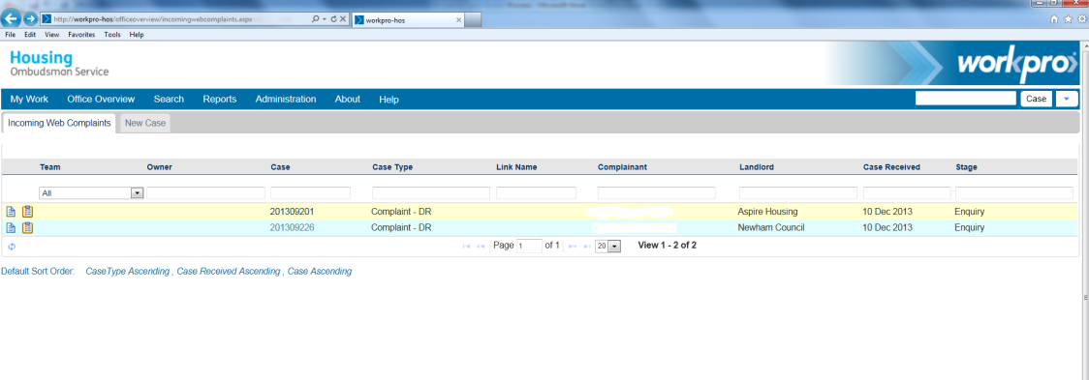
Enter the complaint by right clicking the reference number
a)

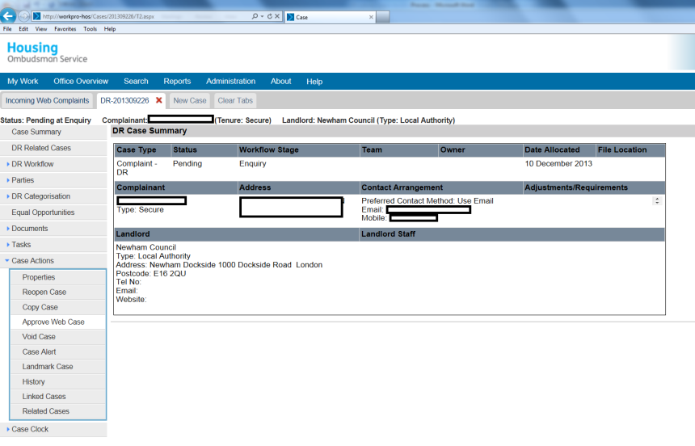
b)
Once you have checked the details through the casework management system search facilities (in a separate window) and decided if it is a duplicate case or not, select Approve

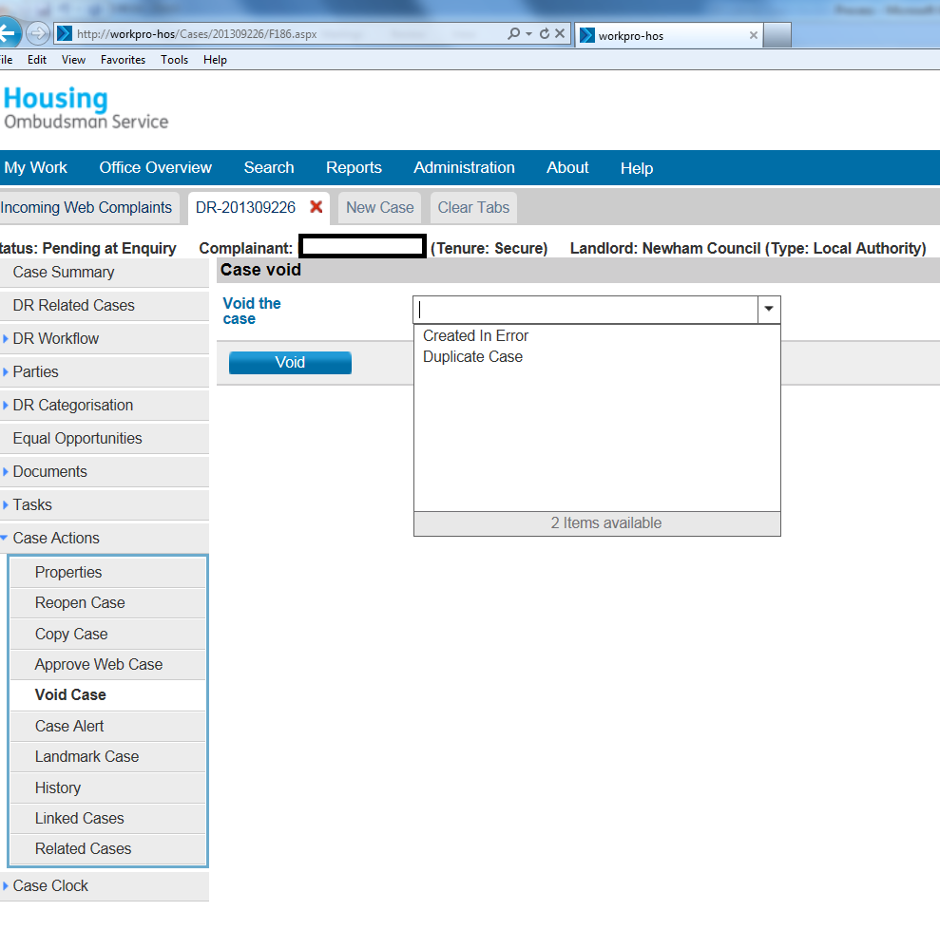
If voiding the case, for example if a case has been created by accident, choose a reason from the drop down menu and then select the Void button below
c)

