Memorandum of Information:

Adult Substance Misuse Services

Appendix 2 - Draft Service Model Outlines

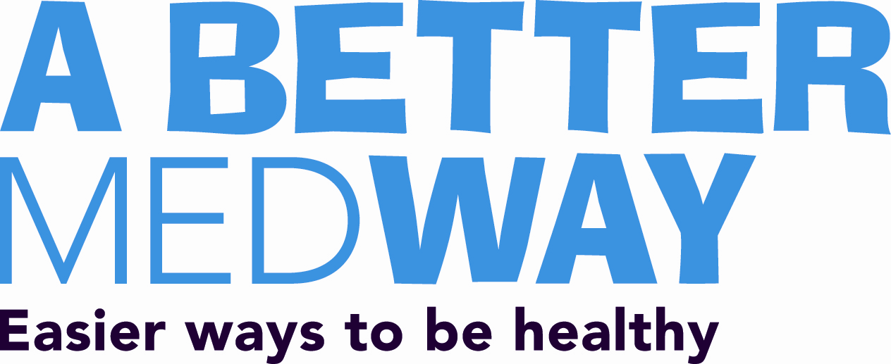

Appendix Two: Draft Service Model Outlines
- Assessment, Engagement and Treatment Service
- Recovery Service

Service Title: Assessment, Engagement and Treatment Service
Key Aims and Objectives
The service will aim to:
- Be inclusive and accessible to people with substance misuse (illicit and including alcohol) problems;
- Assess peoples' holistic recovery needs to deliver and/or support access to treatments to reduce harm and improve health;
- Deliver medical and psychosocial interventions in accordance with all relevant national guidance, appropriate to each individual’s phase of treatment and supporting their progression towards recovery;
- be responsive to diversity particularly emerging communities.
- Prioritise the most vulnerable, difficult to engage and at-risk, including but not exclusively:
  - Domestic abuse victims/survivors and perpetrators;
  - Adults and children involved with social care services.
  - People with complex needs including coexistent mental health and homelessness issues; involvement in sex work.
  - Criminal justice needs;
- Deliver a service which is effectively integrated with community resources to deliver sustainable recovery outcomes and promote independence with particular regard to the commissioned Recovery Service.
- Contribute directly to the reduction of drug related deaths in Medway.

Brief Service Description
The Service will focus community based delivery primarily on adults with a dependency on opiates or alcohol in the initial phase of delivery and will ensure access to a range of brief interventions (including online delivery options) for adults reporting problematic use of drugs and/or alcohol.
The service will ensure that opportunities to engage with treatment (including clinical interventions) are available in ways that enable individuals and groups with complex needs to access specialist services including clinical prescribing options for example, sex workers, parents with children, street homeless.
The service will provide a full range of medical (screening, pharmacological substitution, reduction, detoxification and abstinence support) interventions in line with NICE and other relevant national guidance, appropriate to individuals substance misuse related needs.
The service will deliver an intensive community rehabilitation service, employing evidence based group work approaches.
The service will actively implement segmentation or similar approaches to assessing, planning and delivering OST for opiate dependent adults. The service will provide community based detoxification for alcohol and opiate dependent adults.
Key Service Interdependencies
The service will develop robust and effective working relationships with Medway Council Adult and Children’s Social Care services; agencies providing supported housing to homeless adults; acute and community based health services; local criminal justice agencies.
The service will work alongside the commissioned Recovery service and other providers of services, resources and interventions that promote and sustain the recovery from problematic substance misuse; this includes recruitment of appropriate adults in treatment to peer mentor schemes including the commissioner recovery service.
The service will develop and maintain joint working procedures and protocols with providers of services for young people experiencing problems with substance misuse, including transition arrangements to clinical treatment.
The service will contribute to key joint strategies and action plans that contribute to the health and well being of Medway’s adults, families and communities.

Service Title: Recovery Service
Key Aims and Objectives
The service will aim to:
- Promote the development of a recovery based community in Medway, including enabling the growth of independent projects, interventions and resources that maintain and sustain recovery from problematic substance misuse.
- Promote concepts and application of peer mentor and volunteer led approaches.
- Deliver a service which is effectively integrated with community treatment resources to deliver sustainable recovery outcomes and promote independence with particular regard to the commissioned Assessment, Engagement and Treatment Service (AET) , including enabling the re access to treatment for substance misusers who experience relapse.
- Contribute directly to the reduction of drug related deaths in Medway.

Brief Service Description
Medway has a significant amount of opiate users who have a lengthy history of contact with specialist treatment without experiencing sustained abstinence. Medway also has a population of dependent alcohol users. Both cohorts recovery could be better sustained via the provision of a peer mentor led recovery based services.
Medway Council and its partners wish to build on the specialist and non specialist expertise and experience of developing and delivering community based services and interventions that is available in the voluntary sector.
The service will be required to:
- Recruit adults with experience of problematic substance misuse to act as peer mentors and volunteers that support people with recovery.
- Assist, support and enable service users to maintain effective and appropriate engagement with all relevant services to support and sustain recovery, ensuring that support provided is timely and prevents escalation to crisis.
- Enable service users to define and develop their own personal recovery goals that enhance the development of recovery capital and reduce dependency on statutory services.
- Develop effective joint working with the commissioned AET to ensure effective planned exit from specialist treatment in to recovery provision, recruitment and support of peer mentors, effective re engagement arrangements for adults in recovery who experience relapse.
- Co-design, co-produce and sustain effective support and access to Education, Training and Volunteering/Employment opportunities and links to specialist support where available.
- Develop and sustain effective joint working arrangements with other community based services, resources and interventions that sustain recovery from problematic substance misuse.
- Develop, co-design and co-produce Peer Support and Mutual Aid groups across the county in accordance with service user defined need and ensure that these support networks are facilitated appropriately.

Key Service Interdependencies
The service will develop robust and effective working relationships with agencies providing supported housing and other provision to homeless adults; acute and community based health services; local criminal justice agencies.
The service will develop links with other peer mentor recovery provision both locally and nationally.
The service will contribute to key joint strategies and action plans that contribute to the health and well being of Medway’s adults, families and communities.

