Space Catalyst Fund – pre-market engagement questionnaire
The proposed Space Catalyst Fund (SCF) is designed to help to address the existing information gap among potential investors and contribute toward catalysing investment into the sector. This pre-market engagement questionnaire seeks to gather information about potential suppliers for this programme. Respondents are invited to share thoughts on the development and design of the programme. This questionnaire reflects Part A: Investor Education (Space Economics) which will aim to increase awareness and understanding of the space sector as an investment opportunity, including economic history of the space sector, space technologies and their applications.

The UK space sector generates c.£17.5 billion of income to the economy each year and employs over 48,000 people across 1,590 organisations. The global space economy is projected to grow from £270bn to £490bn by 2030 and this high-growth presents an opportunity for the UK to realise it’s strategic ambitions in space.

In 2021 the UK’s first National Space Strategy (NSS) set the vision to put the UK “firmly in the front rank of the global space industry”. However, the NSS recognises that the UK still lags behind competing nations in space as a result of proportionally lower investment over the past decade. For example, the UK’s public sector space investment was lower in 2020 than in all other major space-faring nations, including Germany, India and Italy. Similarly, while the UK space sector has continued to grow, it is not currently increasing its share of the global space economy. Given the projected scale of growth to 2030 and the emerging technologies which will form the space markets of the future, the UK finds itself at a critical point in the race to develop its space capabilities.

What is the Space Catalyst Fund?
The Space Catalyst Fund is designed as a programme of education and outreach activities that will create new and productive relationships between investors and UK based space sector companies. The programme is designed similarly to a ‘matchmaker’ service. The customer journey is illustrated in Fig 1 and shows how the two customer groups in this programme interact with each other and the programme design. The relevant strand for this questionnaire is Investor Partner Journey, as highlighted, but it is advised that respondents consider the Company Journey as well, to understand where their work could complement the programme wholistically.

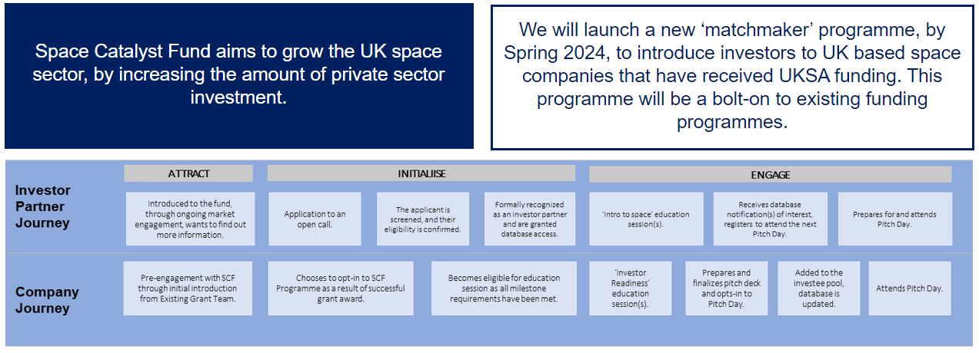
Figure 1 – Matchmaker Programme

Objectives
This programme has four core strategic objectives. The overarching objective of this programme is UKSA’s North Star Metric, maximise total investment into the UK space sector.
Respondents to this questionnaire are invited to reflect on the strategic objectives of this programme and how their participation in the programme could support the achievement of these objectives.
1 | Catalyse investment, by deploying UKSA’s funding and resources to multiply the value of non-Government contracts and private capital secured by UK space organisations.
2 | Provide business stage development to UKSA grant recipients to support the ongoing development of the UK space sector and increase the volume of private sector funding it receives.
3 | Champion the benefits and potential of space to the UK private sector to increase the amount of private investment into the UK space sector.
4 | Directly channel private investment catalysed by UKSA at the opportunities that best meet the principles in UKSA’s investment strategy.

Timeline
Should UKSA choose to undertake a procurement process the stages and timescales may be similar to the below:
- Invitation to Tender via DPS issued to suppliers – January 2024
- Successful Bidder(s) announced – February 2024
- Contract Award –March 2024
- Space Catalyst Fund programme commences – April 2024
- Space Catalyst Fund programme concludes – March 2025
Process and timescales are subject to change.
Scope
UKSA aims to grow the UK space sector by increasing the proportion of private sector investment channelled into the sector and by maximising the value of contracts and grants received and creating new working relationships between investors and UK based space sector companies.
The below provides an outline of some of the likely requirements for partners in this programme. Please note, this is not an exhaustive list, and is subject to change following this questionnaire. If UKSA do decide to undertake a procurement process, a specification will be issued as part of that process.
Outcomes
At the conclusion of the investor education programme, participants should have an increased understanding of the history of the space sector, space sector economics and space technologies.
Modules for study may include but are not limited to:
- UK and EU space policies, governance and financing
- Global space histories
- Space business planning
- New Space markets and market leaders
- Terminology and sector specific verbiage

Schedule
Partners will be expected to conduct at least two education pathways per year and to be scheduled in parallel with Section B: Investee Education (Pitching to Investors). These sessions will be expected to take place in-person, but it is anticipated that digital tools, such as podcasts, webinars, e-learning materials are used to supplement the learning pathway.
Data
UKSA intends to take ownership of all new intellectual property created during this programme, including training materials, with non-exclusive supplier rights.
Location
Customers of this programme will be investors based in various locations and co-location may not be possible for the delivery of this programme. As such, it is advisable that respondents consider ways in which they could utilise digital delivery mechanisms to improve customer satisfaction and accessibility.
Feedback Request
Feedback is requested in relation to the proposals described within this document. Your views will inform the development of any procurement strategy and tender documents that follow.
Please submit your responses via https://forms.office.com/e/9T8WVH3A1j before 23.59 on 4 July 2023

