

AUTHORITY: The Secretary of State for the Home Department acting through Border Force

statement of requirements

CPV SPEEDWELL - MAINTENANCE AND SAFETY EQUIPMENT RECERTIFICATION

DECEMBER 2020

C20204

Contents
Definitions 5
Part 1: General 7
1.0 Background 7
Part 2: Insurance 7
2.0 Insurance 7
Part 3: Objectives, Location and Constraints 8
3.0 Objectives 8
4.0 Location 8
5.0 Constraints 8
Part 4: Provision of Services 9
6.0 General Provision 9
7.0 Project Management 10
8.0 Warranty 11
Part 5: Emergent Work 11
9.0 Emergent Work 11
Part 6: Trials, Certification and Acceptance 12
10.0 Trials 12
11.0 Certification 12
12.0 Project Completion 12
Part 7: Charges and Payment 13
13.0 Charges and Payment 13
Annex A: General Requirements of Work 15
1.0 Shore Power 15
2.0 Berthing 15
3.0 Third-Party Costs 15
4.0 Disposal of Waste and Cleanliness 15
5.0 Insurance 16
6.0 General Provision 16
7.0 Trials 16
Annex B: Inspection, Testing and Certification of Safety Equipment 17
Annex C: Vessel Maintenance Tasks 20
Annex D: Modifications and Defect Rectification 27
Annex E: General Arrangements 30
Annex F: Vessel Details 32
Annex G: Emergent Work Individual Item Proforma 33
Annex H: Emergent Work item Record Spreadsheet 34
Annex I: Handover Certificate 35
Annex J: Acceptance Certificate 36
Annex K: Project Completion Certificate 37
Annex L: Reimbursable Expenses 38
Annex M: Carbon Centre Disc Assembly & Operation M034-0003-EN 39
Annex N: Jet Anodes 521 40
Annex O: CPV Anodes, Cathode Protection and Bonding 41
Annex P: MDKBL Cummins Onan Service 42
Annex Q: 19m GRP Patrol Boat Tech 110416. CPV Paint Scheme 43

For more information on how HM Government classifies its information to ensure it is appropriately protected and your role in that protection, please visit:
https://www.gov.uk/government/publications/government-security-classifications

Definitions
Phrase | Definition
Acceptance | The issuing of an acceptance certificate to the Supplier, signed by the BFOO on behalf of the Authority following the re-floating of the vessel following the lifting out from the water.
Agreed Facility | A single phone number for the Supplier giving access to a point of contact able to give user friendly assistance to persons experiencing technical problems with any part or operation of the Cutters
Alongside Berth | A suitable berth with at least 1m depth below LWS at all times  Complete with access by gangway/brow
BFOO | Border Force Overseeing Officer
Cardinal Date Plan (CDP) | A plan provided by the Supplier mapping out the significant dates for a project.
Coastal Patrol Vessel (CPV) | CPV SPEEDWELL
Collar | RIB Collars (also known as RIB Tubes or Sponson) are the inflatable section of a Rigid Hull Inflatable OR A polyurethane coated closed cell foam cored buoyant Collar offering similar properties.
Defect Rectification | Work undertaken to resolve any kind of defect identified and listed in the work package at Annex D.
Driveline | The CPV Driveline is the engines, water jets and drive shafts, and components used to connect these together.
Emergent work | Any work that emerges from the Planned Maintenance, which is notified to the Supplier in this Statement of Requirements. Any repairs which are required as a direct result of defects found with during this package of works.
Lloyd’s Register | Lloyd’s Register’s Rules and Regulations set standards for the design, construction and lifetime maintenance of ships, offshore units and land-based installations.
Major Defect | Any defect or fault which reduces the performance of the Cutter, so it is unable to perform its duties.
MCA | Maritime and Coastguard Agency
Minor Defect | Any defect or fault which reduces the performance of the Cutter while allowing it to be safely operated for its duties.
Original Equipment Manufacturer (OEM) | The original manufacturer of a piece of equipment.
Project Completion | Formal notification by the BFOO, on behalf of the Authority, to the Supplier that the project is completed to a satisfactory standard. The Supplier will be issued a Project Completion Certificate.
Project Conclusion Meeting (PCM) | The mandated close-down meeting between Supplier and BFOO.
Project Initiation Meeting (PIM) | The initial, mandated, meeting between Supplier and BFOO.
Planned Maintenance | The package of works as detailed as detailed in the requirement.
Project Manager | A member of the Supplier’s personnel who is responsible for the overall planning and execution of a project.
Progress Report | A report giving details of progress against the agreed CDP
Rectification Plan | A plan to rectify a specified defect, giving dates and reasons for relevant actions to effect full rectification of the defect.
Safe Working Load (SWL) | The maximum load a piece of equipment can safely operate under.
Slipway/Dry Dock | A Slipway or Dry Dock of suitable size, complete with dock blocks in accordance with a MTLU supplied docking plan and to the satisfaction of the Border Forcer Overseeing Officer complete with safe permanent means of access to the Vessel.
Spares | Unless specified as Border Force supplied; all spare parts required to complete an overhaul/maintenance/service including paint/anodes are for the Supplier to provide and include in their Quotation
Vessel | CPV SPEEDWELL
Warranty | A guarantee, issued to the Authority by the Supplier, promising to repair or replace something if necessary, within a specified period.
WHO | World Health Organisation
Working Location | The area in which the Cutter is operational
Work in Wake | This is work involved due to preparation and after the repairs/maintenance works are done and must be included in duration and pricewise in the Quotation.
Yacht Designers & Surveyors Association (YDSA) | The UK’s professional association for yacht surveyors and designers.

Part 1: General

1.0 Background
1.1 The Authority currently operates a fleet of eleven sea going patrol craft operating in both UK National and International waters. This consists of five Cutters and six Coastal Patrol Vessels (CPV).

1.2 The six CPVs are equipped and certified to comply with Maritime Coastguard Agency (MCA) MGN 280 (M) Small Vessels in Commercial Use for Sport or Pleasure, Workboats and Pilot Boats – Alternative Construction Standards, Category 2, for service in waters up to 60 nautical miles from a safe haven.

  - The primary roles of the CPVs are: -

1.3.1 To provide a mobile, flexible seaborne force capable of maintaining an effective deterrent against illegal immigration, smuggling and other breaches of the law administered by Border Force both within and outside the territorial waters of the UK.

1.3.2 To increase maritime intelligence, undertake surveillance and improve international liaison in combating illegal immigration, the smuggling of drugs and movement of instruments of terrorism by sea;

    - To intercept suspect vessels in territorial and international waters; and

1.3.4 To provide mutual assistance to other EC countries, the Channel Isles, the Isle of Man and other partners on the UK border.

1.4 In addition to these primary responsibilities, Border Force also undertake tasks on behalf of the Ministry of Defence, Maritime and Coastguard Authority, National Crime Agency, Police and UK Fisheries Agencies.

1.5 The CPVs were originally built by Delta MP as Autonomous Rescue & Recovery Craft (“ARRC”), for use as Search & Rescue (SAR) assets for operation in the North Sea and were recommissioned by Border Force in 2017/18.

1.6 The CPVs are built from a Fibre Reinforced Plastic (FRP) sandwich construction with hybrid buoyant foam / air filled Collar and an enclosed wheelhouse and mission space.

Part 2: Insurance

2.0 Insurance
2.1 The Supplier must hold an in-date insurance certificate that clearly states the limit of liability to be no less than £5,000,000.00.

2.2 The limit of liability, as expressed in 2.1, is to be for each and every accident or series of accidents arising from the same event.

2.3 The insurance certificate is to cover all employees of the Supplier and any individuals sub-contracted by the Supplier or the Authority to conduct undertaking of this requirement.

Part 3: Objectives, Location and Constraints

3.0 Objectives
3.1 The objective of this specification is to provide the requirements for;

3.1.1 the maintenance of equipment and machinery;

3.1.2 the recertification of all safety equipment;

3.1.3 the rectification of specified defects; and, if applicable

3.1.4 conduct modifications to the fabric of the vessel.

Location
  - Due to the operational Working Location of the CPV this requirement is to be undertaken inside the following geographical parameters;

4.1.1 Isle of Portland to Lowestoft.

Constraints
  - All specified work must be completed by the Supplier.
5.2 All quotations are to be submitted in currency GBP.

5.3 All work must be completed in accordance with this Specification of Requirements and must be compliant to all applicable standards or Flag State regulations and in accordance with best industry standards.

5.4 All new parts and equipment fitted are to be supportable for a period of five years following installation.

5.5 All new equipment shall be provided with relevant operator & maintenance documentation, and any applicable certification.

5.6 For the purposes of this requirement, the working week is Monday to Friday and consists of five (5) working days.

5.7 For the purposes of this requirement, the working day is to be no less than any eight (8) hours period between 07:00am and 18:00pm

5.8 The Authority expects the duration of this requirement to be no longer than 10 working days.

5.9 The start date for this requirement is; 01 Mar 2021.

5.10 The expiry date for this requirement is be no later than; 12 Mar 2021.

Part 4: Provision of Services

General Provision
6.1 The Authority will appoint a BFOO for the duration of this requirement who shall be entitled to inspect any work or to have it inspected by their duly authorised representative.
6.2 The Authority may be engaging with OEM manufacturers under separate commercial arrangements. The Supplier is to afford access, as required, and assist with various tasks as instructed by the BFOO to complete this specific work. The OEM’s are;
6.2.1 CHESS DYNAMICS
Quadrant House
North Heath Business Park
North Heath Lane
Horsham
West Sussex
RH12 5QE

6.3 The Supplier shall submit a draft CDP covering the completion of all planned work with the formal quotation for this work package, in an accessible Microsoft Office document format (.doc, .pdf or .xlsx), for approval by the Authority. Once agreed by the Authority this will form the final CDP to be followed.
6.4 During the contract period, the BFOO shall, during normal working hours, be afforded access to all premises of the yard or its suppliers where any parts are being manufactured, repaired or serviced.
6.5 All tasks shall be completed by suitably qualified and experienced personnel (SQEP) in relation to the equipment being worked upon.
6.6 All bunk space soft furnishings, including mattresses are to be removed to a secure clean environment for the duration of this requirement, or covered to adequately protect them from becoming soiled in any way.
6.7 The Supplier is responsible for returning any soft furnishings, including mattresses, that may have become soiled during the conduct of § 6.6 to a clean and usable state.
6.8 At the commencement of the Maintenance and Safety Equipment Recertification Period the vessel will be formally handed over into the custody of the Supplier using the Handover certificate (Annex I).
6.8.1 By accepting the vessel into their custody, the Supplier understands and acknowledges that they are liable to all risks associated, whether known, unknown, identified or implied, whilst the vessel is in the water, whilst being lifted or ashore until the acceptance certificate (Annex J) is signed.
6.9 On completion of the Maintenance and Safety Equipment Recertification period the Acceptance Certificate (Annex J) will be signed by the Supplier and Authority representatives indicating the vessel is now in the custody of the Authority.

7.0 Project Management
7.1 The Supplier must schedule and attend a PIM with the BFOO prior to any works being undertaken on the vessel.
7.2 During the meeting, as stated in § 7.1, the BFOO and the Supplier will confirm the following;
7.2.1 the Emergent Work process;
7.2.2 berthing arrangements;
7.2.3 any Health and Safety arrangements pertinent to the Supplier’s premises;
7.2.4 Border Force crew accommodation / office arrangements;
7.2.5 any OEM manufacturers that are expected to work on the vessel during the Supplier’s CDP period;
7.2.6 the proposed date of the PCM.
7.3 During the course of the Supplier’s CDP period the Supplier is to provide interim reports to the BFOO within twenty-four hours of the identification of any deviation from the submitted CDP. Any cost implications are to be dealt with in accordance with the EW process as stated in § 9.0.
7.4 The Supplier must schedule and attend a PCM with the BFOO.
7.5 During the meeting, as stated in § 7.4, the BFOO and the Supplier will confirm the following;
7.51 all specified requirements have been completed;
7.5.2 any variations to the specified requirements, as agreed by the BFOO, during the Supplier’s CDP period, have been agreed in accordance with § 7.3;
7.5.3 all Emergent Work Individual Item Proformas have been signed and agreed by the BFOO and the Supplier in accordance with §9.0; and
7.5.4 the Supplier and the BFOO are to agree a project total cost.
7.6 Following the PCM, as stated in § 7.4, and to the satisfaction of the BFOO, formal notification of Completion will be given to the Supplier and a Project Completion Certificate issued in accordance with § 12.0.

8.0 Warranty
8.1 The Supplier shall provide an Agreed Facility for reporting faults and obtaining technical advice, covering the hours between 08:00 and 16:30, Monday to Friday, for the logging of faults or data. Response times for such service shall allow for all faults to be logged, given a reference number and Rectification plan agreed between all parties within a maximum of forty-eight hours of the fault being logged.

8.2 The Supplier shall provide warranty repairs in the event that any of the supplied or repaired parts develops a fault during the parts warranty period as detailed in § 8.3 and 8.4.

8.3 All Work carried out by the Supplier during the period of this contract shall be covered by a one-year Warranty commencing from the date of acceptance back in to the custody of the Authority.

8.4 All new parts supplied or fitted during the period of this contract shall be covered by a one-year warranty or such other provided warranty if it is longer than the minimum one year commencing from the date of acceptance back in to the custody of the Authority.

8.5 In the event that a Warranty Major Defect is notified to the Supplier that will render the CPV non-operational. The Supplier shall provide services to ensure the CPV is restored to full working condition within forty-eight hours, calculated from the date and time on which the Authority agrees the Supplier personnel can gain access to the CPV. In the event a Major Defect cannot be rectified within the assigned period, a Rectification Plan must be agreed with the Authority within forty-eight hours of identification of the potential failure.

8.6 In the event that a Warranty Minor Defect is notified to the Supplier, other than those that will render the CPV non-operational, the Supplier shall provide services to ensure the CPV is restored to full working condition, as quickly as possible, and in any event, within ten working days, calculated from the date and time on which the Authority agrees the Supplier personnel can gain access to the CPV. In the event a Minor Defect cannot be rectified within the assigned period, a Rectification Plan must be agreed with the Authority within forty-eight hours of identification of the potential failure.

Part 5: Emergent Work

9.0 Emergent Work
9.1 Only the BFOO can authorise EW on behalf of the Authority.

9.2 The Supplier is to inform the BFOO if authorisation to engage on an EW task is made by any member of the vessel’s crew or a member of Border Force.

9.3 All identified EW proposals are to be submitted to the BFOO on the attached Emergent Work Individual Item Proforma (Annex G) prior to the commencement of any work for authorisation.

9.4 All costs and any time delays to the completion date are to be articulated to the BFOO with the EW proposal.

9.5 The BFOO will authorise the Emergent Work on behalf of the Authority, if deemed appropriate by the BFOO, and provide formal acknowledgement of acceptance of the proposal to the Supplier.

9.6 Any proposals or work that has been undertaken by the Supplier, or a sub-contractor of the Supplier, and that are found to have not been authorised by the BFOO in accordance with § 9.0, upon final invoice submission, will be strictly at the expense of the Supplier and will not be remunerated by the Authority.

9.7 The BFOO and the Supplier are to record the cumulative Emergent Work costs on the attached spreadsheet (Annex H), or in a similar format, which will be cross checked and analysed at the Weekly progress meeting.

9.8 The supplier will scan all Emergent Works Individual Item proformas that have been authorised and email them to the BFOO, along with the overall Emergent Work Item Record Spreadsheet (Annex H).

NB: The Supplier must, therefore, liaise with the BFOO for every item of EW that requires consideration before the Supplier commences work.

Part 6: Trials, Certification and Acceptance

10.0 Trials
10.1 Because of the specialist nature of the vessel, the Authority will provide a minimum of three (3) crew member familiar with the navigational controls and engineering systems of the CPV during any trials.

10.2 On completion of all work and once the Supplier has satisfied themselves that the CPV is in a seaworthy condition; the seaworthiness of the vessel will be demonstrated to the Authority.

10.3 Where propulsion work has been undertaken, trials shall include propulsion and manoeuvring trials measured against original trials data for comparison. This data will be supplied by the Authority.

11.0 Certification
11.1 All certification required for regulatory compliance, or requested by the Authority, shall be supplied enclosed in clear plastic envelopes within a four-ring ring binder, complete with an index. An electronic copy shall be forwarded by e-mail to the Authority in an accessible Microsoft Office format.

11.2 All certificates and reports, specified as required, are to be provided before acceptance.

12.0 Project Completion
12.1 Once approved by the BFOO, formal notification of Project Completion will be given to the Supplier by the issuing of a Project Completion Certificate (Annex K).

12.2 The Project Completion Certificate will only be issued to the Supplier after:

12.2.1 successful completion of all specified items as stated in this requirement;

12.2.2 the Supplier has formally presented all certificates to the BFOO during the PCM in accordance with § 11; and

12.2.3 upon successful completion of any applicable trials required in response to the work undertaken.

NB: The issuing of a Project Completion Certificate to the Supplier by the Authority, or a duly authorised representative of the Authority, does in no way effect the warranty requirements as specified in this requirement nor the statutory rights of the Authority.

Part 7: Charges and Payment

13.0 Charges and Payment
13.1 All invoices are to be submitted in currency GBP.

13.2 All invoice correspondence is to be as per instructions on the Authority-issued PO document only.

13.3 The Supplier will receive one (1) Purchase Order (PO) number for this requirement. It may be amended by the Authority from time to time.

13.4 Upon issue of a PO by the Authority, and following approval from the BFOO, the Supplier can submit an invoice(s) to the email address provided in accordance with the line-items on the PO document ensuring that all mandatory data is on the Invoice.

13.5 On completion, the Supplier shall provide the Authority with a completed schedule confirming the individual cost breakdown for each item of specified work and emerging work for approval. Following BFOO approval and agreement of this schedule the Supplier will invoice the Authority for 100% of the total amount.

13.6 All travel and subsistence costs related to warranty defect repairs shall be recharged at the Home Office reimbursable T&S rates as stipulated in Annex L. Any additional costs outside those in Annex L are to be strictly at the expense of the Supplier.

13.7 The Supplier is to ensure that every item of specified work has been completed in line with this Statement of Requirements or they have a formal acknowledgement from the BFOO allowing for non-completion.

13.8 The Supplier is to ensure that all EW tasks are approved by the BFOO, signed off by the BFOO and serialised appropriately and recorded in the EW spreadsheet (Annex H).

13.9 Failure, by the Supplier, to include EW that is compliant with the instructions set out at § 9.0, will result in the Authority being unable to accept them for remuneration. If non-compliant tasks, either specified or emergent, are invoiced for payment, these costs will be rejected by the Authority and they will be at the expense of the Supplier.

NB: The Authority reserves the right to withhold payment from the Supplier, in part or in full, should any, specified or otherwise, condition as expressed in this Specification of requirements, not be successfully met by the Supplier and to the satisfaction of the BFOO.

Annex A: General Requirements of Work
NB: The vessel is required to be housed in a weather proof building throughout the period it is out of the water during the Maintenance and Safety Equipment Recertification period, including for the Sponson work at Annex C2. A temporary structure e.g. a tent is not considered acceptable.

1.0 Shore Power
  - The supplier is to provide 240-volt 50 Hz 32-amp, Single phase shore power from grid/mains for the duration of the maintenance/LSA period.
  - Supplier to provide costs for;
    - Unit cost per kWh.
  - Payment of electricity consumed will be covered under the Emergent Work process.
  - If direct shore power is not available, the provision of a shore-based generator may be required after consultation with the BFOO.
    - Supplier to provide costs for;
      - Hire of generator
      - Connection and disconnection of power cable
      - Unit cost per kWh

2.0 Berthing
2.1 The Supplier is to be able to provide secure alongside berthing, as required, during this period of works, with a minimum depth of 1m below Low Water Spring Tides.
2.2 Supplier to provide costs for;
2.2.1 Daily cost of berth in accordance with 2.1; and
2.2.2 Suitable gangway access at all times and at all states of the tide. Note it is normal to step straight from a pontoon onto a CPV.
2.3 The Supplier must provide a means of safe access.

3.0 Third-Party Costs
3.1 Where a requirement stipulates the use of a third party, the Supplier is responsible for arranging the attendance of such suppliers. The Supplier is to include those costs in the section which stipulates the attendance.

Disposal of Waste and Cleanliness
  - The Supplier will be expected to clean any working areas, removing and disposing of those component parts that have been replaced. All waste created during this project is to be disposed of in accordance with any and all applicable national and international regulations. In so doing the Supplier will return the vessel to its original state of cleanliness on handover.
  - Supplier to provide costs for the following;
    - petrol, diesel, oils and lubricants;
    - hazardous waste; and
    - general waste.

5.0 Insurance
5.1 Any additional costs that may be incurred by the Supplier due to the undertaking of a bespoke insurance arrangement are to be included in the quote and the Authority is to be notified and then provided with the appropriate documentary proof.

6.0 General Provision
6.1 The Supplier will appoint a Project Manager, as a single point of contact, for the duration of this requirement.
6.2 The Supplier is to confirm they will provide support to the external contractors Border Force has engaged with. This will be the provision of manual labour, cranage, tools, removal and disposal of parts if required and will be dealt with under the EW process.
6.3 During the contract period the Supplier shall provide reasonable office accommodation for use by the Authority, to include printing facilities. All costs associated with this provision are to be at included in any quote/bid submitted by the Supplier to the Authority.
6.4 All minor consumable fixings, sealants etc required to carry out this requirement are to be at the expense of the Supplier.
6.5 The Supplier is required to provide an appropriately secure storage area for any of the vessel’s equipment should anything need to be removed. This storage area should not have a negative impact on the item(s) of the vessel’s equipment that has been removed for storage.

7.0 Trials
7.1 Any trials required shall be to prove that the executed work has been carried out satisfactorily and that the various systems can be checked and confirmed as fully and effectively re-commissioned. Other than fuel, all costs related to the operations of test and trials will be the responsibility of the Supplier. This includes the Suppliers personnel provided for sea trials as well as service engineer attendance.

Annex B: Inspection, Testing and Certification of Safety Equipment
- Requirements for Certification.

  - The following items shall be Inspected and Tested where required. All items shall be issued a separate Certificate of Inspection and Testing.

  - All tasks are to be carried out by an approved examination test house, unless otherwise stated.

  - On completion of all work the supplier should provide inspection reports and certification for each separate task.
- Documentation

  - One copy of all certification required for regulatory compliance or requested by the Authority shall be supplied enclosed in clear envelopes within a four-ring ring binder.

  - The binder shall be assembled using an indexed list of contents.

  - An electronic copy of each, separate, certificate is to be forwarded by the Supplier to the Authority in .pdf format before the vessel is handed back to the Authority.

  - The folder containing all certificates and survey reports, as specified, is required to be provided to the BFOO before the acceptance meeting.

NB: Although these certificates are to be presented at the Acceptance Meeting, to minimize time spent in checking these during the acceptance meeting prior opportunity shall have been given to the Border Force Overseeing Officer to check the contents and the index.

3.0 LIFE SAVING EQUIPMENT

3.1 Service the following portable Fire extinguishers and fire blanket. Identify with indelible service date marking and provide itemised annual certification to BFOO.

3.1.1 CO₂ Extinguishers

3.1.1a Wheelhouse portside

3.1.1b Wheelhouse stbdside

3.1.1c Wheelhouse Chart table

3.1.1d Top of Stairwell

3.1.1e Main Deck aft

    - 6 Kg Dry Powder

3.1.2a Wheelhouse port

3.1.2b Mission space stbd side

    - 6 litre Foam

3.1.3a O/S Engine room

    - Fire Blanket

3.1.4a Galley

3.2 Lay out the 18m fire hose and pressure test the hose to 4 Bar. If test failure occurs, notify BFOO and submit EW request for supply of replacement.

  - Inspect and functionally test firefighting Nozzle. If test failure occurs, notify BFOO and submit EW request for repair or replacement.

  - Carry out annual service and provide certification for all sections of the Hadrian Safety rail. (Hadrian rail fitted around the upper deck to the superstructure at waist height and short sections on the wheelhouse roof, engine room roof and 3 sections in front of the wipers. (Static load test of 300Kn/300kg required horizontally from harness carriages at all critical points the on rail).

  - Inspect and certify 4 lifejacket-to-traveller-Hadrian rail lanyards and 2x working at height harnesses and lanyards.

  - Carry out annual service to 8x inflatable lifejackets and provide certification for. (Crewsaver Seacrewsader 2010 275N).

  - Approved fire safety contractor to undertake annual inspection and test of the fire detection system.

  - Undertake test of rock 7 remote monitoring system sensors and confirm transmission to remote monitoring. (1x intruder, 1x smoke detector, 4x bilge).

  - Undertake 3 annual test and re certification of 8 Crew saver Immersion suits.

  - Itemised certification for lines 3.1 – 3.8 to be provided to the BFOO.

Annex C: Vessel Maintenance Tasks
1.0 HULL

  - Lift the CPV from the water, using an in-date certified lift and appropriate safe process to reduce the stresses on the GRP hull to prevent damage occurring.

  - Pressure wash off the hull with fresh water and degrease.

  - Block off the hull, ensuring hull stresses are minimised.

  - Inspect the GRP hull for damage and advise the BFOO of the results and any recommendations for remedial work.

  - Abrade the hull existing antifouling and apply two coats of International Interspeed 6400 Antifouling paint IAW international paint instructions and CPV paint scheme. The Supplier is to supply the paint.

  - Replace the 2 main hull anodes and 4 sea chest anodes as per drawing at annex O. Supplier to provide anodes. Note opening of the sea chest lid is required to undertake this task, labour and supply of a replacement seal is to be included. Anode studs / securing arrangements to be checked for security. Any additional work identified as required on the anode studs will be through the EW process.

  - Inspect superstructure and deck, providing a report on structure and preservation condition and remedial work recommended in accordance with the emergent work process.

  - Launch the CPV when required.

  - Provide an Alongside Berth as required during LSA / Maintenance period.

1.10 Hull Inspection to the satisfaction of the BFOO to be conducted prior to launch.

2.0 SPONSONS

NB: In order to undertake the sponson pressure test, specified below, and any subsequent repair identified as required, the vessel is to be in an indoor environmentally controlled facility. A temporary structure e.g. a tent is not considered acceptable.

  - Survey of the sponsons, including anti-slip, rubbing strakes and integrity of attachments.

  - Survey of the sponson attachment to GRP hull landing, including soap tests to seams.

  - Carry out sponson air compartment air test to 120% of the working pressure for 30 minutes (2 psi).

  - Inflate all compartments to the working pressure (1.65 psi), record ambient temperature. After 24 hours check working pressure has not dropped taking ambient temperature change into account.

  - Survey all sponson inflation valves and identify to the BFOO any valves that are defective.

  - A satisfactory inflation test certificate is required to be provided to the Authority suitable for Class 2 use under MGN 280 4.5.3. Stating the above has been achieved.

2.7. If a satisfactory inflation test is initially not achieved, a report of the findings and costs to rectify / retest under EW is to be provided to the BFOO.

3.0 DRIVE SHAFTS & COOPER BEARINGS

3.1 Cooper Bearings;

3.1.1 Conduct visual inspection of the 4x seal housings and report findings.

3.1.2 All retaining fittings are checked for appropriate tightness to retain cooper bearings in position.

3.2 Drive Shafts and couplings;

3.2.1 Inspect the two drive shaft drive units and report findings;

3.2.2 Inspect all couplings for cracking, chipping or damage to the corrosion prevention coating found at the flange ends and report findings;

3.2.3 All retaining fittings are to be checked for correct torque values. (Carbon Shaft section M10 Allen bolts 40nm, all other fixings IAW supplied CENTRA installation manual).

4.0 BLACK WATER SYSTEM

4.1 Flush and disinfect the system.

4.2 Carry out a functional test of system, including correct operation of the level indication system, identifying any leaks or issues to the BFOO.

5.0 LOAD TESTING AND STRUCTURAL INSPECTION

5.1 Conduct an annual inspection of the anchor windlass structure security, anchor and anchoring equipment, providing a written report on the findings.

5.2 Load test the anchor windlass to 1.2x the SWL and provide certification (180KG Dynamic and 600kg static).

  - Undertake an inspection of the Sampson post mounting structure and securing arrangements. Provide a report on the findings, including any remedial work recommended under EW action prior to undertaking a 2-tonne load test on completion.

5.4 Conduct an annual inspection of the fwd. securing post and mounting structure, provide a report on the findings to the BFOO.

5.5 Certification / report required for all load test requirements stated above.

6.0 ELECTRICAL 240 AC & 24 DC

6.1 Carry out electrical system inspection, including the accompanying insulation tests on the following systems;

6.1.1 240-volt AC distribution.

6.1.2 24-volt DC distribution.

6.1.3 Shore power cable and connection system.

6.1.4 Undertake PAT testing on up to 15 items identified by the BFOO.

6.1.5 Undertake battery capacity tests on all battery banks (Port, Stbd, emergency, Hamilton jet control and generator start battery).

6.1.6 Provide a report on 6.1.1 – 6.1.5 with recommendations, test results and certification for all the above.

6.2 Carry out radiation test on the microwave oven and certify.

6.3 The Onan 7MDKDL 240-volt AC alternator is to have;

6.3.1 800-hour service by an approved service agent (Full service, including all tasks up to and including 800 hr requirement IAW manufacturer’s schedule provided).

6.3.2 Alternator winding, insulation test carried out and reading supplied in writing to the BFOO.

7.0 FRESH WATER & BILGES

7.1 Open and inspect fresh water tanks, clean as necessary, carry out super chlorination process of the fresh water system, including holding tanks, pipework, calorifier, taps etc, flush and conduct potable water biological test, including legionella test on galley tap, providing potable water certification on completion (total tank capacity 274 Litres).

7.2 Check operation of all bilge alarms and sounder, undertaking a functional test of all manual and electric bilge pumps. Written confirmation of test results to be provided to the BFOO.

7.3 Engine room located calorifier;

7.3.1 Carry out pressure test to 1.5x the working pressure on the pressure vessel and provide certification to the BFOO.

7.3.2 Remove the safety valve, carry out a functional test (4 Bar) and certify or replace with new certified valve. Provide certification to the BFOO.

8.0 NOVEC 1230 FIXED FIRE FIGHTING SYSTEM & FIRE PUMP

8.1 Approved fire safety contractor to carry out an annual service of the fixed firefighting system, including;

8.1.1 Pressure check.

8.1.2 Liquid Level check.

8.1.3 Remote pressure monitoring indicator check.

8.1.4 System Inspection report and certification required on completion.

8.1.4 Functionally test and certify manual fire pump.

9.0 DOMETIC AIR CONDITIONING SYSTEM

9.1 Conduct an annual service on the Wheelhouse and Accommodation Air Conditioning units, including:

9.1.1 Remove and clean the return air filters, dry and replace.

9.1.2 Open up and clean the reversing valve, inspect and replace.

9.1.3 Electrically isolate the system, disconnect the inlet and outlet connections to the condenser coil and undertake a chemical clean of the condenser and saltwater pipework. Flush, reconnect and check for leaks on completion.

9.1.4 Reconnect the system and carry out both a heating and cooling function test on completion when the vessel is afloat, demonstrating correct functionality of both upper and lower systems to the overseer.

10.0 EBERSHACER MODEL D4 AUTRONIC DIESEL OIL FIRED HEATER x2

10.1 An annual service is to be carried out on the 2x Ebershacer Model D4 oil fired diesel heaters by a qualified Ebershacer service agent. Report of service/certification to be provided on completion.

11.0 HM521 HAMILTON JET UNITS

11.1 Undertake a thorough inspection of the Hamilton water jet system and report the findings on any defects / remedial work recommended.

11.2 Undertake annual hydraulic pack oil and filter change. (BF supply oil and filters)

11.3 Undertake annual bearing oil change. (BF supply oil).

11.4 Change all Jet anodes IAW the drawing supplied, including the 4 sited internally within the tailpipe (Part 203127).

Note changing the tailpipe anodes requires removal of the reversing duct, Steering Nozzle, tailpipe and associated linkages. This task is only to be undertaken by a contractor competent in this task who has worked on 521/521A jets previously and is to include setting up of the linkages and commissioning the jets post removal, or they are to use the OEM/OEM approved agent to undertake this work. All Anodes will be supplied by Border Force. The additional seals required for reassembly of the tailpipe, Nozzel and bucket post removal, including the mechanical linkage transom seals will be supplied by Border Force.

11.5 Undertake jet linkage greasing routines.

11.6 Impeller Tip clearance measurements are to be taken during the internal anode replacement and readings provided in writing.

11.7 Prepare and antifoul the jets with Trilux 33 (black). Allow approximately 7m². (Supplier to provide paint).

11.8 Post flood up, the jets are to be commissioned and calibrated by the OEM Hamilton Jet and full functionality demonstrated to the overseer at a basin trial and sea trial.

12.0 HULL VALVES

12.1 The following stainless-steel main sea inlet valves are to be removed, overhauled, leak tested and proven free to move.

12.1.1 2x 3” Ball valves main engine inlets.

12.1.2 1x 2” Ball valve Generator supply.

12.2 The following additional hull valves are to be tested for watertight integrity and confirm that they are free to move, including correct functioning of any remote operating device;

12.2.1 1x Air conditioning SW inlet valve.

12.2.2 2x Air conditioning SW discharge valves.

12.2.3 1x 2” Ball valve Black water discharge valve.

12.2.3 1x manual fire pump sea inlet valve.

12.3 The following Non return valves are to be removed and tested to be functioning correctly;

12.3.1 Air conditioning system discharge valves x 2.

12.4 Certification to be provided for items listed under 12.1-12.3.

13.0 COMPASS SWING

13.1 Not required on this occasion.

14.0 ANNUAL MCA SURVEY AND CERTIFICATION

14.1 Arrange for an MCA approved Class 2 surveyor in accordance with MGN 280M section 27 to undertake the following:

14.1.1 Conduct the requisite out of water survey to satisfy the requirements for continuation of issue of a Small Commercial Vessel Certificate.

14.1.2 To provide a written survey report covering all aspects required by MGN 280M. (Currently Border Force have Class 2 certification with YDSA).

14.1.3 When necessary, sign relevant section of the SCV2A confirming a satisfactory mid-term survey has been completed.

Annex D: Modifications and Defect Rectification
1.0 Upper (Wheelhouse) Air conditioning unit trips on HP during hot weather when used for a sustained period, the likely cause being Insufficient salt water flow through condenser. Prior to system service at Annex C item 9, an additional one way valve and bleed cock are to be installed immediately after the upper pump discharge as per items 5 and 6 of supplied report from a previously modified vessel. All additional components to be supplied.
2.0 Wear marks on Port Jet Hydraulic pack drive belt as per attached photograph. Port jet drive belts to be replaced, and belts correctly tensioned. Note there is a requirement to remove a section of driveshaft to fit the belts. OEM Belts to be provided by supplier. Spare belts to remain in situ. Jet Type Hamilton 521A.
3.0 VSAT Unit does not power up. Power being received to unit. Investigate and rectify. Unit type V3HTS Picture below. Allow 4 hours communications specialist time to investigate and repair. Any additional hardware required will be through the EW process.
4.0 Black water gauge not working (Reads full regardless of tank level). Investigate and rectify. To be undertaken prior to / as part of Annex C item 4. Allow 4 hours electricians time to investigate and rectify. Any additional hardware required to be through EW process.
5.0 Replace Stbd Jet Ahead/Astern and Steering Solenoids. To be undertaken as part of Annex C item 11 and completed prior to / tested at commissioning at 11.8. Border force to supply replacement solenoids.
6.0 Recover rear wheelhouse bench seat base and back with blue vinyl to match stbd wheelhouse bench seat. Allow to replace foam in base and back, recover both base and back in Blue Vinyl material and replace attachment strips for the seat back, including cleaning off old glue. Approximate dimensions IAW photograph below.

Defect 2 picture. Jet drive belt wear
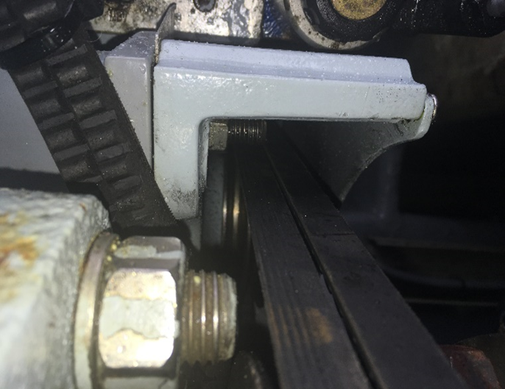
Defect 3. VSAT unit.
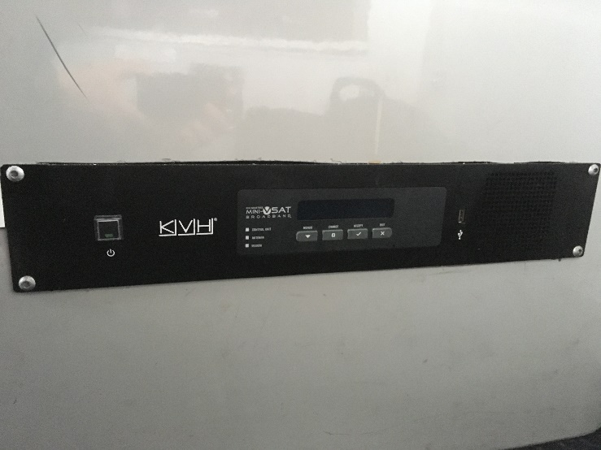
Defect 5 picture. Sample Solenoid for replacement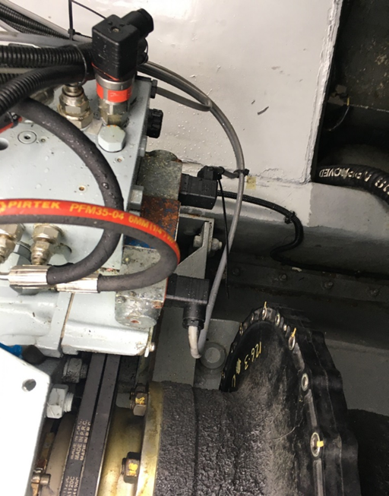
Defect 6 Bench seat and back for recovering.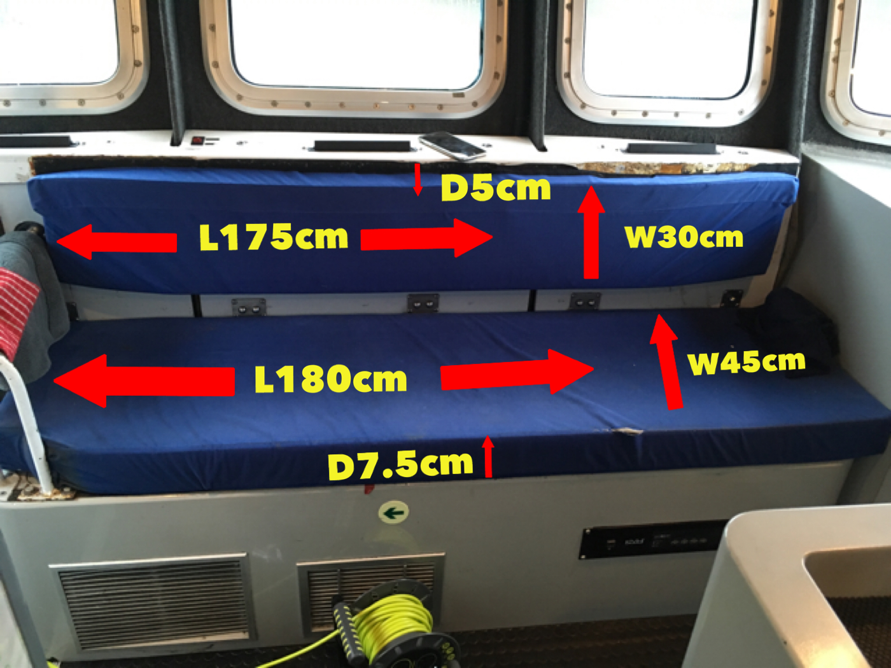

Annex E: General Arrangements

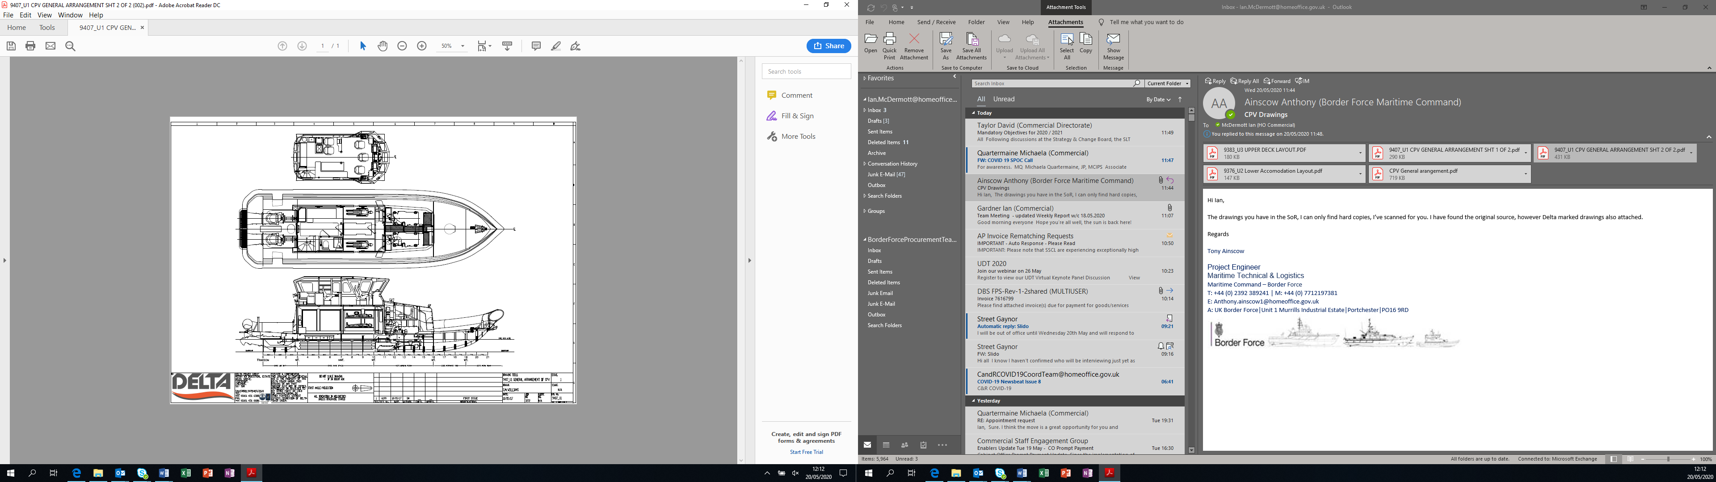

Annex F: Vessel Details
 | Name | MMSI | Callsign
 | CPV EAGLE | 235118128 | 2JQP8
 | CPV NIMROD | 235118129 | 2JQP9
 | CPV ALERT | 235118131 | 2JQQ2
 | CPV ACTIVE | 235118132 | 2JQQ3
 | CPV HUNTER | 235118133 | 2JQQ4
 | CPV SPEEDWELL | 235118134 | 2JQQ5
Length overall (LOA) | 18.80 m including the Collar, waterjet and its guard
Length Rigid Hull | 16.75 m
Length waterline (LWL) | 15.49 m
Beam Overall | 5.60 m
Beam Moulded Hull | 5.22 m
Draught aft full load | 0.96 m
Ht Overall USK to mast | 7.42 m (approx.)
Displacement | c31.1 tonne
Construction | FRP (fibre reinforced plastic)
Main Engines | Twin Caterpillar C18 Marine diesel engines rated output 876 bhp / 644 kW @ 2,200 rpm each. (Total 1,752 bhp / 1,288 kW) Emergency rating 1,000 bhp (747 kW) @ 2,300 rpm
Gearbox | ZF 550 reduction ratio 1.5:1
Propulsion | Twin Hamilton HM 521A Waterjets
Speeds | 28 knots Cruising  34 knots emergency sprint speed in suitable seas
Manoeuvrability | Manoeuvrability at all speeds is good
Range / Endurance | (See Section 11: Fuel, Speed, Range.)
Fuel | Design fuel load 3,424 litres. Max Fuel capacity 3,750 litres.
Fuel Consumption | At Max rated power 195.6 litres / hour
Fresh water | 270 litres
Black Water | 71 litres
Accommodation | 4 berths FOC
Domestic Arrgts | Small Galley, Combined shower and heads (Wheelhouse deck IOC Main Deck FOC)
Crew Seating | 5 Wheelhouse seats
Mission Space | IOC. An open compartment accessed from the main deck level provides non-formatted mission space to accommodate up to 23 persons in addition to the crew. FOC separate compartment containing 4 x Bunk accommodation in Fwd. section of mission space.

Annex G: Emergent Work Individual Item Proforma
Emergent Work (EW) Individual Item Proforma |  |  |  | 
EMERGENT WORK ITEM No: C*****/
Description
Signed, BFOO: |  | Date:
PART I: By Supplier
The above item is accepted as a genuine Emergent work item.
Our Firm Price is*  Our Realistic Estimate is* | £
Signed: | Position:
Signed: | Dated:
TIME PENALTY (if any) ..................................................................... The completion date of the contract* will/will not be affected by this item.
PART II: By Border Force Overseeing Officer
It is agreed that this is a genuine emergent work item and authority is given for the work to be undertaken.
The Above Firm Price/Realistic Estimate* of £ |  |  | ACCEPTED |  | REJECTED
Signed: |  |  | Date:
Notes:
*- Delete as required

All interactions pertaining to Emergent Work are to be carried out strictly in accordance with § 9.0.

Annex H: Emergent Work item Record Spreadsheet
CPV SPEEDWELL |  | 
Supplier:
Contract Number: | CXXXXX
MTL Project Lead:
BFOO:
EMERGENT WORK NUMBER | JOB DESCRIPTION |  | %  COMP
C*****/001

Annex I: Handover Certificate
CPV SPEEDWELL
This Handover Certificate is to be duly signed by a representative of the Authority and the Supplier for the aforenamed vessel at commencement of the Maintenance and Safety Equipment Recertification Period.
Immediately upon signing this Handover Certificate, the Supplier accepts responsibility for the safe custody of CPV SPEEDWELL until they are issued with an Authority-signed Acceptance Certificate.
Statement of Condition issued by (BFOO):

CPV SPEEDWELL is in a safe and stable condition. All systems have been shut down, (except those as listed below, commensurate with the systems as required by the Supplier).

Tank Contents
Fuel |  |  | litres
Fresh water |  |  | litres
Black Water Tank |  |  | litres
Systems Still Operational
Signed: |  | Signed:
For and on Behalf of the Supplier: |  | For and on Behalf of the Authority:
Name: |  | Name:
Position / Capacity: |  | Position / Capacity

Annex J: Acceptance Certificate
Acceptance Certificate
PART I: to be completed by Supplier
CPV SPEEDWELL

CPV SPEEDWELL has completed her Planned and agreed Emergent Work tasks associated with contract C**** to the satisfaction of the BFOO and is in a seaworthy condition ready to undertake sea trials, and, is this day offered for acceptance by Border Force.
Signed: | For and on Behalf of the Supplier:
Print Name: | Date:
PART II: to be completed by The Authority
I attended the acceptance of CPV SPEEDWELL and have satisfied myself that all systems, machinery and equipment are working satisfactorily. I have inspected the CPV and consider she is in a condition suitable for return to the Authority and is hereby accepted.
By Vessel Commander:
Signed: | Print Name / Post:
By Border Force Overseeing Officer:
Signed: | Border Force Overseeing Officer
Print Name: | Date:
PART III: Notes
Distribution
Original - Retained by the Supplier
Copies to - Border Force Overseeing Officer

Annex K: Project Completion Certificate
Project Completion Certificate |  | 
PART I: to be completed by Supplier
CPV SPEEDWELL

CPV SPEEDWELL, having completed contract C**** to the satisfaction of the Authority and having successfully completed any applicable trials and provided all documentation required under this requirement, Contract Number C***** is this day offered as completed to Border Force.
Signed: | For and on Behalf of the Supplier:
Print Name: | Date:
PART II: to be completed by The Authority
By Vessel Commander:
I attended the Project Completion Meeting of CPV SPEEDWELL and have satisfied myself that all systems, machinery and equipment are working satisfactorily. I have inspected the CPV and consider she is in a condition suitable for return to operational service.
Signed: | Print Name / Post:
By Border Force Overseeing Officer:
CPV SPEEDWELL having completed contract C***** to the satisfaction of the Authority and having completed all appropriate trials and received all documentation required under the Contract is hereby accepted at.…......... hours.
Signed: | Border Force Overseeing Officer
Print Name: | Date:
PART III: Warranty
The issuing of a Project Completion Certificate to the Supplier by the Authority, or a duly authorised representative of the Authority, does in no way effect the warranty requirements as specified in this requirement nor the statutory rights of the Authority
Distribution
Original - Retained by the Supplier
Copies to - Border Force Overseeing Officer

Annex L: Reimbursable Expenses
The Supplier may claim the following Reimbursable Expenses at the rates set out below:
1. Travel
Standard rate of allowance for private cars
Initial 10,000 miles 40p per mile
Additional miles over the initial 10,000 25p per mile
Public transport rate 23.8p per mile

2. Hotel rates
London £125 per night
All other locations other than London £90 per night

Annex M: Carbon Centre Disc Assembly & Operation M034-0003-EN

Document Supplied Separately

Annex N: Jet Anodes 521

Document Supplied Separately

Annex O: CPV Anodes, Cathode Protection and Bonding

Document Supplied Separately

Annex P: MDKBL Cummins Onan Service

Document Supplied Separately

Annex Q: 19m GRP Patrol Boat Tech 110416. CPV Paint Scheme

Document Supplied Separately


© Crown copyright 2020
Where we have identified any third-party copyright information you will need to obtain permission from the copyright holders concerned.
This publication is available at https://www.gov.uk/contracts-finder
Any enquiries regarding this publication should be sent For the Attention of Adam Jones via email to adam.jones43@homeoffice.gov.uk

