Jaggaer Two-Factor Authentication (2FA)

Access to the Foreign, Commonwealth & Development Office JAGGAER portal requires Two-Factor Authentication (2FA). This guide outlines the pre-requisites and the steps you need to follow to access the portal. You can also find a list of Frequently Asked Questions at the end of this document.

Pre-Requisites
This process requires an authenticator app to be downloaded from your mobile app store onto the mobile device being used by the user to complete this authentication process. You can use the Google Authenticator or Microsoft Authenticator app (other authenticator apps are available).

Process Guide
The process for Jaggaer 2FA works as follows.
- Log into the FCDO portal via the web login page (as below) enter your username and password. This is your first form of authentication.
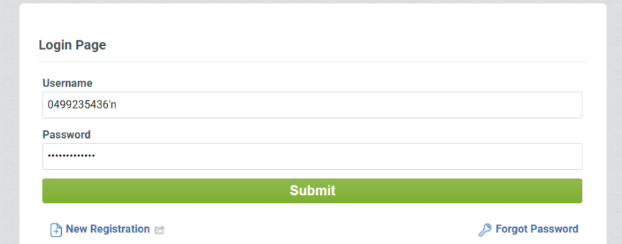
- You will then be presented with a QR code to scan. This requires a mobile phone with the Google or Microsoft Authenticator App.
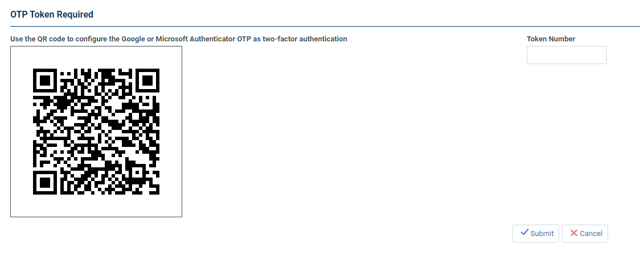
- Upon scanning the QR code with Google or Microsoft Authenticator you are presented with a code.
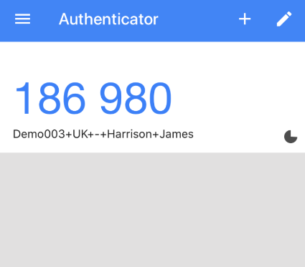
- The code must be entered into the Token Number field within the allotted time. You must then select the “Submit” button on the right hand side of the screen to complete the second form of authentication which completes the Jaggaer login process.
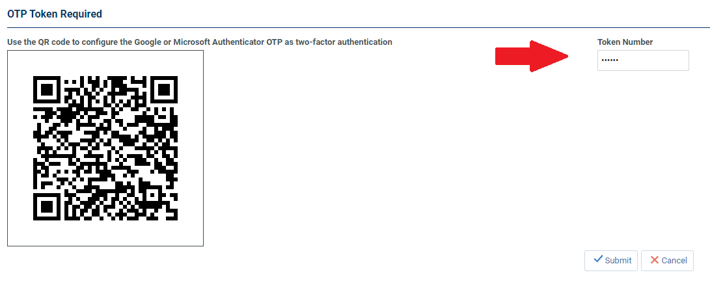

- For all future logins you will not be required to scan the QR code and instead can navigate to the Google or Microsoft Authenticator App and enter the current token into the Token Number field.
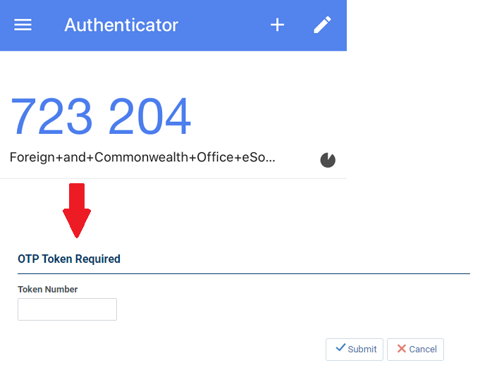

Frequently Asked Questions

What is 2 Factor Authentication? Two-factor authentication (2FA) is a security system that requires two distinct forms of identification in order to access something.
Why is 2 Factor Authentication used on the FCDO Portal? Two-factor authentication is used to strengthen the security of an online account.
My colleagues and I share a login for the portal – how can we manage this going forward? The login is your primary user account and this primary user account can create additional sub-users. To do this, navigate to User Management in the left-hand menu one logged in and select Manage Users and click Users. From here you can select Create and create new user accounts and assign them any user rights they require.
What operating systems can the Google Authenticator application work with? Android version 4.4 and above, iOS 7.0 and above.
I am unable to download an Authenticator application, how can I access my account? Without the application you will be unable to access your account. In the event you have any in-flight activities which require you to access the platform, please get in touch with your contact at the FCDO to advise of your situation and they will manage offline.
I cannot find the Google or Microsoft Authenticator app. If you have an outdated operating system you may not find the app in the app store, please update your operating system.
I have downloaded the app but I am still unable to access my account – what do I do? Please contact help_uk@jaggaer.com for further assistance.

