**Revised closing date & Award timetable**

**INVITATION TO TENDER DOCUMENT**

**PROVISION OF**

**5G Terrestrial & Satellite**

**Network infrastructure**

**Test bed**

**Ref: RFQ-FY17-14**

Please respond by 12:00hrs on 17 May 2017

1. **SATELLITE APPLICATIONS CATAPULT**

The Satellite Applications Catapult Ltd (The Catapult) is a not-for-profit research organisation, which acts as a neutral trusted entry point to an entire network of UK expertise in applications development across government, academia and industry. The company's primary purpose is to promote, develop and facilitate the commercialisation and advancement of the satellite applications industry.

The Satellite Applications Catapult brings together multi-disciplinary and skilled teams to generate ideas and solutions in an open innovative and collaborative environment. We also have a wide range of facilities, platforms and laboratories to enable the best businesses, researchers and end-users to work together to develop new satellite-based products, services and applications - translating ideas from concept to market.

The Satellite Applications Catapult is a not-for-profit company and one of a network of centres established by Innovate UK to accelerate the take up of emerging technologies.

Find out more at <http://www.sa.catapult.org.uk/>

1. **BACKGROUND TO REQUIREMENT**

The UK Government has a clear ambition that the United Kingdom should be a global leader in 5G so that we can take early advantage of its potential and help to create a world-leading digital economy that works for everyone. The Government has had extensive engagement with a wide range of interested parties - including industry and academia - and have received two major reports, commissioned by the Government, that have helped to inform our thinking: •

* The National Infrastructure Commission (NIC) set out in December 2016 its recommendations on steps that the UK should take to become a world leader in the deployment of 5G telecommunications networks.
* The Future Communications Challenge Group (FCCG), established by Department of Culture, Media & Science (DCMS), who provided advice in January 2017 on how the UK could become a world leader in the development of 5G telecommunication networks.

The Government is committed to ensuring that the United Kingdom is a world leader in the development and deployment of 5G, this was announced at the UK government Autumn Statement 2016, the government will invest in a nationally coordinated programme of 5G testbed facilities and application trials. The programme will deliver significant benefits: accelerating the deployment of 5G networks; maximising productivity gains from applications and services; and enhancing commercial opportunities for UK companies (including SMEs) at home and abroad, as well as encouraging investment into the UK by sending a clear signal of the Government’s ambitions. The government’s approach has been informed by the FCCG, who recommended a ‘hub and spoke’ model for the new 5G network test beds.

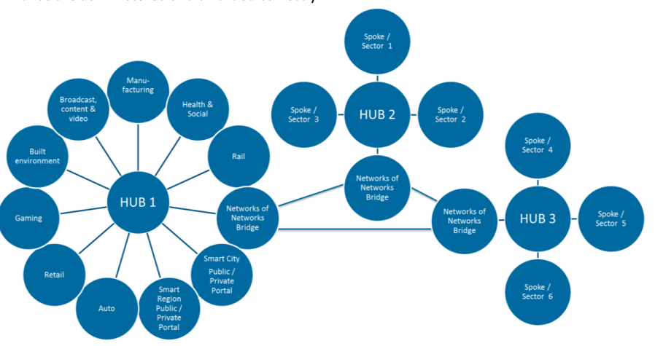

Figure -5G test bed strategy (Hub & Spoke)

The programme will establish ‘hubs’ - facilities that will provide the core network infrastructure to support the testing of 5G use cases. Each hub will be connected to a number of ‘spokes’ - testbeds that provide an environment where new 5G applications and services can be trialled in a controlled way. Testbeds could include partnerships between local areas, public sector bodies, industry and academic institutions. The spokes will test the benefits of a variety of 5G-specific use cases in a range of locations and contexts.

Further details of the government strategy on 5G can be found at the following URL

<https://www.gov.uk/government/uploads/system/uploads/attachment_data/file/597421/07.03.17_5G_strategy_-_for_publication.pdf>

Further details of the Future Communications Challenge Group (FCCG) can be found at the following URL:

<https://www.gov.uk/government/uploads/system/uploads/attachment_data/file/582640/FCCG_Interim_Report.pdf>

1. **5G HIGH LEVEL OVERVIEW**

We understand that 5G is more than an evolution of mobile broadband. It will be a key enabler in our rapidly demanding digital society and provide the next generation of ubiquitous ultra-high broadband infrastructure that will support business transformation in all economic sectors. 5G wireless will support a heterogeneous set of integrated air interfaces: from evolutions of current access schemes to brand new technologies. 5G networks will encompass cellular and satellite solutions. Seamless handover between heterogeneous wireless access technologies will be a native feature of 5G, as well as use of simultaneous radio access technologies e.g. satellite, 802.X technologies

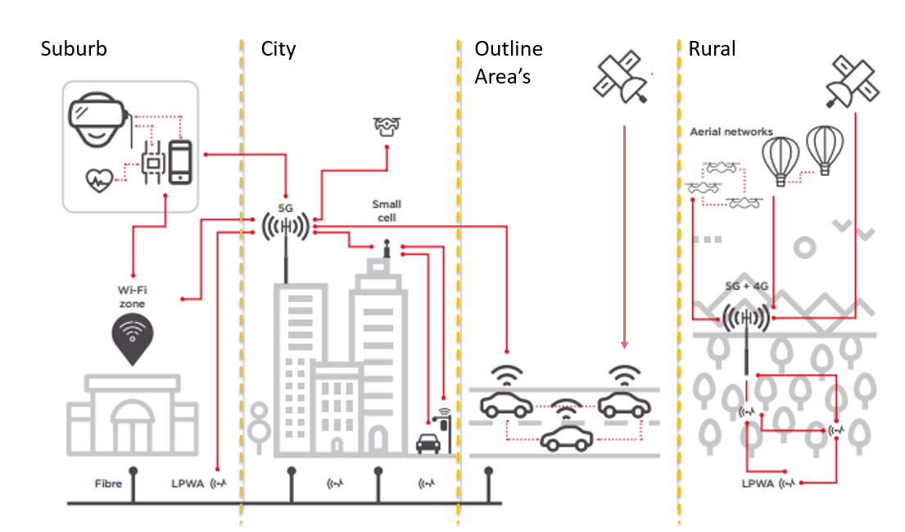

Figure - 5G network vision – © GSMA

The next generation of satellite and terrestrial networks will be a revolution in communications capability, providing seamless and fast communications that will form the backbone of a ubiquitous, ultra-high broadband infrastructure. Being first to market with new applications and services that exploit the networks capability will be a key factor in exploiting their economic benefits.

5G is an end-to-end ecosystem to enable a fully mobile and connected society. It empowers value creation towards customers and partners, through existing and emerging use cases, delivered with consistent experience, and enabled by sustainable business models.

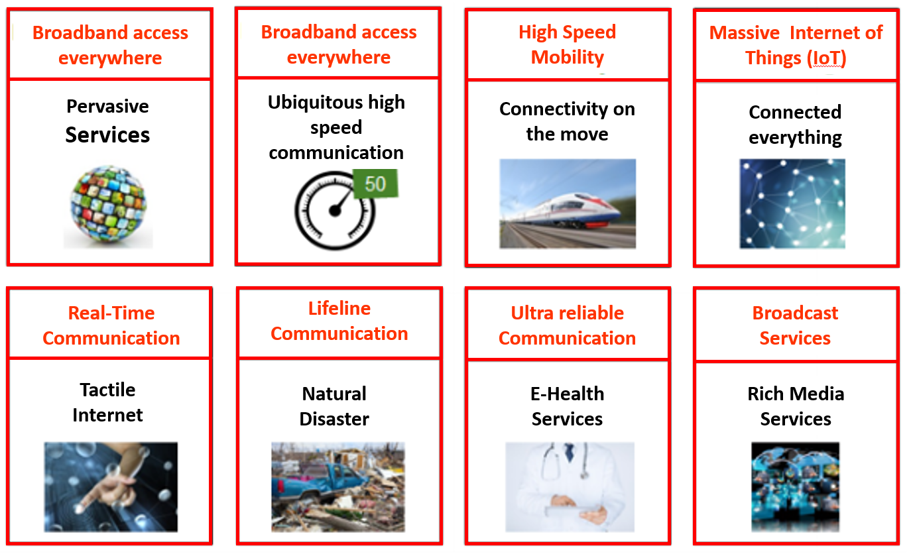

The International Telecommunication Union (ITU) and 3GPP have defined requirements and approved standards for earlier mobile communication generations: IMT-2000 (“3G”) and IMT-Advanced (“4G”). It will play the same role in defining requirements for 5G and eventually approve standards based on technologies that meet these requirements. Today’s conversation being centred on predicting what the telecom’s industry will look like in 2020 and beyond.

Wireless has evolved since its inception and seen several generational changes to the service offerings. The generational term is meant to help delineate differences between technologies and discussions are ramping up about fifth-generation (5G) wireless access. 5G is associated with the next step of IMT and IMT-2020 and initial planning is currently under way in the ITU. Additionally, a number of other changes in the end-to-end system will be a part of 5G evolution, both in the Radio Access Network (RAN) and Core Network, Figure 3 depicts some of the major architectural changes taking place today and into 2020.

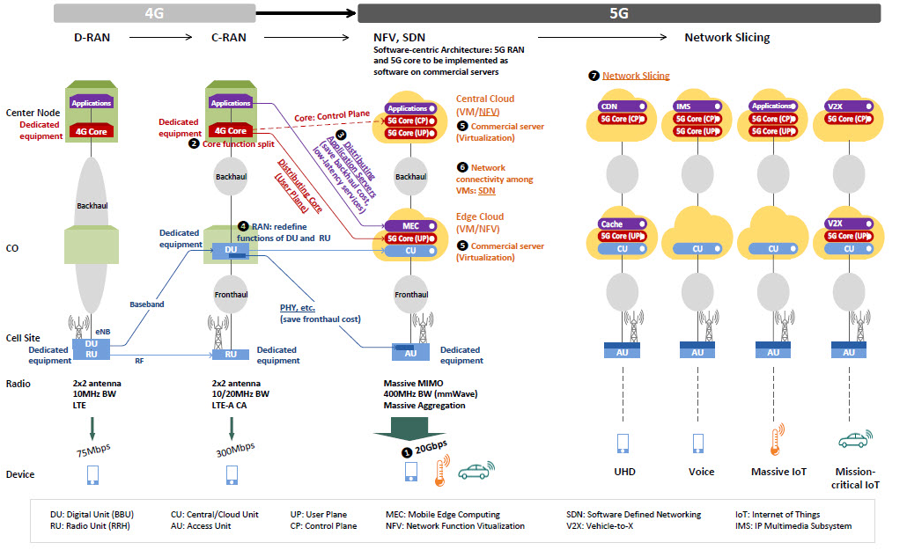

Figure 5G Architecture Evolution – © netmanias.com

There is no doubt that virtualization is going to underpin the whole foundation of these emerging 5G networks. In fact, software-oriented technologies like NFV and SDN play fundamental roles when implementing networks built on 5G architecture.

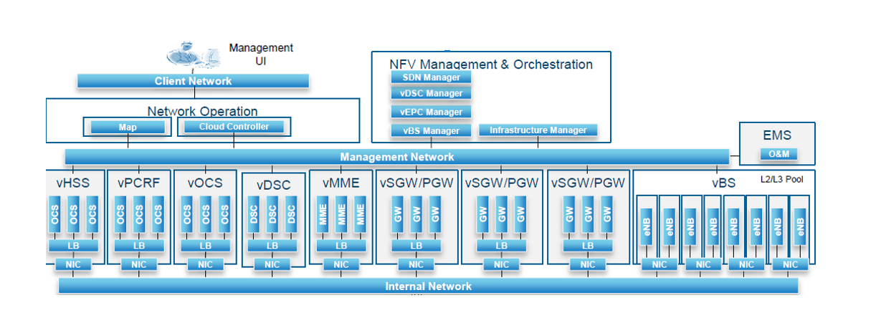

Figure - Virtualised Network

With the vast majority of underlying infrastructure resources and the surrounding support systems becoming virtualized in 5G networks, it is possible to programmatically package or slice out a complete instance of the entire network. This enables network operators to bring Network-as-a-Service offerings to the market, where operators can tailor and optimize packages or slices individually to meet the requirements from completely separate industry verticals such as automotive.

Network slicing is a form of virtual network architecture using the same principles behind software defined networking (SDN) and network functions virtualisation (NFV) in fixed networks. SDN and NFV are now being commercially deployed to deliver greater network flexibility by allowing traditional network architectures to be partitioned into virtual elements that can be linked. Network slicing allows multiple virtual networks to be created on top of a common shared physical infrastructure. The virtual networks are then customised to meet the specific needs of applications, services, devices, customers or operators: Ref Figure 5

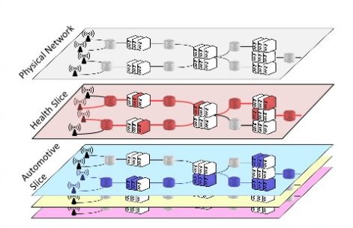

Figure – example of Network slicing

1. **5G Reach & Resilience step out centre**

As a joint funded venture between the Buckinghamshire Thames Valley Local Enterprise Partnership (BTVLEP)[1] and the Satellite Applications Catapult (SAC), we have agreed to establish a 5G Step out Centre (SoC) focused on resilient communications and ubiquitous Internet of things (IoT). At the heart of Buckinghamshire, the centre will be located at Westcott Venture Park[2] this new facility will give hardware, software, platform and applications developers’ access to the latest generation of networking equipment without the need to invest in expensive infrastructure. This will allow them to rapidly prototype and commission new services and applications under representative real-world conditions ahead of market rollout. Westcott will be developed as an inherent part of a 5G testbed ecosystem.

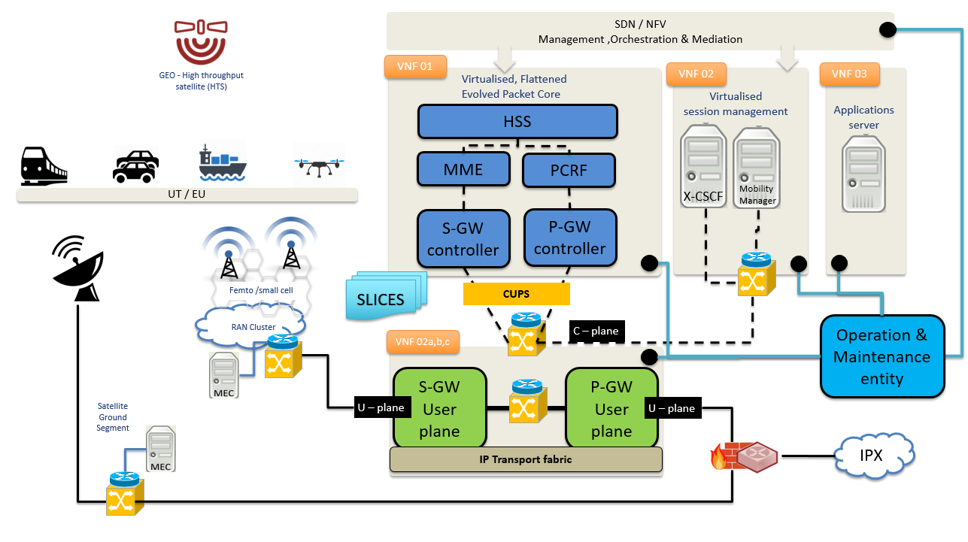

Figure -Westcott 5G R&R SoC

The 5G Reach & Resilience Step out centre (5G R&R SoC) is an environment where start-ups, SME and industrials from around the world are able to develop on a future 5G environment. The 5G R&R SoC has been designed to enable innovative product prototyping in realistic, comprehensive environments, offering interoperability between new prototypes and current CoTS products and existing satellite & 3G/4G network deployments.

5G R&R SoC enables the rapid deployment of proof-of concept as well as for resilience, security and reliability evaluations into the different network areas, addressing the highly diverse requirements coming from the different verticals of the 5G domain, 5G R&R SoC features a set of customized functions as basis for different dedicated network slices.

1. **The high-level scope of the requirement.**

The 5G SoC comprises of virtualised set of interdependent network elements aligning to 4G Long Term Evolution–Advanced (LTE-A) mobile network. The proposed architecture should be compliant with 3GPP release 11, exploiting the capability of SDN/NFV technologies to provide an architectural framework, by this we mean the ability to instantiate network element functions within a cloud environment with the control and user plane segregated and functions having the ability to be centralised or distributed on a function-by-function basis.

The 5G SoC is a network consisting of a series of interconnected network elements (hardware or software) to form a functional architecture to provide mobile connectivity via a wireless medium, in the case of the 5G SoC this will be in the form of a 4G/5G 3GPP network architecture interconnecting to trusted and untrusted 3GPP and non-3GPP networks.

The network will consist of a radio access layer to include base stations, access points and associated wireless access gateways to support end user access, this will form an evolved –UMTS radio access network (E-UTRAN). The packet core must conform to 3GPP standard architecture consisting of an Evolved Packet Core made up of the following entities. A Mobility Management Entity (MME) to manage the control plane mobility related procedures, a Serving Gateway (SGW) Serving GW is the gateway which terminates the interface towards E-UTRAN for each UE associated with the EPC, the PDN Gateway provides interconnection and breakout to intra/Inter/extranets. Reporting, Administration, Accounting and user authentication as well as policy enforcement is provided by the HSS and PCRF.

EPC nodes may be connected to legacy systems (GERAN, UTRAN) so that LTE systems can co-exist with existing access technologies and facilitate seamless handovers, additional to this, the network will also be connected to a satellite ground station and other non-3GPP wireless access networks.

IP Multimedia Subsystem (IMS) will be the preferred architecture element in setting up, conducting, and tearing down of multimedia sessions, additionally supported by Media Gateway(MGW), Media Gateway Control Function (MGCF), Session Border Controller (SBC) these elements will provide the necessary media transcoding, adaptation and security in support of Multimedia services.

Enriching the architecture with more advanced functions such as Mobile Edge Computing (MEC) will be one of a series of functions we wish to incorporate into the centre.

1. **Procurement output**

The key output from this procurement will be:

A series of virtualised network elements or functions to provide a fully functional non-operational private wireless testbed, this will comprise of the following elements connected in such a way to be able to provide wireless mobility services in support of application and service development.

* Evolved UMTS Terrestrial Radio Access Network (E-UTRAN)  / Radio Access Network (RAN) to include:
  + eNode-b
  + Node-b
  + Picocell.
  + Femto Cell
  + Access point
  + He-Node-b operating in either licensed or unlicensed spectrum bands
* Evolved Packet Core / Core Network elements to include:
  + Mobility Management Entity (MME)
  + Serving Gateway (SGW) / Serving GPRS Support Node (SGSN)
  + PDN GW (Packet Data Network Gateway) / Gateway GPRS Support Node (GGSN)
  + HSS (Home Subscriber Server) /Home Location Register (HLR) – to include EIR/AuC/AAA functions.
  + Policy and Charging Rules Function (PCRF)
* Session Management / ancillary network elements
  + IP Multimedia Sub System (IMS to include P-CSCF ,I-CSCF , S-CSCF)
  + Media Gateway Control Function (MGCF)
  + Media Gateway (MGW)
  + Session Border controller(SBC)
  + Security Gateway (SeG)
  + He-Node-b gateway (HeNb GW)
* Mobile Edge Computing –MEC Server / function
* Software defined Networking controller
* Network function virtualization orchestrator
* Server hardware.
* Virtualisation software.

Potential respondents may choose to bid specific network element/functions or a complete turnkey solution. In the case of a turnkey solution the proposal must include, power connectors, RF connector, network cables, interface cables required to integrate network element or functions into the 5G SoC architecture. This will also include any dimensioning information or calculations, performance figures or architecture / interface models or diagrams used in the design, installation or commissioning, furthermore all data pertaining to performance or capability of the network elements or commissioned architecture.

**A list of technical Acronyms used in this document is contained at Annex D. Any questions relating to the terminology used should be submitted as part of the Question & Answer exchange within this tender process**

1. **PURPOSE OF THIS DOCUMENT**

The purpose of this Invitation to Tender (ITT) is for the Catapult to receive sufficient information from potential suppliers interested in supplying the Products and associated support services detailed within this ITT and to allow an assessment to be made of their capacity and suitability to supply these Services.

1. **SPECIFICATION OF REQUIREMENTS** 
   1. **Scope of proposed contract**

The contract is to obtain the equipment required to meet the requirements detailed in **Annex A** as well as installation, support, maintenance for a three-year period.

* 1. **Method**

The successful bidder will be required to install and commission their product by **December 2017**, and provide support services, and or training for a period of three years.

* 1. **Deliverables**

The successful Tenderer will be required to deliver a product(s) or solution, which conforms with or meets the functional specification contained at **Annex A**

1. **AWARD TERMS**

The Contract will be made on the basis of the Satellite Applications Catapults’ provided terms and conditions (See **Annex B**).

Entities wishing to be considered for this contract must, before submitting their proposal, sign and return the declaration contained at **Annex C**, which accepts the terms & conditions issued with this invitation. **Failure to return this declaration will mean that your proposal will not be evaluated.**

**Entities are requested to return this declaration well in advance of submitting their response so that they can be issued with question and answer information detailed in Section 12.**

1. **CONFIDENTIALITY**

All information provided in this document shall remain confidential between the Supplier and the Satellite Applications Catapult. The Satellite Applications Catapult will not share this information with any other organisations or Public Bodies without the permission of the Supplier.

This document and the associated appendices are provided in confidence for the sole purpose of this tender and must not be provided to any third party or used for any other purpose without the express written permission of the Catapult.

1. **COMMUNICATION DURING THIS PROCUREMENT**

All contact regarding this procurement should be made via the email address:

[procurement@sa.catapult.org.uk](mailto:procurement@sa.catapult.org.uk)

Suppliers are been asked to include primary points of contact in their organisation for their response to this ITT. All communications will be made through the Primary Contact. The Supplier must therefore undertake to notify any changes relating to the contact.

1. **CLARIFICATION QUESTIONS**

The Catapult will not enter into detailed private discussions regarding the goods or services. Clarification questions about the procurement should be submitted through the procurement@sa.catapult.org.uk email address by **26 April 2017.**

All questions and answers generated as part of this exchange will be issued to all entities who have previously registered their intent to submit a proposal. Q&A Documentation will be issued to all entities who have registered their interest on **28 April 2017**.

1. **GENERAL NOTICES**

Any expenditure, work or effort undertaken by your Company prior to the award of a contract is a matter solely for your Company’s own commercial judgement.

The Catapult reserves the right to terminate this contract award process at any time and not to enter into any contract. The Catapult and/or its advisers shall not be liable for any costs, liabilities or expenses whatsoever whether incurred (directly or indirectly) by the bidding Company, advisers or sub-contractors, in connection with the preparation of the response to this ITT or in the event of discontinuance of this procurement.

Respondents should note that the Catapult reserve the right at their sole and absolute discretion to reject any or all proposals, with or without reason. The following reasons may lead the Catapult to consider automatic rejection of a bid:

i. Missed deadline for the response.

ii. Failure to respond or, having responded, failure to clarify points raised by the Catapult.

iii. Failure to submit a bid that complies with the Catapult’s requirements.

iv. Any breach of confidentiality whatsoever.

v. Unless specified to the contrary channelling any communications with regard to this project to anyone not specified in the ITT

vi. Substantial non-compliance with the terms agreed to in the Respondents Acknowledgement letter **(see Annex C).**

**Offers submitted in response to this ITT must be valid for a period of 90 days.**

1. **DISCLAIMER**

The Catapult does not make any representation or warranty (expressed or implied) as to the accuracy, reasonableness or completeness of the procurement documents and shall not be liable for any loss or arising as a result of reliance upon information within the documents.

Any persons considering entering into a contractual relationship with the Catapult should seek their own professional technical, financial and legal advice.

Suppliers are advised that nothing herein or in any other communication made by the Catapult (written or oral) shall be taken as constituting a legally binding contract or agreement between the Catapult. (save for a formal award of contract made in writing on behalf of the Catapult).

The Catapult reserves the right to amend any information or any requirements contained in the documentation. Suppliers should form their own conclusions about the methods and resources needed to meet these requirements.

The ITT documentation and the information contained within it are the property of the Catapult; all rights, including intellectual property rights, are reserved. Suppliers may make it available within their organisation or subcontractors solely for the purposes of preparing a bona fide response to a document for the provision of goods and services. The Supplier is to ensure that all such parties are made aware of the confidentiality obligations and take such steps as to guarantee compliance with it.

Suppliers may withdraw their responses at any time prior to accepting the notification of award by sending a notice of withdrawal to the Catapult by email or in writing.

The Catapult shall observe all its obligations under the Data Protection Act 1998 and associated legislation which arise in connection with this tender.

By participating in the procurement process, Suppliers shall be deemed to have agreed to be bound by the notices and undertakings in the procurement documents.

1. **PROCUREMENT TIMETABLE**

The indicative timetable for this procurement is set out in the following table:

|  |  |
| --- | --- |
| **Activity** | **Date** |
| **ITT issue** | **23 March 2017** |
| **Confirmation of compliance to Terms & Conditions** Respondents statement of compliance and intent to bid returned (**Annex C**) |  |
| **Receipt of questions relating to this ITT Process** | **26 April 2017** |
| **Issue of all Answers relating to the ITT Process** | **28 April 2017** |
| **Receipt of Respondents proposals in response to this ITT** | **12:00hrs 17 May 2017** |
| **Evaluation of proposals** Review, score and evaluate proposals, including a credit check of potential suppliers. | **17 May to 07 June 2017** |
| Identification of Respondents who will be invited to present their proposals in more detail | 07 June 2017 |
| **Respondent presentations** | 15 & 16 June 2017 |
| **Notice to all respondents of the results of the selection process, by e-mail & start of mandatory standstill period.** | **16 June 2017** |
| **Preferred Supplier appointment following completion of standstill period** | **27 June 2017** |
| **Contract commences** (with Respondent fully accountable for ongoing service) | **27 June 2017** |
| **Dispatch Contract award notice** | **25 July 2017** |

The timetable listed above is for indicative purposes only and the Catapult reserves the right to amend this timetable at its discretion.

1. **THE EVALUATION APPROACH**

Proposals will be evaluated based on the most economically advantageous tender and will be assessed against the methodology proposed. The Table below contains a list of all criteria.

|  |  |  |
| --- | --- | --- |
| **Criteria** | **Max score available** | **Explanation** |
| Cost | 40% | * Total cost of ownership, licenses costs, hardware requirements to support the product or service, including annual costed upgrades. * Third party hardware or software costs. E.g. operating systems, specific hardware requirements or environmental conditions. * Specialist skill or competence to commission or operate the product or service. * Any mandatory ongoing support or maintenance costs beyond the warranty period. These should include Annual Support and maintenance upgrades for a period of three years. * Please complete the pricing schedule in Section D. |
| Technical solution | 40% | * Ability of the proposed solution to meet all or a majority of the technical requirements; * Proven Interoperability of the proposed products or solution with to work with other vendor equipment; * Product roadmap of committed functionality toward future 3GPP release ( 5G roadmap); |
| Vendor experience , | 10% | * Demonstration that the vendor has a full understanding of the purposes described in this ITT and the ambition and uses of the 5G SoC. |
| interoperability | 5% | * Provide evidence & references on interoperability |
| Implementation | 5% | * Implementation plan and approach; * Vendor’s project management process. * Support services ,helpdesk ,field support |
| **Total** | **100** |  |

Following the closing date receipt of proposals, an evaluation panel made up of project stakeholders will review all received documentation.

The team, using the evaluation criteria indicated above, will collectively determine which proposals are most likely to be most suitable to the Catapult’s requirements. **A** **maximum of 5 (five) Respondents will be shortlisted for the final stages of the evaluation.**

**All Tenderers will be advised whether they have been shortlisted or not on 07 June 2017.**

As part of the evaluation process, the Catapult may undertake reference telephone calls to selected customers of Shortlisted Respondents. Exact dates will be agreed as the ITT process progresses

It is intended that these presentations will take place on **15 & 16 June 2017.**

The Catapult may provide guidance where it considers it appropriate to do so to each Respondent ahead of this presentation as to any specific queries or issues to be covered in respect of that specific Respondents proposal.

Respondents should assume a **90 minute time slot for a formal presentation (circa 60 mins) with around thirty minutes for questions and answers.**

The presentation must be capable of being delivered on a projector with a PC attached (both of which can be supplied if required).

For each Respondent the senior manager that would be responsible for the contract is required to attend the presentation. Respondents may also be required to make themselves available to attend additional meetings if required.

**Following the completion of the Presentation, the Tender Evaluation Panel will review its initial scoring to confirm any areas of information /clarification which come to light in the Presentation stage. These scores will then be submitted to determine the final scores for each shortlisted Respondent.**

**The Supplier which receives the highest evaluated score will be nominated as the Preferred Supplier.**

The recommendation of the evaluation panel will then be put to the Senior Management of the Catapult for approval. It is intended that all Respondents will be informed of the results of the evaluation process on **16 June 2017.**

1. **RESPONSE REQUIREMENTS**

Respondents should quote the Reference number at the front of this ITT in all correspondences related to this tender.

All responses to this ITT must be received before **12:00hrs 17 May 2017 into the following e-mail address:**

[procurement@sa.catapult.org.uk](mailto:procurement@sa.catapult.org.uk)

Responses received beforehand will not be opened until after the closing time and date for receipt of tenders. **Tenders that are received late will not be considered.**

Respondents must format their response using the following structure:

Detailed response to the evaluation criteria contained in Section 11. Tender responses must be submitted in English and should be no more than 40 sides of A4 including appendices. Please note, this twenty-page limit does not include the responses to Sections A-D below.

Completed response to the information requirements in:

* Completed Annex A2 Supplementary questions
* Section A Supplier Organisation Information
* Section B Financial Organisation
* Section C Security Information
* Section D Commercial & Price information
* Completed Annex D

Please detach this page onwards from this document and return by email to procurement@sa.catapult.org.uk by **12:00hrs 17 May 2017**.

|  |  |  |
| --- | --- | --- |
|  | **Supplier** | **Buyer** |
| Company Name:- |  | Satellite Applications Catapult Ltd |
| Contact Name:- |  | John Thompson |
| Telephone Number:- |  | 01235 567999 |
| Email Address:- |  | procurement@sa.catapult.org.uk |
| Position within the Company |  | Procurement Manager |
| Persons authorised to sign on behalf of the Company |  | Antonia Jenkinson – CFO/COO |

**SECTION A** – **SUPPLIER** **ORGANISATION** **INFORMATION**

Please ensure that you complete the questions relevant to your organisation.

|  |  |
| --- | --- |
| A1 | Full name of the organisation submitting the ITT: |
|  | |

|  |  |  |
| --- | --- | --- |
| **A2** | Please confirm the status of the Supplier to be considered: | |
| **GUIDE** | A response to this question is for the Catapult to understand the Supplier. | |
| **A** | Your organisation is bidding to provide the goods or services required itself (if you tick yes, go to question A5) |  |
| **B** | Your organisation is bidding in the role of Prime Contractor and intends to use third parties to provide some services (If you tick yes go to question A3 and A4) |  |
| **C** | The Potential Provider is a consortium (If you tick yes go to question A3) |  |

|  |  |  |  |
| --- | --- | --- | --- |
| **A3** | If your answer to **A2** was **B** or **C**, please indicate in the table all sub-contractors or members of the consortium which will be responsible for each element of the requirement. | | |
| Element of Requirement | | Company / Organisation | How much of the requirement will they directly deliver (%) |
|  | |  | % |
|  | |  | % |
|  | |  | % |

|  |  |  |  |  |
| --- | --- | --- | --- | --- |
| **A4** | Details about the organisation named in A1 (organisation submitting the ITT): | | | |
| **A** | Company Registration Number |  | | |
| **B** | Date of Registration |  | | |
| **C** | Registered address and postcode |  | | |
| **D** | Annual Turnover |  | | |
| **E** | VAT Registration Number |  | | |
| **F** | Please select the legal status of the organisation named in A1: | 1 | a public limited company |  |
| 2 | a limited company |  |
| 3 | a sole trader |  |
| 4 | a partnership |  |
| 5 | a Limited Liability Partnership |  |
| 6 | a consortium |  |
| **G** | Website address |  | | |

|  |  |  |
| --- | --- | --- |
| **A5** | Please provide full contact details of a primary contact to whom future correspondence is to be sent in connection with this ITT: | |
| GUIDE | The person listed as Primary Contact should be the person that has registered their interest in this procurement and will be the person that receives communications accordingly. | |
| Name | |  |
| Position | |  |
| Address | |  |
| Telephone number | |  |
| E-mail address | |  |

**SECTION B – FINANCIAL INFORMATION**

The following questions have been designed to evaluate the financial standing and strength of an organisation. The most recent accounts will be utilised to assess the financial standing and strength of your organisation.

|  |  |  |
| --- | --- | --- |
| **B1** | Financial Statements: | |
| Please attach your most recent accounts | |  |

|  |  |  |
| --- | --- | --- |
| **B2** | Conflicts of Interest: | |
| Is there any other work being undertaken or likely to be undertaken by your organisation (or consortium) which could give rise to a conflict of interest? | | Please provide details |

|  |  |  |
| --- | --- | --- |
| **B3** | Complaints to Professional Bodies: | |
| Has your organisation (or consortium) had any substantiated complaints made against them to any professional body in the last three years | | Please provide details |

|  |  |  |
| --- | --- | --- |
| **B4** | Indemnity and Liability Provision | |
| Please confirm that for the service being tendered your organisation could provide these level of insurances | | |
| Professional Indemnity - £5m | |  |
| Employers Liability - £5m | |  |
| Public/Products Liability - £5m | |  |

**SECTION C – SECURITY REQUIREMENTS**

This question will be evaluated on a PASS/FAIL basis. Tenderers will be excluded from the procurement process if they cannot self-certify to holding the relevant Certification or to having an In-House Policy that fully complies with current legislative requirements.

|  |  |  |  |  |  |
| --- | --- | --- | --- | --- | --- |
| **C1** | Do you have a company representative who is responsible for security | | | | Yes  No |
| **C2** | Does your organisation operate an Information Security Management system certified to International, European or equivalent standard (e.g. BS EN ISO 27001) or is your company certified to Cyber Essentials Plus? | | | | Yes  No |
| **C3** | If you have answered “Yes” to the above, please provide: | Name and approval certificate Number |  | | |
| Certificate Expiry Date |  | | |
| **C4** | Please self-certify that your organisation has an in-house policy for the management of information security that fully complies with current legislative requirements. | | | | Yes  No |
| **C5** | When was the last time an IT Health Check/penetration test was carried out on your company network? | | | |  |
| **C6** | Please provide, as a separate appendix, a record of any security breaches (both cyber and physical) in the last two (2) years. | | | | Yes  No  n/a |
| **C7** | Please self-certify that your organisation has an in-house policy/plan for Business Continuity & Disaster Recovery | | | | Yes  No |
| **C8** | If you have answered “No” to the above question, please describe your arrangements to ensure business continuity and to enable disaster recovery, including scope, validation, risk treatment and leadership in these areas.  *Guidance: You should demonstrate that your organisation keeps copies of documentation setting out your business continuity and disaster recovery procedures. These should include the arrangements for business continuity and disaster recovery throughout your organisation. They should set out how the organisation will carry out its policy with a clear indication of how the arrangements are communicated to the workforce*. | | | | |
| **C9** | Has your organisation (or any member of your proposed consortium, if applicable) Directors or partner or any other person who has powers of representation, decision or control been convicted of any offences named within Annex C (if yes please provide details in separate annex) | | | Yes  No | |

**SECTION D – COMMERCIAL AND PRICE INFORMATION**

The following section outlines the commercial and price offer based on the User Requirement Specification. Prices submitted should be fully inclusive (Ex VAT) in GBP not subject to variation.

|  |  |  |
| --- | --- | --- |
| **Item #** | **Pricing element – example only please amend as required** | **£** |
| 1 | **Price of equipment proposed ( unit ,licence cost , per node, user or other constraint, please specify constraints or scaling factors )** | £ |
| 2 | **Staging , installation & Commissioning** Please provide details and assumptions | £ |
| 3 | **Support & Maintenance for the three-year period**.  (Please include details of the number/frequency/cost of each planned maintenance visit). | £ |
| 4 | **training or familiarisation**  (Please provide a day rate for the supply of any operator training you recommend x the number of days required each year) | £ |
| 5 | **Supply of all operation & maintenance documentation** for the installed equipment plus any updates issued during the three year period | £ |
| 5 | **Consumable items**  Please provide pricing for an ongoing annual basis mandatory ongoing support or maintenance costs beyond the warranty period. These should include consumables, Annual Support, and maintenance upgrades for a period of three years. | £ |
| **Total cost** |  | £ |
|  | |  |

|  |  |  |
| --- | --- | --- |
| **Notes:** | |  |
| * | Please be as specific as necessary when detailed the proposed cost of each deliverable. | |
| ** | Any costs proposed following contract award will require full justification and may not be entertained if it can be demonstrated that these could reasonable be foreseen prior to contract award. | |

|  |
| --- |
| UNDERTAKING |

To be signed by an Officer of the Supplier’s Company in their own name on behalf of the Company.

I certify that the information provided is accurate to the best of my knowledge and that I accept the conditions and undertakings requested in the ITT.

|  |  |
| --- | --- |
| Signed for and on behalf of the Company  SIGNATURE |  |
| Name of person signing on behalf of the Company  PRINT |  |
| Position/status in the Company  PRINT |  |
| Company’s name and address  PRINT |  |
| Date |  |

**Mandatory Exclusion Grounds**

**Participation in a criminal organisation**

Participation offence as defined by section 45 of the Serious Crime Act 2015

Conspiracy within the meaning of

* section 1 or 1A of the Criminal Law Act 1977 or
* article 9 or 9A of the Criminal Attempts and Conspiracy (Northern Ireland) Order 1983

Where that conspiracy relates to participation in a criminal organisation as defined in Article 2 of Council Framework Decision 2008/841/JHA on the fight against organised crime;

**Corruption**

Corruption within the meaning of section 1(2) of the Public Bodies Corrupt Practices Act 1889 or section 1 of the Prevention of Corruption Act 1906;

The common law offence of bribery;

Bribery within the meaning of sections 1, 2 or 6 of the Bribery Act 2010, or section 113 of the Representation of the People Act 1983;

**Fraud**

Any of the following offences, where the offence relates to fraud affecting the European Communities’ financial interests as defined by Article 1 of the convention on the protection of the financial interests of the European Communities:

* the common law offence of cheating the Revenue;
* the common law offence of conspiracy to defraud;
* fraud or theft within the meaning of the Theft Act 1968, the Theft Act (Northern Ireland) 1969, the Theft Act 1978 or the Theft (Northern Ireland) Order 1978;
* fraudulent trading within the meaning of section 458 of the Companies Act 1985, article 451 of the Companies (Northern Ireland) Order 1986 or section 993 of the Companies Act 2006;
* fraudulent evasion within the meaning of section 170 of the Customs and Excise Management Act 1979 or section 72 of the Value Added Tax Act 1994;
* an offence in connection with taxation in the European Union within the meaning of section 71 of the Criminal Justice Act 1993; September 16 v3 2
* destroying, defacing or concealing of documents or procuring the execution of a valuable security within the meaning of section 20 of the Theft Act 1968 or section 19 of the Theft Act (Northern Ireland) 1969;
* fraud within the meaning of section 2, 3 or 4 of the Fraud Act 2006;
* the possession of articles for use in frauds within the meaning of section 6 of the Fraud Act 2006, or the making, adapting, supplying or offering to supply articles for use in frauds within the meaning of section 7 of that Act;

**Terrorist offences or offences linked to terrorist activities**

Any offence:

* listed in section 41 of the Counter Terrorism Act 2008;
* listed in schedule 2 to that Act where the court has determined that there is a terrorist connection;
* under sections 44 to 46 of the Serious Crime Act 2007 which relates to an offence covered by the previous two points;

**Money laundering or terrorist financing**

Money laundering within the meaning of sections 340(11) and 415 of the Proceeds of Crime Act 2002

An offence in connection with the proceeds of criminal conduct within the meaning of section 93A, 93B or 93C of the Criminal Justice Act 1988 or article 45, 46 or 47 of the Proceeds of Crime (Northern Ireland) Order 1996

**Child labour and other forms of trafficking human beings**

An offence under section 4 of the Asylum and Immigration (Treatment of Claimants etc.) Act 2004;

An offence under section 59A of the Sexual Offences Act 2003

An offence under section 71 of the Coroners and Justice Act 2009;

An offence in connection with the proceeds of drug trafficking within the meaning of section 49, 50 or 51 of the Drug Trafficking Act 1994

An offence under section 2 or section 4 of the Modern Slavery Act 2015

**Non-payment of tax and social security contributions**

Breach of obligations relating to the payment of taxes or social security contributions that has been established by a judicial or administrative decision.

Where any tax returns submitted on or after 1 October 2012 have been found to be incorrect as a result of:

* HMRC successfully challenging the potential supplier under the General Anti – Abuse Rule (GAAR) or the “Halifax” abuse principle; or September 16 v3 3
* a tax authority in a jurisdiction in which the potential supplier is established successfully challenging it under any tax rules or legislation that have an effect equivalent or similar to the GAAR or “Halifax” abuse principle;
* a failure to notify, or failure of an avoidance scheme which the supplier is or was involved in, under the Disclosure of Tax Avoidance Scheme rules (DOTAS) or any equivalent or similar regime in a jurisdiction in which the supplier is established

**Other offences**

Any other offence within the meaning of Article 57(1) of the Directive as defined by the law of any jurisdiction outside England, Wales and Northern Ireland

Any other offence within the meaning of Article 57(1) of the Directive created after 26th February 2015 in England, Wales or Northern Ireland

**Annexes**

Annex A – Functional Specification (A1 & A2)

Annex B - Satellite Application Terms and Conditions

Annex C - Acknowledgement Letter

Annex D - List of Technical Acronyms

**Annex A**

**Please refer to the separate document entitled Annex A-1 Technical Requirements & A2 Supplementary questions**

**Annex B**

**Satellite Application Terms and Conditions**

**Please see separate attachment**

**Annex C**

**Acknowledgement Letter**

To: Satellite Applications Catapult Ltd

Attn: Procurement Department

From (Company who will bid):

**Invitation to Tender –** **Ref: ITT-FY17-14 Provision of a 5G Terrestrial & Satellite Network infrastructure Test bed**

We acknowledge receipt of your Invitation to Tender for the above work and are in receipt of all documents listed in the contents.

1. We agree to comply with the requirements of the Instructions to Respondents and confirm that we will respond to your request and submit our bid no later than the date required.
2. We agree to the Terms and Conditions contained in the ITT. We also confirm that if successful, any subsequent substantial departure from these terms during any final negotiations may render our response invalid and the Catapult will be free to enter into negotiations with an alternative Tender Respondent.

Or,

1. We shall not submit a bid. We confirm that all paper copies have been destroyed, that all electronic copies have been erased in their entirety from our systems

(Respondent to delete item as applicable).

Our primary point of contact in connection with this bid is:-

Regards

(Signature & Title):……………………………………………………..

(Printed Name):……………………………………………………..

(Company):…………………………………………………….. …….

**Annex D**

**list of technical Acronyms**

|  |  |
| --- | --- |
| **Term** | **Description** |
| 3GPP | 3rd Generation Partnership Project |
| AWS | Advanced Wireless Services |
| DAB | Digital Audio Broadcast |
| DSL | Digital Subscriber Line |
| DVB | Digital Video Broadcast |
| eHSPA | evolved High Speed Packet Access |
| ETSI | European Telecommunications Standards Institute |
| FDD | Frequency Division Duplex |
| FWT | Fixed Wireless Terminal |
| GSM | Global System for Mobile communication |
| HSPA | High Speed Packet Access |
| HSS | Home Subscriber Server |
| IPTV | Internet Protocol Television |
| LTE | Long Term Evolution |
| MBMS | Multimedia Broadcast Multicast Service |
| MIMO | Multiple Input Multiple Output |
| MME | Mobility Management Entity |
| NGMN | Next Generation Mobile Networks |
| OFDM | Orthogonal Frequency Division Multiplexing |
| PCRF | Policing and Charging Rules Function |
| PDSN | Packet Data Serving Node |
| PS | Packet Switched |
| QoS | Quality of Service |
| RAN | Radio Access Network |
| SAE | System Architecture Evolution |
| SC-FDMA | Single Carrier Frequency Division Multiple Access |
| SGSN | Serving GPRS Support Node |
| GGSN | Gateway GPRS Support Node |
| TDD | Time Division Duplex |
| e-UTRA | Evolved Universal Terrestrial Radio Access |
| e-UTRAN | Evolved Universal Terrestrial Radio Access Network |
| WCDMA | Wideband Code Division Multiple Access |
| WLAN | Wireless Local Area Network |
| 5G-PPP | 5G Public Private Partnership |
| ABS | Adaptive Bitrate Streaming |
| API | Application Programming Interface |
| AQoS | Assured Quality of Service |
| COTS | Commercial Of The Shelf |
| DASH-IF | Dynamic Adaptive Bitrate HTTP – Interoperability Forum |
| DVB | Digital Video Broadcasting |
| E2E | End-to-End |
| ETSI | European Telecommunications Standards Institute |
| GSO Geo-Stationary Orbit | Geo-Stationary Orbit |
| HTS | High Throughput Satellite |
| HTTPS | Hyper Text Transfer Protocol Security |
| IETF | Internet Engineering Task Force |
| IoT | Internet of Things |
| IP | Internet Protocol |
| IaaS | Infrastructure as a Service |
| ITT | Invitation To Tender |
| KO | Kick Off |
| LEO | Low Earth Orbit |
| M2M | Machine-to-Machine |
| MEC | Mobile Edge Computing |
| MNO | Mobile Network Operator |
| MPEG | Motion Picture Experts Group |
| MPEG-DASH MPEG | Dynamic Adaptive Streaming over HTTP |
| NGSO | Non Geo Stationary Orbit |
| NMC | Network Management Centre |
| NVF | Network Function Virtualisation |
| ONF | Open Networking Foundation |
| OTT | Over-The-Top |
| PaaS | Platform as a Service |
| PAT | Port Address Translation |
| PNF | Physical Network Function |
| QoS | Quality of Service |
| SaaS | Software as a Service |
| SDN | Software Defined Networking |
| SFC | Service Function Chaining |
| SOC | Satellite Operations Centre |
| SoW | Statement of Work |
| VNF | Virtual Network Function |
| VNO | Virtual Network Operator |

1. http://www.buckstvlep.co.uk/
2. [Westcott venture park](http://www.westcottventurepark.com/)