MARITIME AND COASTGUARD AGENCY

TCA 3/7/1000 INHERENTLY SAFE HYDRAULIC POWER PACKS – QUESTIONS AND ANSWERS 4

This document provides answers to some questions that have been raised by a tenderer for the above contract. In the interest of fairness we make all new information given to one tenderer, available to them all. The questions are below, with the MCA’s answers in bold.

- Do you have a hydraulic circuit for your system?

No, it is simply a supply and return line from the power pack to the hydraulic pump.

- Have you already got an existing power unit driving your pumps or currently have power units doing the same job, that can be seen or do you have information that we can have (to have continuity of parts etc.)?

The specification reflects the capability of the existing power packs. Pictures supplied below. The existing power packs are very old and parts are scarce.

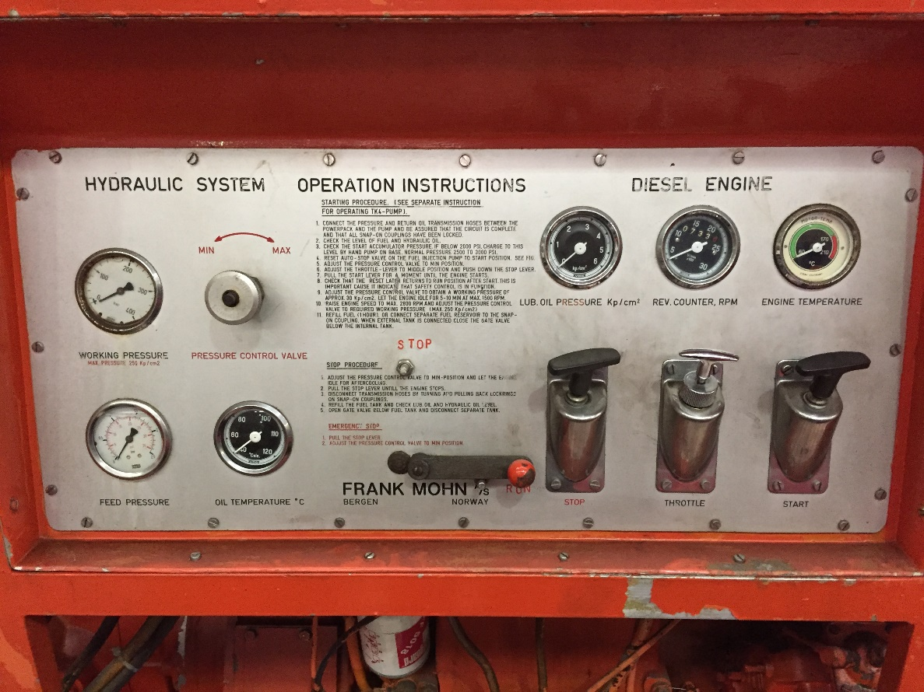
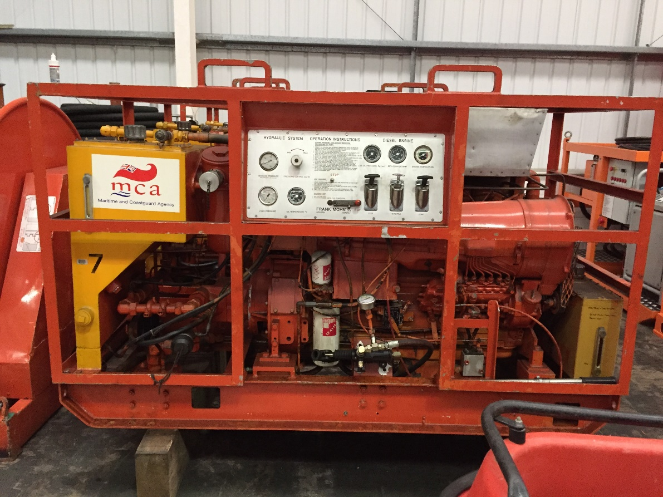

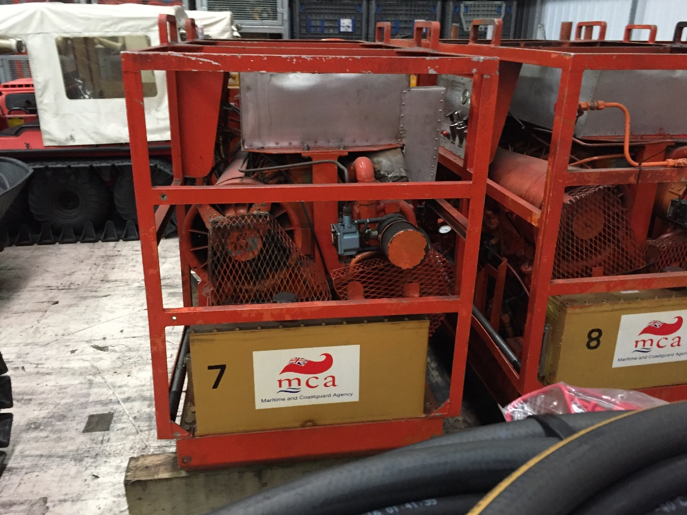

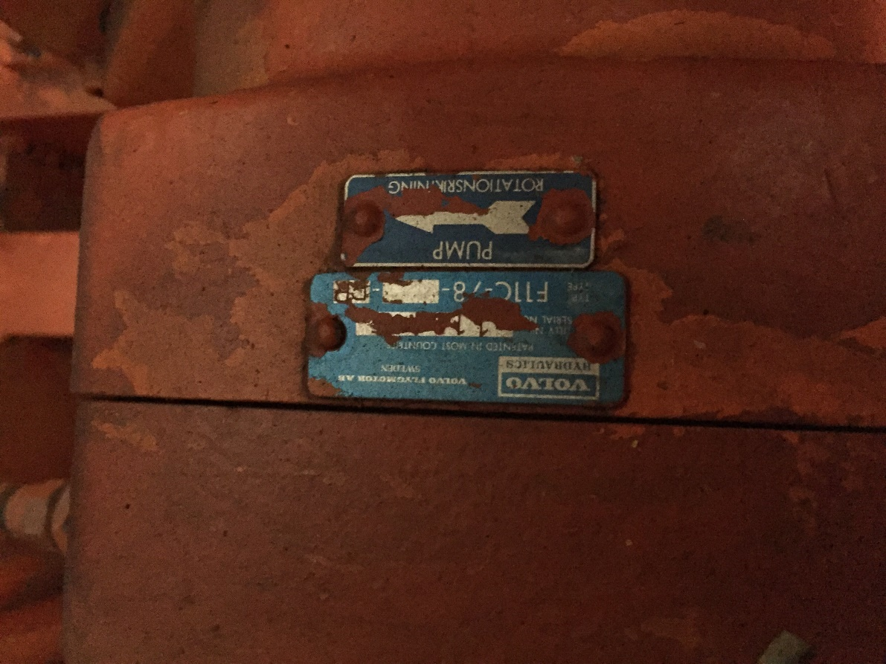

- Normally a system would need to start under no load, what valves do you have in your existing system?

A pressure control valve.

- Is the start for the engine only hydraulic start or can it be pneumatic start?

It could be any non-electric method (wind up spring motor). Air start would require a compressor and reservoir making the unit larger and if the reservoir was empty how would it be filled on remote site to enable start?

- Does the system sit at max pressure for long periods, to see if cooling is required, also do you have hot water available to give heating if used below zero?

Yes, the unit would be expected to be able to work for many hours at max pressure. It is likely to be used in very remote areas with few or no facilities.

- Are there space constraints?

The approximate size of the units is given in the specification.

- Are all controls to be local to the power pack? Yes.

- You mention a “Back up unit” is this full system, duty standby or partial components, if so please specify?

A picture of our back up units given, comprising hoses extra fluid and fuel. We would not require hoses as ours are new.

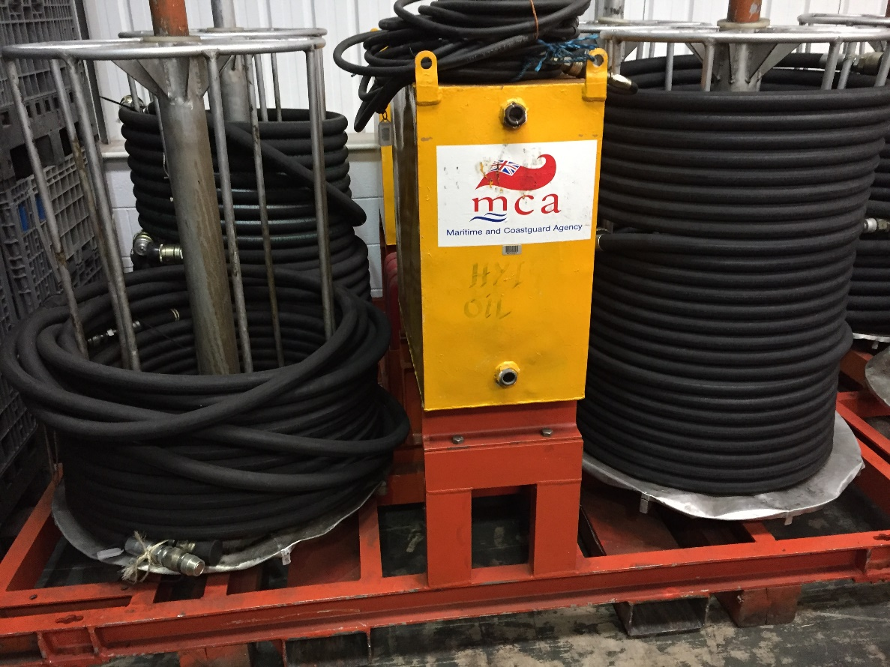

- What ISO class does the oil need to be for your system?

ISO 11158, HM / 6743-4, HM DIN 51524-2 specifications. Type 46.

- Do you have a filter cart to filter oil into power unit or do we need to incorporate extra filtration for this, if so how do you fill your power units now?

Please quote for supply.

- What oil grade and type are you using? TYPE 46.
- Is it likely to have water ingress to the oil from the system i.e. submersible (for our system to require water removal filters)?

Not required.

