London Borough of Lambeth
Roupell Park
Investigative Works and Re-commissioning of the Control System – Scope of Works
215781-00
Issue | 8 July 2015

This report takes into account the particular
instructions and requirements of our client.
It is not intended for and should not be relied
upon by any third party and no responsibility
is undertaken to any third party.

Job number215781-00
Ove Arup & Partners Ltd
13 Fitzroy Street
London
W1T 4BQ
United Kingdom
www.arup.com

Contents

Page
1 Introduction 1
1.1 Related documents 1
1.2 Contact details 1
2 Project History and Background 2
2.1 Project Participants 2
3 Scope of works 4
3.1 Energy Centre Control Philosophy 4
3.2 Summary of Work Packages 5
4 Health and Safety 9
4.1 CDM Statement 9
4.2 General Health & Safety 10
5 Project Documentation 11
6 Timeframe for response 13
7 Form of Response 14
7.1 Methodology 14
7.2 Capability 15
7.3 Competency and Capacity Questions 15
7.4 Pricing Schedule 15
7.5 Opting out of Response 16
8 Assessment Criteria 17
8.1 Quality Scoring Criteria 17
9 Completion Checklist 18

Appendices
Appendix A
References
A1 References

- Introduction
The Roupell Park Estate in Brixton comprises of 571 homes. The heating system for these dwellings is supplied from a communal energy centre containing 4no.1,175kW_{th} boilers and a 500kW_{e} CHP plant.
There have been issues in ensuring the successful operation of the control system for the CHP plant. This is due to a number of reasons detailed in Section 2: Project History and Background.
The London Borough of Lambeth is seeking a Controls Specialist to undertake investigatory and diagnostic works in the energy centre, remedial and re-commissioning works to the control system and provide an ongoing operation and optimisation role for the heating system.
As part of this procurement process, each responding Controls Specialist shall be invited to attend a site walk around prior to submitting their prices for the works. This shall provide an opportunity for them to see and assess the system and ask any questions about the background to the project.
The first stage of the work shall be to undertake a thorough investigatory and diagnostic assessment of the system before making recommendations for bringing the CHP plant into operation.
In their selection and implementation of their design, the successful Controls Specialist shall take on the design responsibility and ownership of the project.
It is important to note that Roupell Park will remain a live heating system throughout the duration of the project. The Controls Specialist shall ensure that means of providing heat to the residents is provided at all times.
  - Related documents
This document is the Energy Centre Controls Scope of Works.
The Energy Centre Controls Scope of Works shall be read in conjunction with all other relevant documents, including the O&M files for the existing system. These are included as attachments to the tender documents. The files contain drawings and plans of the plant.
The Energy Centre Control Scope of Works shall also be read in conjunction with all other relevant Contract Documents, including the Health and Safety Plan and Health and Safety File to cross reference key Health and Safety issues.
  - Contact details
Please direct any queries or requests with regard to this tender as directed in the Request for Quotation document.

- Project History and Background
The existing heating system at the Roupell Park Energy Centre supplies heat to 571 homes.
Heat is currently supplied from 4no.1,175kW_{th} boilers, which predated the 2007 CHP project.
In 2007, London Borough of Lambeth undertook the upgrading of the energy centre to install a 500kW_{e} CHP generation set with a newly designed condensing economiser.
This high efficiency condensing CHP plant design has been installed, however due to a number of setbacks, the system is not currently operational and requires to be re-commissioned including the existing PLC based control system.
This project aims to reconfigure the system to operate in normal (i.e. non-condensing) mode as a minimum (ideally condensing mode) ensuring the running of the CHP plant as the main heat source for the system, with back-up and top-up supply provided by the boilers.
The London Borough of Lambeth is seeking a Controls Specialist to take ownership of the control system in its entirety. This party shall undertake investigations into the current status of the installed control system before designing and installing their proposed solution.
  - Project Participants
    - Organisations
London Borough of Lambeth is the ‘Employer’
Lambeth Housing is the main client for these works and are the owner of the Energy Centre in Roupell Park.
Sir Frederick Snow and Partners Ltd. Is the ‘Project Manager’
Sir Frederick Snow and Partners Ltd. act as Project Managers for London Borough of Lambeth.
Arup
Arup have been appointed as the technical advisor for this project.
Orchard and Partners Ltd.
Orchard and Partners Ltd. undertook the original design of the system including the condensing economiser arrangement.
Their involvement with the project has since ceased and it is not anticipated that they shall be involved with future works.
ENER-G
The CHP generation was manufactured and installed by ENER-G.
PMC Controls
The former Controls Specialists, PMC Controls undertook the design and installation of the original control system for ENER-G.
Their involvement with the project has since ceased and it is not anticipated that they shall be involved with future works.
    - CDM Roles and Responsibilities
Client: London Borough of Lambeth
Principal Designer: Controls Specialist -the ‘Contractor’
Principal Contractor: Controls Specialist -the ‘Contractor’

- Scope of works
  - Energy Centre Control Philosophy
    - General
An existing PLC control system was installed in 2007 as part of the CHP plant installation project but is believed not to have been operational for some time.
The successful Controls Specialist shall establish an operating strategy for the engine based on the principles set out in this section of the document. This shall include but not limited to the following:
- Control and monitoring of the existing CHP plant and the roof mounted dry air cooler;
- Control and monitoring of the existing gas fired boilers;
- Control and monitoring of the existing primary and secondary LTHW circulation pumps;
- Control of the existing gas valve and its associated safety interlocks.
The CHP plant is to be the lead heat source for the heating system with the boilers being enabled to maintain the required LTHW temperature set points either on demand or when the CHP plant is not available. It is anticipated that the CHP plant will operate in heat follow mode, with electricity being exported to the UKPN network.
Boilers shall be called into operation in a progressive cascade when the heat supplied by the CHP plant is not sufficient to provide a flow temperature of 80ºC.
There is an existing condensing economiser connected to the flue extraction from the CHP plant. If it is established during WP1 (investigatory and diagnostic works) that it may be possible to re-commission the condensing economiser, this should be pursued as a secondary objective to the running of the CHP plant in order to maximise the efficiency of the system.
    - CHP Operation and Electricity Export Arrangements
The Controls Specialist should assume that an export arrangement shall be in place to allow electricity to be sold to the grid.
There is no private wire network on site. There is no current intention to establish a private wire network.
The CHP engine shall be operated to maximise the economic benefit to Lambeth Housing. This may include the CHP running through TRIAD periods as a priority (rejecting heat produced by the CHP plant to atmosphere if necessary).
    - Pumping and system operation temperatures
The heating flow temperature is to be the same as that currently provided by the gas boilers currently believed to be 80ºC. This is to be confirmed during WP1 of this scope of works.
    - Controllers
This control philosophy may be established and implemented by a PID control loop which shall use the existing Siemens S7 400 PLC equipment in the energy centre.
Alternatively the Controls Specialist may opt to install a new system in their proposal (see WP2 in section 3.2.3 below).
  - Summary of Work Packages
Prior to the commencement of the contract, each of the bidders shall be invited to attend a site visit which shall consist of a walk round of the energy centre and discussion about the project.
There are three elements of these works:
- Investigatory and diagnostic works (WP1)
- Remedial works to the control system (WP2)
- Ongoing operation and optimisation of the system (WP3)
    - WP1: Investigatory and diagnostic works
The Controls Specialist shall undertake the necessary investigatory and diagnostic works to confirm the modifications required to ensure the operation of the CHP engine in normal (non-condensing) mode.
This review is anticipated to comprise of time spent on site reviewing the installed plant and available documentation which will be provided to the Controls Specialist.
Following the completion of WP1, the successful Controls Specialist shall become the designer of the system for the project going forwards.
The works contained in the Investigatory and Diagnostic Work Package are:
- Review the installed plant;
- Produce a report detailing the issues with the control of CHP engine and the system operation;
- Produce a proposal for the remedial works required in the energy centre.
    - WP2: Remedial works to the control system
Following the completion of the investigatory and diagnostic works, the Controls Specialist shall then undertake the design and implementation of the required remedial works to re-commission and operate the control system for the energy centre.
An operator’s station shall be provided in the mezzanine level of the Energy Centre which shall include a desk, chair and PC which shall act as the head end for the controls system. This shall be supplied with all necessary software and licences for the selected control system.
It is anticipated that there are two options available to proceed with this work package. Controls Specialists are invited to submit proposals for their preferred approach based on their experience and knowledge following the site visit.
It is important to note that Roupell Park will remain a live heating system throughout the duration of the project. The Controls Specialist shall ensure that means of providing heat to the residents is provided at all times.
      - Option 1: Remedial work to existing control system
This approach shall require the Controls Specialist to adapt and re-commission the existing Siemens S7 PLC to provide the necessary control requirements.
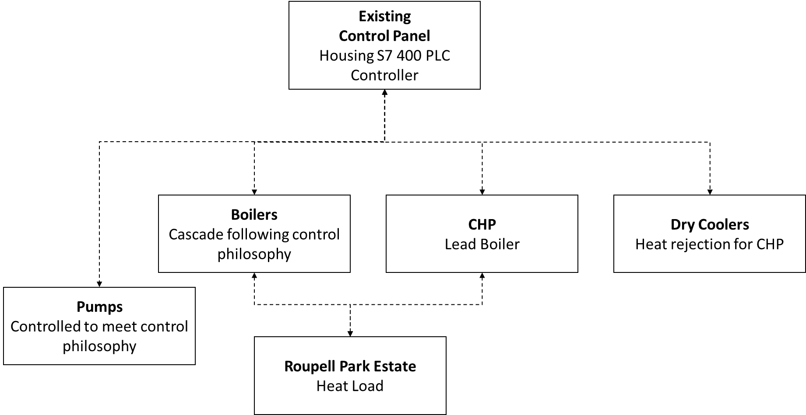
Figure 1: Control System Topography (Option 1)
The Controls Specialist shall be required to assess during the site visit and WP1 which option is best suited for their proposal, and whether there is value in retaining the existing control infrastructure.
The existing control infrastructure is understood to be functioning, but this shall need to be clarified by the Controls Specialist after completion of WP1. The Controls Specialist shall adopt and modify the system to meet the needs of this scope.
O & M manuals shall be produced for the system as reconfigured and re-commissioned.
      - Option 2: Installation of new control system
This approach shall require the removal and replacement of the existing control equipment.
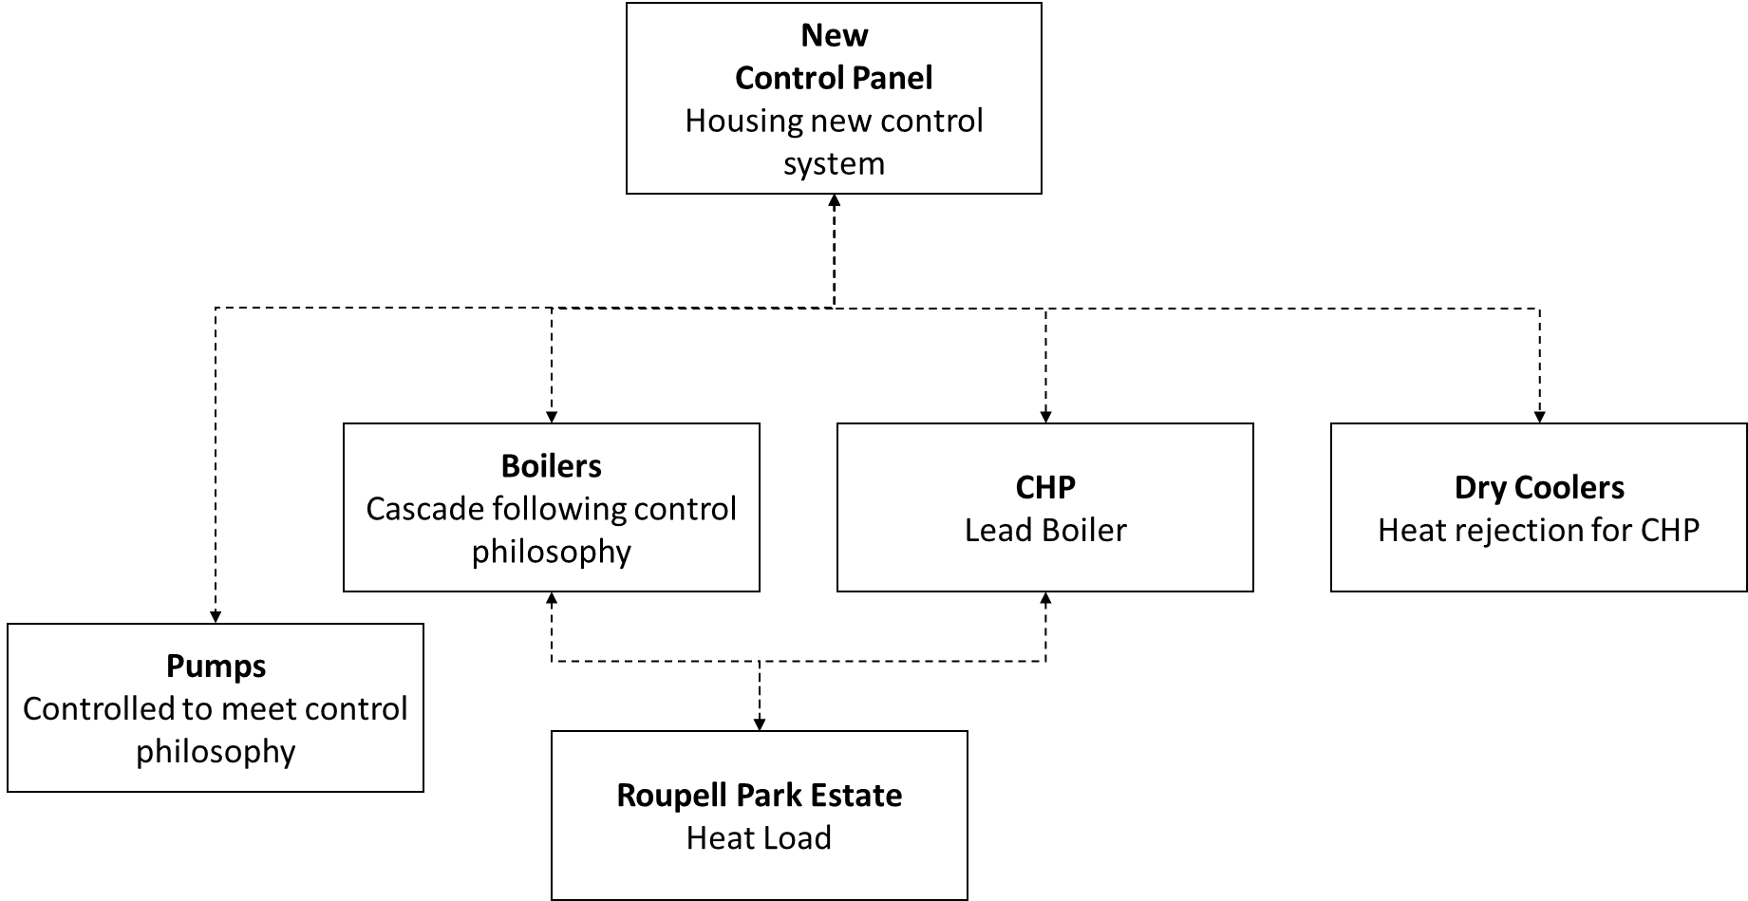
Figure 2: Control System Topography (Option 2)
The tenderer may opt to remove the existing control infrastructure and install a new system of their own design.
Under this option, the Controls Specialist shall be required to supply and install all necessary controls equipment, including panels, wiring, controllers and head end to meet the needs of this scope.
O & M manuals shall be produced for the system as reinstalled and commissioned.
    - WP3:Ongoing operation and optimisation of the system
The Controls Specialist shall be responsible for the ongoing operation, optimisation and maintenance of the controls system. This role shall include ensuring the controls system allows the continuing operation of the engine including supply of heat to the residents of the Roupell Park Estate and sale of electricity to the grid.
The works contained in the on-going operation and optimisation of system Work Package are:
- Training of Lambeth Housing’s operational staff (this service is provided by T. Brown). Two working days should be allowed for this task.
- Ongoing support to incumbent maintenance contractor (currently T. Brown). The quantity of time required will be clarified once WP1 has been completed, and more is known about the system.
- Provision of a Warranty for the system and the provision of maintenance at agreed rates.
    - Target Performance requirements
CHP plant runtime
Once operational, the runtime of the CHP plant shall be maximised in order to provide the base heat requirements for the estate.
Following the completion of WP1, the Employer shall work with the Controls Specialist and the original equipment manufacturers (if required) to establish a target and minimum runtime, informed by the selected control strategy.
This shall form a control system performance guarantee for the completed system.
System efficiencies
Following the completion of WP1, the Client shall work with the Controls Specialist and the original equipment manufacturers (if required) to establish a minimum system efficiency, informed by the selected control strategy.
This shall form a control system performance guarantee for the completed system.

- Health and Safety
  - CDM Statement
The project will be run in accordance with the CDM Regulations 2015.
    - General
All parties involved in this project shall comply with their duties under CDM and provide relevant and significant information for the compilation of the Health and Safety File to the Principal Designer.
    - Co-ordination & Co-operation
Any party undertaking the role of a designer and carrying out designs shall fully comply with Part 3 of the 2015 CDM regulations and co-ordinate with other designers e.g. where they interface and co-operate with the Principal Designer.
    - Structure Of Health & Safety File
This should be identified by the Principal Designer or follow the structure as laid out in the CDM Regulations.
    - Delivery Of Residual Risk Information
All residual risk informationto be included in the Health and Safety File should reach the Principal Designer at least 2 weeks before practical completion unless specified otherwise by the Principal Designer. Any requirements on the format and content of the information should be identified by the Principal Designer, or specified by the Appointed Person. One format should be used.
Where necessary, links to other key documents and drawings should be provided in the residual risk information, provided they are easily accessible, to avoid unnecessary duplication.
All submissions should be succinct and provide useful and valuable information to the end users.
    - Current Health & Safety Issues That Need Particular Attention In Residual Risk Information
Any parties submitting residual risk information should note that particular national emphasis is being placed on managing the following risks:
- Musculoskeletal risks from manual handling
- Health risks associated with use of solvents
- Falls from height
- Falling materials and objects
- Risks associated with electricity
- Movement of vehicles and replacement of plant
- Risks from fire
- Interfaces with members of the public
This list is not conclusive and should be borne in mind during the consideration of more general risks associated with the project.
  - General Health & Safety
    - Regulations & Standards
All parties should adhere to the following Health and Safety Regulations and Standards (which is not conclusive), or their updated versions should they exist:
- Electricity at Work Regulations 1989
- Construction (Design and Management) Regulations 2015
- Construction (Health, Safety and Welfare) regulations 1996
- The Management of Health and Safety at Work Regulations 1999
- Provision and Use of Work Equipment Regulations 1998
- Lifting Operations and Lifting Equipment Regulations 1999
- Health and Safety at WorkAct 1974
    - Risks Prior To And During Installation
Prior to, and during installation, parties undertaking work that involves significant risk shall be expected to have produced site specific risk assessments to demonstrate how risks shall be controlled to a tolerable level. In addition, parties should be fully prepared to write and implement safety method statements detailing how their risk assessments shall be implemented, responsibilities, relevant standards, specific training (if required) etc.

- Project Documentation
The project documentation forms a major part of the contract and consequently only the most professionally prepared and well-presented documentation shall be accepted.
Documentation shall consist of three volumes of which 3 copies of each shall be submitted.
The documentation shall be provided in disc format (CD/DVD) with a hyperlinked index for each volume. Documentation shall be provided in both PDF format and the original format e.g. .docx, .dwg, .xls.
Documentation shall only be provided in paper form if specifically requested.
The three volumes are:
- Energy Centre Controls Project Documentation
- Energy Centre Controls Operator's Manual
- Energy Centre Controls Programmer's Manual
The Energy Centre Controls Project Documentation volume shall be job specific and therefore is the most important volume of documentation. The following details the sections which must be included in this part of the documentation.
- Index (per volume and per disc) - Hyperlinks shall be provided to each document and all document’s drawings and drawings shall be provided with plain English descriptions as well as any drawing or document reference number e.g. LTHW Schematic 1 of 3 M-003-01.
- Schematic Diagrams - This section includes schematic diagrams of the BMS network complete with system numbering and controller locations. It provides an understanding of the network architecture. Also included in this section is a plan view (and elevation view, if required) of the site which combine to give a reader a quick understanding of the site’s/building’s layout.
- Functional Description - This section describes in detail, the program and hard-wired control sequences associated with the systems. It shall reflect any changes made during the Contract. It shall be written in an easy to understand format and include the following:
- Set points values, time schedules etc.
- Mnemonic tag references as detailed in the Specification schedules
- Input/output point addresses
- Software addresses where appropriate e.g. calculation points, global points, etc.
- Detail of required operator action in acknowledging and resetting alarms, etc.
- Input/Output Listings - A complete list of all controls inputs and outputs including device type connected, location, point number and terminal numbers shall be provided in this section.
- Strategy Diagrams/Program Listing - Strategy diagrams or a program listing shall be provided, dependent on the manufacturer's standard software production method, for each controller and unitary controller. The program listing shall include English language descriptions of how the routines work. Both methods shall include the values of all set points, proportional bands, integral reset times, timers etc.
- Configuration Data - This section shall include a list of all English language point and alarm descriptors and other relevant information.
- Maintenance Instructions - This section shall include any specific items of maintenance which are necessary to ensure the safe and reliable operation of the control system, the plant it controls and the control panels.
- Data Sheets - A data sheet for each item of equipment in the control system and in the CEs/MCCs shall be supplied, including all field devices.
- Drawings - A complete set of drawings for the whole CHP plant system shall be supplied, note: liaising with the original equipment manufacturer may be required. Drawings as a minimum shall include the following:
- Schematic diagrams of all systems, detailing the locations of each item of plant in the system and the control actuators and sensors, complete with cross-reference point and item numbers.
- Control panel layouts and label details
- Equipment schedules (including all control panels and field equipment)
- Control panel wiring diagrams
- Field wiring diagrams
If a deviation to the above is required it must first be agreed with the Project Manager. However, any such deviation would be in format or presentation only. All information described above must be included.

- Timeframe for response
For details of the intended project timeframe, please see the Request for Quotation document.

- Form of Response
The Controls Specialists are requested to complete the following section, which shall be used to assess the technical proposal.
  - Methodology
    - WP1: Investigatory and diagnostic works
In no more than 1,000 words, please set out your proposal for undertaking WP1: Investigatory and diagnostic works:
Proposal for WP1
[insert text here]

    - WP2: Remedial works to control system
In no more than 1,000 words, please set out your proposal for undertaking WP2: Remedial works to control system.
Please provide as much detail as possible around the principles being proposed, given that more detail shall only be known following the completion of WP1.
Proposal for WP2
[insert text here]

    - WP3: Ongoing operation and optimisation of system
In no more than 1,000 words, please set out your proposal for the provision of services under WP3: Ongoing operation and optimisation of system.
Please provide as much detail as possible around the principles being proposed, given that more detail shall only be known following the completion of WP1.
Proposal for WP3
[insert text here]

  - Capability
    - Staff
Please provide details of the staff proposed to undertake each work package below and include a brief CV for each key member of the team with your response.
In the field below, please describe in less than 1,000 words how the project will be resourced buy members of the team.
Resourcing
[insert text here]

    - Previous Experience
In no more than 3,000 words, please set out your relevant past experience which demonstrates your capabilities in this area.
Past Experience
[insert text here]

  - Competency and Capacity Questions
Please see the Request for Quotation document for competency and capacity questions.
  - Pricing Schedule
The Controls Specialists are required to return tenders showing the breakdown of pricing as shown in Table 1 below.
Table 1: Required Breakdown of Pricing
Element of Works | Pricing Guidance | Fixed Price (exc. VAT)
Investigatory and diagnostic works (WP1) | Please provide a fixed price for WP1
Remedial works to control system (WP2) | Please provide a fixed price for WP2
Ongoing operation and optimisation of system (WP3) | Please provide a fixed annual price estimate for the maintenance service as described in your response to WP3 above.
Please also provide a schedule of rates for additional works in Table 2 below.
Table 2: Schedule of rates for additional services
Staff Name | Grade/Level | Specialism | Hourly Rate
 |  |  | £/h
Add more rows as necessary | Add more rows as necessary | Add more rows as necessary | Add more rows as necessary
  - Opting out of Response
In the event that you would not, for any reason, opt to return a price for undertaking the work, please indicate below, including a note regarding your reasons.
[insert text here]

- Assessment Criteria
The responses submitted will be assessed on the following basis
Table 2: Assessment Weighting
Element of Works | Weighting
Quality of technical proposal | 65%
Price | 35%
  - Quality Scoring Criteria
Table 3: Quality Scoring Criteria
Element of Works | Details | Weighting
Methodology  WP1  WP2  WP3 | Overall scope is clear and comprehensive.  Gives the Council confidence that the Controls Specialist will deliver a successful resolution to the project, ensuring the efficient operation of the CHP engine. | 40%
Quality of Staff | CVs will be assessed to ensure the persons presented are of sufficient technical capability. | 12%
Relevant experience | Description of past experience demonstrates capability to deliver required services. | 13%

- Completion Checklist
The Controls Specialists are asked to check that they have included the following in their response
Element of response | Complete?
Answers to questions in Section 7
Completed Pricing Schedule
CVs requested for key staff undertaking the works

References

  - References
Should more recent versions of these references exist, the newer version should be used.
Standard | Title | Year
BS 6231 | Specification For PVC-Insulated Cables For Switchgear And Controlgear Wiring. | 2006
BS 7671 | Requirements For Electrical Installations. | 2001
BS EN 60044-1 | Instrument Transformers – Part 1: Current Transformers. | 1999
BS EN 60073 | Basic And Safety Principles For Man-Machine Interface, Marking And Identification – Coding Principles For Indicators And Actuators. | 2002
BS EN 60269-1 | Low-Voltage Fuses – Part 1: General Requirements. | 1999
BS EN 60269-2 | Low-Voltage Fuses – Part 2: Supplementary Requirements For Fuses For Use By Authorized Persons (Fuses Mainly For Industrial Application). | 1995
BS EN 60439-1 | Low-Voltage Switchgear And Controlgear Assemblies – Type-Tested And Partially Type-Tested Assemblies. | 1999
BS EN 60529 | Degrees Of Protection Provided By Enclosures (IP Code). | 2001
BS EN 60534 | Industrial Process Control Valves.
BS EN 60898-1 | Circuit-Breakers For Overcurrent Protection For Household And Similar Installations – Circuit-Breakers For A.C. Operation | 2003
BS EN 60898-2 | Circuit-Breakers For Overcurrent Protection For Household And Similar Installations – Part 2: Circuit-Breakers For A.C. And D.C. Operation | 2001
BS EN 60947-1 | Low-Voltage Switchgear And Controlgear – Part 1: General Rules. | 2004
BS EN 60947-2 | Low-Voltage Switchgear And Controlgear – Part 2: Circuit-Breakers. | 2003
BS EN 60947-3 | Low-Voltage Switchgear And Controlgear – Switches, Dis-connectors, Switch-Dis-connectors And Fuse-Combination Units. | 1999
BS EN 60947-4.1 | Low-Voltage Switchgear And Controlgear – Part 4.1: Contactors And Motor-Starters – Electromechanical Contactors And Motor-Starters. | 2001
VDI/VDE 2173 | Fluidic Characteristic Quantities Of Control Valves And Their Determination | 2007

