Service Specification

Service Specification No.
Service | Tier 3 Weight Management Service
Commissioner Lead | Sharon Hemley
Provider Lead | TBC
Period | TBC
Date of Review

Service summary
A multicomponent, multidisciplinary Tier 3 weight management service for CYP (Children, Young People) over the 99.6 centile in weight and / or from a high-risk group. High risk groups are those: from deprived areas, who have a disability, belong to specific ethnic groups. This offer will be tailored to the needs of each individual CYP and will assess their needs in the context of their lives and families. The service will work from the community in settings acceptable to CYP and their families.

Population Needs

National context and evidence base
Obesity continues to be a major public health challenge in England with significant impacts on both adults and children. Evidence suggests that excess body weight increases the risk of a range of chronic diseases including type 2 diabetes, cardiovascular disease, many cancers, liver diseases and mental health conditions.. Overweight and obesity is a key risk factor for long term conditions such as Type 2 diabetes and there are increasing numbers of children with Type 2 diabetes. It is predicted that around 55% of obese children go on to be obese in adolescence, around 80% of obese adolescents will still be obese in adulthood and around 70% will be obese over age 30.

The obesity crisis has been brought to the fore during the COVID-19 pandemic, following emerging evidence linking obesity and COVID-19 to serious complications, hospitalisation, and mortality from COVID-19.

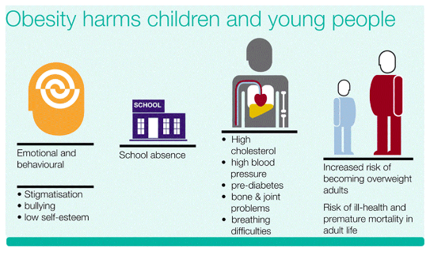
Source: Childhood obesity: applying All Our Health - GOV.UK (www.gov.uk)

Childhood obesity which continues into adulthood has long term cost implications for the NHS and the wider economy. Obesity costs the NHS £6 billion annually, a figure which is expected to rise to over £9.7 billion each year by 2050.

The National Child Measurement Programme (NCMP) measures the height and weight of children in Reception class (aged 4 to 5) and year 6 (aged 10 to 11). Obesity rates in both reception-aged and year 6 school children increased by around 4.5 percentage points between 2019-20 and 2020-21, this is the highest annual rise since the NCMP began in 2006/07, the previous highest rise was less than 1 percentage point.
In London (2021 to 2022), childhood obesity has remained persistently high with 21.9% of Reception children (aged 4-5 years), compared to 22.3% nationally and 40.5% in Year 6 (aged 10-11 years) are overweight or obese, compared to 37.8% nationally, respectively. Forecasts using the NCMP data highlight that child overweight and obesity at reception might rise by 25% by 2040 and for Year 6 pupils it is expected to rise to over 40%.

There are significant inequalities in overweight and obesity in England. The prevalence of obesity for children in the most deprived areas in both age groups continues to be more than double that of those in the least deprived areas. Severe obesity prevalence is around three times higher for Reception children from the most deprived areas and around four times higher in Year 6.

Obesity prevalence also continues to vary by ethnic group in England. As in previous years, obesity prevalence is highest in children of Black ethnicity at 16.2% in Reception and 33.0% in Year 6. It is lowest in children of Chinese ethnicity in both Reception and Year 6 (4.5% and 17.7% respectively).

Local context and evidence base
In the 2021/2022 around 1 in 5 children (22.0%) of Reception aged children and 2 in 5 (41.9%) of Year 6 aged children in Croydon were classified as overweight including obesity.
Prevalence of excess weight by age, 2021/22
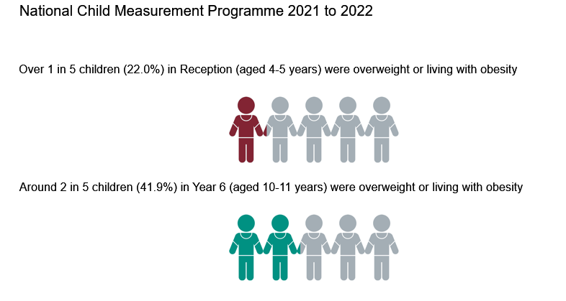
Prevalence of Obesity in Croydon
The prevalence of obesity for Reception aged children in Croydon when compared to its statistical neighbours is similar, whereas the prevalence of obesity in Year 6 children is worse.
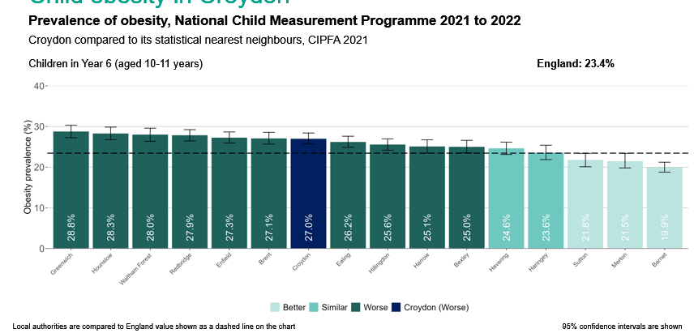
Source: Obesity Profile - Data - OHID (Office for Health Improvement and Disparities) (phe.org.uk)
There are inequalities in childhood obesity associated with area, deprivation, and ethnic group. Croydon NCMP data highlights that the prevalence of obesity is highest for children of Black ethnicity at 14% in Reception and 30.4% in Year 6.
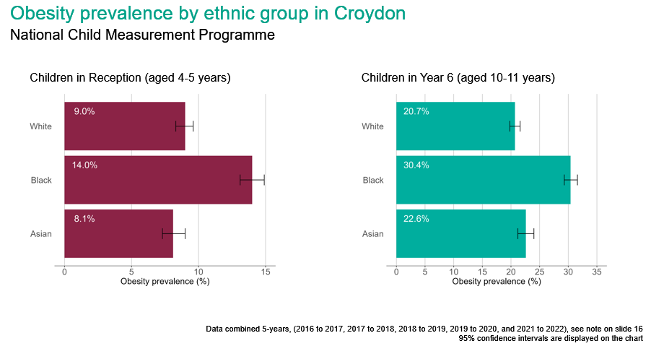
Source: Obesity Profile - Data - OHID (phe.org.uk)
When you consider obesity by deprivation and age, 28.4% of Year 6 aged children living in the most deprived areas were living with obesity compared to 15.7% living in the least derived areas.
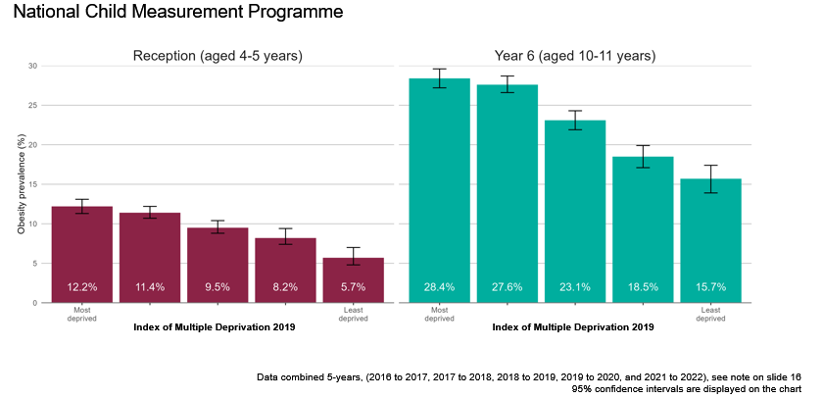
Source: Obesity Profile - Data - OHID (phe.org.uk)
Children living with obesity also varies by where they live in Croydon. Children living with obesity is less prevalent in the South of the borough compared to the North.
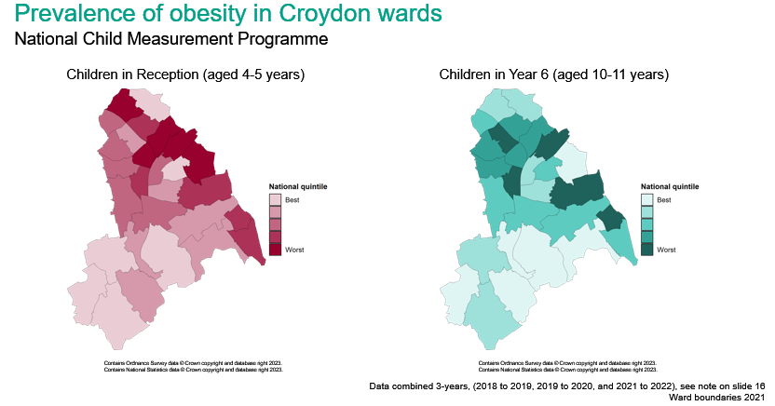
Source: Obesity Profile - Data - OHID (phe.org.uk)

Evaluation and outcomes
- An evaluation framework should be in place from the start of the service; a recent update by NICE identified gaps in the evidence base
- A cost effectiveness evaluation should be undertaken as this is a gap in the evidence base.
- A range of process and outcome measures will be used to assess the success of the programme. These will be captured through conversations with children and families, feedback forms, results of the school health survey, referrals information and service documentation of assessments and progress report.
- The service will collect protected characteristic data to ensure monitoring use of the service by at risk groups. These will be collected at the referral stage.
- Primary outcome measures will be collected at baseline, completion of the programme and 6 months post programme
- Session data will also be recorded e.g., time, location, length of session and type and delivery of session to inform the evaluation.
- There is a lack of evidence in relation to facilitators and barriers for participating in lifestyle weight management programmes; consequently, this will be collected as part of the evaluation thus informing the future evidence base.

3.1 NHS Outcomes Framework Domains & Indicators

Domain 1 | Preventing people from dying prematurely
Domain 2 | Enhancing quality of life for people with long-term conditions
Domain 3 | Helping people to recover from episodes of ill-health or following injury
Domain 4 | Ensuring people have a positive experience of care
Domain 5 | Treating and caring for people in safe environment and protecting them from avoidable harm

Public Health Outcomes Framework

Domain A | Life expectancy at birth (males and females)  Reduced differences in life expectancy and healthy life expectancy between communities
Domain B | Pupil Absence
Domain C | Year 6 prevalence of overweight (including obesity)
Domain C | Percentage of physically active children and young people

Child BMI (Body Mass Index) classification definitions for population monitoring

For population monitoring purposes body mass index (BMI) is classified according to the following image using the British 1990 growth reference.

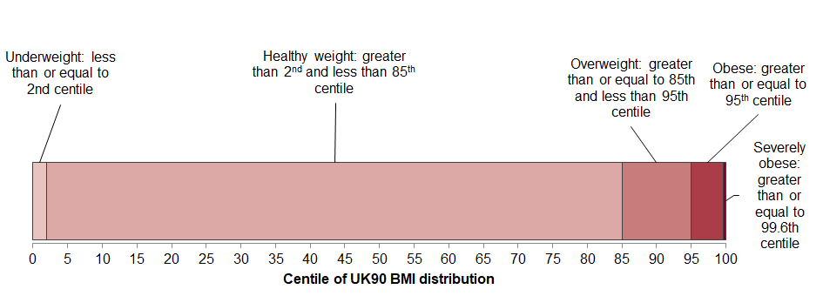

Classifying overweight, obesity and central adiposity in children and young people
Define the degree of overweight or obesity in children and young people using the following classifications:

- overweight: BMI 91st centile + 1.34 standard deviations (SDs)
- clinical obesity: BMI 98th centile + 2.05 SDs
- severe obesity: BMI 99.6th centile + 2.68 SDs.

4. Aims, objectives and eligibility criteria of the service

4.1 Aims
- To reduce the risk of children and young people developing long term conditions such as diabetes, mental health issues because of obesity.
- To reduce the inequalities associated with obesity.

4.2 Objectives

- Establish a multi component Tier 3 service for obese children and young people (ages 4 to 17/18 or 16 as a 2 year programme and 25 for SEND (Special Educational Needs and Disability)) for targeted and high risk groups, including black children and children with learning disabilities and autism.
- To offer tailored support to children, young and their families which recognises the complex factors underpinning obesity.
- To support children and young people who are obese to achieve a healthy weight through a range of interventions including psychological approaches, dietetic support, and exercise.
- Provide a service that is acceptable to children and young people of different ages, culture, ethnic groups, sex, gender, health status.
- Co-design the service and individual packages with children, young people, and their families.
- Ensure the Tier 3 service is embedded in all care pathways and is linked with the widest possible range of community support options.
- Use a range of evaluation methods to demonstrate the effectiveness of the intervention.
- To deliver interventions that achieve improvements in physical activity levels, dietary behaviours, and quality of life/emotional wellbeing.
- To deliver interventions that address participants’ presenting needs and enable them to develop coping strategies and make behavioural changes to have a sustained or reduced BMI centile.
- To be a specialist resource for other health professionals including schools regarding obesity management in conjunction with local expertise

4.3 Eligibility Criteria
This service will target children and young people aged 4 to 17 and 25 for SEND with severe and complex obesity who represent the most at-risk group from the wider obese population for whom cost of health care is the highest and inequalities experienced the greatest.

The vulnerable populations for this service are those with higher rates and risk of obesity and the development of obesity related long term conditions. This includes Children and young people:

- Living in deprived areas
- From Black ethnic groups
- With learning disabilities and autism

Inclusion criteria
- Aged 4 to 17, 25 with SEND
- Registered with a GP (General Practice) in Croydon or Croydon resident
- 99.6 centile and above
- 98 centile and above for high risk CYP population groups for obesity
- 91 centile and above for CYP with disabilities
- Children and young people with physical and mental health complications due to their weight

Exclusion criteria
- Pregnancy
- Diagnosis of active eating disorder, including binge eating disorder
- Disengaged family and/or an untreated significant mental health problem.

4.4 Service delivery expectations
The service is expected to deliver across the following areas.

Working with partners
- The main provider is not expected to have all the required staff in its organisation. The main provider is expected to work with partner organisations such as Croydon Health Services, SLAM (South London and Maudsley), St. Georges for the provision of the clinical and psychological aspects of the service.
- The main provider is expected to work with partner organisations to ensure provision of learning disability and neurodiversity friendly programme of services to achieve the outcomes, aims and objectives as set out above.

Service mobilisation
- The provider is expected to work with the service advisory panel and residents during the mobilisation period to ensure the service meets local needs.
- Work with services across the partnership particularly SEND and high-risk groups to promote the service, using a range of approaches to reach the different target populations.

Reach
- Funding for the service is anticipated to reach between 250 and 300 CYP per year. However, recognising the complexity of need prevalent in the target cohort, the provider is expected to demonstrate how they will reach the highest number of recipients and attrition rates for sustaining impact or healthy behaviours.
- Use multiple strategies and opportunities to reach children and families in the at risk groups.
- Build up relationships with other services providing activities for CYP – physical activity, mentoring, to encourage referrals and link CYP into options that will help sustain their behaviour change.

Co-production
- All aspects of the service, overall and individual to be co-produced with the children, young people, their families and with the specific targeted population groups.
- Co-production will be required throughout the two years and as part of the evaluation.

Inequalities
- The service is funded through inequalities funding and the provider will be required to have systems in place (e.g. how to collect protected characteristics of attendees) to demonstrate how it is reaching the targeted groups and how the intervention is reducing or will reduce inequalities.

Service location
- Service delivery is expected to be in locations that families and young people find accessible and appropriate.
- Service delivery should be adapted to meet the needs of the children and young people and their families.

Referral pathways, assessment, and programme

Referral pathways and assessment
- Establish effective referral pathways including self-referral and monitor pathways for effectiveness and reach
- Demonstrate assessment conversation with CYP and their parents/carers are holistic and culturally sensitive

Programme Outline

- Provide a phased programme approach with personalised care packages for each CYP
- Programme to include access to digital resources and support for both CYP and their parents/carers.

Exit planning
- Demonstrate effective exit planning with the CYP with access to ongoing support.
- Ensure arrangements for transitional care for children and young people who are moving from paediatric to adult services.

Data collection and evaluation
- Robust data collection and evaluation of intervention effectiveness are a key deliverable of the programme.

Safeguarding
The provider will provide appropriate and effective safeguarding services for both adults and children and will be expected to adhere to relevant national and local requirements and guidance and implement them wherever necessary.
The Provider must comply with the requirements and principles in relation to the safeguarding of children and young people set out or referred to in:
- The Children and Families Act 2014 Act and associated Guidance
- The Children Act 1989 and the Children Act 2004 and associated Guidance

The Mental Capacity Act (2005) applies to everyone involved in the care, treatment and support of people aged 16 and over who are unable to make all or some decisions for themselves. The Mental Capacity Act (MCA) is designed to protect and restore power to those vulnerable people who lack capacity. The provider must ensure compliance with the MCA and Deprivation of Liberty safeguards (DoLS) as well as patients detained under the Mental Health Act (1983)

The safeguarding team’s functions include but are not limited to: -
- Develop systems and processes that will enable the organisation to fulfil its statutory safeguarding functions under all the relevant legislation:
- Care Act (2014)
- Mental Capacity Act (2005)
- PREVENT Duty (2015)
- Organisational management of domestic abuse
- Contribute to all statutory processes within Adult Safeguarding

Overall outcomes: Overall outcome: CYB and Adults will be protected from abuse/harm and remain healthy as well as enjoying a good quality of life.

The provider must have safeguarding policies and procedures that have been developed with reference to relevant legislation, national and best practice guidance.

The provider will meet the requirements of the Croydon Safeguarding Children Partnership (CSCP) and the Safeguarding adult Board (SAB).

4.6 Team staffing
The provider will establish a multidisciplinary staff team that meets best practice to deliver a CYP Tier 3 service weight management service in accordance with NICE guidance. The MDT is expected to have the relevant qualifications, experience and knowledge of both pediatrics, child development, clinical psychology, family therapy as relevant to their role and responsibility.

All staff will be expected to have awareness of neurodiversity and learning disabilities, be culturally sensitive and trauma practice informed.

4.7 Service location and delivery
The provider should ensure that:
- The service is delivered in locations acceptable to CYP and their families.
- The service is delivered in locations suitable for individual and group face-to-face activities including disability access for all.

4.8 Minimum data set
The proposed data set is included in appendix 1. The data set included a mix of quantitative and qualitative measures. The purpose of the data set is to:
- Monitor progress made by individual participants, this may include family members.
- Report on uptake of the service by protected characteristics and the high risk population groups.
- Report on the quarterly KPIs.
- Support evaluation of the service and contribute to the national evidence base.

4.9 Reporting
The following items are expected to be reported on monthly.
- Number of CYP attending.
- Physiological measurements.
- Psychological measurements.
- Behavioural measurements.

4.90 Data security
- NHS secure email

5. Applicable Service Standards
5.1 Applicable national standards

The service shall be delivered in accordance with:

- Clinical Commissioning Policy: Complex and Specialised Obesity Surgery (NHS England, 2013)
- Commissioning guide: Weight assessment and management clinics (tier 3) (British Obesity and Metabolic Surgery Society, March 2014)
- Guidance on behaviour change at population, community, and individual level (NICE PH Guidance 006, 2007)
- Obesity: Guidance on the prevention, identification, assessment, and management of overweight and obesity in adults & children (NICE Guidance 43, Dec 06)
- Weight management: lifestyle services for overweight or obese children and young people (NICE PH47, October 2013)
- Obesity: identification, assessment and management (NICE Guidance CG189, September 2022)
- Standard Evaluation Framework for Weight Management Interventions (National Obesity Observatory, 2009)
- Obesity - working with local communities (NICE PH Guidance 42, Nov 12)
- Department of Health (DH) ‘Healthy Lives Healthy People - a call to action on Obesity in England’ (DH , 2011)
- Tackling Obesity: Future Choices (Foresight 2007)
- National Obesity Forum Obesity Guidelines and Toolkit
http://www.nationalobesityforum.org.uk/index.php/healthcare-professionals.html
- Scottish Intercollegiate Guidelines Network (SIGN), ‘Management of Obesity. A national clinical guideline’ (Clinical Guideline 115, 2010)

6. Applicable quality requirements
TBC

7. Location of Provider Premises
The Provider’s Premises are located at: TBC

8. Individual Service User Placement

  - Key performance Indicators

KPI | TARGET
Number (%) of participants enrolled in the service who, as a baseline, meet eligibility criteria as defined in the Service Specification. | 100%
Number (%) of participants enrolled in the service are from identified high risk groups | Xx%
Number (%) of participants who complete the active intervention. | xx%
Number (%) of participants who are completers achieving a healthy BMI, maintained BMI or reduced BMI. | To be established
Number (%) of completers who provide a height and weight measure at 6 months. | Xx% 35% ??
Number (%) of completers who provide a height and weight measure at 12 months. | Xx% 20%
Number (%) participants and families who are invited to provide feedback at the end of the active intervention. | 100%
Number (%) of enrolled participants provide feedback | At least xx
Number (%) of participants, parents satisfied or very satisfied with service. | Xx%
Number (%) of participants who would recommend the service to others. | Xx%

NHSDigital. Health Survey for England 2019 Overweight and Obesity in Adults and Children. Government Statistical Service; 2020
Kearns K, Dee A, Fitzgerald AP, Doherty E, Perry IJ. Chronic disease burden associated with overweight and obesity in Ireland: the effects of a small BMI reduction at population level. BMC Public Health. 2014;14:143.
Predicting adult obesity from childhood obesity: a systematic review and meta-analysis - PubMed (nih.gov)
PHE. Excess Weight and COVID-19: Insights from new evidence. London: PHE; 2020 July 2020. Contract No.: GW-1405
New obesity treatments and technology to save the NHS billions - GOV.UK (www.gov.uk)
National Child Measurement Programme, England 2020/21 School Year - NHS Digital
Obesity Profile - Data - OHID (phe.org.uk)
Future health challenges: public health projections - childhood obesity | Local Government Association
National Child Measurement Programme, England 2020/21 School Year - NHS Digital
Part 3: Ethnicity - NDRS (digital.nhs.uk)
Obesity Profile - Data - OHID (phe.org.uk)
Obesity Profile - Data - OHID (phe.org.uk)
https://www.nice.org.uk/guidance/cg189/chapter/Recommendations#identifying-and-assessing-overweight-obesity-and-central-adiposity, 2022.
Exploring the evidence base for Tier 3 specialist weight management interventions for children aged 2–18 years in the UK: a rapid systematic review | Journal of Public Health | Oxford Academic (oup.com)
https://www.nice.org.uk/guidance/cg189/chapter/Recommendations#identifying-and-assessing-overweight-obesity-and-central-adiposity, 2022.
Cole TJ, Freeman JV, Preece MA. Body mass index reference curves for the UK, 1990. Archives of Disease in Childhood 1995 73:25-29.
Recommendations | Obesity: identification, assessment and management | Guidance | NICE
Standard Evaluation Framework for Weight Management Interventions (publishing.service.gov.uk)

