**Tender for REDMILE Play Area refurbishment**

**DOCument two - Specification**

|  |  |
| --- | --- |
|  | **CONTENTS** |
|  | Introduction |
|  | Background |
|  | Requirement |
|  | Service Conditions and Environmental Factors |
|  | Quality Requirements |
|  | Whole of Life Support |
|  | Security |
|  | Project Start and End Dates |
|  | Monitoring Arrangements |
|  | Appendix 1 – Location of play area and example draft specification |

**1. Introduction**

Barkestone, Plungar and Redmile Parish Council ( the Parish Council), is seeking a reputable organisation to upgrade the existing play area in the village of Redmile, to supply and install new play equipment similar to that specified in the draft design document, Appendix 1, and if feasible to refurbish some of the existing play equipment.

The Parish Council have been awarded a grant from WREN for this refurbishment and have up to a maximum of £60,000 *excluding VAT* to cover the design, equipment, installation and all associated costs, including warranties. As a condition of funding the works should ideally commence by December 2018 and complete, ideally, by the end of March.

Redmile is a village in the north eastern corner of Leicestershire, ten miles north of Melton Mowbray and 7 miles west of Grantham.

**2. Background**

The Redmile Play Area is in use all year round for a range of activities:

* The 14 pieces of play equipment currently in place are used by local children and visiting children alike
* The picnic benches are used by cyclists and hikers visiting the Vale of Belvoir as well as local families
* The fixed seating bench is often used by locals walking through the village
* The open spaces are used by organised fitness classes and for playing ball games such as football, cricket and basketball
* The whole park is occasionally used for village gatherings such as the annual Halloween Party, summer fetes and pop-up barbeques

However, in recent years, the annual inspection (made as a condition of ongoing public liability insurance), has noted that several of the original pieces of equipment are nearing end of life - particularly those which have predominantly wooden structures.

As such, the community have conducted a series of fundraising activities to enable a significant replacement and upgrade of the facilities and ensure that the park remains an attraction for the foreseeable future.

**3. Requirement**

Rather than competing on price, tenders are invited to make the most of the £60k available for the refurbishment of the play area and the submitted bids must include:

**3.1**The design/re-design of the play area *based on the example draft specification included in Appendix 1of this document, i.e.:*

* The example draft specification proposes a layout (Appendix 1, Figure 3) whereby the north-eastern side of the park is to be laid fully to grass and kept open for ball-games and continuation of other non-play uses noted in Section 2 above and
* The western and southern aspects are used to maximise the inclusion of new and refurbished play equipment
* The example draft specification includes details of new equipment for indicative purposes only. We appreciate that not every supplier may be able to provide the range of equipment from different manufacturers shown. However, please ensure that your response includes broadly the same mix of equipment detailed as this comprises the various requests from the public consultation performed to date
* *The list of equipment in Appendix 1, Figure 3, is for indicative purposes only. The manufacturers of this equipment have not gained any advantage.*
* Please refer to Appendix 1 for more details. Alternative designs which vary significantly from the draft specification will be considered but may not be successful.
* Supply and installation of new equipment where required
* Refurbishment of some of the existing equipment where appropriate, if considered to be feasible and safe – see the existing layout and associated refurbishment notes (Appendix 1, Figure 2)
* The Parish Council also consider that the two pieces of equipment on lorry springs adjacent to the main road could possibly be refurbished too.
* All prices and costs must be itemised for each piece of equipment and each aspect of the works - see the existing layout (Appendix 1, Figure 2) and associated refurbishment notes
* An independent Post Installation Safety Inspection Report

NB: Tenders that exceed the available funding will not be considered.

**3.2 Details of the new / refurbished play area;**

All equipment must be located within the boundary of the current play area as seen in Appendix 1, Figures 1 to 3.

All equipment must be sympathetic to the surrounding environment. We have a preference for equipment constructed from either stainless steel, Aluminium, powder coated steel or wood or, if no viable alternative, green plastic if possible. This is to ensure that the playpark retains its current character and also to reduce the impact on the environment and the need for ongoing maintenance.

The choice of new equipment to be installed will be at each company’s discretion but subject to the Council’s approval.

Appropriate safety surfacing is left to each company’s discretion. Sand, grass mats, play bark or wet pour will be permitted.

Bidders must provide full details of each piece of equipment, including height, width and what they are constructed of, in their completed Response document - Document 4.

**3.3 Location and Access**

Please see Appendix 1, which shows the area for development. The final position of equipment is to be agreed as best position after the contract has been awarded at the initial project meeting on site.

Access to the site will be via Main Street, Redmile. A portion of the front fence has been designed such that it can be removed to facilitate access to the park.

Please note that the Contractor will be responsible for all aspects of the site during the project including but not limited to, vehicular parking and access, toilets, electrical power, construction machinery, water, safety fencing, disposal of wastes etc.

All bidders are strongly encouraged to visit the play area prior to submitting their bid and to meet with local representatives to discuss options.

**3.4 Priced Contract Specification**

Please include a clear breakdown of your costs in your response, which must include the cost of each aspect of the works and each individual piece of equipment and its installation, plus a breakdown of all other costs associated with the works e.g., equipment and plant hire, safety fencing, site preparation, disposal of wastes, making good, etc. as noted in Section 3.3 above.

The successful bidder will be responsible for the disposal of topsoil, grass, mud, stones and any other waste materials created by the works.

The successful bidder will also make good any surfaces damaged in accessing the site and otherwise make good the site as found.

**3.5 Design Drawings**

Submitted designs **must not include** company, or identifiable logos, so as not to unduly influence the evaluators, who may include the local village population. The designs must **NOT** include figures of children or adults.

All designs must be a maximum of A1 size (841 x 1189mm or 33.1 x 46.8 in) and by submitting a response for consideration in this tender exercise, bidders accept other bidders may provide a design up to A1 size for consideration by the Evaluation Panel comprised of Parish Councillors - and possibly also by local children and families.

**3.6 Timescale**

The intended start date on site is ideally no later than December 2018 and the new play area should be fully open and operational for the public ideally by no later than 31st March 2019. All dates are indicative.

Installation may be subject to weather permitting and this should be considered in any project plan provided.

Responses to this document should be received no later than the deadline stated.

**3.7 Lead in times**

The Parish Council are aware that a given period of time may be necessary to allow for any play equipment that forms part of the bidder’s proposal to be made and / or shipped to fulfil the contract. Bidders must ensure that they take into account such production and delivery timescales to achieve the installation dates provided. Bidders must make clear all such delivery timescales in their submitted tenders.

**3.8 Noise Control**

The play area is close to local homes and so contractors must give due consideration to noise.

Restrictions are in place for the use of the following (and as laid out in Document 3, section A34, security / safety / protection, part 330).

Pneumatic drills and other noisy appliances are not permitted without consent during the hours of:

* Monday – Friday 6pm – 8am
* Saturday: 1pm to midnight
* Sunday & Bank Holidays: Prohibited

**3.9 Form of Contract**

The Council intends to use the JCT Minor Works Building Contract with Contractors Design 2011 Edition.

**3.10 Decision**

The contract award will be based on the evaluation of Document 4, the Response document. Those responses that meet the suitability criteria will be evaluated by a panel which may include, but not be limited to, Parish Council Officers and community representatives. The panel will assess the responses to the evaluation questions and assess the designs.

The designs may also be assessed by local children and families.

Please note that the Evaluation Panel will make no assumptions and will not take previous knowledge or past experience into account when evaluating the bids.

The evaluation will be based solely on the information provided in the responses to the evaluation questions and the submitted designs.

The Council asks that you do not use acronyms in your responses or where these are necessary please explain clearly what they mean (e.g., PCR15 = Public Contract Regulations 2015).

**User evaluation**

All designs submitted may be shown to local residents and children. Their preferences and comments may be taken into account as part of the evaluation using the methodology described in Document 1, Instructions.

**4. Service Conditions and Environmental Factors**

All design plans submitted are expected to have taken into consideration the siting of existing drains, power cables, services and other environmental factors that might impact on the works proposed. Please refer to section A34, point 510 of Document 3, terms and conditions.

The successful bidder will comply with all current Health and Safety regulations as laid out in the Health and Safety at Work Act 1974 and as amended.

All bidders must comply with the guidance set out in Document 3, Preliminaries.

**5. Quality Requirements**

The finished Project must conform to current BSEN (British Standard European Norm) 1176 and BSEN 1177 or as up-dated

The successful bidder must ensure an independent RoSPA report (Royal Society for the Prevention of Accidents), is provided at the end of the project, prior to final sign-off and handover.

**6. Whole of Life Support**

**6.1 Maintenance cost**

Please declare all maintenance costs of the equipment and surfaces you propose to install and how often such maintenance is required. This information is purely for the Council to be aware of ongoing costs and should not be included within your costing of the works.

The Council will assume responsibility for annual and weekly maintenance checks once the independent safety inspection report has been undertaken and provided on completion of the works.

**6.2 Warranties**

Bidders must provide a copy of all warranties for the equipment, materials, coatings and treatments and workmanship on completion of the works.

**7. Security**

All site security including equipment, fencing, machinery etc. is the responsibility of the successful bidder until completion and handover.

**8. project start and end dates**

The dates given in Section 3 are determined by external factors. Therefore it is important that these dates are met as closely as possible for completion of this project.

The Project should commence ideally no later than December 2018 as this is a condition of the funding from WREN. The new play area should be fully open and operational for the public ideally by no later than 31st March 2019.

**9. Monitoring Arrangements**

A Clerk of Works will be appointed by The Parish Council to oversee the installation process and ensure that instructions detailed in Document 3, are adhered to, as laid out in A10 Project Particulars, section 190.

Bidders should also include a proposed inspection regime that is suitable for the equipment supplied. These inspections will be carried out by local volunteers and/or the Parish Council weekly, fortnightly or monthly as required but also by the supplier or other independent company at intervals suggested by the Supplier.

**Appendix 1**

**Redmile Play Area – Location in Redmile Village (Fig 1)**

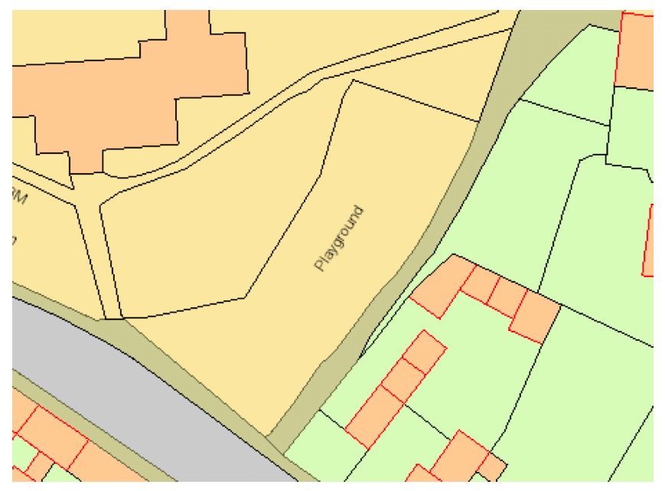

**Redmile Play Area – Current Configuration (To approximate scale) (Fig 2)**

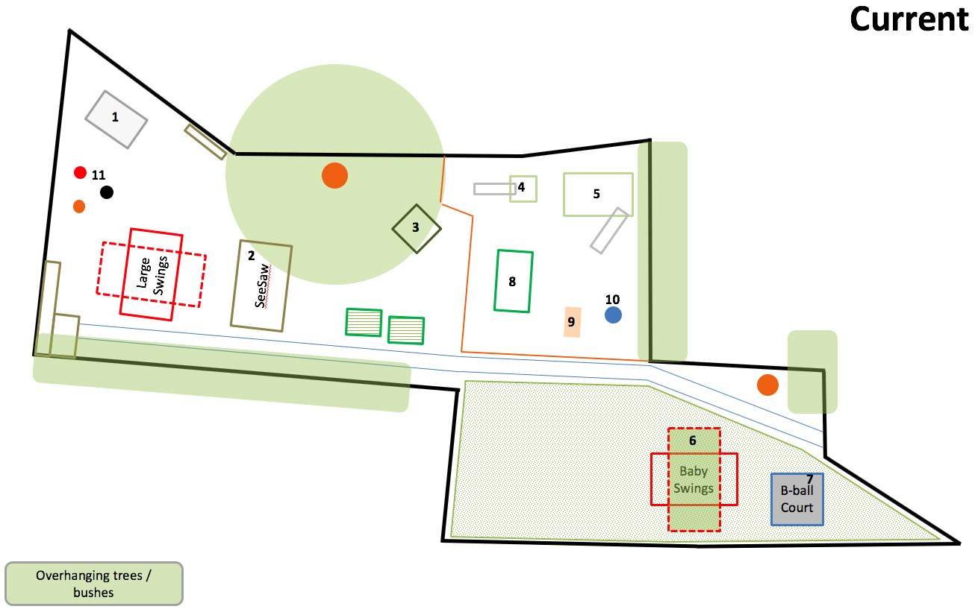

**Example Refurbishment Specification** – please itemise the cost for each separately as noted in Section 3.1 above.

* *Site Clearance*
* Including disposal of old equipment and surfacing that cannot be refurbished for re-use.
* Provide pricing on a piece-basis to demolish

1) concrete slab at south west corner

2) existing see-saw and Notts turf

3) A-frame climber

4) small climber and slide

5) large climber, net and slide

6) baby/toddler swings and Notts turf

7) basketball frame and slabs

8) pirate ship

9) rocking camel

10) spinner – Re-use the stainless steel slides on new equipment if possible

* *Bark area (denoted by brown line on Current and Future plan – Figures 1 and 2 respectively)*
* Remake new retaining barrier (3x post width high)
* Consider re-using some of the telegraph pole timbers from small / large climbers to make “stepping stone” trail in the bark area, or/and as part of the bark retaining surround or elsewhere
* Add new play bark to required depth
* *Wooden Horses*
* Repair / remake wooden horses (11) on lorry springs and repaint with weatherproof gloss
* *Grass areas*
* Make good all grass areas disturbed by works with high-wear grass seed or turf
* *Trees*
* If any tree work is deemed necessary, other than that outlined below, the contractor must liaise with the Parish Council as permission to work on trees is required as the park lies in a Conservation Area.
* The Parish Council has applied to remove the willow Tree which is growing in the bark pit. If permission is granted it will be removed at the Parish Council’s expense.
* It is expected that the Conifers adjacent to the bark pit will be trimmed back as part of the Parish Council’s responsibility to maintain the graveyard.

**Redmile Play Area – Example Draft Specification – Future Layout (Fig 3)**

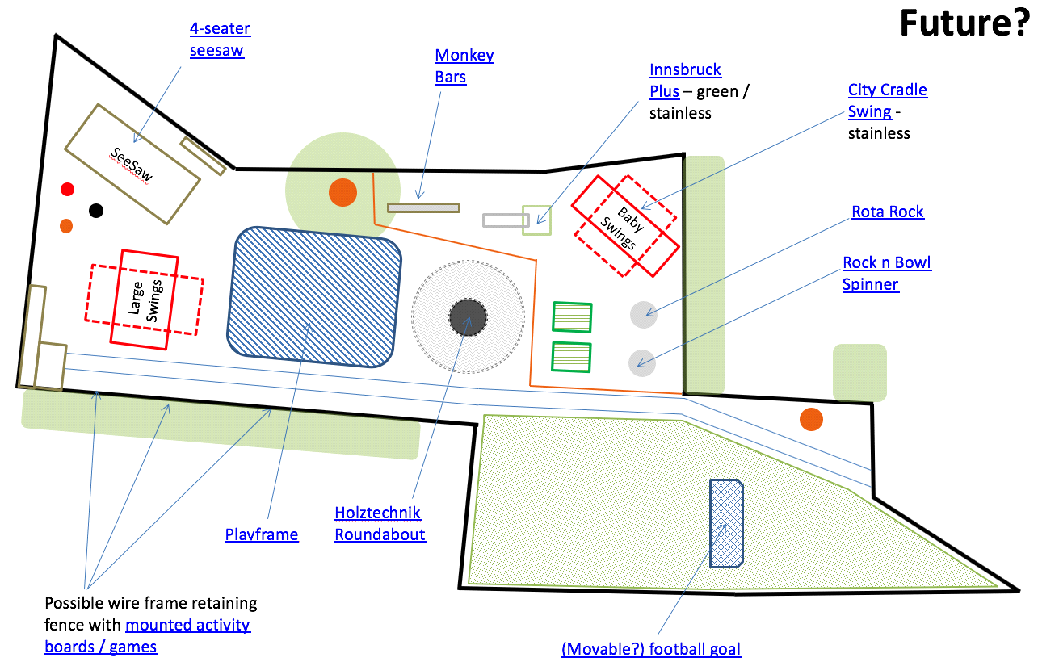

**Example equipment** included in Figure 3 – please refer to notes in Section 3.1 for details of expected variation. This is a suggestive list only and not definitive.

* **4 Seater Seesaw** - <https://www.ijreka.com/product/42/5529/wooden-seesaw-4-seater-robinia>
* **Monkey Bars** - <https://www.playdale.co.uk/playground/playground-favourites/playground-climbing-frames/swing-bars.html>
* **Junior Clumber** - <https://www.playdale.co.uk/playground/junior-play/play-towers-big-city-plus/innsbruck-plus.html>
* **Baby Swings** - <https://www.playdale.co.uk/playground/playground-favourites/swings/city-cradle-swing.html> - please ensure these confirm to DDA standards
* **Rota Rock** - <https://www.playdale.co.uk/playground/junior-play/movers/rota-rock.html>
* **Rock and Bowl Spinner** - <https://wicksteed.co.uk/products/traditional/roundabouts/rock-n-bowl/>
* **Roundabout** –
* **Large Playframe** - <https://www.playdale.co.uk/playground/playground-favourites/playground-climbing-frames/playframe.html>
* **Activity Boards** - <http://www.fahr-industries.com/Play_Panels>
* **Football Goal** - <https://www.stadia-sports.co.uk/football-goal-posts/7-a-side-football-goal-posts/elliptical-aluminium-freestanding-goals-mini-soccer.html>

**All equipment proposed by the Supplier must be located within the boundaries of the play area as indicated above**