Invitation to tender

Office Furniture at Newquay TR84HP

Ref: Piran SPF

1. Background

Having worked on world leading projects in a variety of industries as a manufacturer and direct consultant to major projects Piran Advanced Composites (PAC) Limited have now established ourselves offering a complete service from design, engineering and manufacture of one off, R&D, low volume and high volume structures and components. We have developed novel technologies to be able to offer high quality services to a variety of industries such as Aerospace, Defence, Medical, Automotive and Marine. Our experience ranges from ultra-lightweight novel Aerospace R&D aerostructures through to low/high volume propulsion and flight critical Components

2. General Requirement

PAC will be moving to new premises at Southern Hangar 1, Space port Cornwall, Newquay, Cornwall TR84HP in May 2024. The new premises will enable the company’s growth plans to be realised and undertake manufacture of airframes with large wind spans. As part of the overall refurbishment of these premises, PAC wishes commission a company to provide the office furniture.

The purchase of this system is part of grant funded PAC has secured from the Shared Prosperity Fund. We will assess tenders received on a Most Economically Advantageous Tender.

3. Tender requirements

Where specific products/finishes are detailed, bidders may offer alternatives providing they are equivalent to or exceed the specifications listed; any alternatives should be raised as part of the clarifications. The supplier is invited to tender for the following:

3.1 Outline Drawings and Concept

3.2 | Reception
 | Image | Product Description | Qty
3.2.1 |  | 2400w x 1200d  Natural oak veneer base Natural oak veneer top  No power/cable management included  5 Year Warranty | 1
3.2.2 |  | - Upholstered in Remix 163 fabric  - Black 4 star phyramidal swivel base  - With tilt  - On glides  - With arms  - 5 Year Warranty | 1
3.2.3 |  | Moulded foam construction  Fully upholstered in Re-Wool 718 fabric, with perimeter piping  Tubular steel black frame Single tone  Plastic glides  5 Year Warranty | 2
3.2.4 | 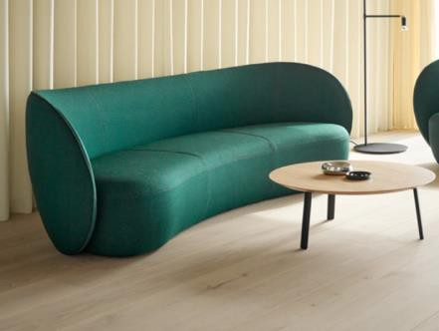 | - Moulded foam back rest  Cut foam seat carcass  - Fully upholstered in Sumi Chiba SUR08 fabric  - Single tone  - Plastic glides  5 Year Warranty | 2
3.2.5 | 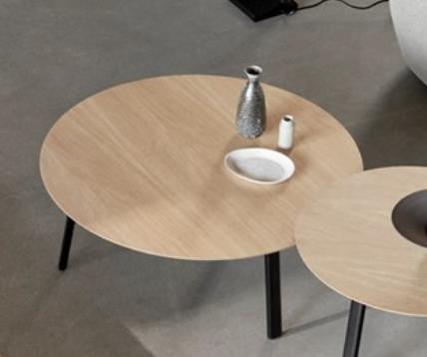 | - 1000dia  285h  - Top in clear oak  Base in black  5 Year Warranty | 1
3.2.6 |  | - 800dia  - 315h  - Top in black  - Base in black  5 Year Warranty | 1
3.2.7 | 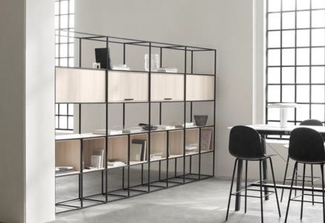 | 2660 total width  Shelves in clear oak  Frame in black  5 Year Warranty | 1
3.3 | Offices
 | Image | Product Description | Qty
3.3.1 |  | - Accomodates 2 users  - 1200w x 1400d x 735h  - 700d tops with scallop edge  - MFC white top with ply edge  - Black metal legs  - With cable tray & frameless screen in  - Blazer Lite, Retreat LTH39 colour  5 Year Warranty | 8
3.3.2 | 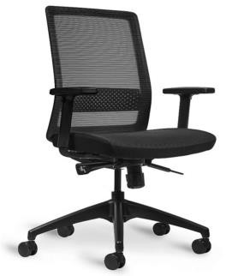 | Black mesh back  Black fabric seat pad  Height adjustable armrests  - Multi-locking synchronous mechanismwith tension adjustment  Adjustable lumbar support  Seat height & slide adjustment Black base & frame  5 Year Warranty | 16
3.3.3 | 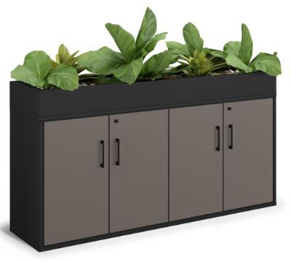 | - 4 door cupboard  - 2x adjustable shelves  - Black square handles  - Carcass in anthracite, doors in oak  - Including top planter box (liner & plant work not part of supply)  1600w x 500d x 890h 5 Year Warranty | 2
3.4 | Boardroom
 | Image | Product Description | Qty
3.4.1 |  | 5400w x 1400d x 740h  3 Piece top, each with central grommet in white metal finish  Legs in black  - White MFC top with ply edge  - With cable tray  No power supplied  5 Year Warranty | 1
3.4.2 |  | Breathable black mesh upholstery Gas height adjustment  Black frame and base On castors  5 Year Warranty | 12
3.4.3 | 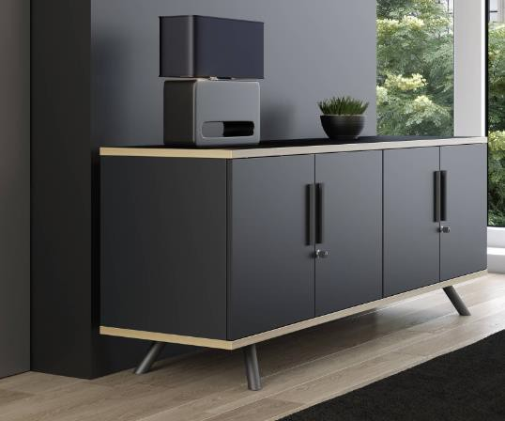 | 2000w x 500d x 740h  4x soft close doors, with 2x adjustable shelves  Lockable, includes 2x keys  In nanotech black, with ply edging on top and bottom panels  5 Year Warranty | 1
3.5 | Meeting Room 1
 | Image | Product Description | Qty
3.5.1 | 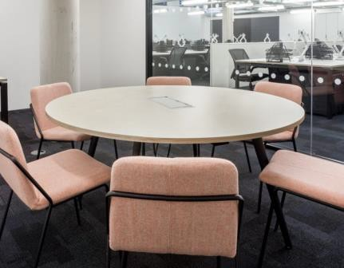 | 1400dia x 740h  With central grommet in white metal finish  Legs in black  MFC white top with ply edge With cable tray  No power supplied  5 Year Warranty | 1
3.5.2 |  | With arms  QTY 2 upholstered in Warwick Plush Airforce colour  QTY 2 upholstered in Warwick Plush Fjord colour  Black metal 4 leg base  5 Year Warranty | 4
3.5.3 | 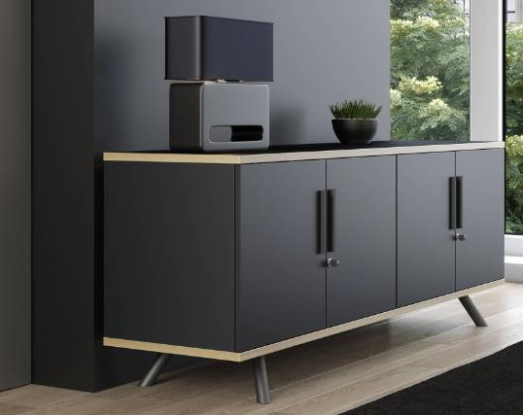 | 1500w x 500d x 740h  3x soft close doors, with 2x adjustable shelves  Lockable, includes 2x keys  In nanotech black, with ply edging on top and bottom panels  5 Year Warranty | 1
3.6 | Meeting Room 2
 | Image | Product Description | Qty
3.6.1 | 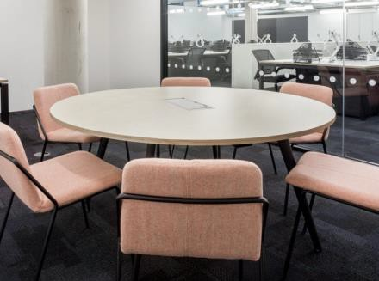 | 1400dia x 740h  With central grommet in white metal finish  Legs in black  MFC white top with ply edge With cable tray  No power supplied  5 Year Warranty | 1
3.6.2 |  | With arms  QTY 2 upholstered in Warwick Plush Airforce colour  QTY 2 upholstered in Warwick Plush Fjord colour  Black metal 4 leg base  5 Year Warranty | 4
3.6.3 | 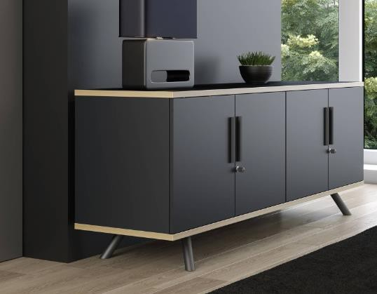 | 1500w x 500d x 740h  3x soft close doors, with 2x adjustable shelves  Lockable, includes 2x keys  In nanotech black, with ply edging on top and bottom panels  5 Year Warranty | 1
3.7 | Meeting Room 3
 | Image | Product Description | Qty
3.7.1 |  | 1400dia x 740h  With central grommet in white metal finish  Legs in black  White MFC top with ply edge  With cable tray  No power supplied  5 Year Warranty | 1
3.7.2 |  | With arms  QTY 2 upholstered in Warwick Plush Airforce colour  QTY 2 upholstered in Warwick Plush Fjord colour  Black metal 4 leg base  5 Year Warranty | 4
3.7.3 | 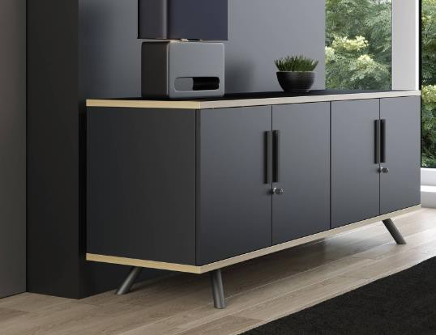 | 1500w x 500d x 740h  3x soft close doors, with 2x adjustable shelves  Lockable, includes 2x keys  In nanotech black, with ply edging on top and bottom panels  5 Year Warranty | 1
3.8 | Kitchen
 | Image | Product Description | Qty
3.8.1 | 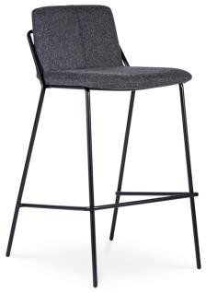 | 450w x 510d x 890h  Black powder coated wire frame Upholstered in Spradling Valencia  Chestnut colour Vinyl  5 Year Warranty | 4
3.8.2 |  | 1000dia x 740h White MFC top With ply edge  Black graphite base  5 Year Warranty | 2
3.8.3 | 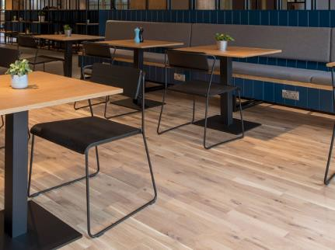 | Non upholstered  Seat and back in oak  Black powder coated wire frame Stackable up to 5  5 Year Warranty | 8
3.8.4 | 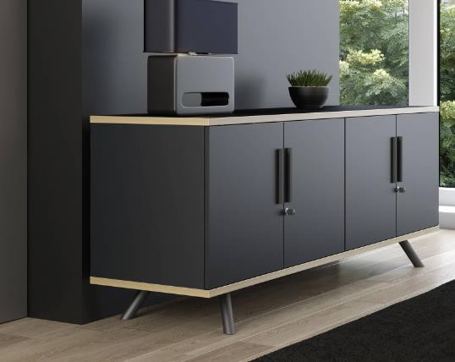 | 1500w x 500d x 740h  3x soft close doors, with 2x adjustable shelves  Lockable, includes 2x keys  In nanotech black, with ply edging on top and bottom panels  5 Year Warranty | 1
3.9 | Workspace
 | Image | Product Description | Qty
3.9.1 |  | Corner sofa - two toned Arm on both sides  Including linking brackets  Outer upholstered in Sumi Chiba SUR08  Inner upholstered in Remix 143 Scatter cushions not included 5 Year Warranty | 1
3.9.2 | 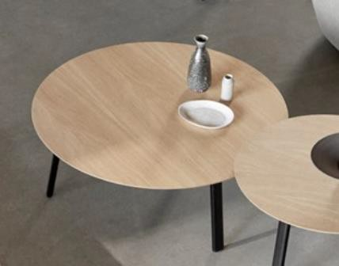 | 1000dia 285h  Clear oak top Black legs  5 Year Warranty | 1
3.9.3 |  | Moulded foam construction  Fully upholstered in Kvadrat Re-Wool 718, with perimeter piping  Tubular steel black frame Single tone  Plastic glides  5 Year Warranty | 1
3.10 | Miscellaneous
 | Image | Product Description | Qty
3.10.1 | 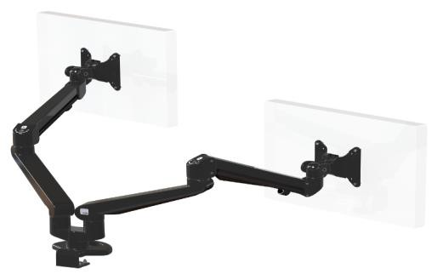 | In black, with baby-c fixing Dual screen application  Integral cable management  Maximum screen size 36"  Lockable quick release VESA function Each arm holds from 3-8kg | 16
 | Image | Product Description | Qty
3.10.2 | 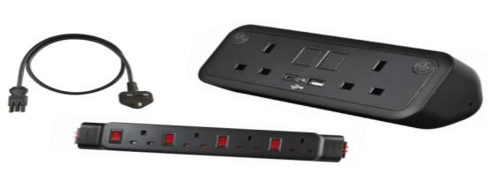 | UNO Power Bundle  1x Black UNO - 2 UK power & 2 USB A&C  1x Powerlink - 4 UK power  (Individually fused thermal rest switches)  1x 2m Starter lead  30W | 8
3.10.3 | 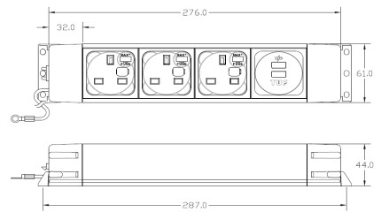 | Meeting Table Power  Matt black aluminium power box comprising: 3x UK sockets individually fused at 3.15A, 1x replaceable A+C twin fast charger (Max 5A), 250mm earth lead  With 3M starter cable to 13amp plug Power box to sit loose in table cable tray | 3

3.11 Delivery to our premises and installation

3.12 Provisional sum of £10,000 for plants, decorations and soft furnishings

4. Budget

The total maximum budget available for this commission is £65,000 (exc VAT) but inclusive of all expenses.

Tenders that exceed the total budget will not be considered.

The budget will be reviewed as part of the tender evaluation detailed in Section 10 and will reflect the degree to which there is a saving on the maximum budget

5. Tender and commission timetable

The timescale of the programme is from the date of signing the contract until acceptance by PAC. The timetable for submission of the Tender, completion of the programme are set out below:

Milestone | Date
Date ITT available on Contracts Finder | 16 August 2024
Last date for raising queries | 1700: 26 August 2024
Last date for clarifications to queries | 1700: 27 August 2024
Deadline to return ITT | 1700: 5 September 2024
Evaluation of ITT | 6 September 2024
Award of Contract | 9 September 2024
Contract start | 9 September2024
Contract completion | 4 October 2024

6. Tender submission requirements

Please include the following information in your Tender submission.

6.1 Covering letter (two sides of A4 maximum) to include:

- Confirmation that the tenderer holds current valid insurance policies as set out below and, if successful, supporting documentation will be provided as evidence:

- Professional Indemnity Insurance with a limit of indemnity of not less than two million (£2,000,000),
- Employers Liability Insurance with a limit of indemnity of not less than Five million (£5,000,000)
- Public Liability Insurance with a limit of indemnity of not less than Five million (£5,000,000).

- Conflict of interest statement
- Copy of ISO9001 accreditation or equivalent
- Copy of ISO140001 accreditation or equivalent
- Confirmation you hold Planet mark or equivalent
- Confirmation you are part of the Safe Contractor Scheme or equivalent
- Copy of your FICA or equivalent
- Confirmation the warranties stipulated in Section 3 can be met

6.2 Details of 3 similar projects of value (or greater) and size. Each Example should be no more than 2 sides of A4. Links to websites will not be viewed.

6.3 Project Method Statement. This should include:
a. The management organisation of the company to include who will be responsible for Health and Safety onsite and who will be the Project Manager. Provide the CVs of both of these members of staff (the CV should be a maximum of 1 page of A4).
b. Programme of work that demonstrates how you will meet the proposed timetable and key milestones.
c. Details of any design proposals
d. After sales service

6.4 Budget. Completed costing document at Enclosure 1

7. Sub-contracting

Tenderers should note that a consortia can submit a tender but the sub-contracting of aspects of this commission after appointment will only be allowed by prior agreement with PAC Limited

8. Conflicts of Interest

Tenderers must provide a clear statement with regard to potential conflicts of interests. Therefore, please confirm within your tender submission whether, to the best of your knowledge, there is any conflict of interest between your organisation and PAC Limited or its programme team that is likely to influence the outcome of this procurement either directly or indirectly through financial, economic or other personal interest which might be perceived to compromise the impartiality and independence of any party in the context of this procurement procedure.

Receipt of this statement will permit PAC Limited to ensure that, in the event of a conflict of interest being notified or noticed, appropriate steps are taken to ensure that the evaluation of any submission will be undertaken by an independent and impartial panel.

9. Tender clarifications

Any clarification queries arising from this Invitation to Tender which may have a bearing on the offer should be raised by email to:

procurement@pirancomposites.co.uk

in accordance with the Tender and Commission Timetable in section 5.

Responses to clarifications will be anonymised and uploaded by PAC Limited to Contracts Finder and will be viewable to all tenderers.

No representation by way of explanation or otherwise to persons or corporations tendering or desirous of tendering as to the meaning of the tender, contract or other tender documents or as to any other matter or thing to be done under the proposed contract shall bind PAC Limited unless such representation is in writing and duly signed by a Director/Partner of the tenderer. All such correspondence shall be returned with the Tender Documents and shall form part of the contract.

10. Tender evaluation methodology

Each Tender will be checked for completeness and compliance with all requirements of the ITT. Tenders will be evaluated to determine the most economically advantageous offer taking into consideration the award criteria.
Tender returns will be assessed on the basis of the following tender award criteria
Ref 6.1 Covering Letter
Acceptable covering letter including confirmation of the requirements detailed at 6.1 | Pass/ Fail
Ref 6.2 Previous examples | 30
Details of 3 similar projects of value (or greater) and size. Each Example should be no more than 2 sides of A4. Links to websites will not be viewed.
Ref 6.3 Project Method Statement | 20
Project Method Statement. This should include:
a. The management organisation of the company to include who will be responsible for Health and Safety onsite and who will be the Project Manager. Provide the CVs of both of these members of staff (the CV should be a maximum of 1 page of A4).
b. Programme of work that demonstrates how you will meet the proposed timetable and key milestones.
c. Details of any design proposals
d. How you are going to meet some of the SPF-Net-Zero-Construction-Project-Guidance (Enclosure 1)
Ref 6.4 Budget | 50
A fixed fee for this work (exc VAT) including travel and other expenses

The lowest bid will be awarded the full 50marks. Other bids will be awarded a mark that is proportionate to the level of their bid in comparison to the lowest bid i.e. Marks awarded = 50 x lowest bid / bid

11. Assessment of the Tender
The reviewer will award the marks depending upon their assessment of the applicant’s tender submission using the following scoring to assess the response:
Scoring Matrix for Award Criteria
Score | Judgement | Interpretation
100% | Excellent | Exceptional demonstration of the relevant ability, understanding, experience, skills, resource and/or quality measures required to provide the goods/works/services. Full evidence provided where required to support the response.
80% | Good | Above average demonstration of the relevant ability, understanding, experience, skills, resource and/or quality measures required to provide the goods/works/services. Majority evidence provided to support the response.
60% | Acceptable | Demonstration of the relevant ability, understanding, experience, skills, resource and/or quality measures required to provide the goods/works/services, with some evidence to support the response.
40% | Minor Reservations | Some minor reservations of the relevant ability, understanding, experience, skills, resource and/or quality measures required to provide the goods/works/services, with little or no evidence to support the response.
20% | Serious Reservations | Considerable reservations of the relevant ability, understanding, experience, skills, resource and/or quality measures required to provide the goods/works/services, with little or no evidence to support the response.
0% | Unacceptable | Does not comply and/or insufficient information provided to demonstrate that there is the ability, understanding, experience, skills, resource and/or quality measures required to provide the goods/works/services, with little or no evidence to support the response.

.

13. Tender Award
Any contract awarded as a result of this tender process will be in accordance with terms and conditions agreed between the two contracting enterprises.

14. Tender returns

Tenders are to be returned by email.

Tenders are to be returned in accordance with Section 5
Latest date to be returned: As per Section 5
Latest time to be returned: 17:00

Emailed tenders should be sent electronically to

procurement@pirancomposites.co.uk

with the following message clearly noted in the Subject box;

‘Office Furniture at Newquay TR84HP’

Tenderers are advised to request an acknowledgement of receipt of their email.

15. Disclaimer

The issue of this documentation does not commit PAC Limited to award any contract pursuant to the tender process or enter into a contractual relationship with any provider of the service. Nothing in the documentation or in any other communications made between PAC Limited or its agents and any other party, or any part thereof, shall be taken as constituting a contract, agreement or representation between PAC Limited and any other party (save for a formal award of contract made in writing by PAC Limited or on behalf of PAC Limited).

Tenderers must obtain for themselves, at their own responsibility and expense, all information necessary for the preparation of their tender responses. Information supplied to the tenderers by PAC Limited or any information contained in PAC Limited’s publications is supplied only for general guidance in the preparation of the tender response. Tenderers must satisfy themselves by their own investigations as to the accuracy of any such information and no responsibility is accepted by PAC Limited for any loss or damage of whatever kind and howsoever caused arising from the use by tenderers of such information.

PAC Limited reserves the right to vary or change all or any part of the basis of the procedures for the procurement process at any time or not to proceed with the proposed procurement at all.

Cancellation of the procurement process (at any time) under any circumstances will not render PAC Limited liable for any costs or expenses incurred by tenderers during the procurement process.

16. Enclosures

1. Costing Document

