Barnham Cross Common SSSI
Higher Level Stewardship Management Plan
AG00632233

October 2014

These additional prescriptions and guidance form part of your Environmental Stewardship agreements, and should be read in conjunction with Part 3 of your agreement documents.

Introduction

Barnham Cross Common Site of Special Scientific Interest (SSSI) forms part of one of the finest blocks of Breckland grass heath, together with Thetford Heath, RAF Barnham and Little Heath, Barnham, remaining today. A wide spectrum of vegetation types occur on the common with calcareous, acid and fixed dune grasslands being of most importance. These habitats support a range of animals and plants including several rare or scarce species.

The chalk-rich grass heath is best developed in the north western part of the site and is an interest feature of the Breckland Special Area of Conservation (SAC). The turf contains a great variety of small flowering plants including Stemless Thistle, Bird's Foot Trefoil, Purging Flax, and Kidney Vetch. In this area are recorded two Breckland plant rarities; Purple stem Cat's Tail is a rare Red Data Book (RDB) plant and Sickle Medick is nationally scarce. The RDB Spanish Catchfly and Field Wormwood used to be found on the common, but have not been seen in recent years.

In the south-west of the common stone-striping or 'patterned ground' is seen where bands of chalk and acid soils are reflected in the vegetation. This feature was formed during the last glacial period and is a scientifically important Breckland geomorphological phenomenon. Acidic grass heaths are well developed on the eastern half of the Common. Sand sedge, a plant of sand dunes, often dominates, especially on uneven ground left by small scale gravel workings. Breckland Pansy occurs here as does the RDB plant, Breckland Thyme, which has been re-found in recent years. The nationally scarce Tower Mustard is also present in various parts of the site.

Barnham Cross Common is included in the Breckland Special Protection Area (SPA) as it provides foraging habitat for ground nesting birds, namely Woodlark, Nightjar and Stone Curlew. It is also rich in invertebrates, including a nationally scarce Biodiversity Action Plan listed moth, but is certainly under recorded. It does, however, support locally important populations of Brown Argus, Dingy Skipper, Purple Hairstreak and Green Hairstreak butterflies.

The site has a history of neglect and the lack of management over a prolonged period has led to a gradual increase in mesotrophic grassland, and a significant increase in the extent of secondary woodland and scrub. This has been at the expense of the chalk, acid and fixed dune grasslands and vascular plant assemblage that form part of the reason for the SSSI notification. Wavy hair-grass, Ragwort and Rosebay Willowherb also form extensive patches over the eastern part of the Common.

The management proposed under the HLS agreement aims to restore the characteristic Breckland flora and fauna to the common. This will be achieved through the creation of a short, open sward and large scale tree and scrub clearance. Regular grazing and/or cutting will create/maintain the desired short turf, and rabbit activity e.g. burrowing together with mechanical cultivations will generate the required level of disturbed ground required for seed germination and seedling establishment.

Summary of the important features of Barnham Cross Common.

 | Importance
Site Feature | National | Regional | Local
1. Geomorphology  Peri-glacial patterned ground | High
2. Vegetation Types  Calcareous grassland*  Fixed dune and acid grassland types  Mixed gorse, broom, hawthorn, oak, pine scrub | High  High |  | Average
3. Species  Plants:  Field wormwood (Artemisia campestris)**  Spanish catchfly (Silene otites)***  Purple stem Cat's tail (Phleum phleoides)  Sickle medick (Medicago sativa subsp. falcata)  Tower mustard (Arabis glabra)  Breckland thyme (Thymus serpyllum)  Star of Bethlehem (Ornithogalum umbellatum)  Breckland pansy (Viola tricolor sub sp. curtisii)  Invertebrates/birds:  Brown argus  Dingy skipper  Purple hairstreak  Green hairstreak  Woodlark, stone curlew & nightjar*  nightingale  ( * = European interest features)  (** = possible reintroduction)  (*** = Not recorded since 1975) | High  High  High  High  High  High  High | High  High  Average  Average  Average | High  High  Average  High

1 Restoration of areas of species-rich semi-natural grassland to be delivered under the HK7 grassland option

RLR field Number:

All of the unimproved grassland areas on the above field parcels have been entered into the HK7 option. This option is targeted at grasslands that are potentially rich in plant and associated animal life. They are often located on difficult ground and may have suffered from management neglect or they may have been selected for agricultural improvement. The botanical diversity of such grassland may be enhanced by simply amending existing management practices. However, pro-active restoration management may be required involving introduction of seeds and creation of gaps for their establishment. Substantial changes of livestock type, timing of grazing or control of dominant species may also be required. The option can also contribute to protecting valued landscapes and archaeology, and the promotion of good soil conditions.

1.1 Indicators of Success

- By year 3, high value positive indicator species for acid, calcareous and dune grassland should be frequent or occasional in the sward as indicated below.

- By year 3, sward height ranges specified below in Section 1.2.1 should be met.

- The sward should comprise 40-90% flowering plants other than grasses,
undesirable species and bracken.

- By year 3, cover of bare/disturbed ground should be between 10% and 20%, e.g. through rabbit warrens or through mechanical cultivation means such as rotovation, ploughing, turf stripping and soil inversion, or as agreed with Natural England.

- The minimum 10% bare ground target should be created through mechanical cultivations and rabbit activity. For this to count the ground needs to be bare/ sparsely vegetated between mid-March and September. Other measures which create bare/sparsely vegetated turf, such as mole activity and scrub clearance, should be considered as above and beyond the minimum 10%.

- The control of undesirable species through spot spraying and weed-wiping using an approved herbicide is permitted. Other methods of control should be agreed with your Natural England contact.

- Archaeological / historic features shown on the Historic Environment Report (5945, 54548, 57836, 60058, 60059) have suffered no damage or degradation.

1.2 Management Requirements

1.2.1 Sward height
The aim of cutting/grazing management across the grassland communities is to maintain large areas of short (<5cm) swards, together with fine mosaics of juxtaposed short and taller vegetation, allowing flowers and grasses to set seed patchily. Sward heights of above 20 cm on more than 20% of the site indicates a lack of grazing management

From year 1 onwards, manage the sward by grazing/cutting to achieve the following sward heights across the areas of grassland in the period end April-mid July:

2cm or less on at least 50% of the site
5cm or less on at least 80% of the site.
10-20cm on up to 20%.

High intensity rabbit grazing will be a key contributing factor towards achieving these site specific targets. Because large parts of the site currently have long swards with little or no rabbit activity, it is recommended that high stock levels should be used in the early years to initially get the sward height down

1.2.2 Ground disturbance

Create and maintain between 10% and 20% of disturbed ground across the grass heath habitats. Bare/sparsely vegetated areas >20% should not normally be deemed unfavourable, provided other site features are not negatively impacted. Areas maintained by rabbits may exceed 20% cover, but is likely to be temporary with the natural dynamism of rabbit populations. Cover of bare ground/sparse vegetation at less than the minimum 10% threshold would indicate unfavourable condition.

Disturbed ground is to be generated through a range of mechanical disturbance techniques including (e.g. ploughing, rotovating, turf stripping and soil inversion), together with rabbit activity (e.g. through grazing and burrowing). Figure 1 identifies the areas where cultivated plots are likely to be located. Previous studies within Breckland have shown that mechanical cultivation techniques offer a considerable biodiversity benefit (e.g. Dolman and Sutherland 1992, Dolman and Sutherland 1994, Dolman et al 2010, and Pedley et al 2013).

Management requirements:

- The plots should be created/managed during late autumn to winter (i.e. Late November – February) to create suitable bare ground conditions for early successional plant and invertebrate species and the following spring. Ideally the required quota of plots should be created/managed throughout this period to benefit a range of species, which require different cultivation timings. This approach will also maximise soil nutrient leaching, helping to reduce soil nutrients in the long term.

- The plots should be located within areas with low rabbit densities, but avoid species-rich grassland and archaeological / historic features shown in the Historic Environment Report. A thorough archaeological survey will be undertaken in advance of any works, except a) in areas where the archaeological interest has already been assessed, and b) where trees and scrub are to be felled to facilitate access.

- In all cases, no seeding (other than in a targeted manner with seed of Breckland species specified in the Plantlife project brief) will take place. The purpose of the management proposals are to regenerate, in as natural a way as possible, the skeletal grassland assemblage most appropriate to the site; this will be achieved by natural colonisation from the rest of the site rather than by seeding.

- Generation of bare ground may cause short term weed problems. Where necessary injurious weeds, e.g. ragwort, rosebay willowherb, creeping thistle, can be treated with an appropriate herbicide by spot spraying/weed-wiping prior to cultivation.

1.2.3 Tree/scrub clearance

A programme of large-scale tree/scrub removal is to be undertaken on the common to reverse the decline of grass heath habitat. A total of 14 ha has been identified for removal as shown in Figure 1, with approximately half of this area being cleared during 2014 and 2016. This will increase the extent of grassland area under HK7 to 24.02 ha on the western side of the common and 30.49 on the eastern side. The second phase of the clearance work is likely to begin in 2017 and is set to increase the extent of HK7 grassland still further to 28.53 on the western half and 35.05 ha in the east. The work programme will be reviewed at the end of the first phase to ascertain how much of the woodland and scrub has been cleared, and if the extent of the HK7 grassland needs to be revised.

Figure 1. Proposed areas for tree and scrub removal and possible locations for cultivation

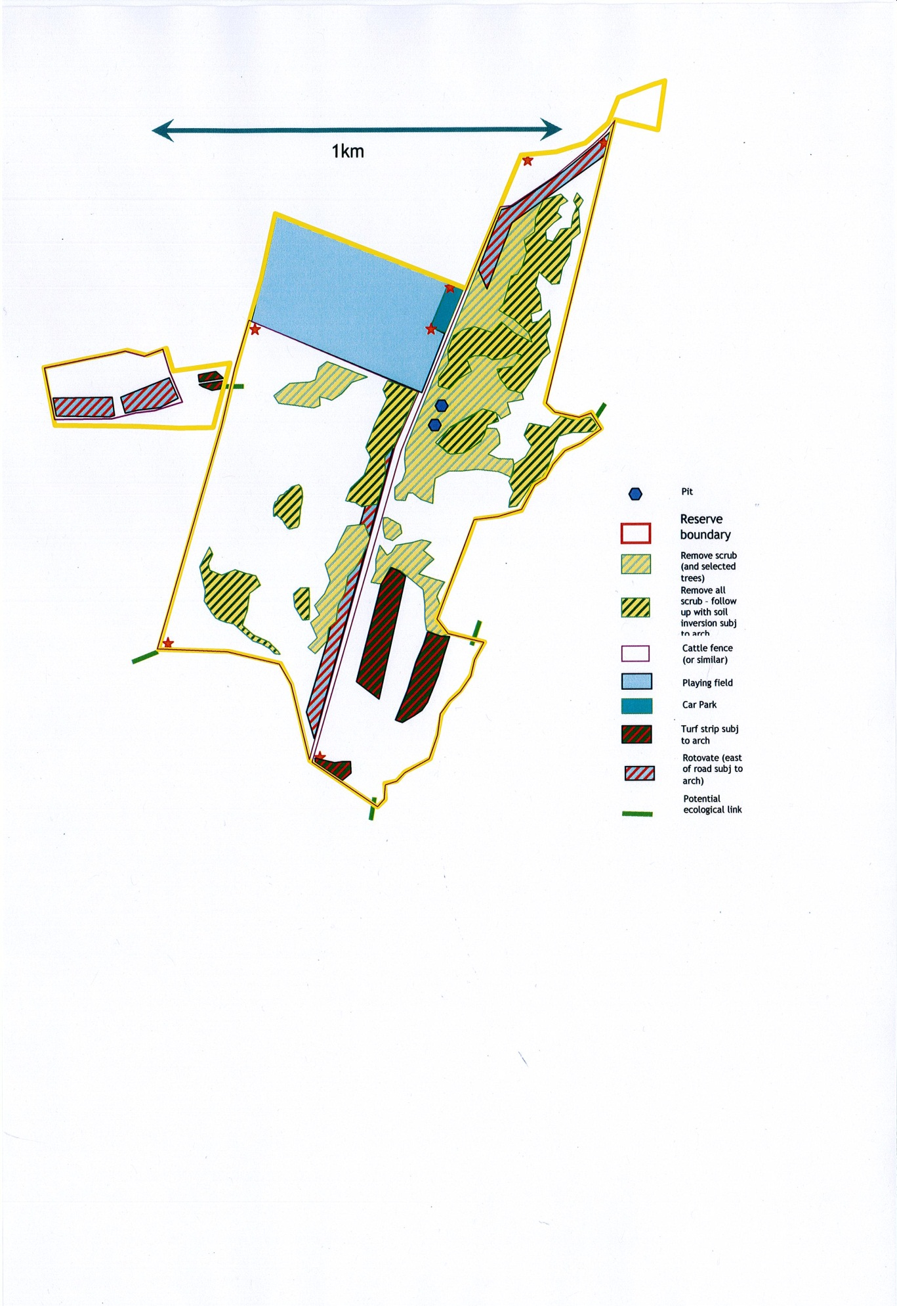

1.2.4 Feature Specific Indicators of Success

The species in bold are typical of short, open swards and/or bare ground and sparsely vegetated areas. Some of these species are relatively short lived, and may not be visible in surveys undertaken later in summer (June onwards). Absence of these species in late summer surveys will only indicate unfavourable condition where the bare ground/sparsely vegetated ground attribute target is not attained.

Calcareous grassland (CG6 Avenula pubescens grassland (MG1-related, CG2d-related)

From the following list, at least two species/taxa frequent and two species occasional throughout the sward. Record the frequency of positive indicator species in period May- July)

Agrimony | Agrimonia eupatoria
Common knapweed | Centaurea nigra
Greater knapweed | Centaurea scabiosa
Wild basil | Clinopodium vulgare
Lady’s bedstraw | Galium verum
Bloody crane’s-bill | Geranium sanguineum
Field scabious | Knautia arvensis
Meadow vetchling | Lathyrus pratensis
Rough/lesser hawkbit | Leontodon hispidus/saxatilis
Bird’s-foot trefoil | Lotus corniculatus
Orchid spp | Orchidaceae spp
Marjoram | Origanum vulgare
Burnet saxifrages | Pimpinella spp
Cowslip | Primula veris
Salad burnet Small | Sanguisorba minor
Wood sage | Teucrium scorodonia
Thyme spp | Thymus spp.,
Goat’s beard | Tragopogon pratensis

Species-rich parched grassland (U1b,d – Festuca ovina-Agrostis capillaries grassland
praecox/pulegioides grassland).

From the following list, at least two species/taxa frequent and four species occasional throughout the sward. Of these, at least two should be from those species shown in bold. Record the frequency of positive indicator species in period end April-mid July.

Early/silver hair-grass | Aira spp.
Parsley piert | Aphanes spp.
Thyme-leaved sandwort | Arenaria serpyllifolia
Purple milk-vetch | Astragalus danicus
Common centaury | Centaurium erythraea
Lichens | Cladonia spp.
Cushion forming mosses | Acrocarpous mosses includes species such as Polytrichum juniperum, P. piluliferum, Dicranium scoparium.
Maiden pink | Dianthus deltoides
Blue fleabane | Erigeron acer
Common stork’s-bill | Erodium cicutarium
Common whitlow-grass | Erophila verna
Lady’s bedstraw | Galium verum
Common rock-rose | Helianthemum nummularium
Rough hawkbit / lesser  hawkbit | Leontodon hispidus / L. saxatilis
Bird’s-foot trefoil | Lotus corniculatus
Early forget-me-not | Myosotis ramosissima
Bird’s foot | Ornithopus perpusillus
Mouse-ear hawkweed | Pilosella officinarum
Buck’s-horn plantain | Plantago coronopus
Sheep’s sorrel | Rumex acetosella
Biting stonecrop | Sedum acre
Shepherd’s cress | Teesdalia nudicaulis
Thyme | Thymus spp.

The species in bold are typical of short, open swards and/or bare ground and sparsely vegetated areas. Some of these species are relatively short lived, and may not be visible in surveys undertaken later in summer (June onwards). Absence of these species in late summer surveys will only indicate unfavourable condition where the bare ground/sparsely vegetated ground attribute target is not attained.

References:

Dolman, P. M., Sutherland, W. J. (1992) The ecological changes of Breckland grass-heaths and the consequences of management. Journal of Applied Ecology, 29, 402-413.

Dolman, P.M., Sutherland, W.J. (1994) The use of soil disturbance in the management of Breckland grass heaths for nature conservation. Journal of Environmental Management, 41, 123-140.

Dolman, P.M., Panter, C.J., Mossman, H.L. (2010) Securing Biodiversity in Breckland: Guidance for Conservation and Research. First Report of the Breckland Biodiversity Audit. University of East Anglia, Norwich

Pedley, S.M., Franco, A.F., Pankhurst, T., Dolman, P.M. (2013) Physical disturbance enhances ecological networks for heathland biota: A multiple taxa experiment. Biological Conservation, 160, 173-182.

