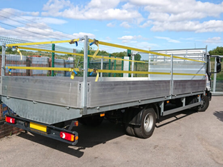**7.5T Drop-side Specification**

**Vehicle Specification**

* 7500kg GVW
* 4x2 axle configuration
* Twinned rear wheels
* 3-seater cab
* Height indicator in cab
* 2kg Dry powder fire extinguisher fitted in cab
* Air conditioning
* Flatbed drop-side body
* Solid fall arrest bars
* Metal headboard sufficiently strong to support scaffold poles
* Safe access and egress into the load area
* Lashing points in load area
* 360-degree visible beacons
* Audible reversing alarm
* FORS Silver camera system cyclesafe sidescan

**Hire Specification**

* Hire with maintenance:
  + 60-month term
  + 2,000km per annum
* Road Fund Licence
* Full Maintenance Package:
  + Full maintenance
  + Servicing & Inspections
  + Tyres
  + MOT Testing and Preparation
  + Maintenance of Fitted Equipment
  + Delivery & Collection (Service & Repairs)
  + Maintenance planning and management
  + Maintenance record keeping
* Breakdown and Recovery

**Additional Requirements**

* Familiarisation training provided to operators on delivery
* Operating instructions
* Maintenance instructions
* Return condition terms and conditions
* Early termination or break clause terms and conditions
* Delivery address: Magnox Ltd, Chapelcross Site, Annan, Dumfriesshires, DG12 6RF