
Shifnal Town Council

Main Tender Document

Provision to design and build a new
Multi Use Games Area.

Wheatfield Drive, Shifnal, TF11 8HU

To be submitted no later than 18th June 2021.

Late submissions will be disregarded.

General Enquiries
Shifnal Town Council
Dave Gough
01952 461 420
dave.gough@shifnaltowncouncil.gov.uk
RESPONSIBLE PARTIES

The Employer
Shifnal Town Council
Library Building, Broadway
Shifnal
Shropshire
TF11 8AZ

Contract Administrators
Dave Gough – Shifnal Town Council
Lucie Pritchard - Shifnal Town Council

TABLE OF CONTENTS

1. General Requirements.........................................................................................4

  - Overview and Objective of Project............................................................4

  - Budget and Costings ................................................................................5

1.3 Non-Consideration of a Tender Response................................................5

2. Contract Conditions..............................................................................................5

2.1 Works and Standards................................................................................5

2.2 Purchase Order and Contract Agreement ................................................6

2.3 Insurance ................................................................. ................................6

2.4 Contractor Documentation ........................................................................6

3. Scope of Works......................................................................................................6

3.1 Requirements ............................................................................................6

3.2 Specifications.............................................................................................7

3.3 Removals, Relocation and Disposals ........................................................7

4. Timetable for Project .............................................................................................8

5. Scoring of Submissions........................................................................................8

5.1 Scoring Criteria ..........................................................................................8

5.2 Scoring Matrix.............................................................................................9
6. Procurement Process .........................................................................................10

6.1 Type of Procedure....................................................................................10

6.2 Site Meeting with Interested Parties.........................................................10

6.3 Questions and Clarification ......................................................................10

6.4 Notice of Intent to Bid...............................................................................10

6.5 Consultation or Public Engagement ........................................................11

6.6 Revisions and Negotiation.......................................................................11

6.7 Decision and Award of Contract..............................................................11

6.8 Supplier Responses.................................................................................11

7. Named Contact for the Project ..........................................................................11

8. Supplier Submission Checklist and Instructions.............................................12

8.1 The Supplier Checklist.............................................................................12

8.2 Delivery of Hard Copies...........................................................................12

1. General Requirements

  - Overview and Objective of Project

Shifnal Town Council (The Employer) is seeking a suitably qualified company (The Contractor) to design and install a new Multi Use Games Area (MUGA) and new pathway from the car park to the MUGA.

The location of the site is Wheatfield Drive, Shifnal, Shropshire, TF11 8HU

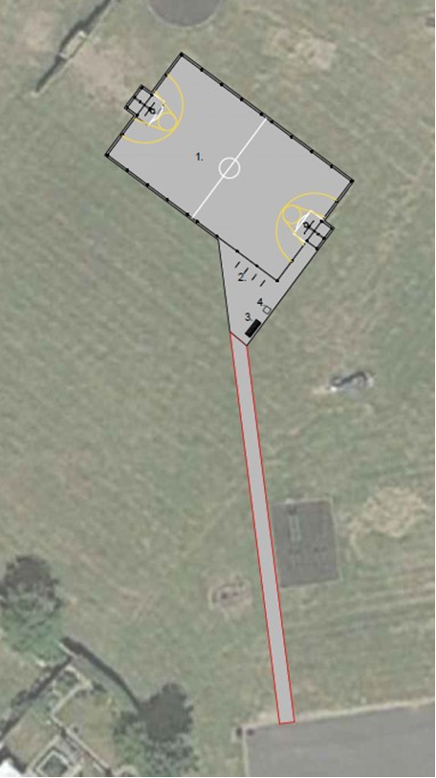

The aim is to create a free facility that can be used for various informal sports by the residents of Shifnal. The Site has an existing semi MUGA ends which will need to be removed intact as there is plans to reuse them at another location. A new pathway is to be constructed from the existing car park to the MUGA and also connecting to the existing outdoor gym area. The orientation of the MUGA is shown above. The existing site is shown below. The MUGA size will be 24mtr x 13 mtr.

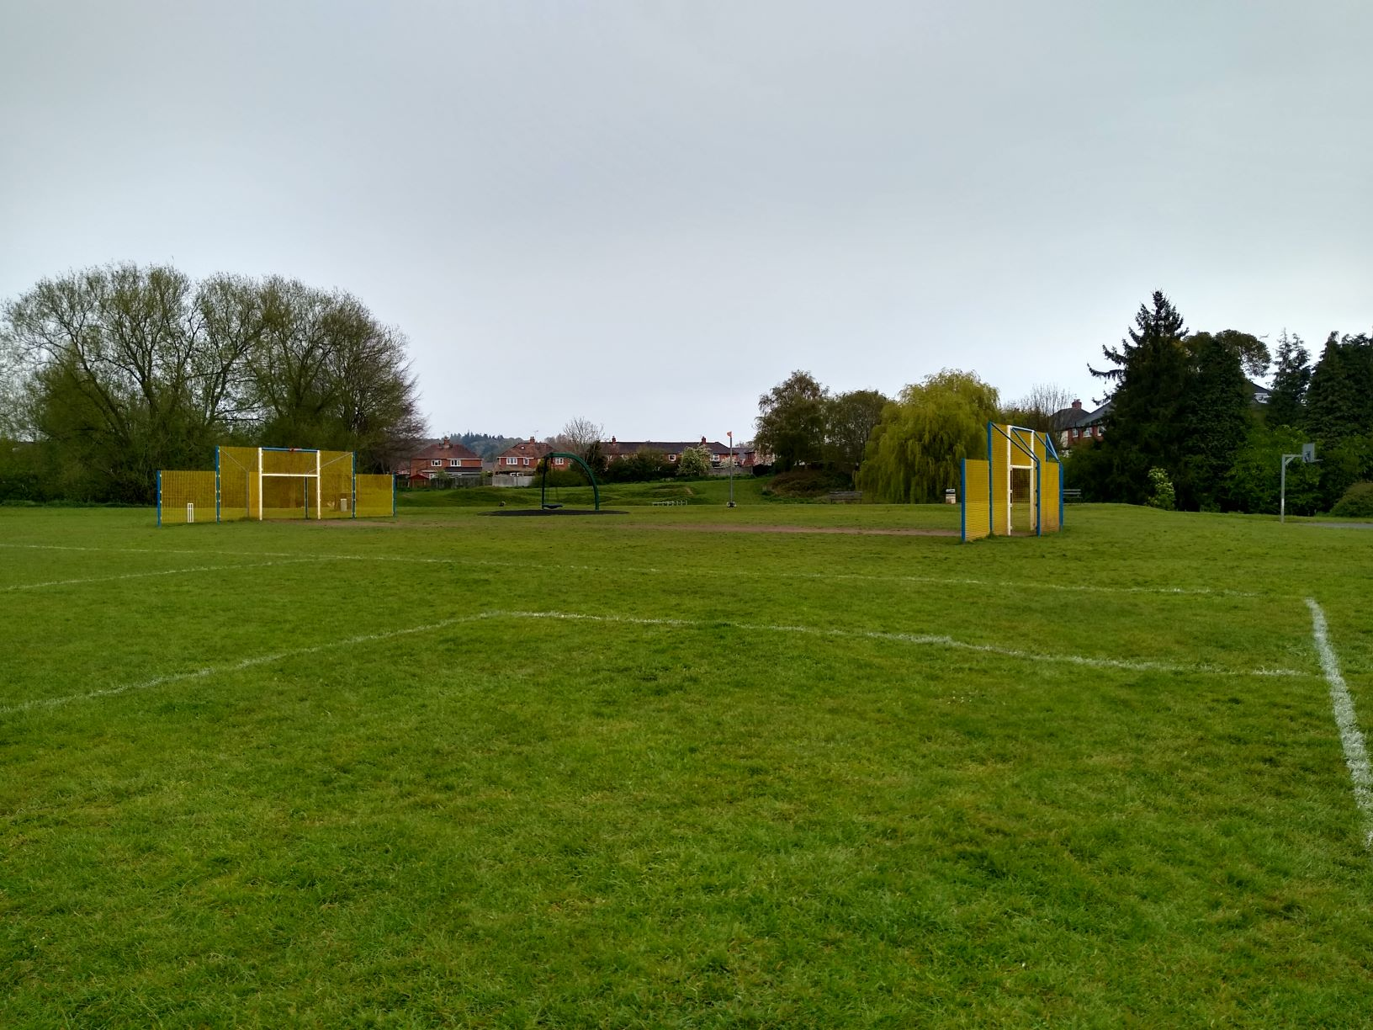

  - Budget and Costings

➢ The council has set aside a budget of approx. £70,000.00 (Ex VAT).
However, pricing will be part of the scoring criteria.

➢ All pricings should be exclusive of VAT and in GBP (£)

➢ Pricing to be valid for 90 days from the due date of the response.

➢ Prices will be fixed and firm for the duration of the contract.

  - Non-Consideration of a Tender Response

The council has the right to refuse any or all submissions without tenderers being able to claim any compensation. All costs associated with the tender process and submission is the responsibility of the suppliers that have been decided to participate.
The council may refuse a tender response if there has been any attempt to vary or alter the details within the document or is not able to provide all the information required by the council to make a full evaluation. Any offence or inappropriate actions by the supplier, including an offence under the Prevention of Corruption Act may result in disqualification. Anything other than “appropriate” contact made to the individuals named within this document for the purposes of clarifying the requirements or raising any questions pertaining to the tender may be considered a breach in the procurement process.

2. Contract Conditions

2.1 Works and Standards

The work is for the design, supply and installation of appropriate groundworks, sub-base, edging, sports surfacing, sports fencing, and associated works which should comply to any relevant regulations and guidance by appropriate sporting organisations.

If there is evidence that the work does not conform to the required standard and as a result the materials or workmanship are substandard or require replacement or repair, this will be completed at the cost of the Contractor.

The contractor must follow the 2015 CDM regulations and will have the skills, knowledge, and experience, and, if they are an organisation, the organisational capability, necessary to fulfil the role that they are appointed to undertake, in a manner that secures the health and safety of any person affected by the project.

2.2 Purchase Order and Contract Agreement

The successful contractor will enter into an agreement by way of a Purchase Order with Shifnal Town Council. In addition, a binding contract (Appendix 3) with agreed terms and conditions will be provided for both the Employer and the Contractor to jointly authorise, the agreement will not be final until both parties have signed this contract.

The contract will refer to all documents received, and communications during the tender process which form the total understanding and obligations of what has been agreed the Contractor will supply the Employer.

2.3 Insurance

The successful contractor must be able to provide evidence of:
➢ Public Liability Insurance of no less than: £10 Million
➢ Product Liability Insurance of no less than: £5 Million
➢ Employers Liability Insurance of no less than: £5 Million
➢ Professional Indemnity Insurance of no less than: £1 Million

2.4 Contractor Documentation

The selected contractor will commit to periodic meetings on site during construction between agreed parties from both The Employer and The Contractor, until work is completed and handed over. The timing of these site visits will be agreed before work commences, and The Contractor will provide in advance of any construction the following:

➢ A Construction Phase Plan

➢ A Risk Assessment and Method Statement

➢ An Organisational Chart outlining escalation contacts that are
available to remedy any issues that arise, and their roles

3. Scope of Works

3.1 Requirements

The Council has decided to replace the existing partial MUGA with a new enclosed MUGA with hard playing surface for multiple use by the residents of Shifnal to include:

- Football markings and goals
- Basketball marking and hoops
- Cricket Panel
- External cycle stands
- External seating
- New pathway from the car park to the MUGA
3.2 Specifications

3.3 Removals, Relocation and Disposals

Removal of any spoil and packaging off site and disposed in an appropriate waste depot. The site will be cleared of the existing MUGA ends with a view to them been reused and levelled in preparation of the new build; However, suppliers may wish to visit the site once this has been completed to ensure all aspects of the area are considered.

4. Timetable for Project

Below is the table set out for the project which suppliers will need to confirm they can achieve to ensure the primary deadline is met.

Action: | Date
Tender Release Date: | 7th May 2021
Site meeting for interested contractors (30 minute slots from 10:00am to 15:00pm): | 17th May 2021
Notification of your intention to provide a response and any questions about the tender: | 21st May 2021
Tender Submissions Due: | 18th June 2021  16:00 (4:00pm)
Decision on Preferred Supplier: | June 2021
Work to Commence: | August 2021

5. Scoring of Submissions

5.1 Scoring Criteria

Criteria | Information Required | Weighted Percentage
5.1.1 Specifications | Complete Appendix 4 in response to each of the required specifications outlined in Section 3.2. Answer with either a ‘Yes’, ‘No’ or ‘Partial’ and notes to accompany response which detail the specifications you are proposing.  Scoring (Points):  Non-Compliant – 0  Partial Compliance – 1  Compliant – 2  Exceed Compliance – 3  Maximum score is 39 which will then be  calculated on the weighted percentage. | 40%
5.1.2 Questions | 1. Confirm how your company manages supply chains in relation to meeting time frames, quality control, health and safety and assess their performance and output. Please be specific in terms of processes, performance indicators and the personnel involved.  Scoring: 10%  2. Outline details of how you may ‘Value Engineer’ the initial design or during construction by consulting with the Installation Team, Employer and/or Consultant in relation to potential time or cost saving methods that will have minimal to no impact on the quality of the proposed design change.  Scoring: 10%  3. Outline details of the experience and qualifications in terms of the company, employees and sub-contractors that will be involved in delivering this project. Provide  specific detail on individual qualifications, company memberships and what sector and facilities the company specialise in.  Scoring: 10% | 30%
5.1.3 Total Cost | Scoring will be made according to the overall cost of the design, assuming the minimum specifications of the brief are met. Scoring on cost will be based on increments that are proportionate and fair to the submissions provided from highest to lowest cost as a  percentage of the proposed budget. Example: proposals that are within the budget will score an automatic 5/10 then increase based on the increment of submissions. If the cost difference is deemed minimal (i.e. less than 1%) between suppliers, the scoring will be considered equal. | 20%
5.1.4  Design Presentation  and Quotation | Suppliers are to provide:  1. 1 x 3D visual  2. 1 x CAD or scaled Google Map of the design  3. An itemised quotation | 10%

5.2 Scoring Matrix

Responses to 5.1.2 and 5.1.3

9-10 | Superior | Exceptional demonstration of the relevant ability, understanding, experience, skills, resources & quality measures required to meet the projects aims or requirement. Response highly relevant with comparable contract value.
7-8 | Good | A comprehensive response submitted in terms of detail and relevance and clearly meets most of the project aims or requirement with no negative indications or inconsistencies
5-6 | Adequate | Reasonable achievement of the requirements specified in the tender offer & presentation for that criterion. Some errors, risks, weaknesses, or omissions, which can be corrected/overcome with minimum effort.
3-4 | Below Expectations | Minimal achievement of the requirements specified in the tender offer & presentation for that criterion. Several errors, risks, weaknesses, or omissions, which are possible, but difficult to correct/overcome and make acceptable.
0-2 | Poor to Deficient | Limited or no response provided, or a response that is inadequate, substantially irrelevant, inaccurate, or misleading

6. Procurement Process

The Procurement Process will be conducted and in compliance with The Public Procurement Regulations 2015 and any updated guidance since. The objective is to be fair, transparent, and proportionate based on the type of project, and to ultimately select the Most Economically Advantageous Tender.

6.1 Type of Procedure

The tender process will be an Open Procedure, Single Stage Tender.

6.2 Site Meeting with Interested Parties. There will be a site meeting to give all suppliers the opportunity to meet with the consultant in 30-minute individual slots to clarify any questions. However, this is not mandatory, and suppliers are welcome to visit the site at their own convenience without penalty.

Should there continue to be Government restrictions or guidance in relation to COVID-19 and a site visit is not possible, it will be postponed until further notice or suppliers can visit the site if this is appropriate to do so. If a site visit was not possible due to the Government restrictions, then an extension may be given until such time as suppliers have been able to visit the site.

6.3 Questions and Clarification

Please note that any responses to queries or clarification requests will, subject to there being a confidentiality issue that cannot be resolved, be circulated to all bidders. Questions should be emailed to the council, not by telephone or in person other than the site meeting. Suppliers are forbidden to approach any person/s outside of the named person (Section 7) within this document in relation to this tender and project, failing to do so may result in disqualification of the tender process.

6.4 Notice of Intent to Bid

Suppliers should notify the named consultant a confirmation of your intent to provide a submission by the due date, and all questions relating to the tender will need to be made no later than the date provided in Section 4.

Failure to notify your intention to bid, or are unable to attend the site meeting, circulation of any questions or updates to the Tender Process may not be sent to your organisation, potentially missing relevant information and submitting an incomplete response.

6.5 Consultation or Public Engagement

The Employer reserves the right to conduct a public consultation. The purpose of any consultation will primarily be to update the community on the preferred design, allowing an opportunity to collect feedback which may contribute to any revisions. Guidance on how the consultation will be conducted and what information should be
collected will be discussed between The Employer and any relevant third parties such as a consultant. However it will not be used to score any of the original designs submitted.

6.6 Revisions and Negotiation

If required, the council will engage with the preferred contractor to amend the design or negotiate any changes or costs associated with the submission, however, will not be deemed “substantial” changes to the original brief. These revisions will be discussed and agreed to before any agreement or purchase order is made final.

6.7 Decision and Award of Contract

The Employer will be responsible for making the final decision based on the scoring criteria set out in the tender document. All parties who have submitted a formal tender response will be notified of the outcome and scoring results of the preferred contractor and that supplier only. An agreement (Appendix 3) will be provided setting out any specific terms and conditions to be signed by both The Employer and The Contractor.

6.8 Supplier Responses

The submissions received by each of the suppliers will not be disclosed to other parties and should not be requested by other parties. Only the scoring of the submissions will be provided on request. The preferred contractor will be advised either via email or on Contracts Finder when the Award Notice is issued.

7. Named Contact for the Project

Shifnal Town Council

Contact: Dave Gough

Phone: 01952 461 420

Mobile: 0745 805 4144

Email: dave.gough@shifnaltowncouncil.gov.uk

8. Supplier Submission Checklist and Instructions

8.1 The Supplier Checklist

Response | Format (Fill in supplier name with your company)
- Completed Copy of Appendix 1 | PDF or Word Document Labelled – Supplier Name Appendix 1
- Completed Copy of Appendix 2 | PDF or Word Document Labelled – Supplier Name Appendix 2
- Completed Copy of Appendix 4  (Response to 5.1.1) | Excel Document Labelled –  Supplier Name Appendix 4
- Response to each question in 5.1.2 | PDF or Word Document Labelled – Supplier Name Questions
- Quotation | PDF or Word Document Labelled – Supplier Name Quotation
- Design Drawings | PDF or JPG Document Labelled – Supplier Name CAD  Supplier Name 3D
- An Email or electronic transfer of all above responses should only be sent after the contract is awarded. | Email above files as attachments or an electronic transfer with no expiry date
Do NOT include the following information for the initial tender response:

➢ TUV Certificates
➢ Copies of Insurance Certificates
➢ Installation documents and drawings
➢ Trade Association or other member certificates
➢ Warranty Certificates or Health and Safety Policies

8.2 Delivery of Hard Copies

The above documentation should be submitted to Shifnal Town Council by the date shown in Section 4 as a sealed bid. All envelopes should be marked in the top left corner “MUGA Tender Documentation – Sealed Tender”.

MUGA Tender Documentation Sealed Tender
Shifnal Town Council
Library Building, Broadway
Shifnal, Shropshire
TF11 9EH

