Location
Peter Driver Sports Field
Bourley Road
Church Crookham
GU52 8DY
Google Maps Link : Peter Driver 3G Pitch

Specification
Church Crookham Parish Council (CCPC) would like to replace the surface on its existing 3G 5-a
side pitch. The pitch was built in 2012 and the surface is due to be replaced. The pitch is floodlit, and currently let on a commercial basis for around 5 hours a night Monday to Friday. Outside of these hours the pitch is available for casual use by the wider community mainly local youngsters.
- The pitch surface is 40m x 20m and is marked out with 5-Aside football pitch markings.
- The existing surface is described as long pile synthetic turf, product name is Condor Ultimo 60mm.
- Examples of proposed replacement surface material should be provided and CCPC would be open to exploring different quality grades that affect longevity and cost.
- The quote should include the provision and fitting of new goal posts / enclosed goal mouths avoiding the current use of goal nets. This is considered a desirable item if the budget permits so please separate this cost out as part of your quote.
- All contractors will be required to carry out their own risk assessment and ensure that they follow safe working practices.
Tenders must include all elements of surfacing, delivery, construction, installation and safe removal and disposal of rubbish along with providing protection for he general public from the work zone.
Vehicular access to the playing fields and the 5-aside pitch will be made available, however this is not suitable for vehicles in excess of 7.5 tons . Pitches on the site will be in use, so storage of materials and plant should be outlined as part of the tender.
Tenders will be shortlisted to 3 contractors. Subject to shortlisting CCPC would like to visit a local site of recent installation. A decision made by the parish council based on the following criteria and weighting mechanism.
Scoring and evaluation
Criteria
Within Budget Guide | Met/Not Met
Satisfactory references for installation | Met/Not Met
Evidence of Insurance Policy | Met/Not Met
Ability to deliver in timescales | Met/Not Met
Insurance backed 5yr guarantee for works | Met/Not Met

The following criteria will be scored on a scale of 1-5 , and weighted as shown.
Criteria | Weighting | Potential Score
Value for Money  - Warranties and guarantees  - Discounts  - Product deatils | 2
Added Social Value  - Environmental statement  - Equality statement  - Any other social value factors | 1

Where 0 score = No response, 1 = Significantly below expectations, 2 = Below Expectations, 3 = Meets expectations, 4 = Above expectations and 5 = significantly above expectations.

The budget for the project is £35-£45k and the design should include the following:
- All contractors must hold the following liability insurance:
- Employers liability: £10,000,000
- Public liability: £5,000,000
Evidence of this cover must be provided at the initial quotation stage.
- Risk Assessments and method statements must be provided by the contractor before any contracts of works are awarded.
Site visits can be arranged, contact details as below.
Please provide the following to Malcolm Thompson (Facilities Officer)
- Complete Contractors Questionnaire
- Quotation and scope of works
- Surface Product details with samples
- Warranty details
- Maintenance requirements, along with any ongoing costs.
- Testimonials/Reference site
- Insurance Certificates
- Delivery and installation timetable
- Address and contact details of local installation to visit (subject to shortlisting)
If you have any questions, please address them to Malcolm Thompson via email: admin@churchcrookham.org.uk
- 5pm 16th March 2023- Full response (Questionnaire, Design, Quotation etc) to be received by Malcolm Thompson – Facilities Officer - Church Crookham Parish Council), Church Crookham Community Centre, Boyce Road, Church Crookham, GU52 8AQ
- 16th to 22th March 2023 - All responses will then be reviewed by working party and a short list of three tenders agreed
- 27th March – preferred option selected by the Parish Council at the Parish Council meeting on 27th March 2023.
- Installation to commence in April 2023.
- Post Installation Inspection Report

Photographs of the site:
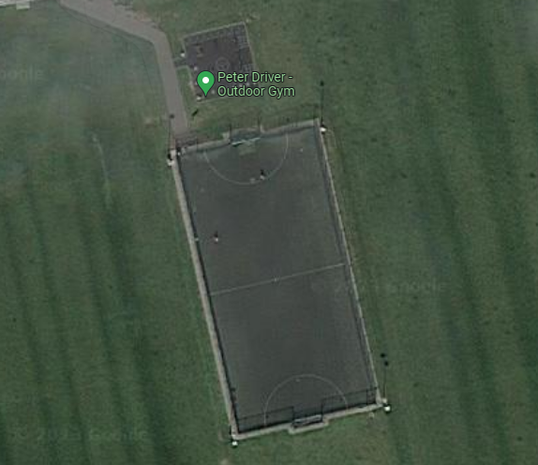
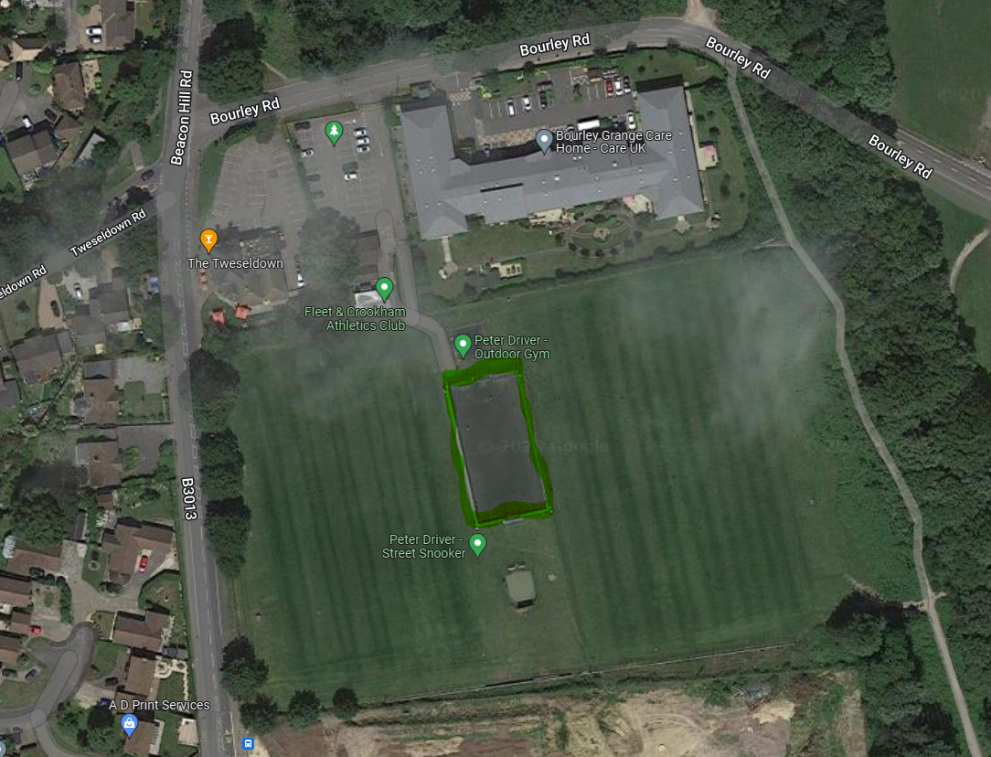

Evaluation scoring scale and definitions (Comparative criteria)
Superior response | 5
Exceeds the requirement. Comprehensively documented with all claims adequately detailed and substantiated.
Credible response | 4
Highly convincing and credible. Response complies and meets the specification requirement. Complete documentation.
Credible with shortcomings | 3
Minor omissions. Convincing and credible. Meets the specification requirement.
Acceptable | 2
Meets the specification requirement. Minor deficiencies and shortcomings which could be resolved with the tenderer’s clarification. Would be manageable with minor changes and/or additional information at contract negotiation stage.
Barely acceptable | 1
Does not fully meet specification requirements. Some responses are unworkable. Requires additional information from tenderer to progress evaluation. Could be manageable with changes to tenderer’s responses during negotiation.
Unacceptable | 0
Does not fully meet the specification requirements. Has shortcomings and deficiencies not resolved by the tenderer. Requires additional information from tenderer to progress evaluation.

