**INVITATION TO TENDER**

**St. Johns Recreation Ground Paddling Pool resurfacing 2023**

**Location**

St. Johns Rec. St. Johns Road, Hedge End, SO30 4AF

<https://goo.gl/maps/rDWzkCyaYt4msydm8>

Hedge End Town Council are looking to resurface the paddling pool ahead of the 2023 season which begins in May. The existing facility is extremely popular, so it is crucial that these works are completed ahead of the May opening.

**Site Description**

The paddling pool was originally installed by Sunsafe in 2001 and has been resurfaced twice since in 2007 and 2014.

The pool is located on the southern end of St. Johns Recreation Ground. Access is through a gate on the northern boundary leading directly from a tarmac car park. There is no formal road to the site, but the field can be safely traversed during late spring/ summer providing it has not been too wet.

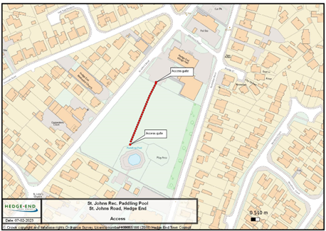 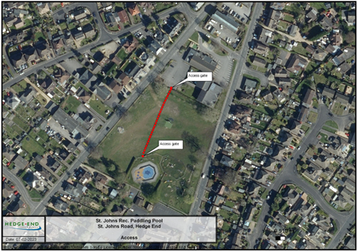

The existing pool wetpour surfacing is approximately 300m2 in total, including the areas below the water level, the area above water level and the area directly outside the main pool that edges the perimeter drains.

**IMPORTANT:** A site visit can be arranged to assess access, gain detailed measurements, location of nearby properties and access points to and around the site. To arrange a site visit please contact Brett Athow on 01489 780440 or preferably by email [opsmanager@hedgeend-tc.gov.uk](mailto:brett.athow@hedgeend-tc.gov.uk)

The Contractor should visit the site at their own expense to satisfy themselves as to any conditions on site that may affect in any manner whatsoever the execution of the works detailed hereafter.

**Tender brief**

Provide options and prices to resurface the paddling pool wetpour surfacing. Quotes must include removal and disposal of the existing surface.

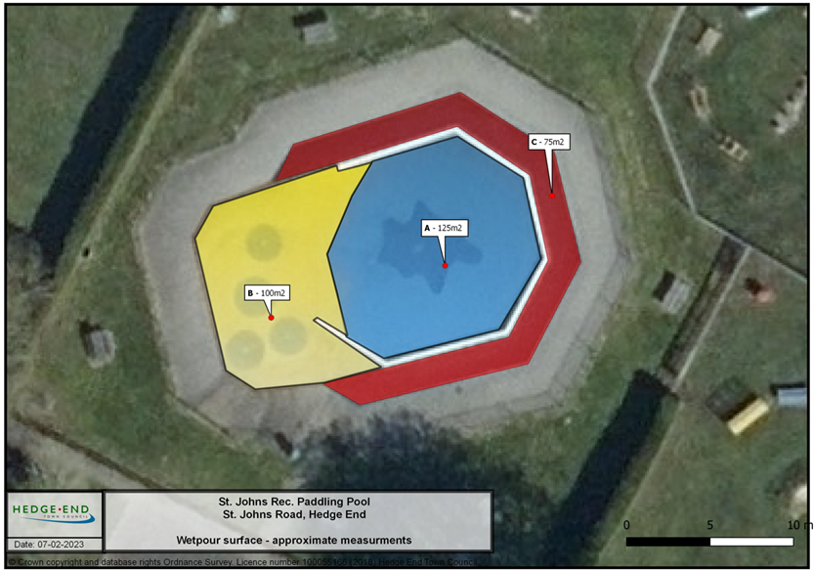

**Option 1** – To remove existing surfacing (Areas A, B & C on map above) and to supply and lay a total of (approximately) 300m² of 20mm depth EN1177 certified wetpour rubber surfacing. The design will consist of 3 ‘splash’ shapes around the water features, a splash shape within the pool itself and a change in colour between the area in the water and the shoreline (Beach) in a mix of 3 colours - yellow, aquamarine blue and a dark blue.

**Option 2** - To remove existing surfacing in areas ‘A’ and ‘B’ and to supply and lay a total of (approximately) 225m² of 20mm depth EN1177 certified wetpour rubber surfacing. The design will consist of 3 ‘splash’ shapes around the water features, a splash shape within the pool itself and a change in colour between the area in the water and the shoreline (Beach) in a mix of 3 colours yellow, aquamarine blue and a dark blue. In addition, area ‘C’ requires repair at the join between the wetpour and the drains which is approximately 45m in length.

**Option 3** - To remove existing surfacing in the blue (A) area only and to supply and lay a total of (approximately) 125m² of 20mm depth EN1177 certified wetpour rubber surfacing. The design will be similar to the existing in aquamarine blue and a dark blue ‘splash’ shape in the centre of the pool. In addition, area ‘C’ requires repair were the wetpour joins the drains which is approximately 45m in length.

**Additional –** We would be interested to see example designs, motifs etc of previous projects as well as an indication of costs that could add interest to the site.

**Guarantees**

Please provide details of all guarantees and warranties

The Contractor will need to supply the Town Council with a copy of their site risk assessment, method statement and a copy of their public liability insurance at least 14 working days before the start of the project.

The Contractor will be held accountable for, and shall make good any damage whatsoever caused as a result of these works during the resurfacing of the paddling pool area to gates, paths, roadways, walls, fences, gardens, trees, etc. Full payment may be withheld until the site and adjoining areas are left in a state deemed acceptable, and to the satisfaction of the Town Council.

**Prices**

All prices are to be **net, excluding VAT.**

**Timescale**

Tender submissions must be submitted by 26 March 2023

Works to be completed no later than 30 April 2023.