Dear bidders,

Thank you for your consideration of our ITT: The Delivery of Decarbonisation Training Needs Analysis in support of Regional Skills Mapping
Please see below for responses to the queries raised by tenderers.
Query | Response
Given the tight timelines for this project, what is the minimum number of employers ECW would consider acceptable for the supplier to engage with? | As detailed in the tender, we would expect the successful tenderer to aim to consult with up to 20 companies, and at minimum 5 large (100+ employees) companies. Some stakeholder engagement is already underway with companies within this cluster, and the successful tenderer would be supported by a Stakeholder Coordinator to help enable the substantial engagement required.
Has ECW a list of energy intensive industry employers, in the Ellesmere Port area?  Do ECW want to influence the selection of (up to 20) employers to participate in the TNA-P? | The list of employers to contact will be agreed in coordination with ECW and the project steering group, based on methodology advised in Activity 1, stakeholder views, and the successful bidder's analysis.

In the final version of the MoU issued to ECW by OCEJ the Regional Skills Pilot as a whole, OCEJ provided the below clarifications on the overall timetable for delivery. This may compress the time available to conduct some elements of this tender.
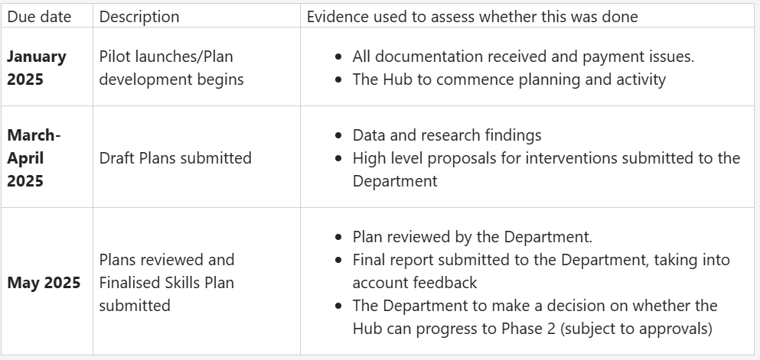
Training plans would therefore need to be completed by the end of April 2025 in order to feed in to the wider skills mapping work – brokerage activities could be completed after this time, but conclude no later than May 31st.
In the light of the above slight modification, we are extending the deadline for submissions to this piece of work by one day to Thursday 13th February 2025 (16:00 hours).
Given this change, interviews for this work would now take place on Tuesday 18th February.

We look forward to receiving your submissions to this tender exercise.
Many thanks,
Michael Wolffe

