Thornbury Town Council

Design Brief
For

Chantry Road Play Area

Contents

1.0 Introduction 3
1.1 Project Information 3
2.0 Preliminaries 4
2.1 The Design Brief 4
2.2 Health and Safety 4
2.3 Working Times 4
2.4 Community Liaison 4
2.5 Manner of Performance 5
2.6 Statutory Undertakings, Drains and Services 5
2.7 Light and Power 5
2.8 Meetings 5
2.9 Site Cleanliness 6
2.10 Sub Contractors 6
3.0 Specification 7
3.1 Community aspirations 7
3.2 Location 7
3.3 Overall Requirements 8
3.4 Play Features 8
3.5 Materials Specifications 9
3.6 Safer Surfacing 9
3.7 Installation 9
3.8 Maintenance and Aftercare 9
3.9 Budget 10
3.10 Payment 10
3.11 Timescale 10

1.0 Introduction

This project seeks to design and create replacement innovative play features at Chantry Road Play Area, Thornbury. Our objective is to create playable spaces that offer young people access to as wide a range of play opportunities as possible. We actively encourage the use of Play England’s ‘Design for Play’ to encourage a design that meets the specification in Section 3.

1.1 Project Information

NAME OF PROJECT Chantry Road Play Area

PROJECT BUDGET £60,000

LOCATION OF PARK Chantry Road Play Area, Tilting Road, Thornbury, BS35 1EP

NAME/ADDRESS OF OWNER Thornbury Town Council, Town Hall, 35 High Street, Thornbury, Bristol, BS35 2AR

GRID REFERENCE ST6384290624

PROJECT MANAGER Wendy Sydenham – Deputy Town Clerk

2.0 Preliminaries

2.1 The Design Brief

a) The Contractor should visit the site at their own expense to satisfy themselves as to any conditions on site that may affect in any manner whatsoever the execution of the works detailed hereafter.

2.2 Health and Safety

a) The Contractor shall take all precautions as are necessary to protect the Health and Safety of all persons employed by him and shall comply with all the requirements of any Acts, Regulations, orders or directions pertaining to the health and safety of employed persons, the employees of the Council and all other persons.

b) The Contractor shall take due note of the Council’s Health & Safety Policy statement. The Contractors own statement and safe working practices shall be to no less of a standard than that of the Council. The Project Manager reserves the right to instruct the Contractor to revise their submission in such areas as it may be considered to fall short of the Council’s existing standards.

c) The Contractor shall allow the Project Manager or their representatives and the Council’s own Safety Officer such access as may be required to buildings, locations, vehicles or operations used in relation to this contract.

d) The Contractor shall notify the Project Manager of any accident to any of his employees or member of the public happening during the duration of this contract and which causes the injured person to be absent from work for more than three working days.

e) The Contractor shall advise the Project Manager immediately of any notifiable occurrences as defined in the Reporting of Injuries, Diseases and Dangerous Occurrences Regulation (1985).

f) A method statement of works and a risk assessment must be submitted and agreed with the Project Manager or their nominated representative prior to work commencing on site.

2.3 Working Times

The Contractor shall restrict his operation to working times of between 9.00am to 5.00pm Monday to Friday, unless it is a prescribed requirement within the Specification. The Contractor must obtain the approval of the Project Manager prior to working outside of these times.

2.4 Community Liaison

A key element of this project is the involvement of the local community. When requested by the Project Manager or their nominated representative, the Contractor shall be required to work in partnership with the Council to enable supervised site visits by the community. The Project Manager will give the Contractor adequate notice of such requirements.

All works relating to such events will be carried out in accordance with the conditions, specifications and general regulations contained within this document, due regard being given to health and safety regulations and the health and safety of park users. At all times, the Contractor is required to answer simple enquiries as they arise and to treat members of the public courteously and with respect.

2.5 Manner of Performance

The Contractor will at all times during the Contract period employ sufficient persons of sufficient abilities and skills that have the required training for the proper performance of the works detailed hereafter.

In addition to their statutory obligation, the Contractor shall be expected to be aware of the accepted practices and methods used in undertaking good construction, play feature installation and refurbishment work. Where there is any doubt in the interpretation of any method or practice this should be clarified with the Project Manager in advance of work commencing.

2.6 Statutory Undertakings, Drains and Services

It is the Contractor's own responsibility to establish the presence and precise location of, and ramifications of the presence of all services and statutory undertakings on site when carrying out works in accordance with the Contract. The Contractor will be responsible for informing those bodies responsible for services, etc, where damage is caused and will bear the subsequent cost of making good such damage.

The Contractor will also be responsible for informing such bodies where works may involve the encroachment, disconnection or hazard to those services, etc. Where appropriate the Contractor will take adequate measures for the protection of all pipes, ducts, sewers, service mains, overhead cables and the like during the execution of the works.

The Contractor must not interfere with the operation of existing services such as Gas, Water, Electricity, Telephones, buried cables or sewers, drains and roadside ditches without the permission of the Project Manager, statutory authority or private owner as appropriate. In all instances of damage/interference, the Project Manager must be notified.

2.7 Light and Power

The Contractor is to ascertain the suitability of supplies and provide any artificial lighting and electrical power required for the use on the works, including providing all temporary connections, distributing leads, fittings etc. and to clear away on completion. The Contractor will pay all fees for electrical supply.

2.8 Meetings

The Contractor shall be required to attend such meetings as the Project Manager or their nominated representative may require for the administration and successful completion of this Contract.

2.9 Site Cleanliness

The Contractor will be responsible for ensuring that all hard surfaces are kept free of litter, debris, mud and glass, etc, whilst undertaking works associated with this Contract. All arisings shall be picked up and removed from the site, approach roads and entrance ways and disposed of at the end of each working day and upon completion as directed.
Sweeping shall be carried out by hand or by approved mechanical sweeper or sucker. Damage to grassed areas should be minimised and repaired.

2.10 Sub Contractors

The Contractor must ensure that the Project Manager and/or their nominated representative are made aware of any sub contracting that take place on each project and the work they are to carry out.

3.0 Specification

This project will focus on the provision of new playful activities to replace the existing ones and the Contractor is to design and create a play area in accordance with the following general specification.

3.1 Community Aspirations and Community Involvement Through Consultation

The play area needs to meet the needs of children from toddler age through to mid teenage years. The existing play park is used by all ages of children alike and the community would like the new play features to link sympathetically with the surrounding area.

We are keen to see the following elements within the new park (subject to available space and Health and Safety guidelines):

- Trampoline(s)
- Toddler swings
- Pod swing
- Wheelchair accessible roundabout
- Slide

None of the existing equipment (see images) needs to be retained and therefore it would need to be safely removed and disposed of.

It is important that we involve the local community in creating the final design. We would therefore need to have some form of consultation included in the project. In order to ensure that would comply with any COVID restrictions, we would like this to comprise of a well-publicised online process, but with the option of adding in a public consultation “event” such as hiring a stand in the nearby shopping centre on a Saturday morning to obtain feedback. The public event will be dependent upon current COVID restrictions. The Contractor should take the lead in designing and running this consultation process in liaison with the Council.

As we would also like to see a springer and/or rotating seesaw included (dependent on budget), options for this could form part of the consultation with the local community.

This play area does not require fencing. Appropriate safety surfacing, seating and provision of litter bins should be incorporated into the design. Any design should incorporate best practice around ‘Safer by Design’.

3.2 Location

The play area is located in the middle of a residential area in central/west Thornbury. The play area takes up a portion of a small field which is surrounded by houses. The new play area could stay within the space currently used by the existing play area, but it could also take up further space if the design necessitated this. However, it should ideally not use up more than two thirds of the whole green space.

The area can be accessed in two ways – the first is vehicular access via a wide lane from Tilting Road, and the second is via a narrower pedestrian-only pathway from Chantry Road. The vehicular access is wide enough for a medium sized van or truck and access is controlled by the use of a locked bollard which Council has full control over. There is no dedicated parking for the play area.

The play area itself unfenced, although the majority of the whole green space has a fenced border made up of fencing at the back of gardens.

(see images)

3.3 Overall Requirements

We would like to see a site that is innovative and which encourages and enables physically active play, and which is attractive to children from toddler age through to early teenage. The site should be appealing and accessible for children with additional needs and minority groups. Play activities should be open-access, with children free to independently move between them.

There is also a need for the new design to be a welcoming and restful place for parents with younger children to meet and socialise.

We ask you to consider these nine key expectations within your design:-

1. The site is ‘bespoke’
2. Makes use of natural elements
3. Provides a wide range of play opportunities
4. Accessible to children with additional needs
5. Meets community needs
6. Allows children of different ages to play together
7. Builds in opportunities to experience risk and challenge
8. Are sustainable and easy and affordable to maintain
9. Allows for change and evolution

3.4 Play Features

Play features provided should offer challenges to all children, regardless of their capabilities, initiative and skills. Where possible, play activities for children with additional needs should be integrated with other activities. The play area should be designed to minimise the degree of assistance a child with additional needs may require, with special adaptations only where necessary and without fostering an atmosphere of separateness.

Play area features should be easily maintained; spare parts should be readily accessible and affordable.

3.5 Materials Specifications

All play equipment should meet relevant safety manufacturing and installation standards and be easy and affordable to maintain.

- Metal Equipment:

Metal Equipment: ASTM B117 (1500hr rating)
Bolts and washers are to be stainless steel
Specific equipment guarantees

3.6 Safer Surfacing

The site layout and safer surfaces should be designed with regard to anticipated high levels of site use and abuse and with respect to the maintenance and revenue implications, to sustain and prolong the life of the play area. Certification and specification of surfacing must be included.

3.7 Installation

The contractor shall supply and secure the play area, in accordance with H&S guidelines, for the duration of the work with Heras fencing.

All rubbish and excess spoil is to be removed from site by the contractor at the end of the construction works, to include reinstatement as agreed with the Project Manager, to grass areas and existing surfaces.

All works arising from a post installation inspection carried out by, or on behalf of the Project Manager, must be rectified by the Contractor at their own expense before the site is handed over.

3.8 Maintenance and Aftercare

A full schedule of maintenance requirements is to be provided once the play area is completed. This should include a breakdown of items, specifications, and maintenance requirements to assist with the future site management and maintenance.

Copies of all relevant warranties and guarantees should be provided with the application.

The works will be subject to an independent Post Installation Inspection (PII) before the project is signed off. The contractor shall undertake any remedial issues identified as part of the PII report, as part of the existing project cost. The play area must not be opened for public use until the PII has been signed off to the satisfaction of the Project Manager.

3.9 Budget

The budget available for the project is a maximum of £60,000 to cover:

- All design costs and associated fees
- Supply of materials and information for consultation with community groups including presentation of initial design
- Purchase of all equipment including -
Play equipment/features
Safer surfacing
Fencing/borders
Landscaping materials
- Delivery costs
- Storage of materials during contract period
- Temporary safety fencing, site security and any other security measures as required during completion of the project
- All installation costs including any necessary ground works and removal and disposal of surplus existing equipment
- Relocation of specified equipment
- Any remedial work identified as part of the PII report or as part of a reasonable request from the Project Manager.

The play area specification must be available for the cost quoted for a minimum of 120 days from the date that the application is received by Thornbury Town Council.

3.10 Payment

Payment will be made upon completion of the project, (although staged payments will be considered).

3.11 Timescale

All tenders should be returned by 12.00 noon on Monday 5 July 2021. We would then want the chosen Contractor to work with us during the second half of July and first half of August to consult with the community on a final design which will then be approved week commencing 16 August 2021. The expectation is that installation should begin no earlier than the beginning of September and completed by Friday 15 October 2021 at the latest.

Images

Arial View of Existing Play Area

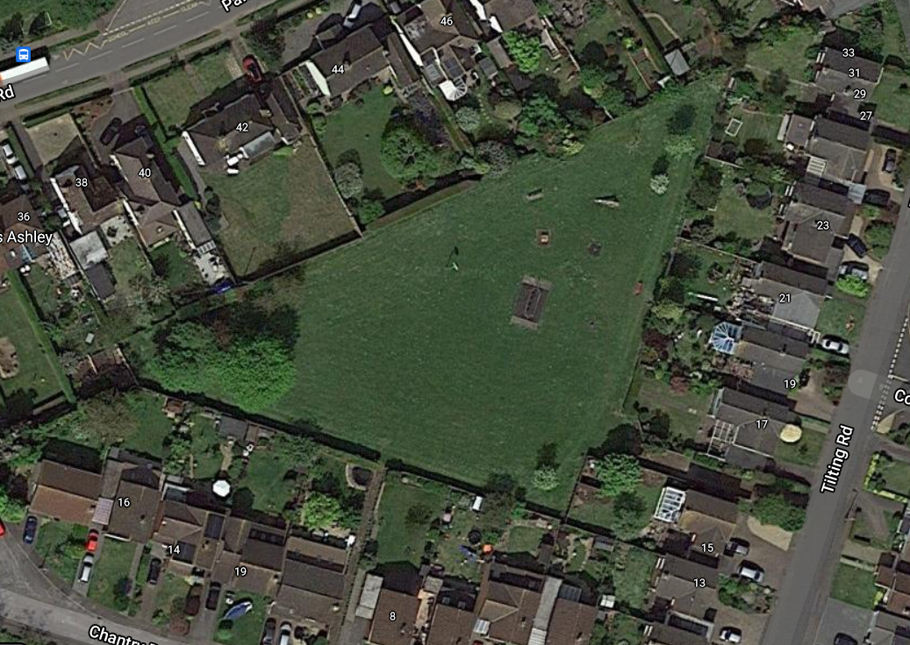

Existing Play Area and Surrounding Green Space

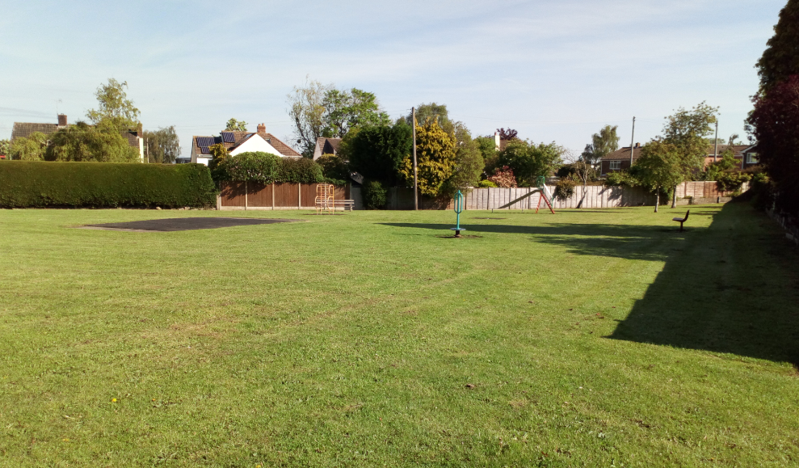

Some of the Existing Play Equipment

