Below are proposed Layouts for the Solar panels at each location.
It is the responsibility of the contractor to confirm building dimensions and layouts, these are for indicative purposes only.

Willowbrook Panel Layout.
Includes Roof Size.
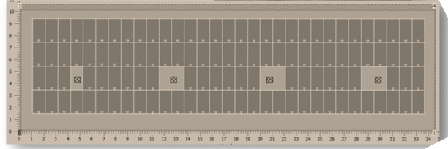

Civic Hall Panel Layout
See Dimensions separately.
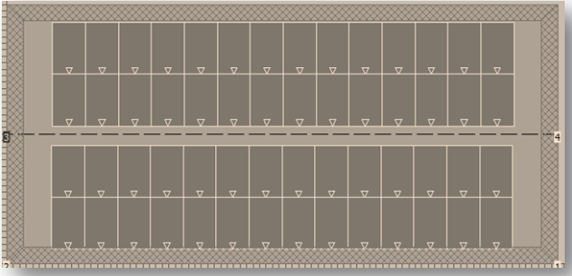
Approximately 25meters by 9meters.

Outdoor Services Building.
Includes Dimensions
