Annex A

Schedule of Mannequins

Insight Gallery Mannequins | COLOUR
2 x standard short torso mannequins for 1961-06-2-1 and 1973-03-8-17 | Cream mannequin, Pole RAL 7047 telegray 4
2 x longer torso mannequins for 1994-03-198-1 and 1974-11-31-1 | Cream mannequin, Pole RAL 7047 telegray 4
1 x new pole and baseplate for 1959-11-74-1 | Cream mannequin, pole RAL 7047 telegray 4
West Indian Soldier Mannequins
1 x full male mannequin with head, with pole and baseplate  Zouave Uniform jacket, shirt, breeches & Fez hat  1970-07-17-3, 1974-03-97-3, 1963-09-312-2, 1955-03-64-1 | Black mannequin, Pole and base plate black
1 x male torso mannequin with no head, short pole and baseplate  1974-02-117-1  Jacket, short frogged, officers’, Jamaica Light Horse, worn by Isaacs Gomez da Costa, 1830 (c). | Black mannequin, pole and baseplate

IMAGES OF UNIFORMS FOR INSIGHT MANNEQUINS

1961-06-2-1

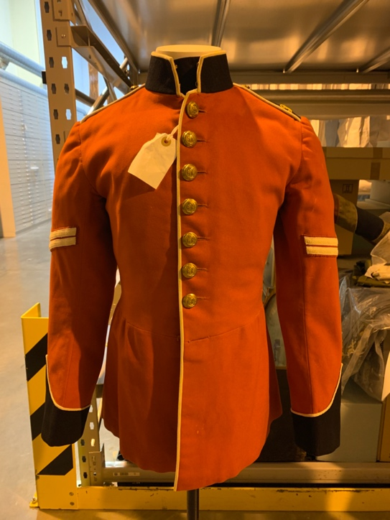

1994-03-198-1

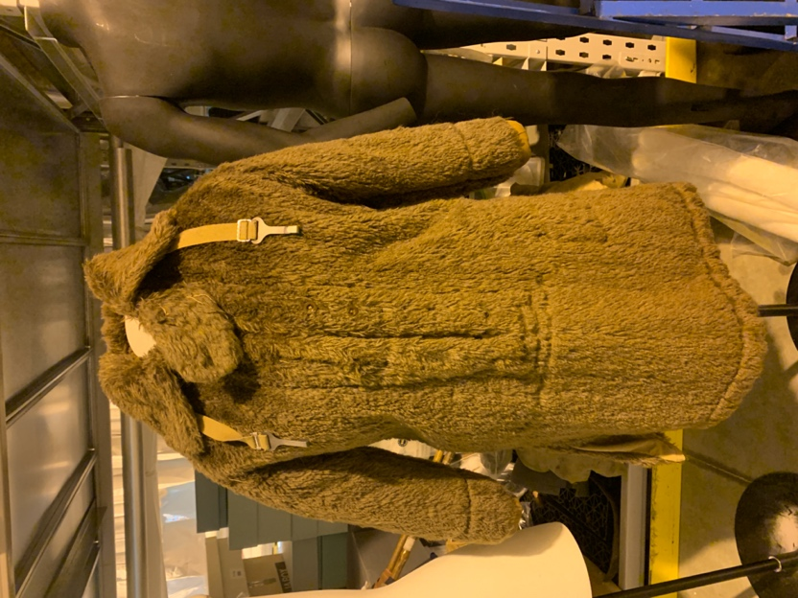

1973-03-8-17
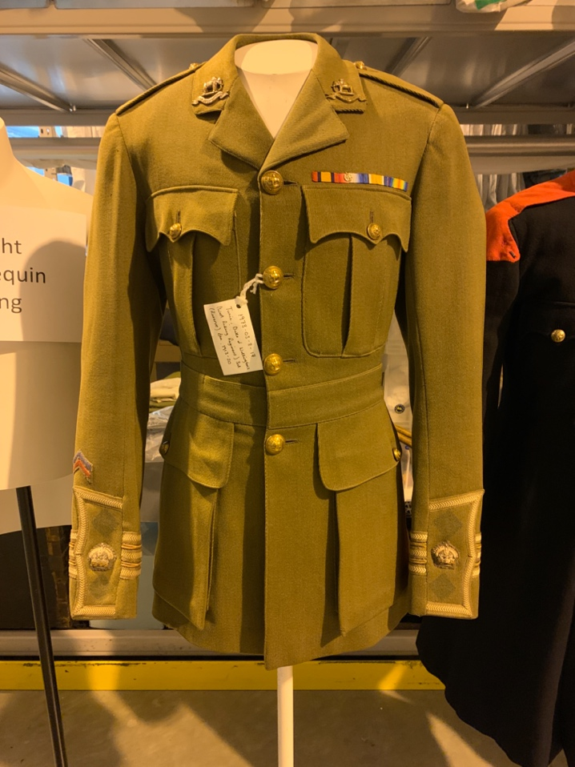

1974-11-31-1
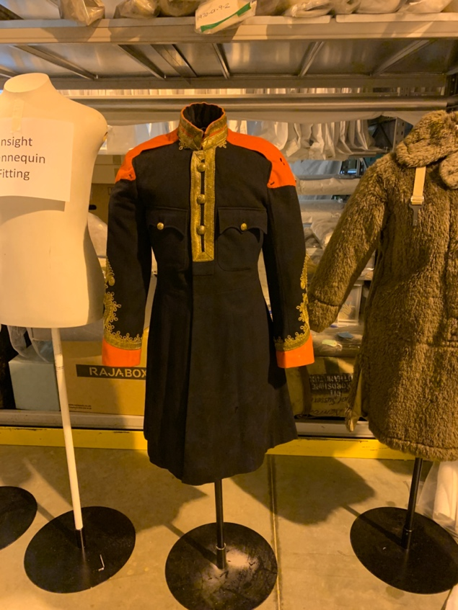

IMAGES OF UNIFORMS FOR WEST INDIAN SOLDIER MANNEQUINS:

1974-02-117-1Jacket, short frogged, officers’, Jamaica Light Horse, worn by Isaacs Gomez da Costa, 1830 (c).

Zouave Uniform jacket, shirt, breeches & Fez hat
1970-07-17-3, 1974-03-97-3, 1963-09-312-2, 1955-03-64-1

