Key objects for Nuclear Deterrent exhibition:

Nameboards:

* Revenge
* Resolution
* Renown

RNSM A31/01/83: Port Crew Patrol Flag from HMS Resolution

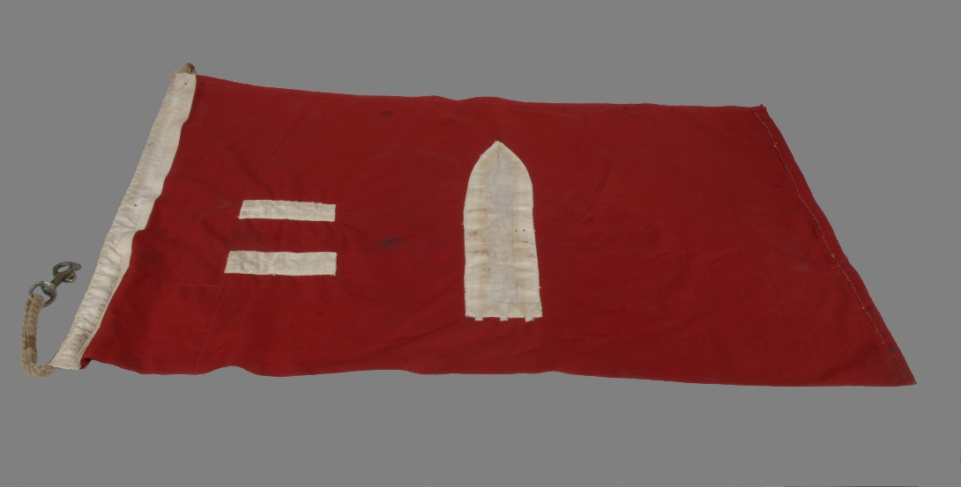

RNSM 2002/302/3: Keys for firing unit of HMS Repulse

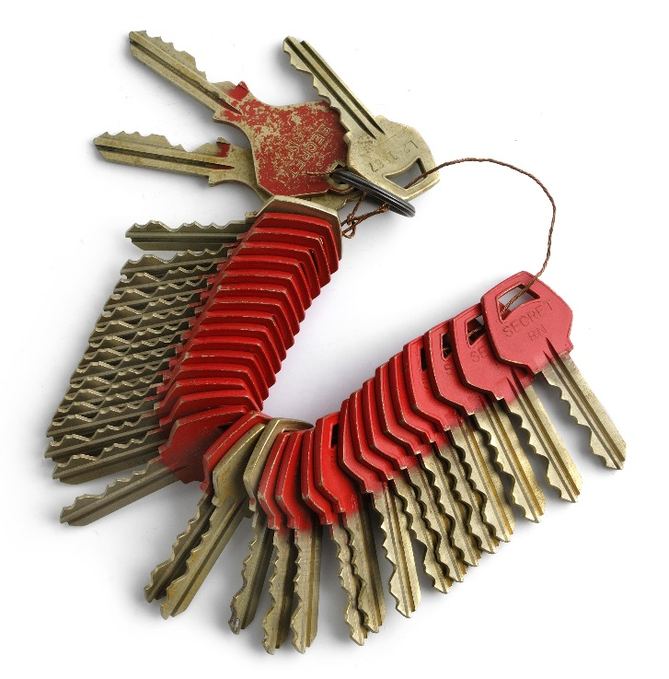

RNSM 2001/1263/1: Polaris firing trigger

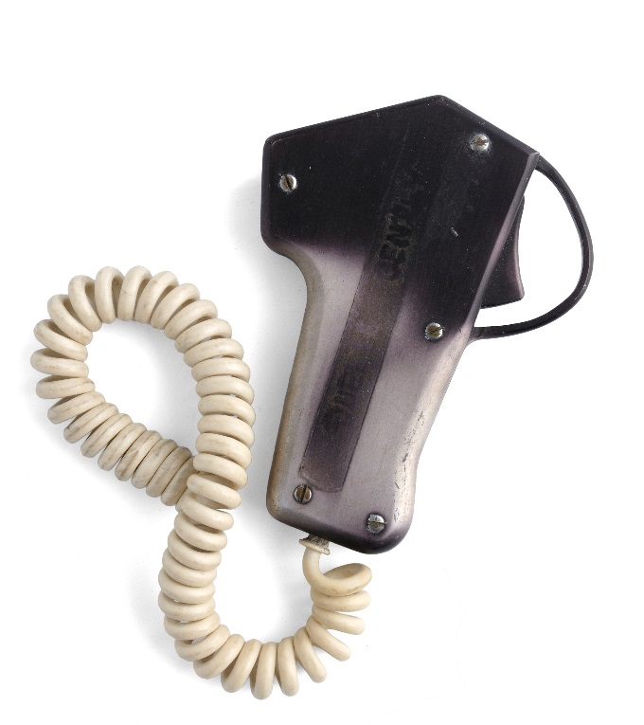

RNSM 2007/56/1: Paperback books taken on Polaris patrols

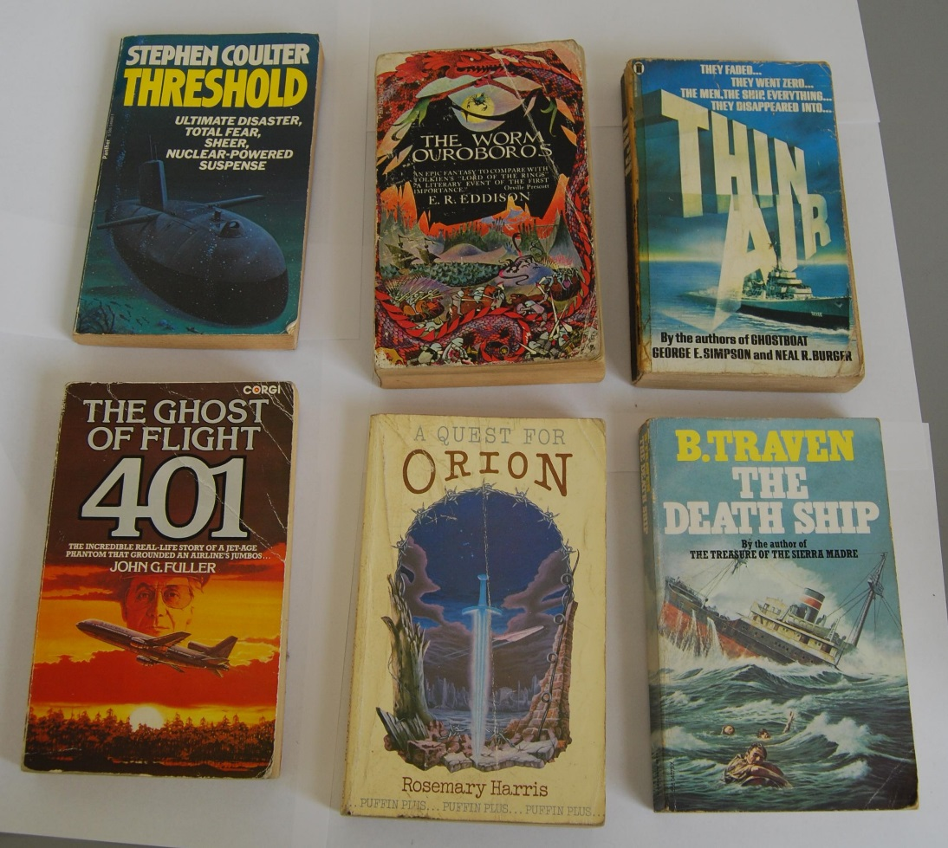

RNSM 2015/14/1: Plaque for HMS Renown

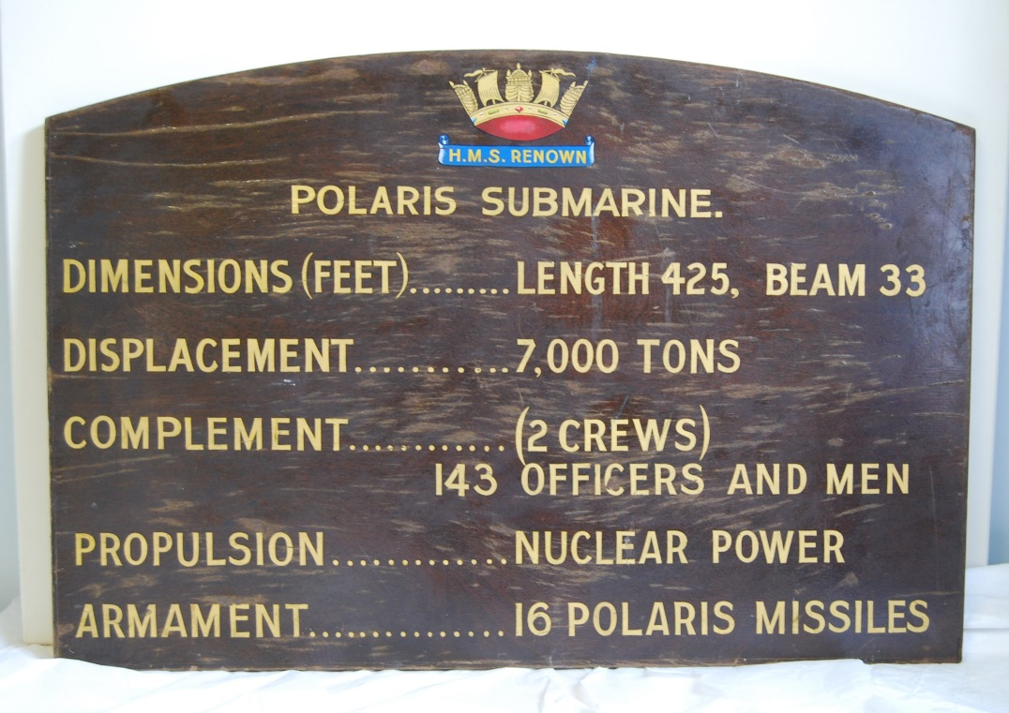

RNSM 2002/223/5: T-shirt from HMS Repulse

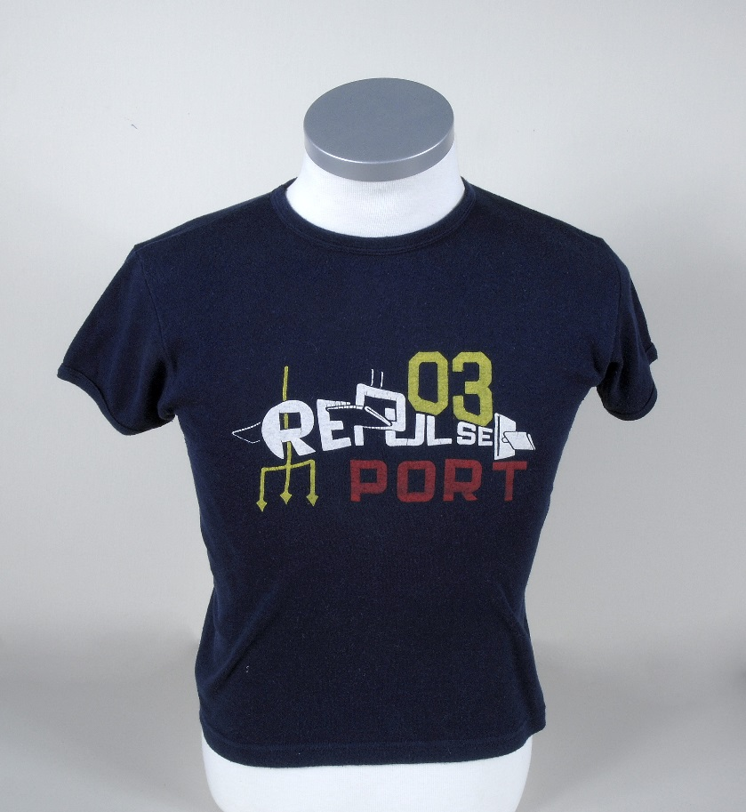

RNSM 2001/1832/1: Radar Mast from Resolution class submarine

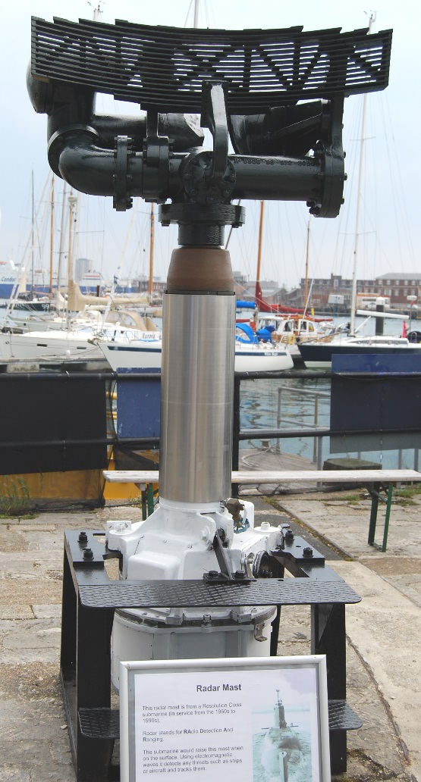

RNSM P31/01/83: 100th Polaris Patrol Tankard of HMS Resolution

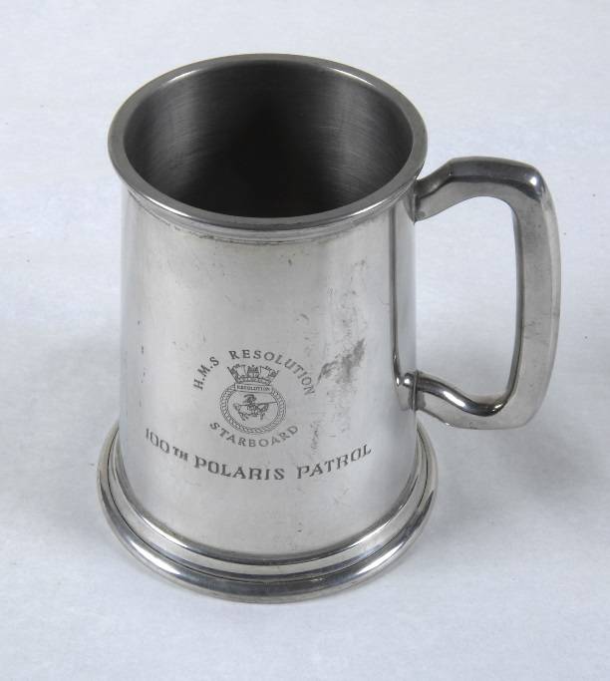

RNSM 2007/60/2: 'Housewife' sewing kit of David Heap (and used on Polaris submarines)

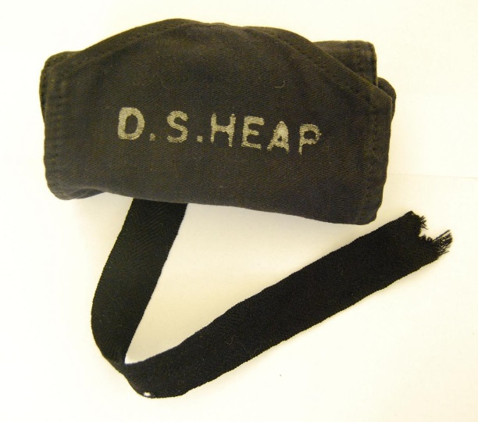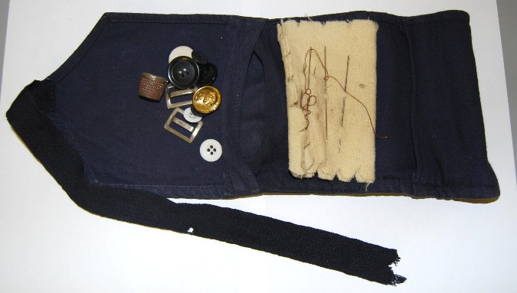

(Part of a collection of items that were used on Polaris submarines, including hair clippers, shirt, socks, cards, kit bag. The majority of this is on display in the Bunk Space Display, upstairs, JFB Building).

RNSM 2008/33/1: T-shirt from HMS Repulse (Port Crew) Summer Cruise 1988

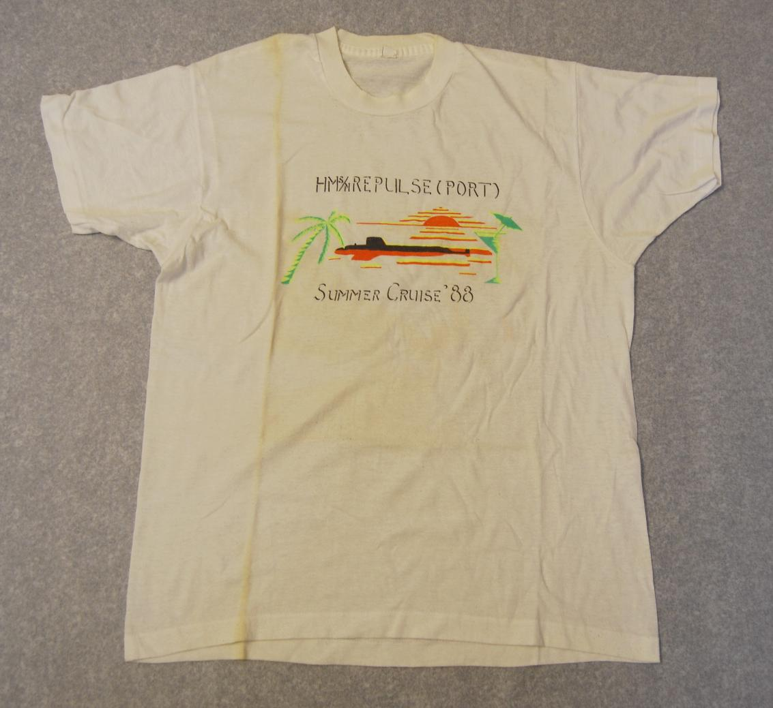

RNSM 2013/3/15: Drawing of SSBN Submarine, ‘It’s Genuine Ming!’

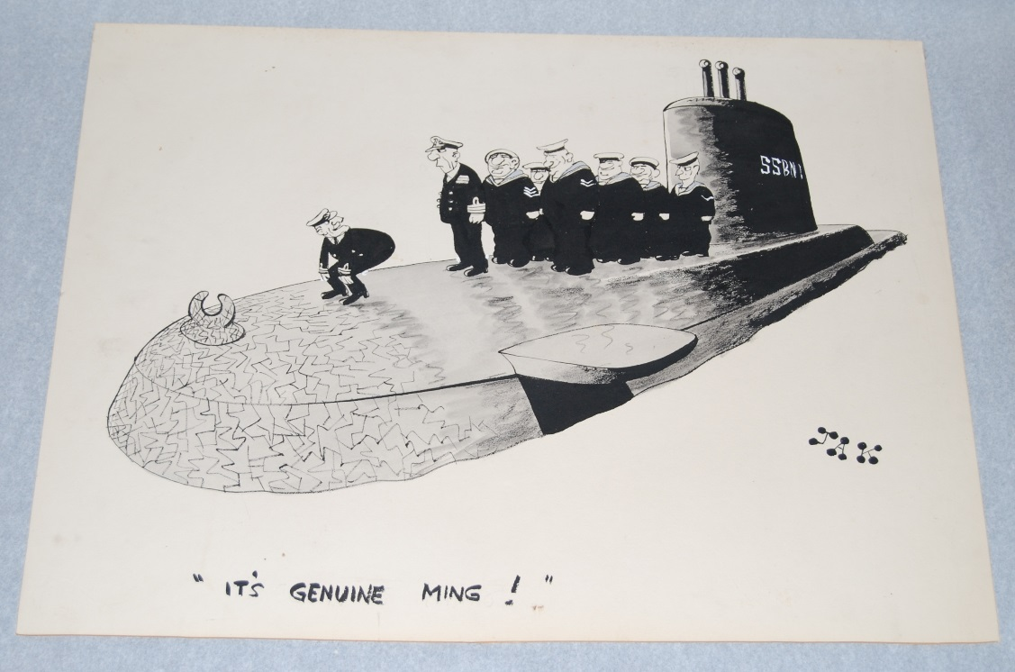

RNSM 2001/1192/1: Plaque to commemorate end of Polaris subs

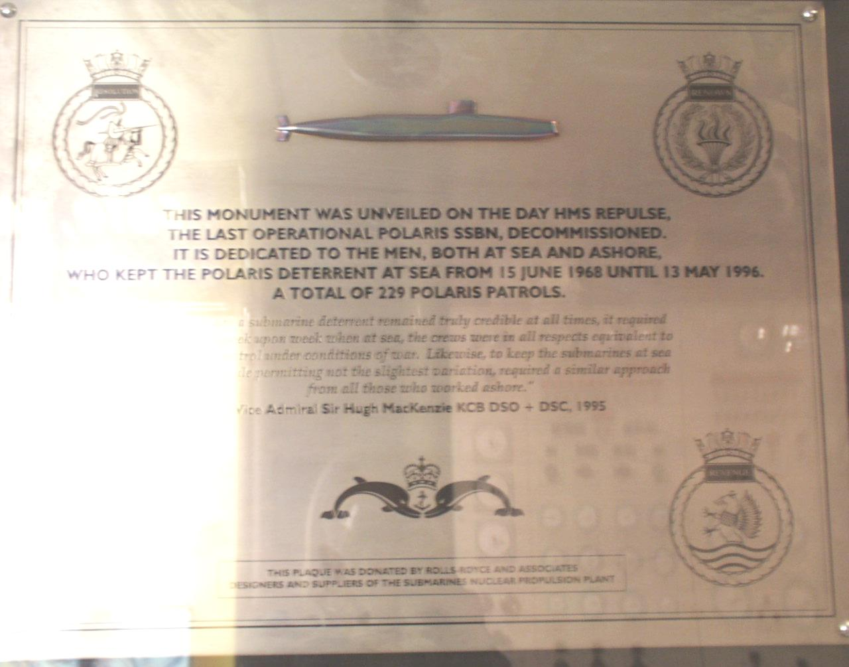

Resolution Certificate:

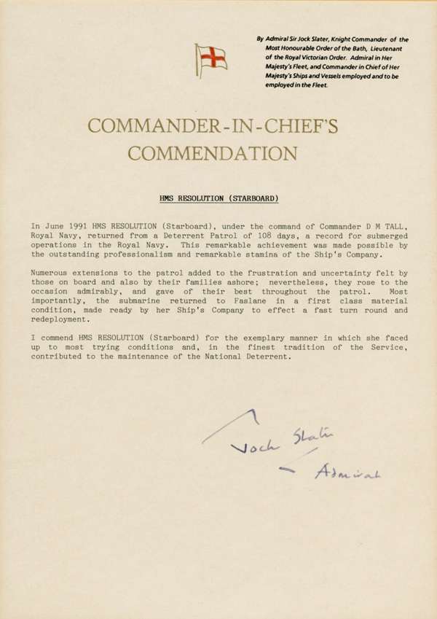

Polaris nose cone

Currently on display at the Explosion Museum, Missiles Gallery

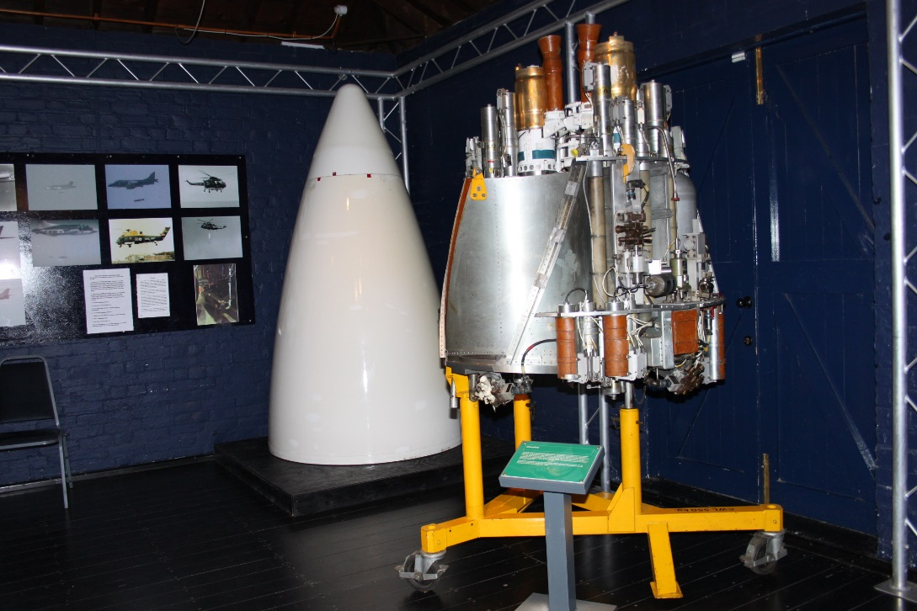

Renown bell with christening names.

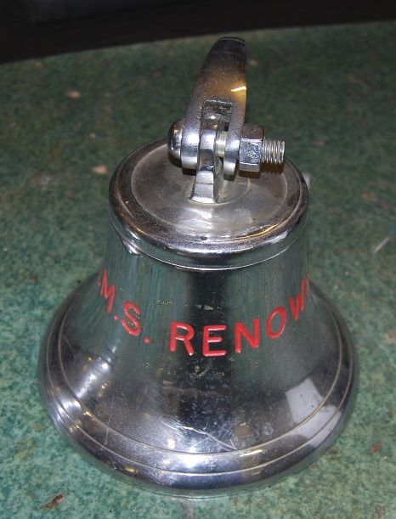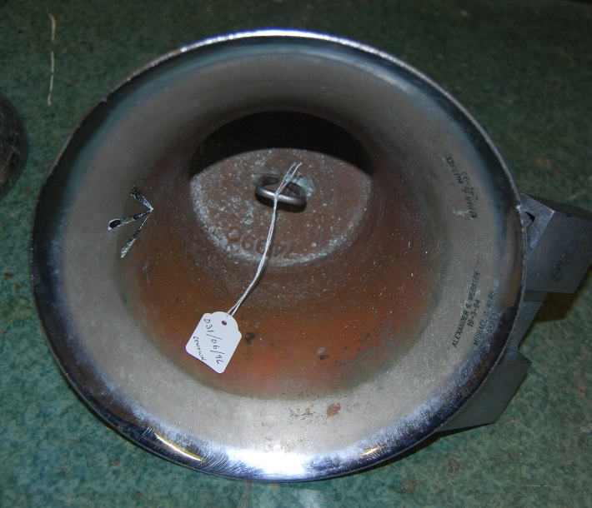

Polaris badges.

