Planning for measures to control water quality agricultural impacts

(for discussion)

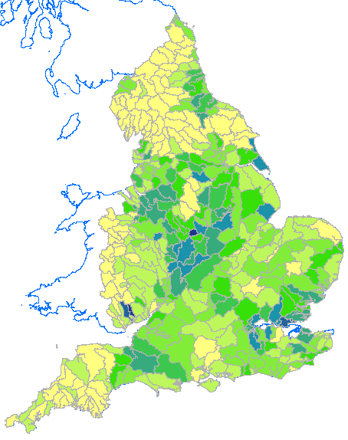
N Murdoch E&B | May 2018

Contents
1. Purpose 3
2. Scope 3
3 Determining Reductions 3
3.1 Modelling 3
3.2 Model Outputs 4
4 Determining Measures 4
5 Making Decisions 4
Appendix 1 Fair Share 5
Appendix 2 Impact and related maps (from SAGIS_SIMCAT) 8

1. Purpose

The purpose of this note is to describe:
- how to determine the required agricultural impact reductions to meet a water quality target
- how to decide which measures to apply to secure this reduction
- or if measures are not available (for reasons consistent with the regulatory context eg technical feasibility, affordability) what actions to take.

2. Scope

The scope is the Water Framework Directive and River Basin Management Plans, for the pollutant, Phosphorus.
Much of the approach may be applicable to other areas; differences will arise with regard to sector apportionment and related fair share issues, and what to do in the event of remedial measures being unavailable.

3 Determining Reductions

Environmental Quality Standards (EQS) are used to specify the target water quality. This target is then compared with monitored (or inferred) water quality. Where the latter exceeds the target, reductions in inputs will be considered.
Where a number of sectors, eg Water Industry and Agricultural, are involved a means to apportion the reductions across sectors is needed. For WFD, this is based on the fair share principle (see appendix 1).

3.1 Modelling

Modelling is used to calculate the impact of each sector and its target share. Here impact means concentration, specifically annual mean concentration for phosphorus. By comparing its current impact with target share, the required reduction is identified. This reduction may be expressed as a percentage of the current concentration. The reduction factor so calculated applies equally to loads; a 20% reduction in impact concentration will occur if there is a 20% reduction in input loads.
The modelling system used is SAGIS-SIMCAT. It takes sector loads as inputs and computes their combined impact in river systems, going from headwaters to coast. River flow data are derived from Low Flow statistics and calibrated at gauging stations, of which there are approximately 1000 across England. River sample data (from approximately 5000 sites) are used to calibrate the models for water quality. Inputs and outputs are expressed statistically, allowing comparison with EQS.

3.2 Model Outputs

Outputs are available at the following scales:
- Point (every 1 kilometre)
- Water Body
- Operational catchment
- DEFRA Management Catchment
- (River Basin and National summary statistics may also be derived.)

There are a number of issues to consider when deciding appropriate scale at which to work. These issues are:

- Modelling uncertainty
- Catchment homogeneity
- Treating all farmers equally
- Practicality

Consideration of these suggest that:
- Farmer target share should be computed at operational catchment scale. This reduces modelling uncertainty, treats all farmers in the catchment equally (as they have the same target) and is practical, not over complex. Also operational catchments are reasonably homogeneous, unlike the larger DEFRA Management Catchments.
- The same required reduction can be applied to all farmers. This may be refined by looking at the agricultural concentrations at water body scale to identify hot spots.
National model output maps for:
- Current diffuse concentrations
- Required reductions
are appended.
Note that for large parts of the country, the required reductions is high, in excess of 50%.
(Models developed by River Basin Management Services.)

4 Determining Measures

Having determined the required reductions as defined above, FarmScoper can be used to identify the measures to provide these reductions. As mentioned above the percentage found for the required reductions may be applied to the FarmScoper loads.

5 Making Decisions
The above approach determines possible measures.
For River Basin Planning, these measures would then be cost-benefit analysed and if necessary alternative objectives set. From this the chosen measures can be decided upon.

Appendix 1 Fair Share
Targeting action on a fair share basis
When determining what action should be taken to improve or to prevent deterioration of the water environment, consideration should be given to the proportion each sector, business or individual contributes to the problem. Action to reduce pollutants should be targeted on a ‘fair share’ basis, whereby each sector, business or individual deals with its proportional contribution. This approach is rooted in the ‘polluter pays’ principle.
Individual sectors, businesses or individuals are able to do more than their fair share if they are willing to do so and this additional burden is supported, where relevant, by their customers. When a sector cannot achieve its fair share reduction, on grounds of technical infeasibility, we should work with other sectors to identify alternative measures to deal with the problem that are both technically feasible and cost-effective. Any additional obligation imposed on a sector, business or individual, to offset inaction by others, should not compromise its ability to deal with its own fair share.
This ‘fair share’ approach should be applied when developing programmes of measures for protected areas and catchments.
Fair share approach for water quality.
Setting the baseline
In PR09 and PR14 action to improve water bodies under the environment programme drivers was on a strict fair share basis based on the polluter pays principle, unless water companies volunteered to go further. It was assumed that other sectors would also do their share to ensure that objectives were achieved. The baseline for fair share must, therefore, be set to 2009 so that there is no further requirement for sectors that have already reduced their pollution load in line with fair share to have to go further. The establishment of new standards i.e. revised Common Standards Monitoring Guidance targets do not reset the baseline. This means that work carried out by any sector already is not ignored.
Consideration of technical feasibility
Before we will ask other sectors to do more than their fair share there should be evidence available to confirm that measures for some sectors are truly not technically feasible.
Establishing the scale
The Water Framework Directive is based around a catchment approach to planning. A catchment planning approach can, in the right circumstances, do more for the environment following the ‘polluter pays’ principle.
Confirmed approach
Sector shares are determined by their proportion of baseline river concentration at assessment points.

$$sector share \left(\%\right)=\frac{sector concentration}{total concentration}*100$$
Assessment points will depend on the nature of the catchment and will be determined by examination by the interested parties. Assessment points will typically be discharge points, monitoring points, water body entry points and water body exit points. They are selected with a view to maximising compliance, and where there is evidence of eutrophication. Discharge points are the preferred assessment points, but if reasonable, others may be used.
For point sources, their sector share at assessment point is their baseline cumulative (ie sum of all upstream discharge contributions) concentration divided by the baseline river concentration. Our Proportional Catchment Reduction Tool can be used to calculate this from baseline catchment model outputs.
For the diffuse sector it is preferable, for reasons of equity and practicality, to have a single share value. Otherwise some operators will be treated differently, hence unfairly, compared to others. A single diffuse sector share value is calculated from the assessment point values (via a form of averaging) thus:
$$diffuse sector share\left(\%\right)= \frac{\sum{diffuse concentration}}{\sum{total concentration}}*100$$
where the summation is over the assessment points.
A similar single catchment share figure may be derived for the point sources. This may be used, as an alternative to the above, for calculating the point source solution, providing the potential for compliance is not compromised. A single share figure may simplify the application of the catchment permitting option.
Here share means the share of the target (EQS) allotted to each sector.

Additional note: Applying Fair Share for diffuse sector at Operational Scale
- Sector target share will be proportional to sector share at baseline year. The greater the sector share at baseline the greater the target share.

- The mean diffuse concentration in the operational catchment is obtained from the SAGIS-SIMCAT models and selecting type’6’ features; which are plotting points every kilometre.

- The national average diffuse concentration is 0.071 mg/l. (Arable 0.015mg/l, Livestock 0.35 mg/l, Urban 0.020 mg/l)

- There are a number of ways to calculate the point concentration for the operational catchment. These are:
  - Option 1 – monitoring points
  - Option 2 – downstream discharge points
  - Option 3 – all points
  - Option 4 – 85th percentile of all points

- These options give different estimates of the point source contribution. On a national scale they are:

Option | Concentration (mg/l)
1 | 0.184
2 | 0.398
3 | 0.101
4 | 0.395

- Traditionally fair share has been calculated at downstream discharge points (option 2) for point sources. Clearly an all points (option 3) calculation would much diminish the point source target share. This is because point source impacts are impulsive rather than evenly distributed as (relatively speaking) for diffuse. This impulsive characteristic has been reflected in choosing the discharge points as assessment points. Option 4 is an alternative way to take account of the spatially impulsive nature of point source impacts. The advantage with option 4, which is close to option 2 in value, is that it avoids situations where a single discharge in a catchment has a large local, but not catchment wide effect, which would otherwise result in a unrealistic low share for diffuse.

- Option 4 will be consistent with the PR19 approach for point sources, and is recommended for calculating the diffuse share.

- Below comparisons between option 2 and option 4 are presented.

Appendix 2 Impact and related maps (from SAGIS_SIMCAT)
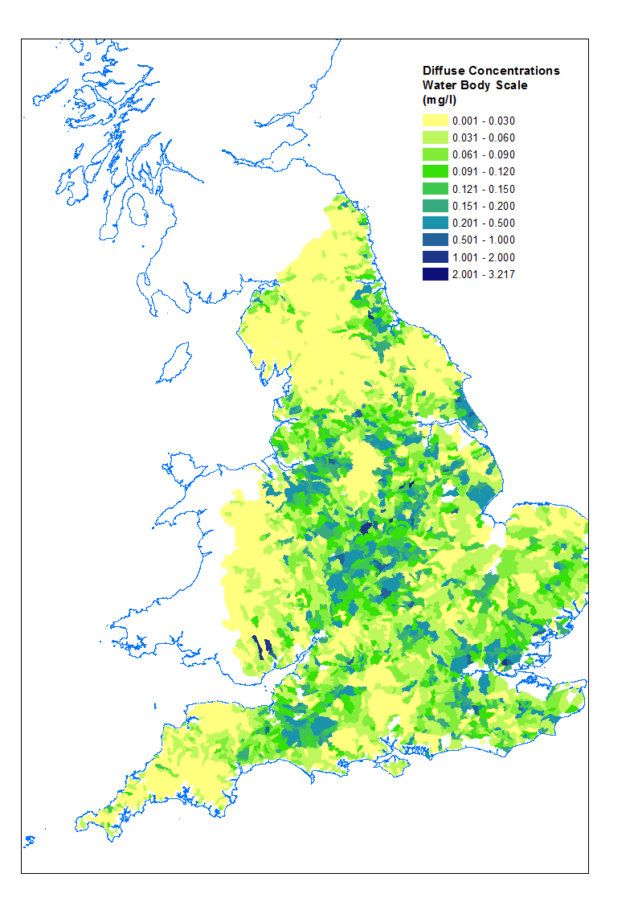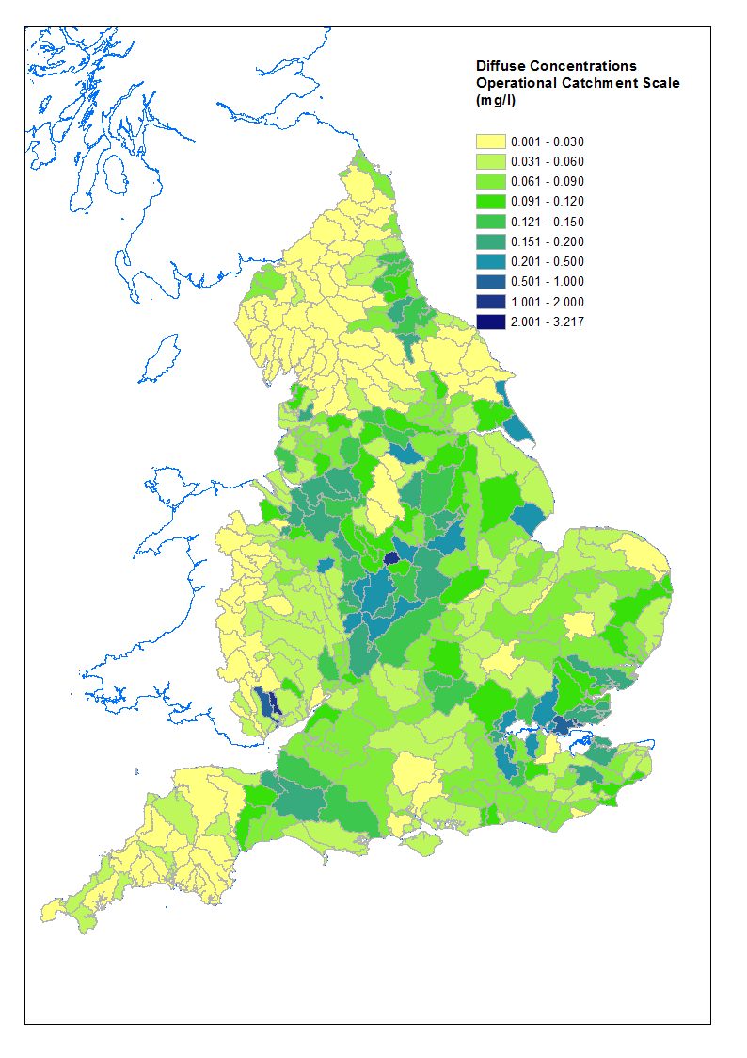
Figure 1. Diffuse concentrations

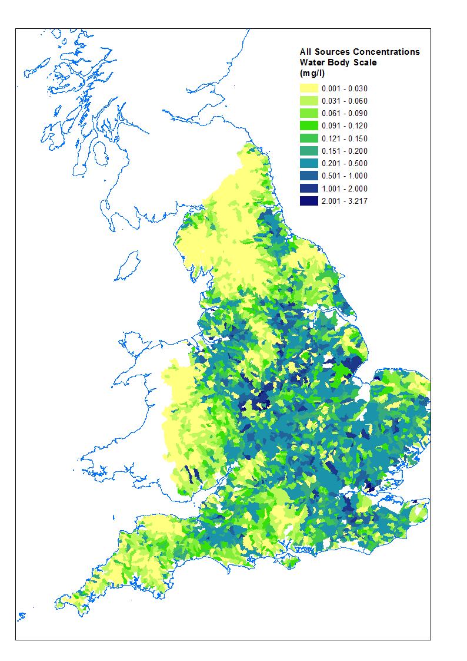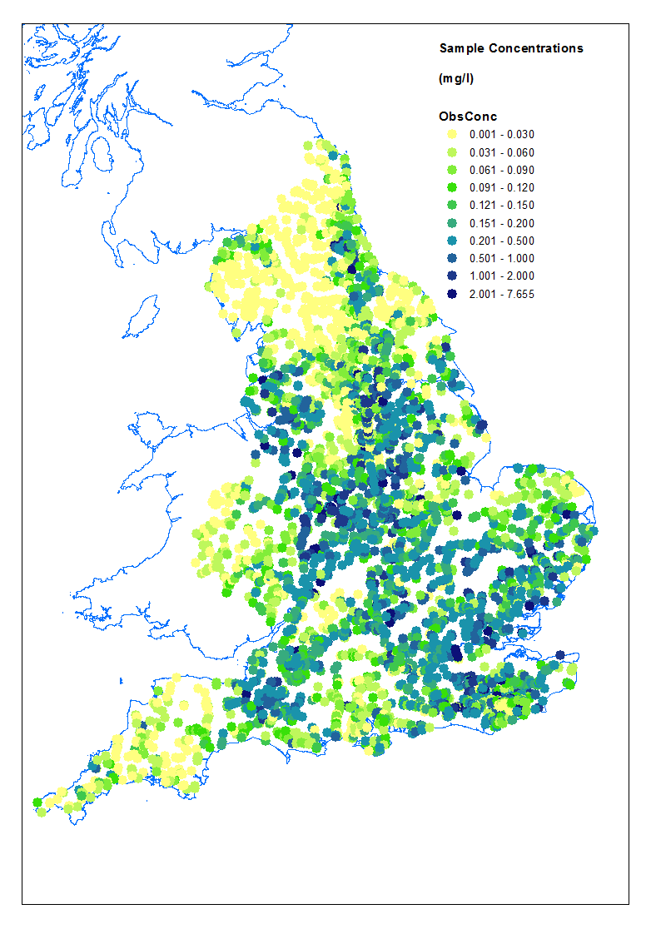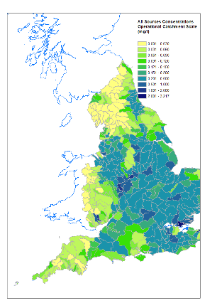

Figure 2. All sources concentrations
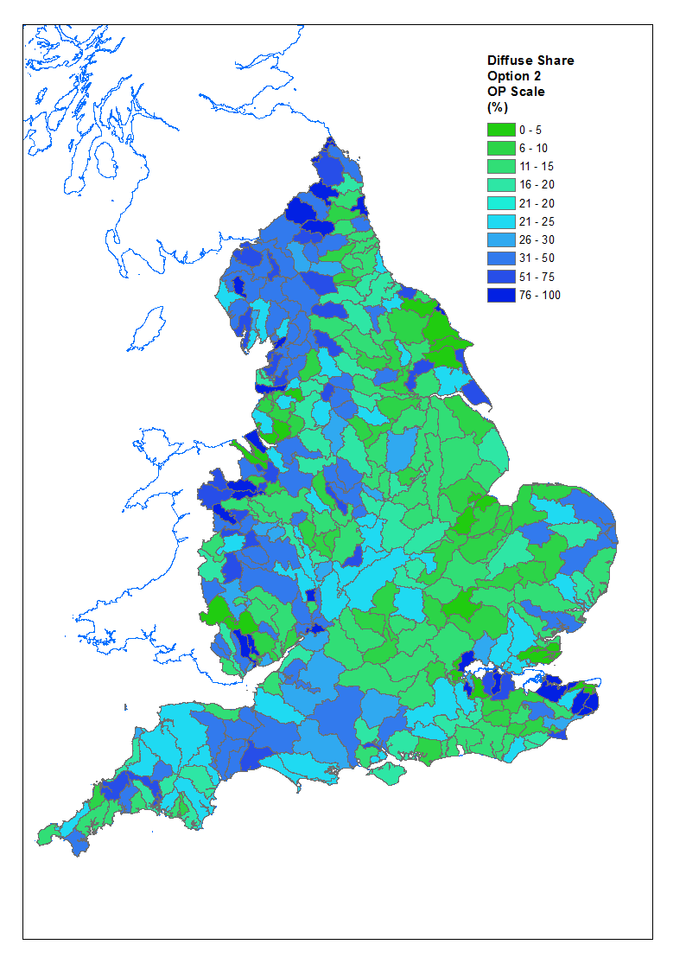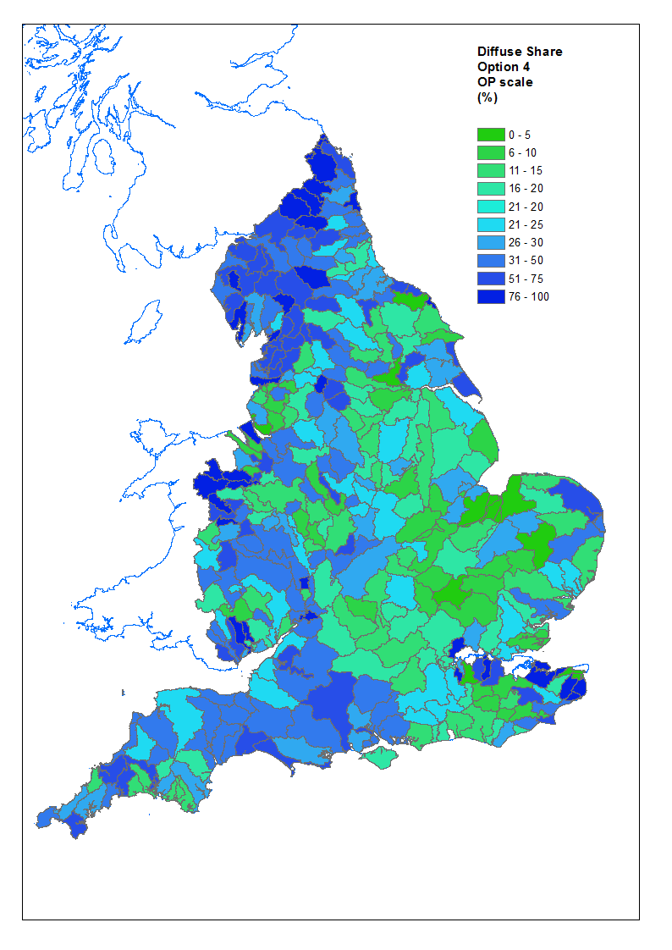
Figure 3. Diffuse Share estimates (mean 24% by option 2, 34% by option 4).
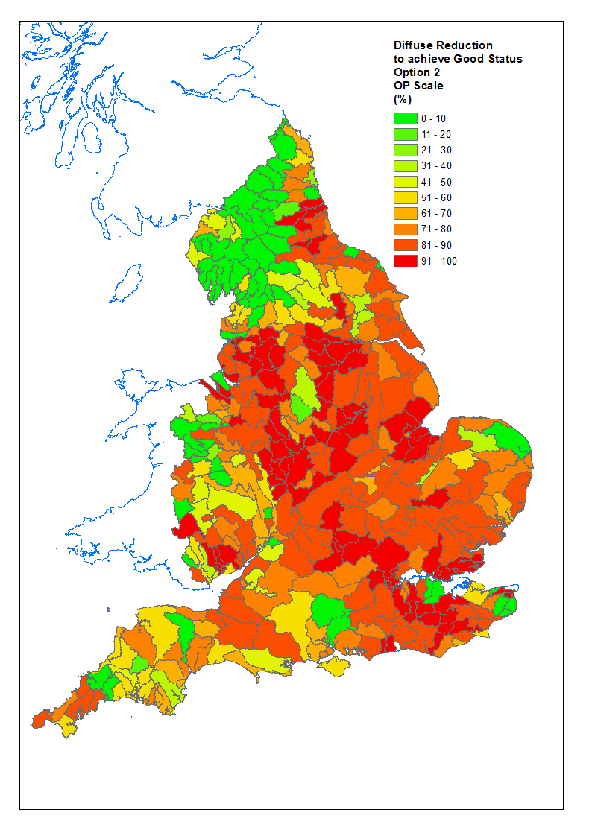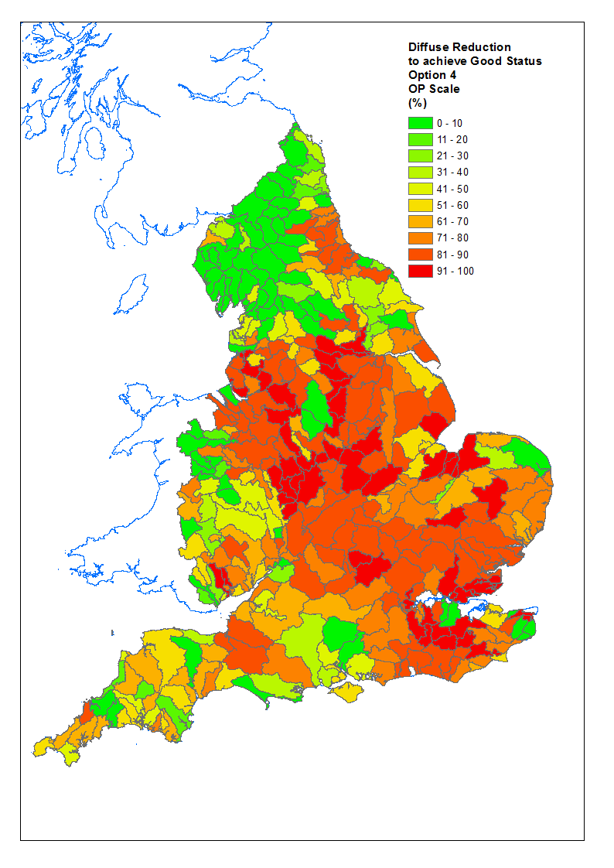
Figure 4. Diffuse reduction estimates, to achieve ‘good’ status.
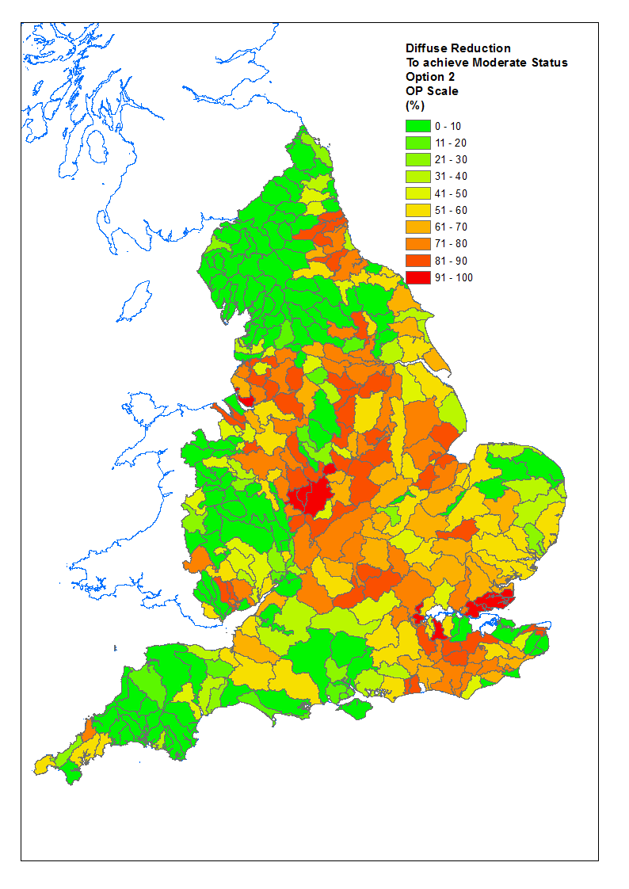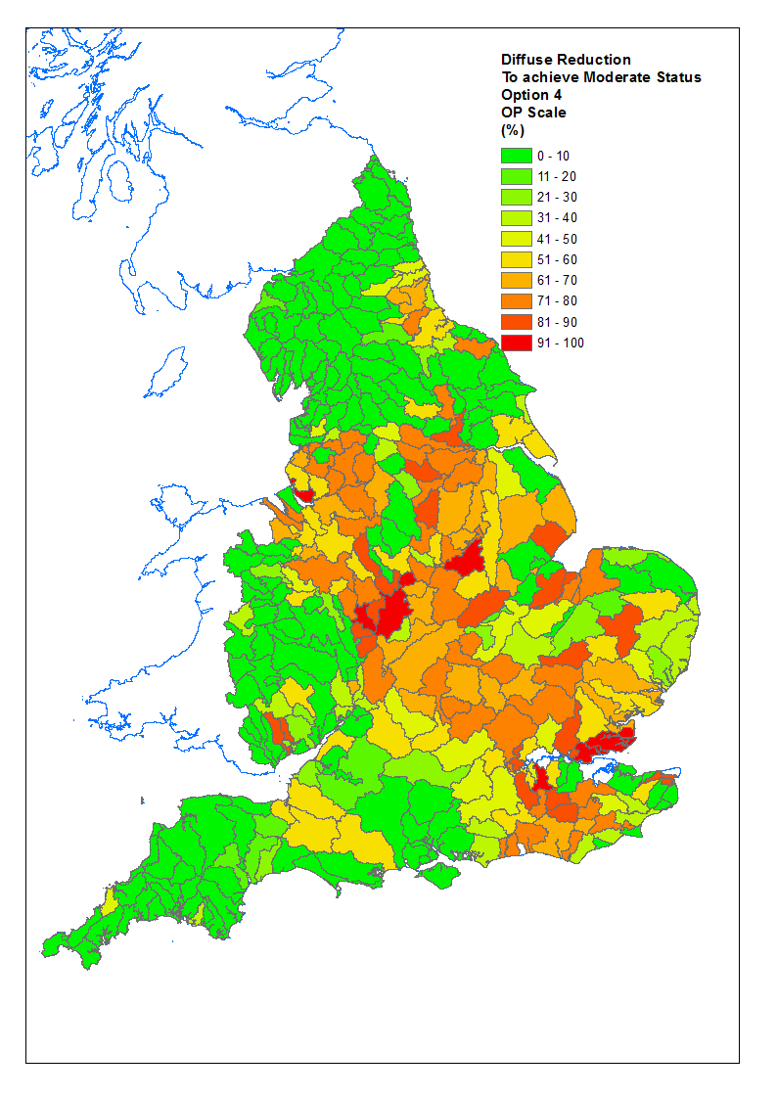
Figure 5. Diffuse reduction estimates, to achieve ‘moderate’ status.
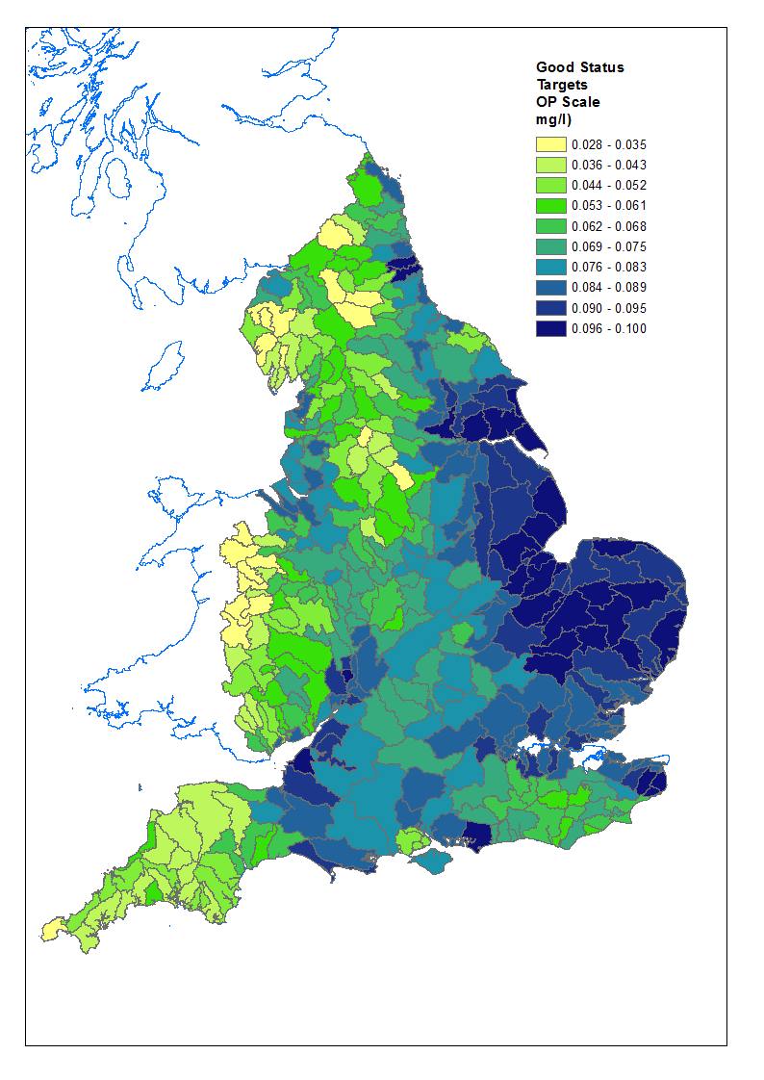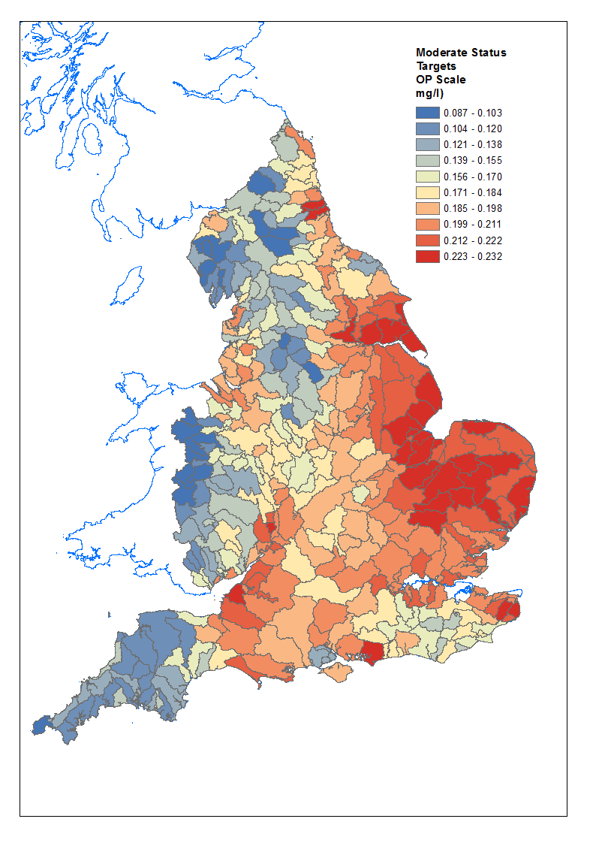
Figure 6. WFD status targets. For P.

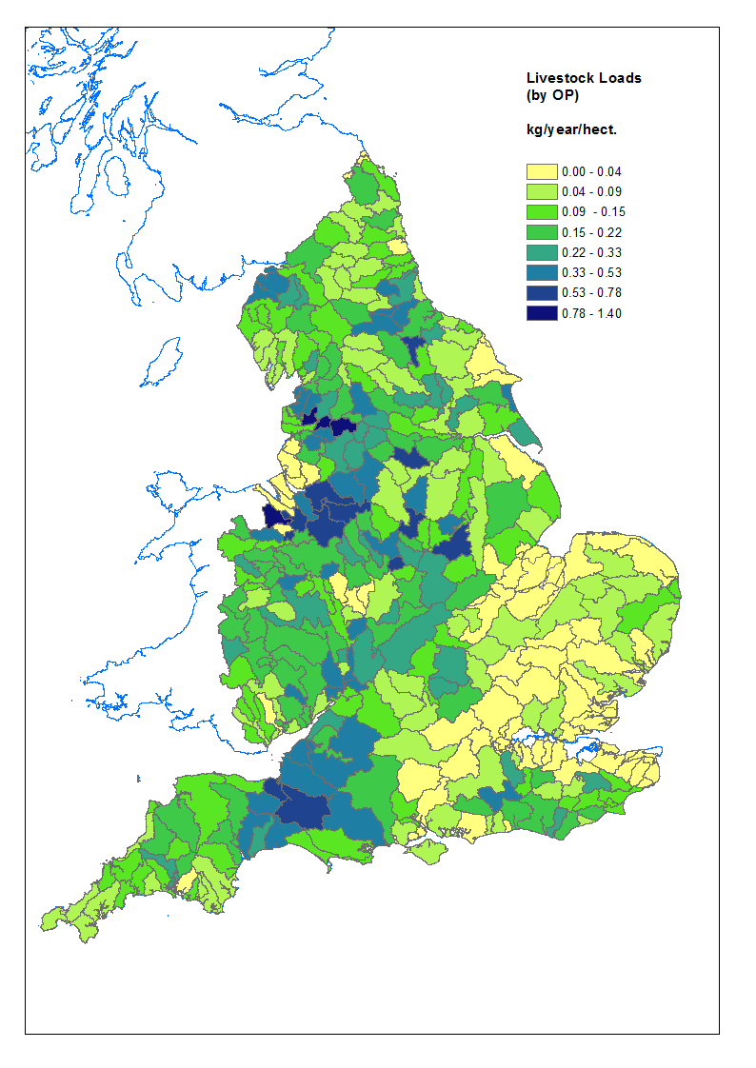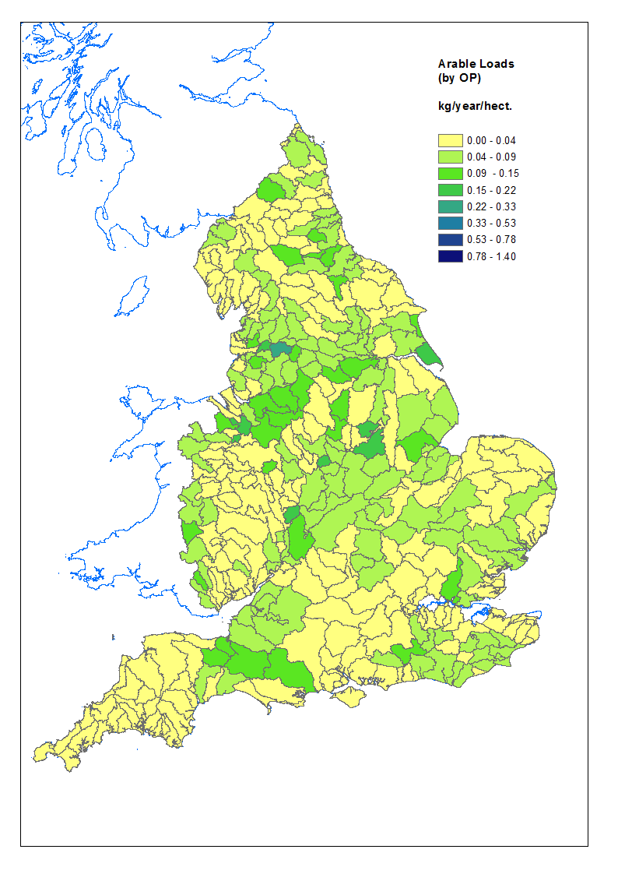
Figure 7 Agricultural loads input to rivers.

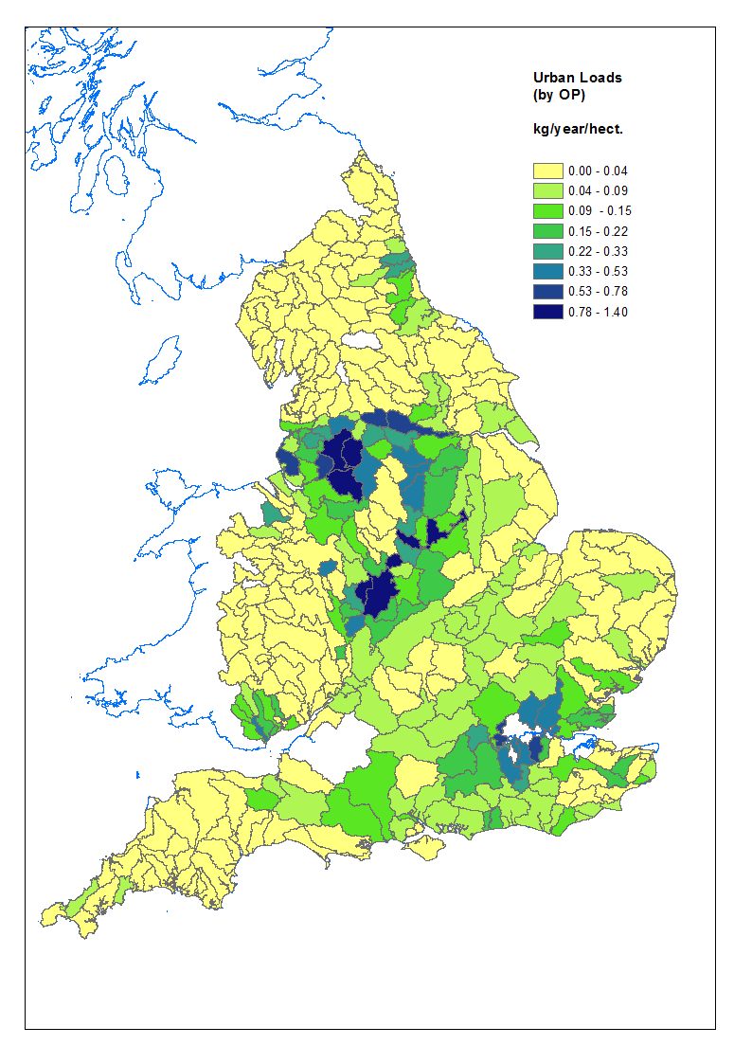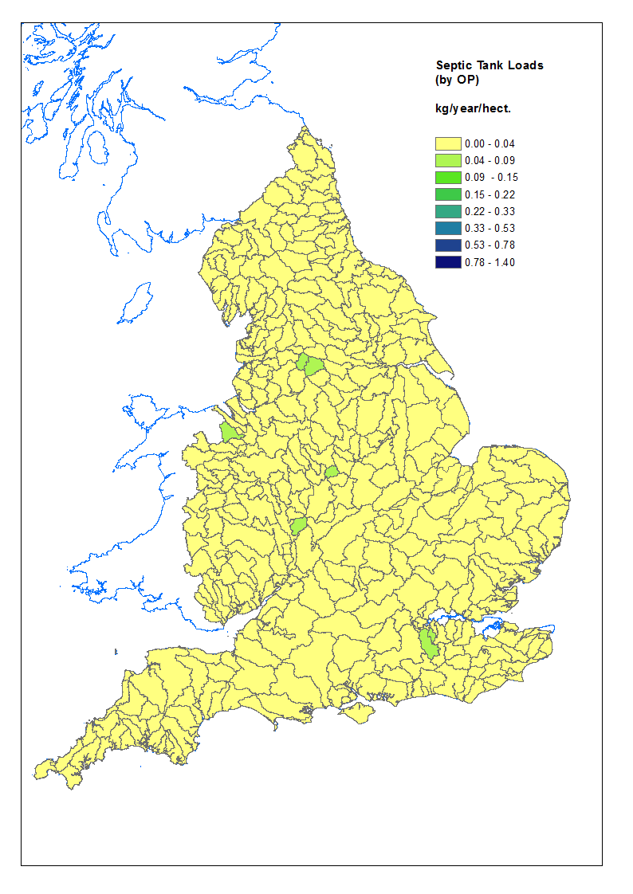
Figure 8 Urban and septic tank/small discharge loads, input to river system.

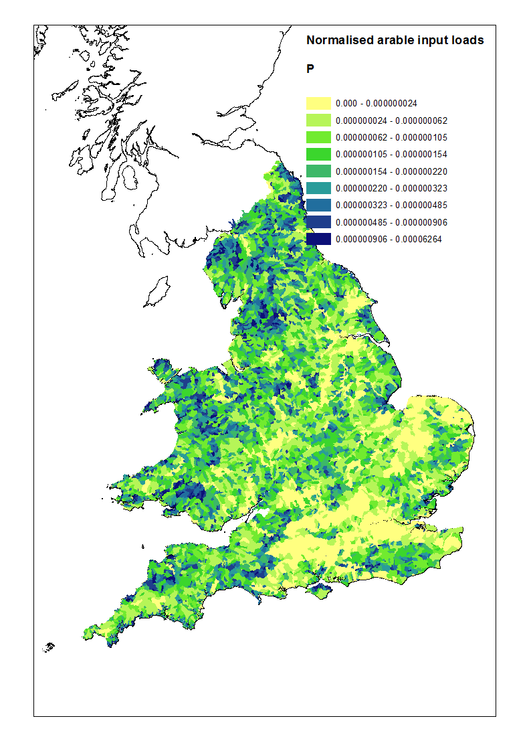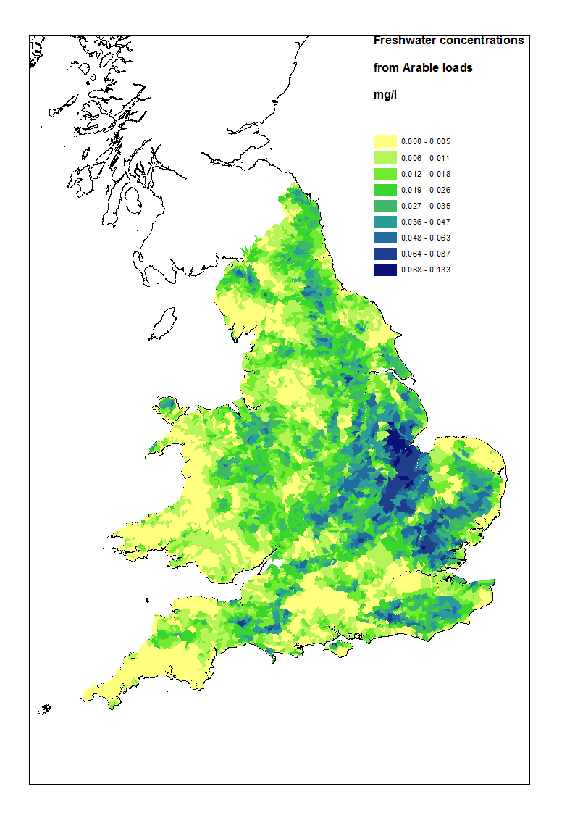
Figure 9. Comparison of arable loads and concentrations.

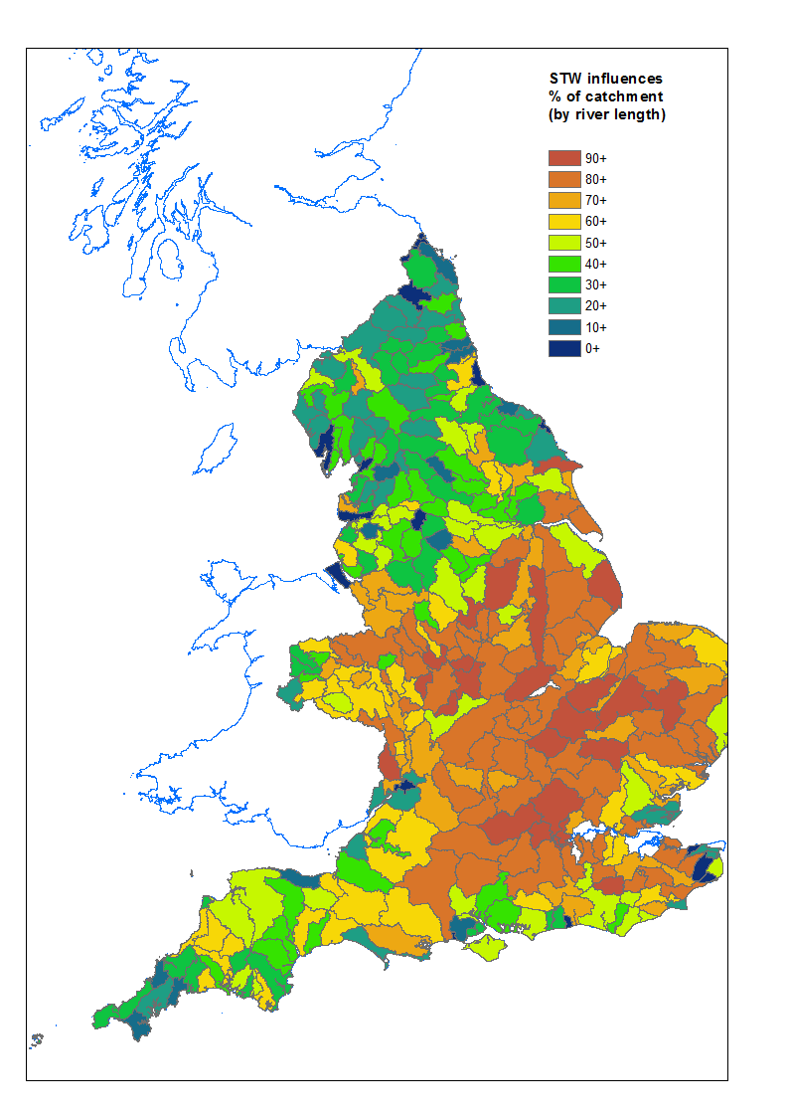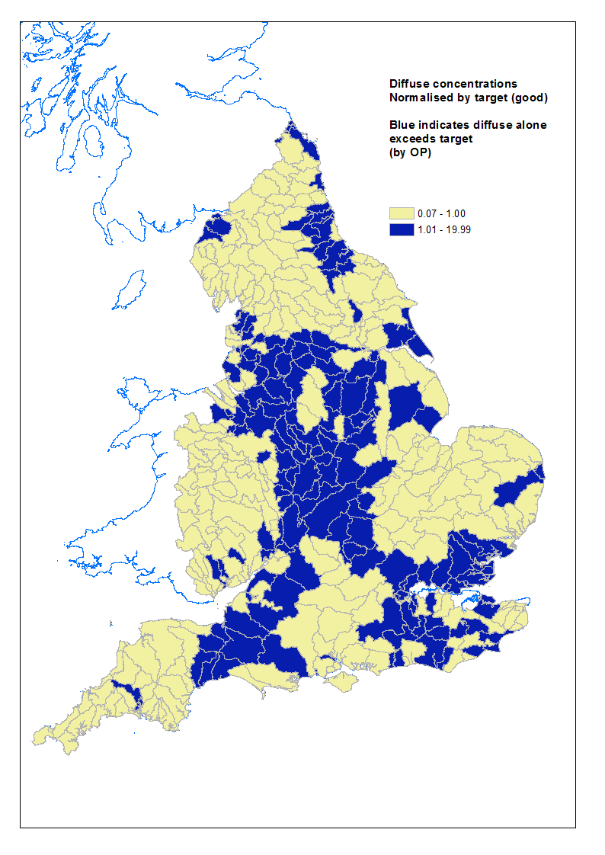
Figure 10. Percentage of catchment influenced by STWs. Figure 11. Diffuse concentration, normalised by Good Target.

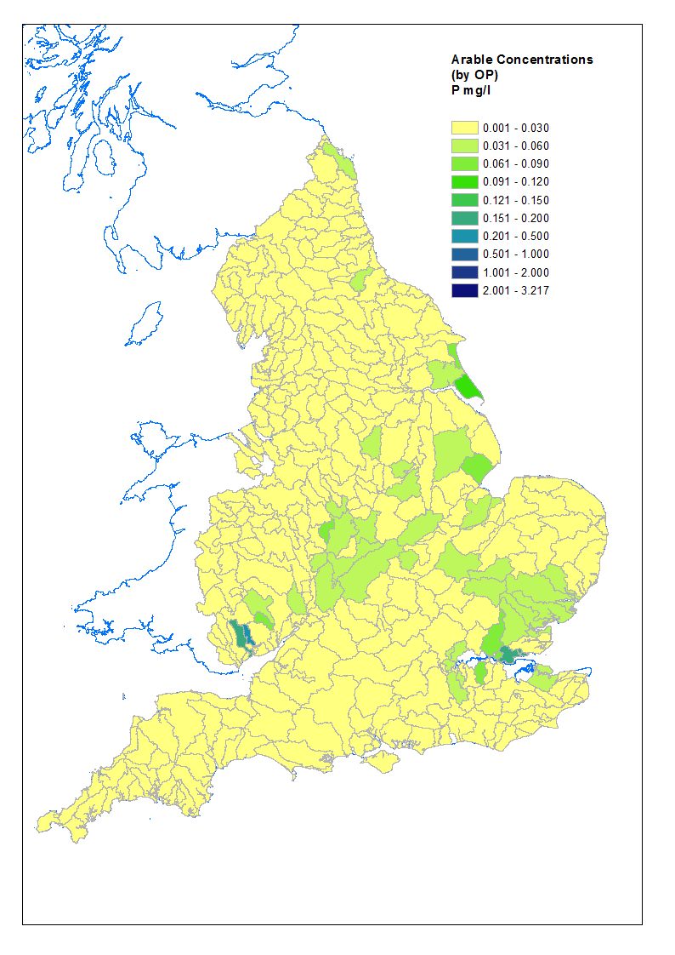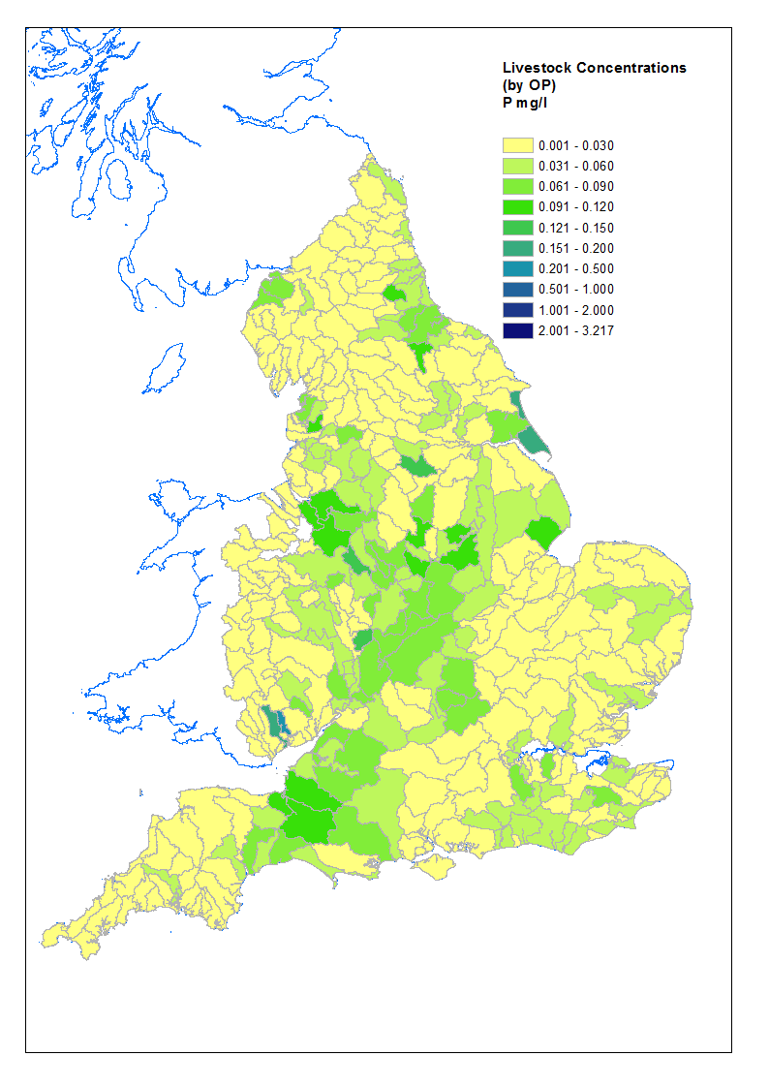
Figure 12 Arable concentrations, by Operational catchment. Figure 13 Livestock concentrations, by Operational catchment.

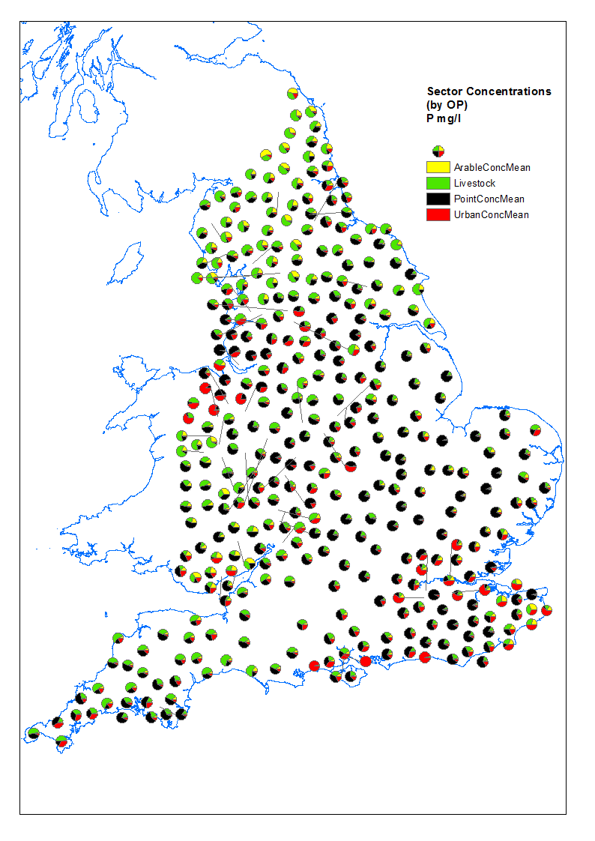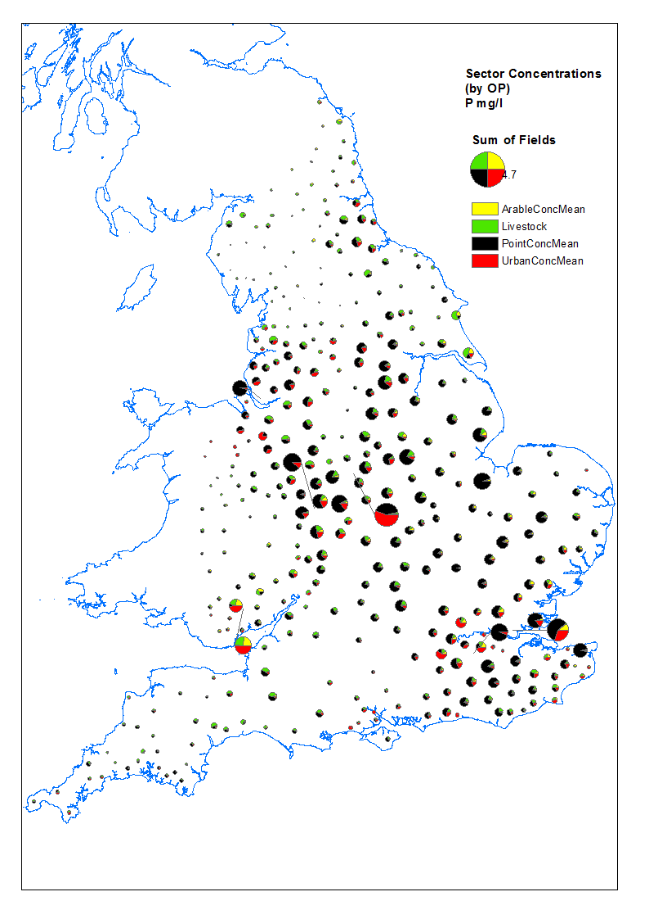
Figure 14. Sector concentrations, by OP. Figure 15. Sector concentrations, scaled by size, by OP.

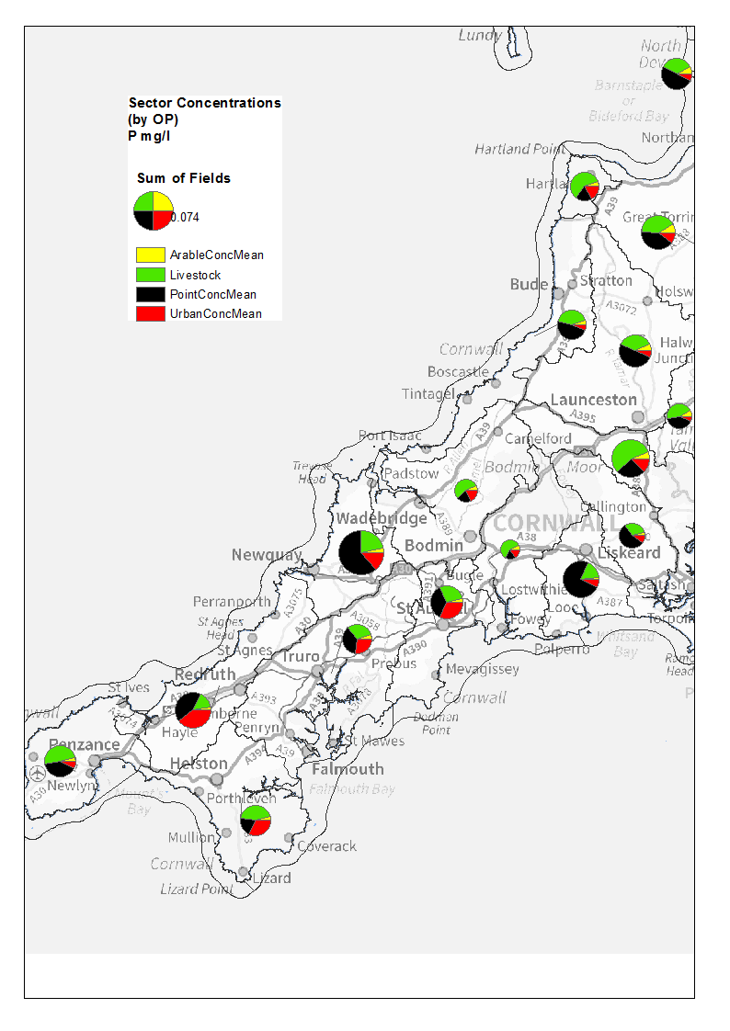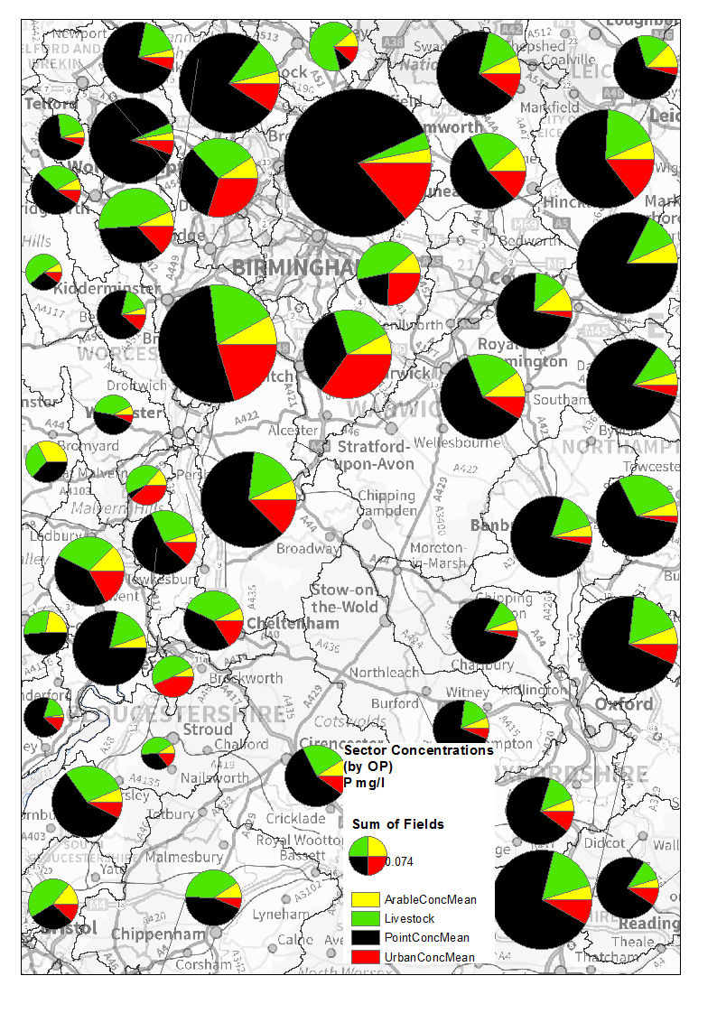
Figure 16. SW sector apportionment. Figure 17. Midlands sector apportionment (same scale as figure16).

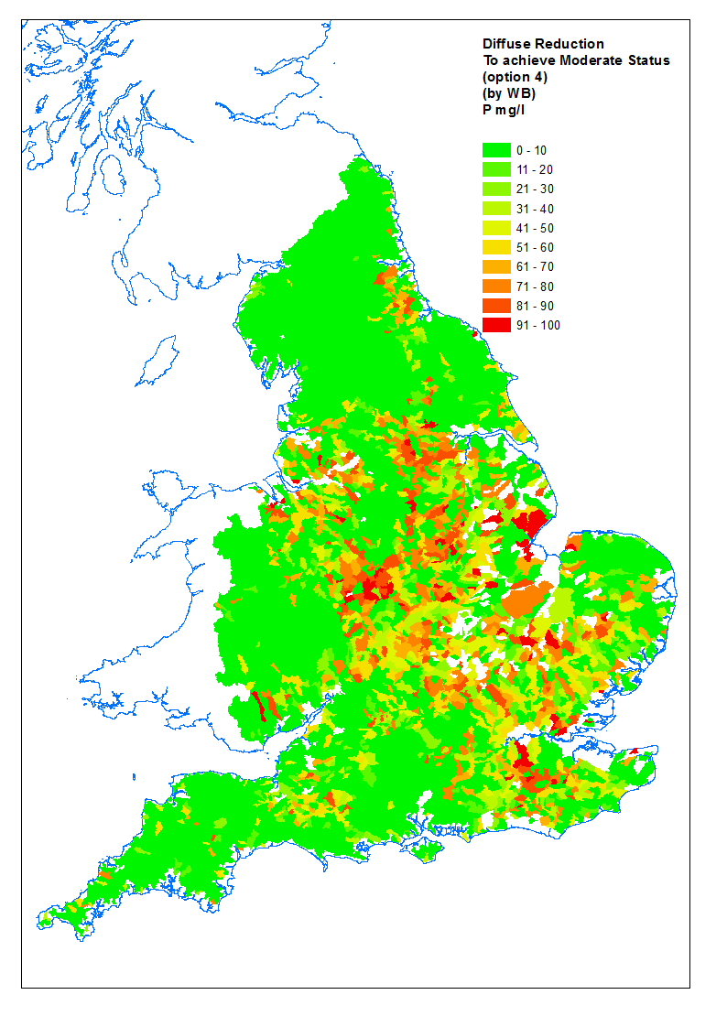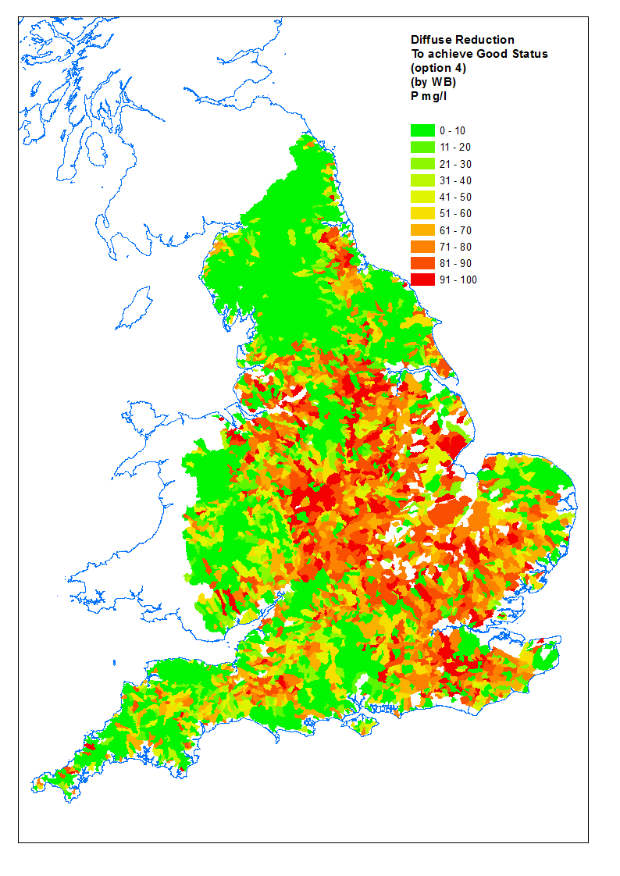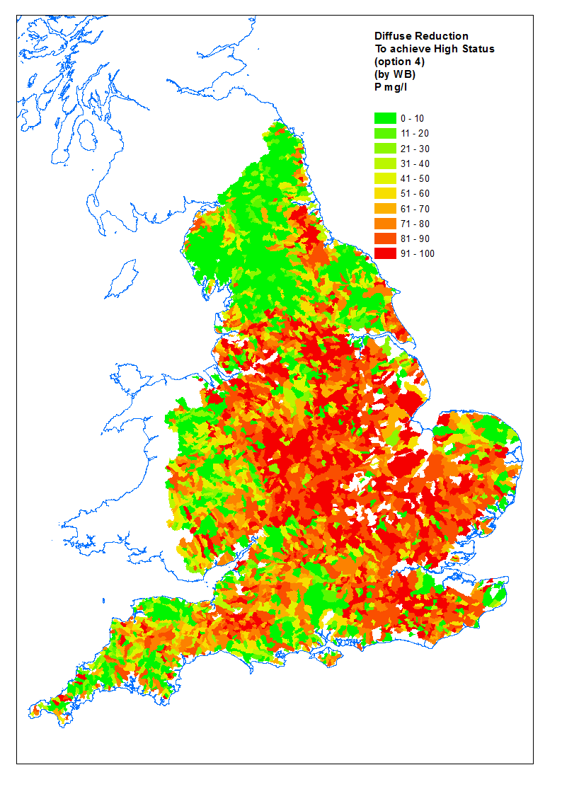
Figure 18. Diffuse reduction requirements for moderate, good and high status.

