Demountables Civil Works
Council of the Isles of Scilly wishes to contract a single provider to construct at various sites around St Mary’s and St Agnes:
- Six foundations and pillars to be used for demountable flood barriers
- Associated minor civil works
  - Moving steps forward at the Rechabite shelter
  - Constructing low walls at two sites and extending an existing wall
The demountable flood barriers are being supplied by Lakeside Flood Solutions. The barriers are constructed of stainless steel or aluminium planks that at the side are slotted into either:
- Temporary uprights that are supplied by the suppliers of the demountables; or
- Permanent uprights fixed either to solid structures or to a standard concrete pillar (SCP). The uprights are fitted by the suppliers of the demountables. The SCP is to be constructed by the successful tenderer for the Demountables Civil Works.
The ground receiving channel for the demountable systems is a channel recessed into a flat piece of ground with a cover fitted to prevent dirt ingress. This channel will be supplied by the suppliers of the demountables but will be fitted by the successful tenderer.
Details on how the civil works are expected to be prepared for the fitting of the demountables for a Supply Only contract (similar to the arrangement Council has with the supplier) are provided in the “LFS Supply Only Manual (C).pdf” attached.
- Pillars with foundations
Standard concrete pillars (SCP) and associated foundations are to be supplied and constructed by tenderers as part of this tender.
Six pillars with foundations are required. The standard concrete pillars (SCP) will be constructed to be freestanding posts, 200x200 mm square, up to 985 mm above the ground, 500 mm deep below ground, with structural reinforcement using rebar no closer than 50 mm to the pillar face, to allow barrier post fittings to be drilled. The SCPs should be constructed according to the specifications attached.
- Associated minor civil works
Various minor civil works are required to augment the demountable systems. These include:
- At Porthcressa Bank opposite the laundrette (Figure 1), the existing wall 560 mm high (Figure 2) will be removed and a new core-filled concrete block wall 215 mm thick with reinforcing bars, 2 m long will be extended from this location to a height of 7.1 m above local datum (but no more than 985 mm above local ground) into the Porthcressa Green area. A raised earth bund to 7.1 m height above local datum, with 500 mm top width and 1:4 side slopes to existing levels will adjoin and wrap around this block wall (Drawing 10059091-ARC-XX-XX-DR-1005).
- At the library (Figure 4), a reinforced 215 mm thick reinforced concrete block wall 2.3 m long, to 7.3 m above local datum (but no higher than 985 mm above the lowest point of local ground) is to be constructed at the western end adjacent to the path (Figure 6), with localised landscaping grading into the ground behind (Drawing 10059091-ARC-XX-XX-DR-1006).
- At the Porthcressa Bank site, two reinforced concrete walls 685 mm high at the path end will be needed either side of the path, each 3.9 m long
- Reforming the existing steps either side of the Rechabite Shelter in Hugh Town on St Mary’s. This will push the steps forward, to provide a continuous surface onto which the demountable units may be fitted with a single level at the base. The general approach for these step extensions is to provide reinforcing keyed into the underlying steps, then pour a shuttered concrete mass with steel reinforcing. Each of the two step extensions will need to be C40 reinforced concrete pushing the steps forward 0.7 m by 2 m by 150 mm steps producing a lift of 700 mm (to top step) and 0.4 m by 2 m by 150 mm steps producing a lift of 600 mm (to top step).
- The wall at Trench Lane on the eastern side of the road needs to be raised from the existing 300 mm (right) and 350 mm (left) to 685 mm high for 0.5 m distance to provide a fixing surface for the demountable uprights. The face of the walls is to be saw cut to provide to fit the demountable upright vertically. The walls are approximately 450 mm wide (Drawing 10059091-ARC-XX-XX-DR-1003).
- The walls at Old Town Café on the northern side of the road needs to be raised from the existing 600 mm to a height of 5.7 m above local datum (at least 985 mm high above local ground at the position of the demountable fixings) for approximately 16 m distance to the position of the raised wall extent at e) above (Drawing 10059091-ARC-XX-XX-DR-1003). The wall width is approximately 450 mm. This will both provide a fixing surface for the demountable uprights and close the low gap between the 2 demountables. The existing small rock ‘dressing’ on top of the wall will need to be removed for this distance to facilitate keying in the new section of wall to the existing concrete. These dressing stones should be replaced and fixed with mortar when the raised wall is completed. Note, the concrete wall generally is backed by a properly-formed slab faced with local granite cobbles on the Trench Lane side, but from a position 4 m east of the corner with Old Town Lane, the road side of the wall is faced with concrete that has been formed against an existing drystone wall. This has left some drystone cobbles loose on the building side. To accommodate the overlying wall extension, it may be necessary to form the concrete wall on the building side. Test drilling of the existing concrete wall must be completed by the contractor to determine whether the building side needs further work to support the overlying extension.
- The existing earth and stone wall at the Duchy Cottages on Tolman Point Road is to be demolished for a distance of approximately 12 m and reconstructed as core filled concrete block wall 215 mm thick, at least 5.6 m above local datum (Drawing 10059091-ARC-XX-XX-DR-1003 and -1008)
- At some sites, providing 15 concrete pads onto which corner posts and middle posts can be affixed. Each pad to be 250 mm x 250 mm in plan, excavated 150 mm deep into the surface it is recessed into. Concrete pads are required for the following posts:
  - 2x middle posts at Rechabite Slip Span 1
  - 1x corner post at Rechabite Slip
  - 1x middle post at Rechabite Slip Span 2
  - 1x corner post at Rechabite Slip
  - 1x middle post at Rechabite Slip Span 3
  - 3x middle posts at Rechabite Slip Side
  - 1x middle post at Rechabite Shelter right steps
  - 1x middle post at Rechabite Shelter left steps
  - 2x middle posts at Old Town 2
  - 2x middle posts at Old Town 3
- At Rechabite Slip, preparing the ground so that a level base is available to fit the ground channel. The ground (see Figure 9a) is to be levelled to allow the demountable system to site square in the frame between the wall and the intermediate post at the edge of the slipway. This work may involve cutting the ground so that the base channel is lower than existing ground close to the wall and the lowest demountable plank can fit within this ‘gutter’. If a ‘gutter’ is left as a consequence of this levelling work, it must be covered with a removable steel plate recessed onto a supporting lip at each side, to reduce the risk to pedestrians.
- At Rechabite Slip and Old Town sites, where new ground levels are being prepared, casting the base channel for the demountables into the new concrete or asphalt footpath and road to provide a level base for the demountables. Guidance on preparing base channels is contained in section 3 of the Lakeside Supply Only Manual. For clarity, Lakeside will cut the channel into the ground at other sites.

By site:
In the following, required civil works are highlighted in bold.
1) Porthcressa Bank – council land
a) L/H side – raised wall to 985 mm high above ground, over the top of existing wall which is between concrete footpath and grassed area. This could be a single block of granite, properly attached to the underlying wall.
b) R/H side – SCP placed in concrete surfaced footpath adjacent to building
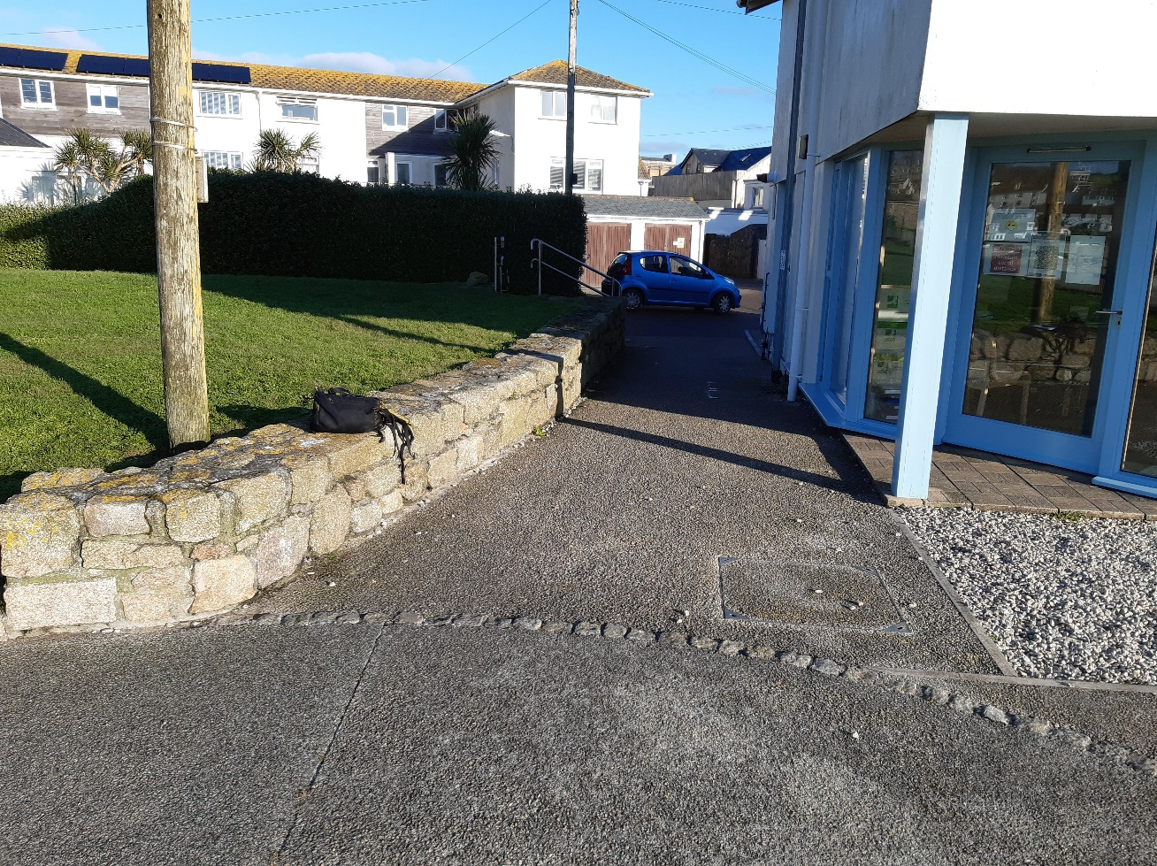
Figure 1: Site 1a – laundrette site at Porthcressa
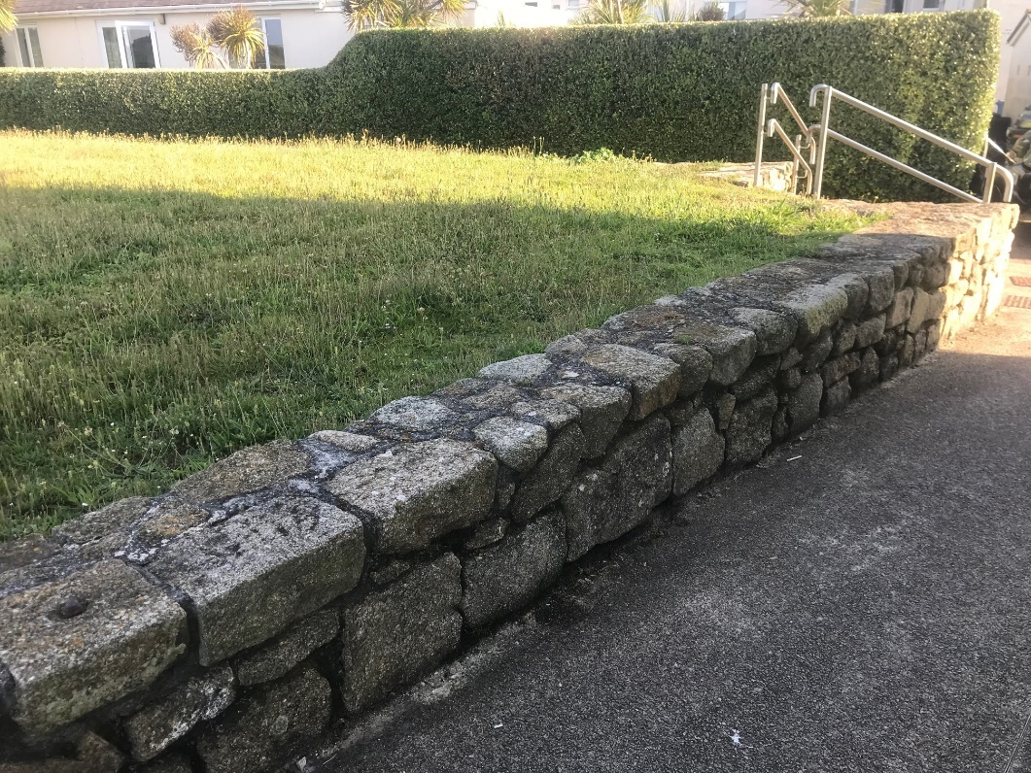
Figure 2: Site 1a – existing 560 mm high wall at Porthcressa laundrette
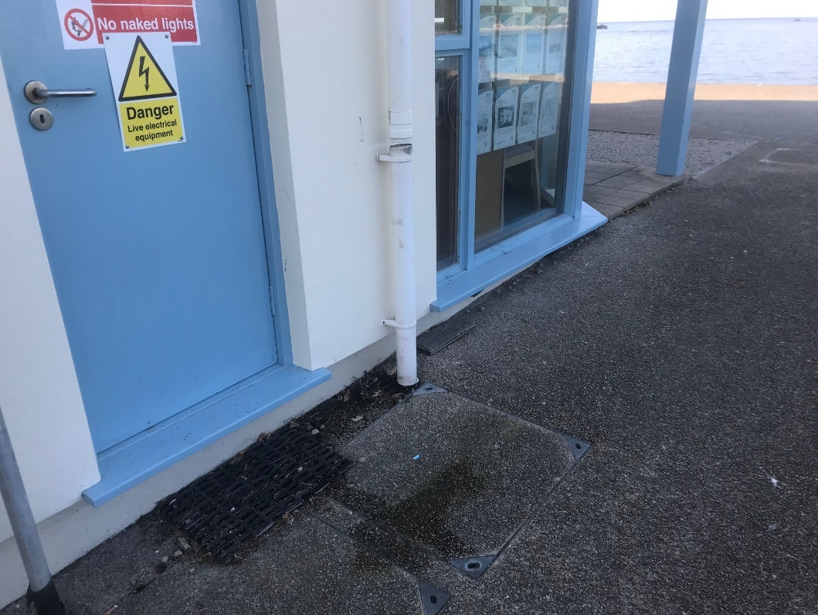
Figure 3: Site 1b – existing building at Porthcressa laundrette

2) Library – council land
a) L/H – SCP 985 mm in concrete surfaced footpath adjacent to building
b) R/H – new wall 985 mm high above ground adjacent to concrete path, graded over 3 m length into the grass bank behind
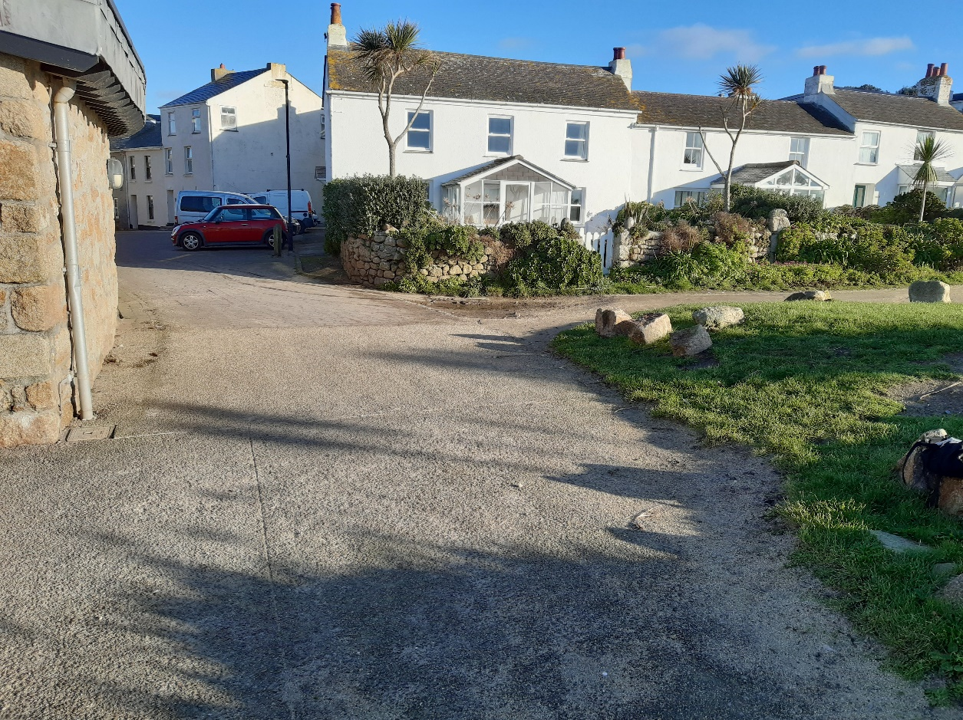
Figure 4: Site 2 – library site
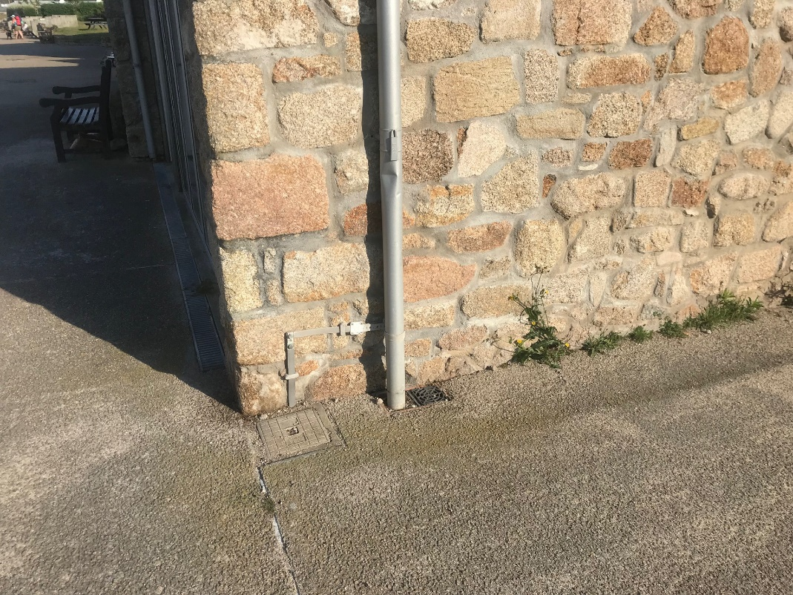
Figure 5: Site 2a – wall of library
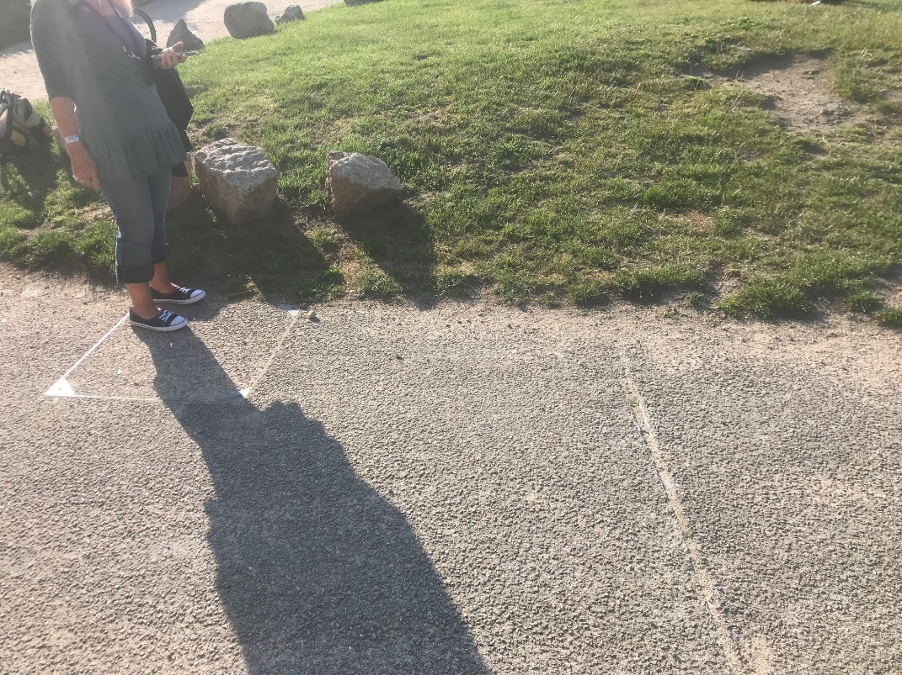
Figure 6: Site 2b – location of new wall and demountable endpoint in grass bank at library

3) Porthcressa Bank – middle – council land
a) L/H – SCP 685 mm at edge of concrete block path, & construct new 685 mm max stone wall adjacent and graded into ground (Figure 7)
b) R/H – SCP 685 mm at edge of concrete block path, & construct new 685 mm max stone wall adjacent and graded into ground (Figure 8)
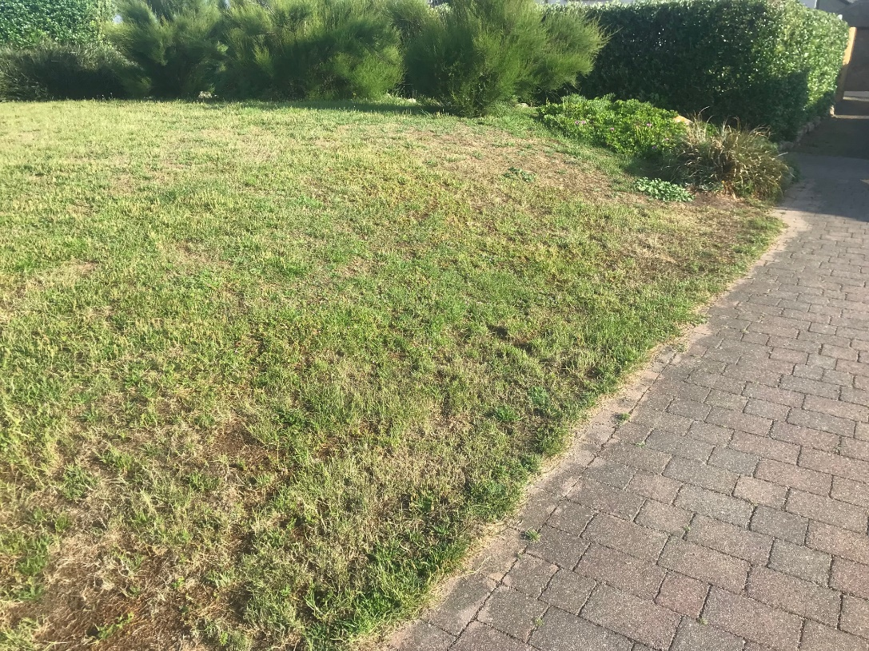
Figure 7: Site 3a – location of new wall and demountable endpoint at edge of concrete block path
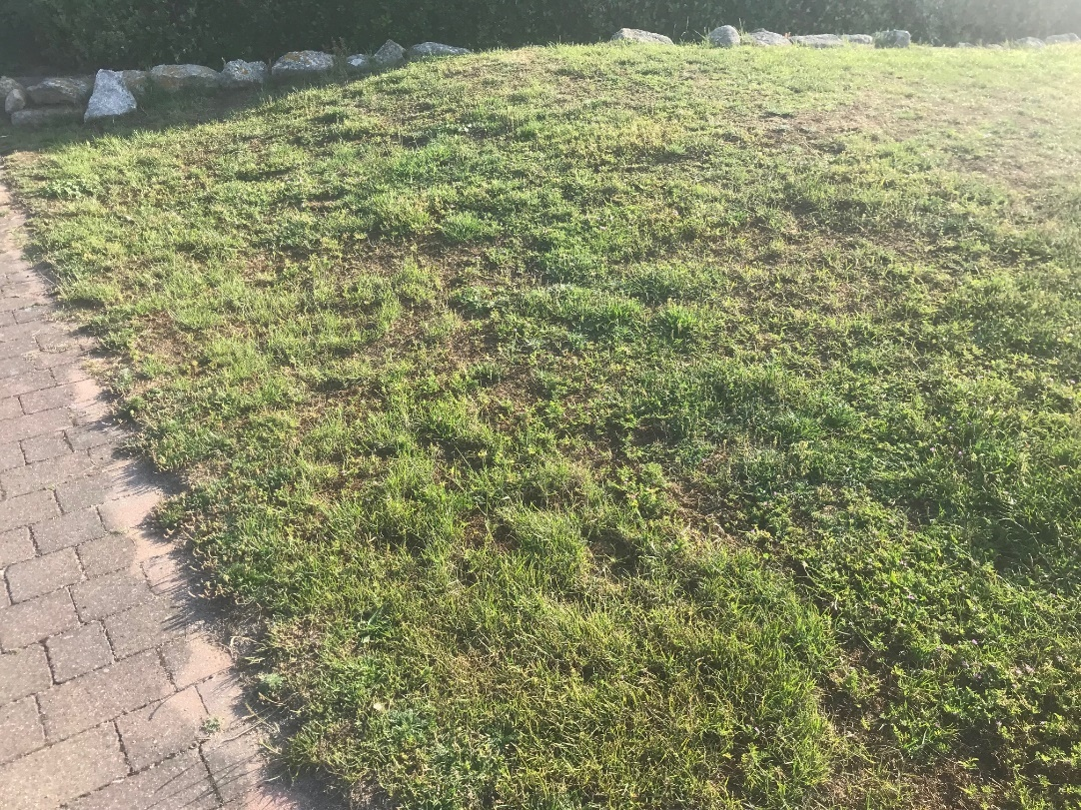
Figure 8: Site 3b – location of new wall and demountable endpoint at edge of concrete block path

4) Rechabite Slip Main
a) Span 1 L/H – 800 mm post to corner post by others
b) Span 1 R/H – 800 mm fix to toilet block by others
c) Span 2 L/H – 600 mm to corner post at a) Span 1 L/H by others
d) Span 2 R/H – 600 mm R/H to wall by others
e) Span 3 L/H – 600 mm fix to corner post by others
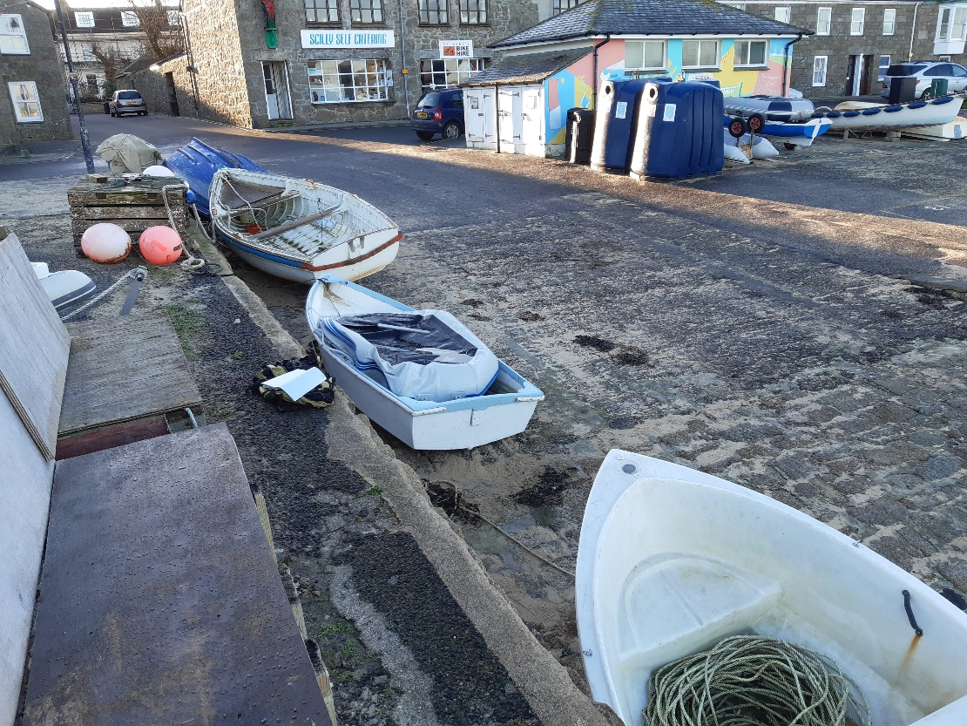
Figure 9: Rechabite slip area
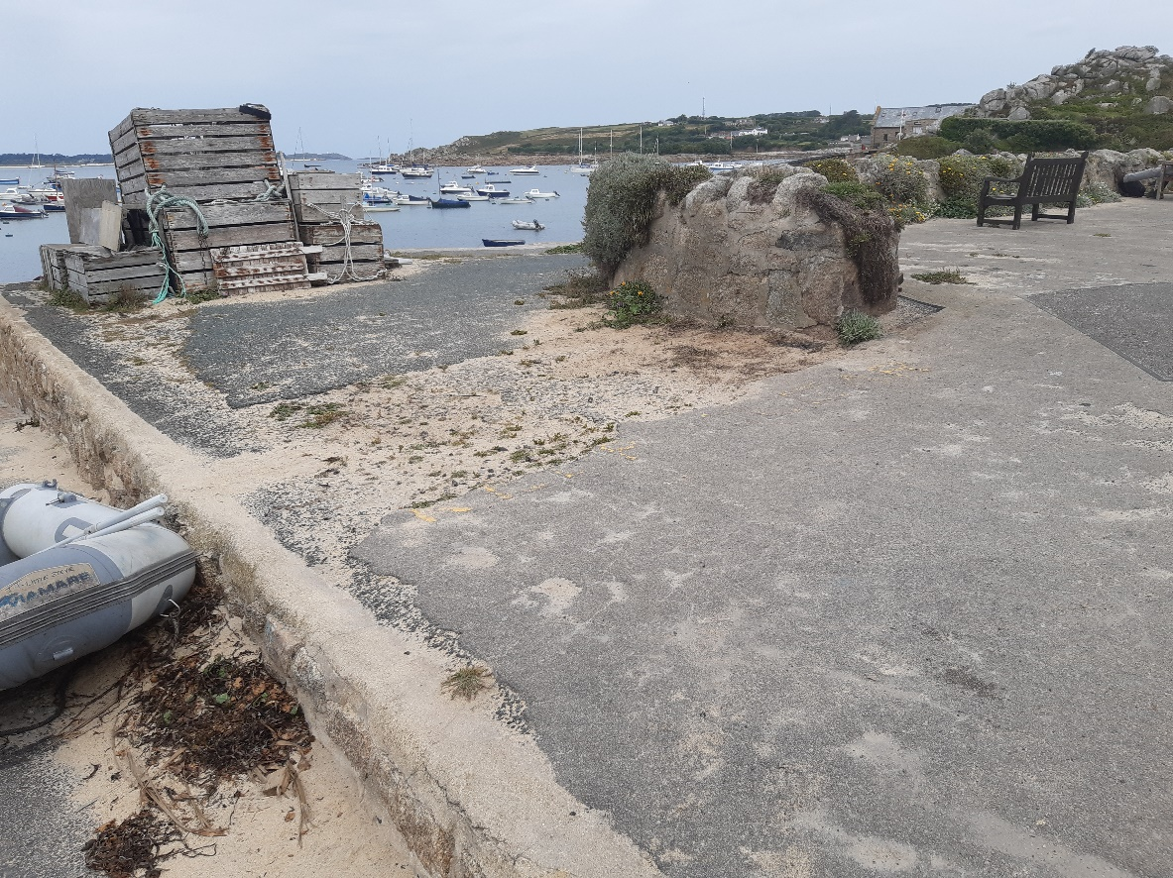
Figure 9a: Position of the base plate for the demountable on the east side of Rechabite Slip, from the stone wall at right, across the sandy broken tarmac to the concrete edge by the boat at left, where an intermediate corner post will be situated.
5) Rechabite Slip Side – council land (boat park)
a) L/H – 600 mm fix to toilet block by others
b) R/H –685 mm SCP – not graded to ground

6) Rechabite Shelter Right Steps – council land
a) Steps (Figure 10) to be moved forward by formwork and concrete pour with reinforcing to provide uniform surface for base of demountable.
b) L/H – 600 mm reveal fix to wall by others
c) R/H – 600 mm reveal fix to shelter by others
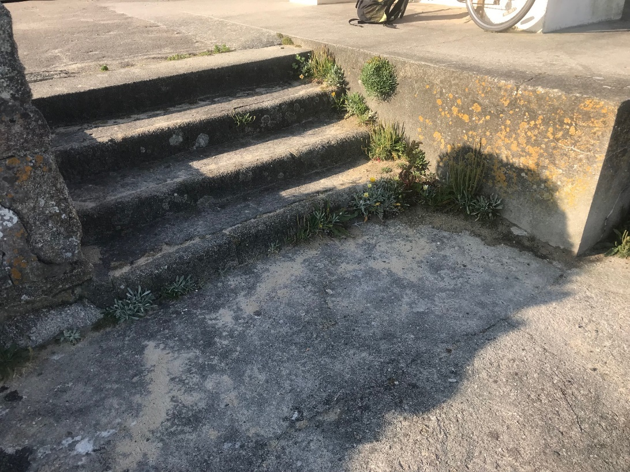
Figure 10: Site 6 – Rechabite steps right
7) Rechabite Shelter Left Steps – council land
a) Steps (Figure 11) to be moved forward by formwork and concrete pour with reinforcing to provide uniform surface for base of demountable.
b) L/H – 600 mm reveal fix to shelter by others
c) R/H – 600 mm reveal fix to wall by others
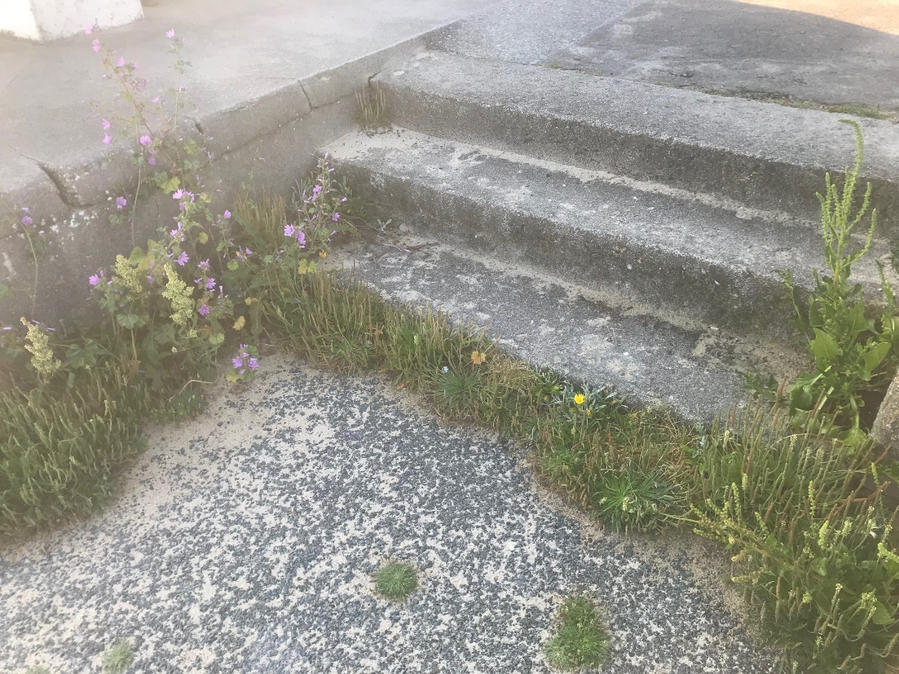
Figure 11: Site 7 – Rechabite steps left

8) Old Town 2 (Trench Lane)
a) R/H – wall to be raised from existing 300 mm to 685 mm high over 0.5 m length (Figure 12)
b) L/H – wall to be raised from existing 350 mm to 685 mm high over 0.5 m length (Figure 13)
c) R/H – 600 mm reveal fix on raised wall
d) L/H – 600 mm reveal fix on raised wall
e) Between 8a and 9b, the wall to be raised to 5.7 above local datum
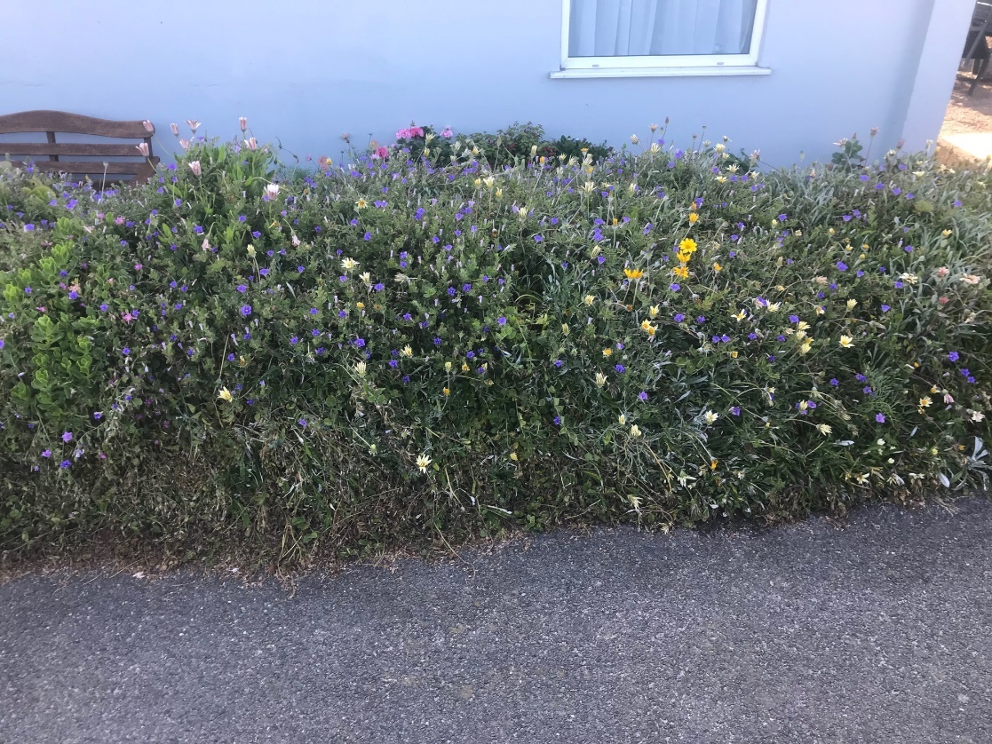
Figure 12: Site 8a – Trench Lane R/H wall
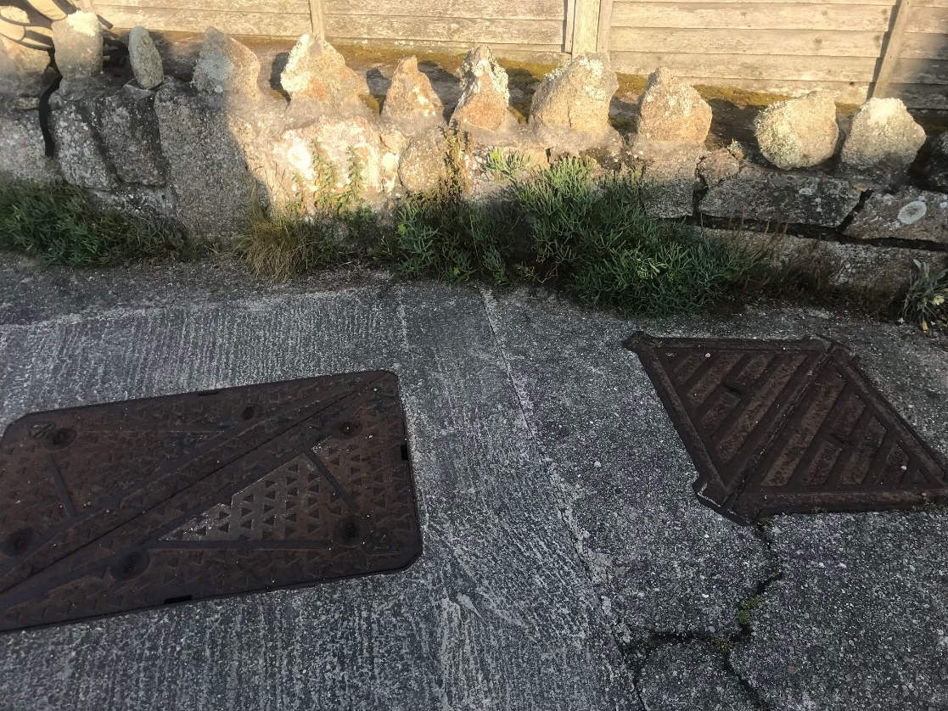
Figure 13: Site 8b – Trench Lane R/H wall

9) Old Town 3 (Old Town Café)
a) L/H – 985 mm SCP at an angle against existing wall to allow for reveal-fix installation diagonally across road (Figure 14); bring footpath down to road level for a distance of 3 m to allow demountable base to run at constant height to the SCP (Figure 15)
b) R/H – raise wall from existing 700 mm to 985 mm high to allow reveal fix (Figure 16)
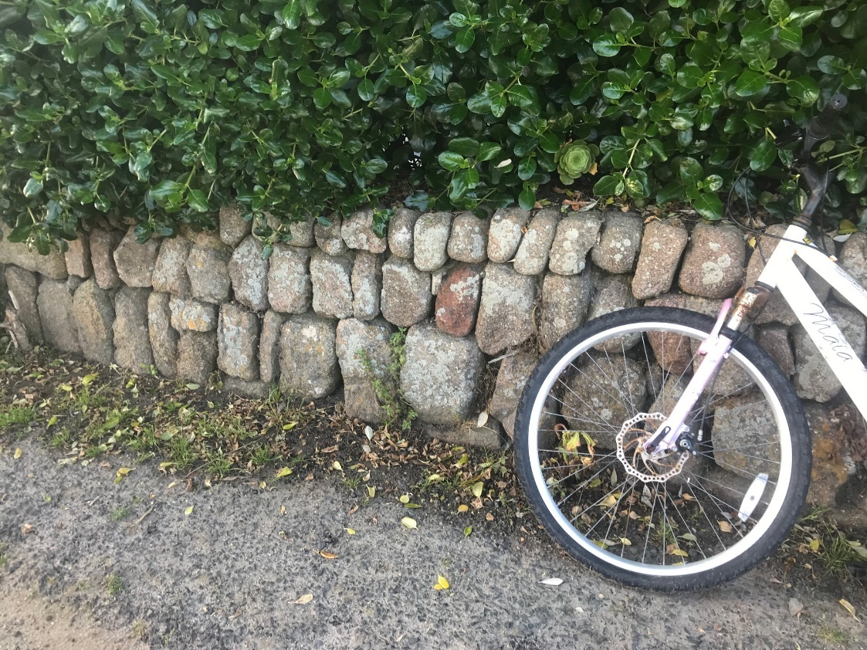
Figure 14: Site 9a – Old Town Café L/H wall
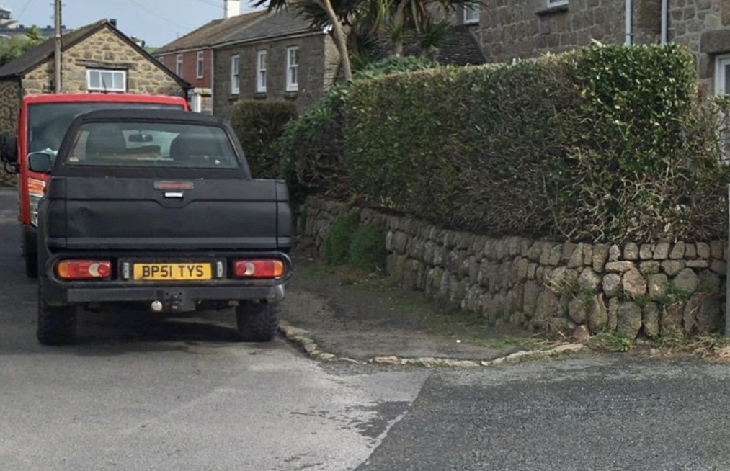
Figure 15: Site 9a – Old Town Café L/H wall, section of footpath to be lowered to road level, from corner of footpath to position of SCP, 3 m along footpath

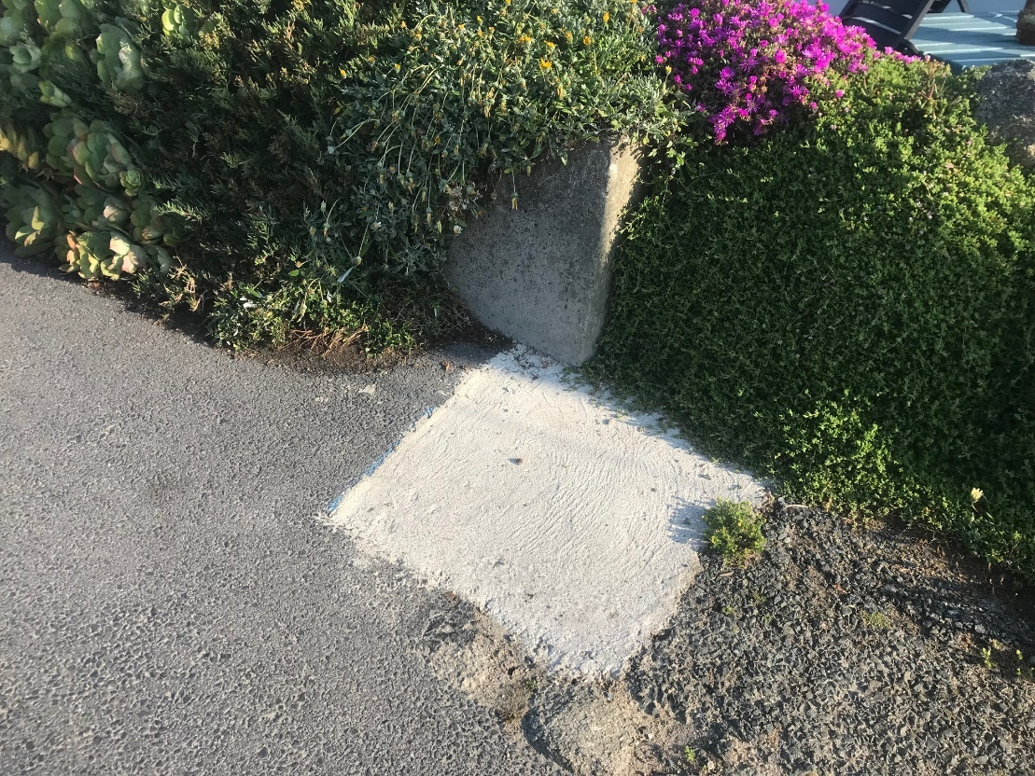
Figure 16: Site 9b – Old Town Café R/H wall

