Recital A
Crown Commercial Service
__________________________________________________________________________________
Call Off Order Form and Call Off Terms for Goods and/or Services
__________________________________________________________________________________

12/08/2013
PART 1 – CALL OFF ORDER FORM
SECTION A

This Call Off Order Form is issued in accordance with the provisions of the Framework Agreement RM988 Lot 5 for the provision of Contact Centre Services dated 1st June 2017.

The Supplier agrees to supply the Goods and/or Services specified below on and subject to the terms of this Call Off Contract.

For the avoidance of doubt this Call Off Contract consists of the terms set out in this Call Off Order Form and the Call Off Terms.

Agreement Number | ECM 7224 | Note: assignments shall be governed by the issue of a Customer Purchase Order.
From | Public Health England  ("CUSTOMER") | Wellington House  133-155 Waterloo Road  London SE1 8UG
To | Sitel UK  ("SUPPLIER") | Earlsdon Park  53-55 Butts Road  Coventry CV1 3BH

SECTION B

- call off contract period

 | Commencement Date: | 1st May 2018
 | Expiry Date:  End date of Initial Period  End date of Extension Period  Minimum written notice to Supplier in respect of extension: | 31st July 2020  31st July 2022  Three months

- goods and/or Services

2.1. | Goods and/or Services required:  In Call Off Schedule 2 (Goods and/or Services) | The Services to be provided shall be in accordance with the Customer’s instructions.  For the avoidance of doubt the Customer wishes to engage with the Supplier for Contact Centre Services on occasions when its main service provider requires additional call-handler capacity. All services provided shall be triggered by the issue of a Customer Purchase Order.

- Implementation Plan

3.1. | Implementation Plan: | Not applicable

- contract performance

4.1. | Standards: | The Services shall be provided in accordance with Clause 11 (Standards) and the definition of Standards in Call Off Schedule 1 (Definitions).
4.2 | Service Levels/Service Credits: | Not applied
4.3 | Critical Service Level Failure: | Not applied
4.4 | Performance Monitoring: | Clause 19 (Performance Monitoring) and the provisions of Part B of Call Off Schedule 6 (Service Levels, Service Credits and Performance Monitoring) refer.
4.5 | Period for providing Rectification Plan: | Clause 38.2.1 (a) (Rectification Plan Process) refers. The Rectification period shall be 10 days.

- personnel

5.1 | Key Personnel: | Not applicable
5.2 | Relevant Convictions (Clause Error! Reference source not found. of the Call Off Terms): | Not applicable

- PAYMENT

6.1 | Call Off Contract Charges (including any applicable discount(s), but excluding VAT): | The applicable Call Off Contract Charges are detailed in Annex 1 and 2 of Call Off Schedule 3 (Call Off Contract Charges, Payment and Invoicing).
6.2 | Payment terms/profile | Payment terms and profile are detailed in Annex 2 of Call Off Schedule 3 (Call Off Contract Charges, Payment and Invoicing).
6.3 | Reimbursable Expenses: | Reimbursable Expenses are not permitted.
6.4 | Customer billing address | Payables@phe.gov.uk
6.5 | Fixed period for Call Off Contract Charges | For the purpose of paragraph 8.2 of Call Off Schedule 3 (Call Off Contract Charges, Payment and Invoicing):  One (1) Call Off Contract Year from the Call Off Commencement Date, and annually agreed thereafter.
6.6 | Supplier periodic assessment of Call Off Contract Charges | For the purpose of paragraph 9.2 of Call Off Schedule 3 (Call Off Contract Charges, Payment and Invoicing):  1st May of each Call Off Contract Year during the Call off Contract Period
6.7 | Supplier request for increase in the Call Off Contract Charges | Paragraph 10 of Call Off Schedule 3 (Call Off Contract Charges, Payment and Invoicing): the Supplier is permitted to request an increase of the Call Off Contract Charges after the expiry of the period during which the Call Off Contract Charges should remain fixed under paragraph 10 of Call Off Schedule 3 (Call Off Contract Charges, Payment and Invoicing).

- LIABILITY and insurance

7.1 | Estimated Year 1 Call Off Contract Charges: | Redacted
7.2 | Supplier’s limitation of Liability (Clause 36.2.1 of the Call Off Terms); | The Supplier’s financial limit of liability shall be limited to the value of purchase orders raised for each financial year, commencing on 1st May 2018.
7.3 | Insurance (Clause 37.3 the Call Off Terms): | Additional public liability insurance to cover all risks in the performance of the Call-Off Contract, with a minimum limit of £1 million for each individual claim.  Additional employers' liability insurance with a minimum limit of £1 million indemnity.  Additional professional indemnity insurance adequate to cover all risks in the performance of the Call-Off Contract with a minimum limit of indemnity of £1 million for each individual claim.  Product liability insurance cover all risks in the provision of Deliverables under the Call-Off Contract, with a minimum limit of £1 million for each individual claim.

- TERMINATION and exit

8.1 | Termination on material Default (Clause 41.2.1 (c) of the Call Off Terms)): | Guidance Note: consider Clause 41.2.1.(c) (Termination on Material Default). Insert an appropriate percentage to facilitate the ability of the Customer to terminate the Call Off Contract for material Default where, as a result of any Defaults, the Customer incurs Losses in any Call Off Contract Year which exceed a certain percentage of the value of the Supplier’s aggregate annual liability limit for that Call Off Contract Year as set out in Clause 36.2.1 (Financial Limits).
8.2 | Termination without cause notice period (Clause 41.7.1 of the Call Off Terms): | Guidance Note: consider Clause 41.7.1 (Termination without cause). Confirm the minimum number of Working Days that should be the notice period in respect of termination without cause. It is suggested that in long term contracts this should be a minimum of 30 Working Days, as stipulated in Clause 41.7.1.
8.3 | Undisputed Sums Limit:  In Clause 42.1.1 of the Call Off Terms | Guidance Note: consider Clause 42.1.1 (Termination of Customer Cause for failure to pay) in respect of the Supplier’s right to terminate the Call Off Contract for undisputed sums which have not been paid by the Customer. Insert an appropriate sum that should be the “Undisputed Sums Limit”. It is suggested that this should normally be the equivalent to one (1) month’s average Call Off Contract Charges.
8.4 | Exit Management:  Not applied | Guidance Note: see Clause 45.5 (Exit Management) and Call Off Schedule 9 (Exit Management). Call Off Schedule 9 is likely to be relevant in the context of procuring Services or Goods and Services rather than Goods only, with emphasis on procuring Services or Goods and Services on an ongoing basis. Select the third option if you have any specific exit requirements in addition to, modification or substitution of the default provisions in Call Off Schedule 9 (Exit Management).

- supplier information

9.1 | Supplier's inspection of Sites, Customer Property and Customer Assets: | Not required
9.2 | Commercially Sensitive Information:  [TBA] | Guidance Note: see Clause 34.4.8 (Transparency and Freedom of Information) and the definition of Commercially Sensitive Information in Call Off Schedule 1 (Definitions). Specify any Commercially Sensitive Information of the Supplier and the duration for which it should be confidential. Notwithstanding the designation of any such information as Commercially Sensitive Information, if the information would not be exempt under FOIA or the EIRs the Customer may publish it under Clause 34.4.8 (Transparency and Freedom of Information).

- OTHER CALL OFF REQUIREMENTS

10.1 | Recitals (in preamble to the Call Off Terms): | Recitals B to E  Recital C - date of issue of the Statement of Requirements: 1st May 2018  Recital D - date of receipt of Call Off Tender:  1st May 2018
10.2 | Call Off Guarantee (Clause Error! Reference source not found. of the Call Off Terms): | Not required
10.3 | Security: | Call Off Schedule 7 (Security); and the definition of “Security Policy” in Call Off Schedule 1 (Definitions):  Select short form security requirements
10.4 | ICT Policy:  Not applied  [OR]  [To be provided by the Customer before the Commencement Date] | Guidance Note: if the Customer wants the Supplier to comply with its ICT Policy, ensure it is handed over to the Supplier before the Commencement Date.
10.5 | Testing:  [Not applied]  [OR]  [In Call Off Schedule 5 (Testing)]  [OR]  [Call Off Schedule 5 (Testing) shall be amended as follows: [ ]] | Guidance Note: see Clause 12 (Testing) and Call Off Schedule 5 (Testing). Select the third option if you have any specific testing requirements in addition to, modification or substitution of the default provisions in Call Off Schedule 5 (Testing).
10.6 | Business Continuity & Disaster Recovery:  Not applied  [OR]  [In Call Off Schedule 8 (Business Continuity and Disaster Recovery)]  [OR]  [Call Off Schedule 8 (Business Continuity and Disaster Recovery shall be amended as follows:[ ]]  Disaster Period:  For the purpose of the definition of “Disaster” in Call Off Schedule 1 (Definitions) the “Disaster Period” shall be [insert period of time] | Guidance Note: see Clause 15 of the Call Off Terms and Call Off Schedule 8 (Business Continuity and Disaster Recovery). Select the third option of you have any specific Business Continuity and Disaster Recovery requirements in addition to, modification or substitution of the default provisions in Call Off Schedule 8 (Business Continuity and Disaster Recovery).  See the definition of Disaster in Call Off Schedule 1 (Definitions). Note that the definition of Disaster will not be made out unless the Goods and/or Services are (or reasonably anticipated to be) unavailable for a specified period of time. Specify the applicable period.
10.7 | Failure of Supplier Equipment (Clause 32.8 of the call off Terms:  [Not applied]  [OR]  [For the purpose of that Clause the value for X shall be [insert number of Service Failures] and the value for Y shall be [insert number of months]] | Guidance Note: see Clause 32.8 (Supplier Equipment) which allows the Customer to request the replacement of any Supplier Equipment if it causes ‘X’ number of Service Failures within ‘Y’ months. Note the definition of Service Failure in Call Off Schedule 1 (Definitions). Specify if the Clause should apply and, if so, populate the values for ‘X’ and ‘Y’ referred to in Clause 32.8.
10.8 | Protection of Customer Data (Clause 34.2.3 of the Call Off Terms):  [ ] | Guidance Note: See Clause 34.2.3 (Protection of Customer Data). If required from the outset, specify the format for the Supplier to supply the Customer Data to the Customer when needed.
10.9 | Notices (Clause 55.6 of the Call Off Terms):  Customer’s postal address and email address: [ ]  Supplier’s postal address and email address:  [ ] | Guidance Note: Specify the postal address and email address of both the Customer and the Supplier for the purpose of serving notices under the Call Off Contract as required under Clause 55 (Notices).
10.10 | Transparency Reports  In Call Off Schedule 13 (Transparency Reports) | Guidance Note: Consider Call Off Schedule 13 (Transparency Reports). If Transparency reports are required, populate Annex 1 of Call Off Schedule 13.
10.11 | Alternative and/or additional provisions (including any Alternative and/or Additional Clauses under Call Off Schedule 14): | Guidance Note: Include any other provisions in addition to, modification or substitution of the Template Call Off Terms prior to those becoming the Call Off Terms of the Call Off Contract. Include any Alternative or Additional Clauses from Call Off Schedule 14 (Alternative and/or Additional Clauses).  f you place repeat Orders of the same nature which contain repeat requirements, consider creating a customised set of amended and/or refined Template Call Off Terms or a Call Off Schedule containing those amendments or refinements (including incorporating any Alternative or Additional Clauses from Call Off Schedule 14 (Alternative and/or Additional Clauses)) which you can use with every Order.
10.12 | Call Off Tender: | In Schedule 15 (Call Off Tender)  Not applicable
FORMATION OF CALL OFF CONTRACT
BY SIGNING AND RETURNING THIS CALL OFF ORDER FORM (which may be done by electronic means) the Supplier agrees to enter a Call Off Contract with the Customer to provide the Goods and/or Services in accordance with the terms Call Off Order Form and the Call Off Terms.
The Parties hereby acknowledge and agree that they have read the Call Off Order Form and the Call Off Terms and by signing below agree to be bound by this Call Off Contract.
In accordance with paragraph 7 of Framework Schedule 5 (Call Off Procedure), the Parties hereby acknowledge and agree that this Call Off Contract shall be formed when the Customer acknowledges (which may be done by electronic means) the receipt of the signed copy of the Call Off Order Form from the Supplier within two (2) Working Days from such receipt.
For and on behalf of the Supplier:
Name and Title | Karl Brough – General Manager UKI
Signature | 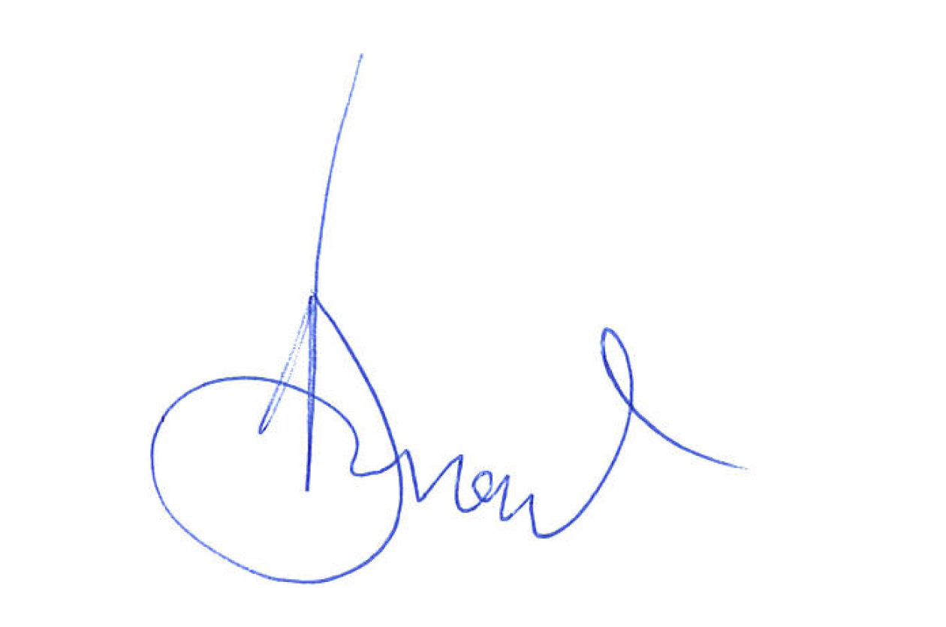
Date | 18th February 2020
For and on behalf of the Customer:
Name and Title | Helen Hampton, Deputy Director, Marketing
Signature | 
Date | 25 February 2020

Schedule 3 - Call Off Contract Charges, Payment and Invoicing
Annex 2

The services to be provided for COVID-2019 shall be in accordance with the Statement of Work as follows:

