F&B Operator at the

Horniman Museum and Gardens – Visitors & Events

Information Pack

Introduction 2

Role of and Vision for the Catering Provision 3

Current Audience 4

The Catering Opportunities 5

Historic trading information 13

The selection process: 16

Appendix I – Asset Register 17

Appendix II – Division of Responsibilities 18

# Introduction

The Horniman Museum and Gardens is a unique attraction in southeast London where world cultures and the natural world are brought together for everyone to enjoy. The Museum holds internationally important collections of anthropology and musical instruments, as well as a popular natural history gallery and Aquarium. The 16 acres of beautiful Gardens feature a tropical Butterfly House and small animal enclosure and offer stunning views across London. The Horniman was awarded Art Fund Museum of the Year 2022.

Horniman Museum Enterprises Ltd is the commercial arm and helps fund the charitable work of the Horniman, passing its taxable profit to its parent company Horniman Public Museum and Public Park Trust. Contracts between any food and beverage operators will sit with Horniman Museum Enterprises Ltd.

We are looking for a creative commercial partner who understands our audiences and aligns with our mission ‘to connect us all with global cultures and the natural environment, encouraging us to shape a positive future for the world we all share’.

This information pack is provided as part of the tender documentation. It sets out the operational requirements, historic trading information, the asset register and the planned timeline for the tender process. If you have questions or require further information or clarifications, please contact [rosana@tonic-ldn.com](mailto:rosana@tonic-ldn.com)

The Aquarium. Photo Credit: Laura Mtungwazi

# Role of and Vision for the Catering Provision

The catering provision at the Horniman is an integral part of the visitor experience and must fulfill the following requirements:

* Enhance the overall visitor experience
* Attract both the Horniman’s existing and target audiences, including current non-visitors
* Generate significant unrestricted revenue for the Horniman
* Provide excellent food, drink and service
* Provide food and drink at different price points that appeal to a diverse range of audiences
* Increase the dwell time across the Museum and Gardens
* Encourage visitors to return
* Be welcoming, inclusive and democratic
* Source healthy products and create food and drink sustainably
* Support the Horniman’s climate and ecology manifesto
* Work to reduce waste in product sourcing and food preparation
* Observe the principles of the Kids in Museums Family Café Standard.

There are several F&B outlets set around the grounds. The addition of a Nature Explorer’s Adventure Zone to include a new children’s café (opening in 2025) will afford the Horniman the opportunity to re-position the food and drink offers in the other outlets to provide:

* A range of options in style and price point to appeal to a diverse range of visitors
* Sufficient capacity of F&B to well serve the significant number of visitors to the Horniman
* Distinctive and excellent quality F&B offers that enhance the reputation and appeal of the Horniman as a repeat venue.

The Horniman wants all its visitors to feel welcome at any of its F&B outlets, however each will be designed to reach a different audience. The differences in experience for the guest will be achieved through:

* The menu
* The price points of the menu
* The service style
* The environment.

# Current Audience

The total visitors to the Museum and Gardens for April 2022 – March 2023 were 862,015, up from 2021/2022 (608,054). Pre-pandemic, the Horniman welcomed up to 940,000 visits per year and during the pandemic was the 12th most visited attraction in the UK according to ALVA. We expect to reach in excess of one million visitors in the future once the Nature + Love project has been completed.

The Horniman Museum and Gardens has historically drawn a primarily local audience with those based in London accounting for three quarters of visits over the year 2022/23. ​Families make up a large proportion of the audience, 65% in 2022/23. Overall motivation to visit the site involves being able to spend time with friends and family, closely followed by entertaining and educating children. ​The recent visitor research resulted in a perfect rating for positive visit experience of 100% and a very high likelihood to recommend of 93%.

The Horniman’s audience development ambitions are driven by a commitment to being as open and accessible as possible for all, and in particular to better reflect the diversity of the local London population in terms of ethnic diversity, social and economic background and disability. Other important audience outcomes include the quality of the experience and engagement onsite and online, and an increased awareness of the climate emergency and appreciation for nature. The Horniman wants everyone to have the opportunity to engage with, and be inspired by, our collections, buildings, Gardens and programming.

Bandstand Terrace in summer. Photo Credit: Sophia Spring

# The Catering Opportunities

The catering provision at the Horniman Museum and Gardens includes the following locations and opportunities:

Café locations:

* The main Museum café
* The kiosk on the main café terrace
* The Dutch Barn kiosk on the Bandstand
* The new Children’s Café – planned for opening in May 2025.

Public Programming Events:

* Weekly Sunday Market
* Gardens events, Bandstand events/music concerts and other pop-ups, activities and events throughout the year

Event Locations:

* The Pavilion
* The Conservatory
* The Bandstand
* Museum meeting room
* Main museum building

Venue Hire Commercial Events:

* Weddings and private events
* Filming and photography
* Corporate hire e.g. away days and conferences
* Children’s parties, celebrations and other private events

## Tender Opportunities Available

Currently the catering offer at the Horniman is provided by two separate companies. However, the Horniman is open to proposals from operators for either:

* Visitor catering: Main Museum Café, Kiosks and new Children’s Café
* Event catering: Weddings and private events/other venue hire
* Combined visitor and event catering.

## Trading hours

* The Museum is open daily, from 10am - 5.30pm
* The Butterfly House is open from 10.30am - 4pm (last entry 3.30pm)
* The Cafe is open from 9am - 5.30pm daily.
* The Gardens are open daily, from 7.15am (or 8am Sunday and Bank Holidays) until dusk (hours change seasonally).

For up-to-date opening hours please see here <https://www.horniman.ac.uk/plan-your-visit/food-drink/>

## Locations and capacity

## Visitor Catering

#### Main Museum Café

Currently a counter service model. It has approx. 50 covers inside and 80 covers outside.

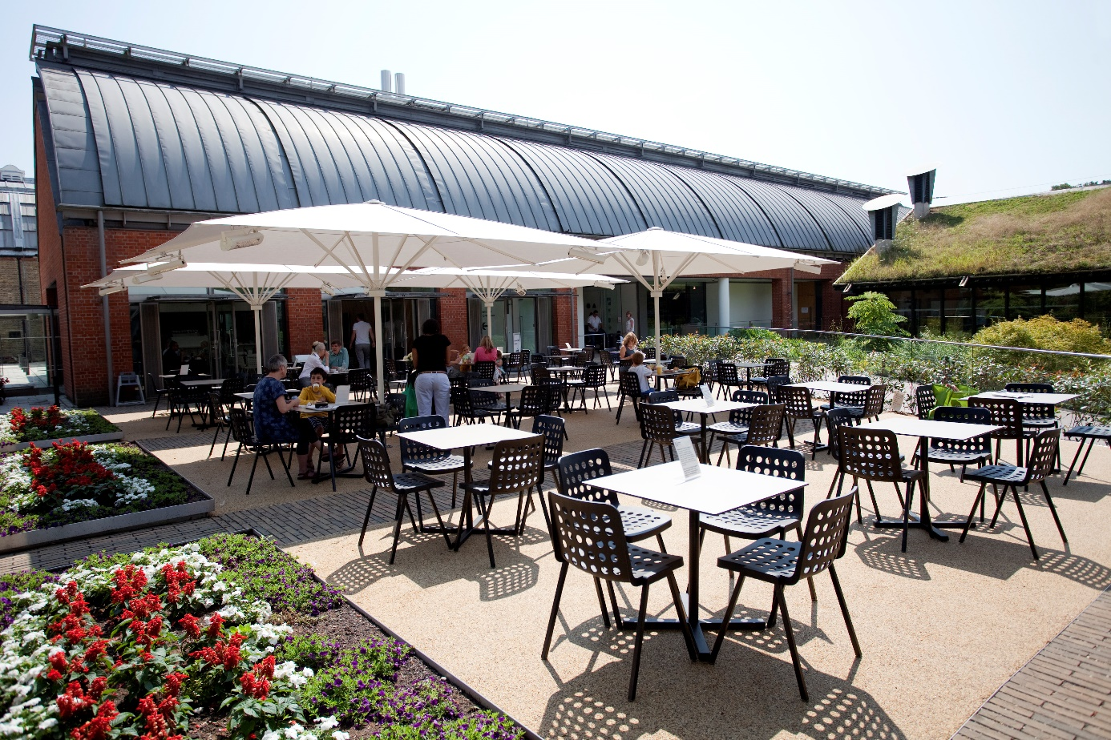

The café’s terrace. Photo Credit: Ludo Des Cognets

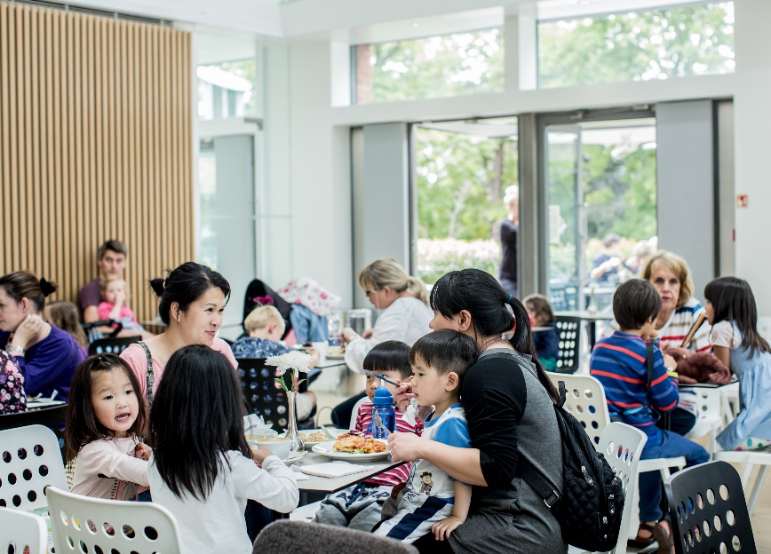 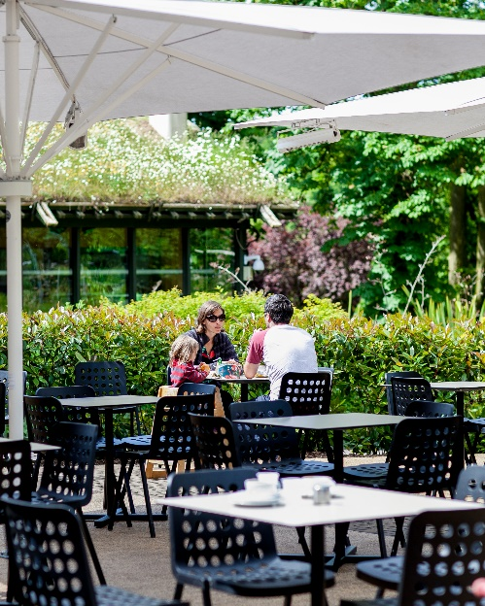

Photo Credit: Sophia Spring

Inside the Museum’s cafe. Photo Credit: Sophia Spring

The front of house including servery is approximately 111 sq metres. The kitchen is approx. 33 sq metres with additional back of house space and storage (some not pictured) of 38 sq metres.

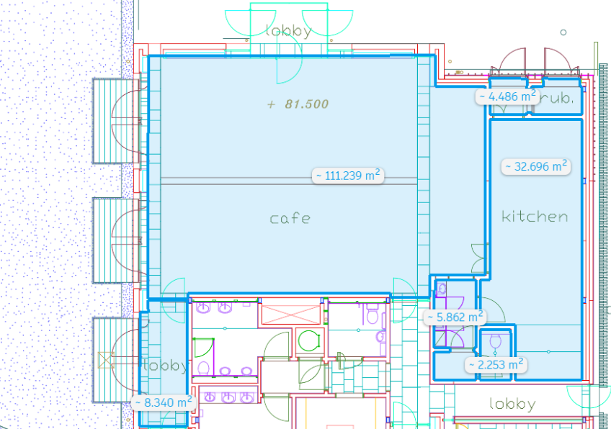

The café terrace is approx. 166 sq metres with four motorised parasols and the café terrace kiosk.

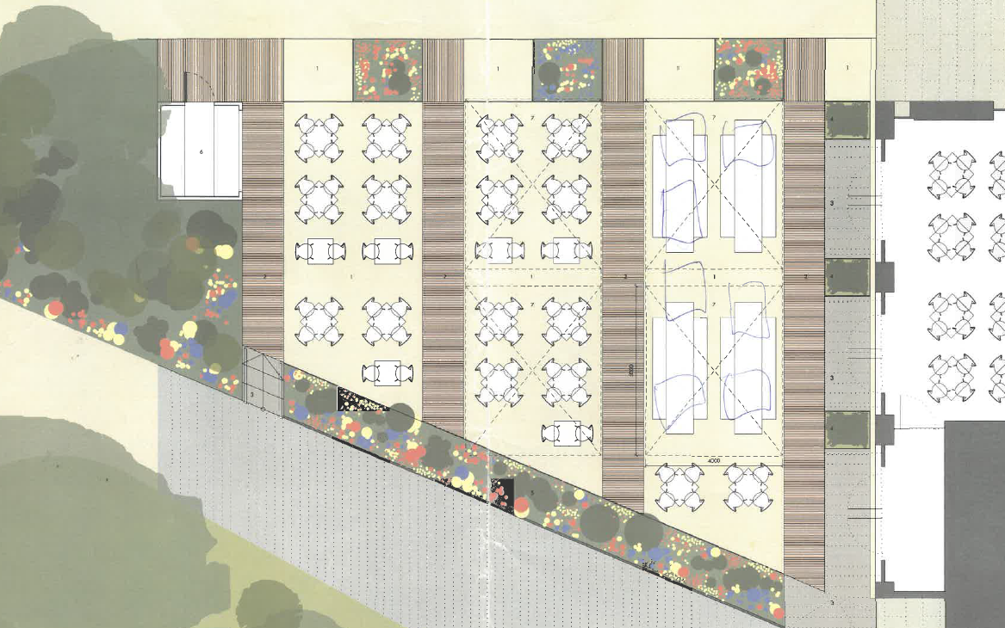

#### Children’s Café (Opening 2025)

Approximately 70-80 covers over a mix of unheated indoor and outdoor space. The new children’s café is part of the Nature + Love capital project and will be situated within a new Nature Explorer’s Adventure Zone (play area).

Children’s Café: concept image. Image credit: Feilden Fowles

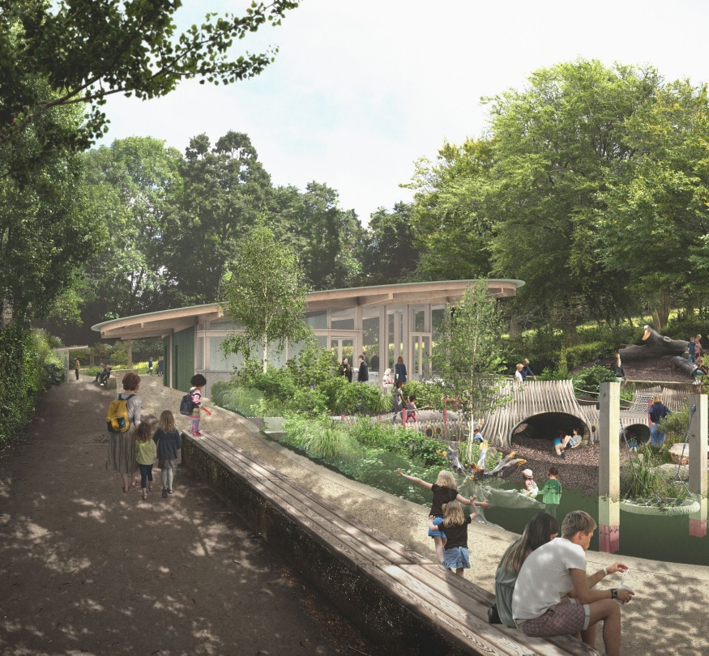

The Nature Explorers Adventure Zone, introduces a nature-themed play area and children’s café, encouraging learning and wellbeing through exploration and play. This zone will also provide a new departure point for improved access to and better interpretation of the Horniman Nature Trail.

Designed by Feilden Fowles architects, the children’s café will sit amidst the play area at the northern end of the existing concrete area.

Good coffee and healthy menus will be on offer in a relaxed, welcoming environment that enables close proximity to and supervision of children enjoying the nature-based play area, taking inspiration from Berlin’s kinder café culture. A circular, cantilevering, timber roof will be the distinctive feature of the café building.

The roof will angle upwards to give views of the play area and the meadow field from the seating beneath. Offering both indoor and outdoor seating alongside associated seating and picnicking areas within the footprint of the old model boating pond, the children’s café will offer a vital new facility not only to this area of the site but will also relieve pressure on other busy areas of the Horniman, potentially creating the opportunity to redevelop the main café to become a more adult-friendly destination.  
  
Café Kiosk and Bandstand Kiosk

The two existing kiosks allow the caterer to flex the food and drink offer in response to peak periods and seasons. One is situated opposite the main museum café at the far end of the terrace, and the other on the Bandstand terrace, the main location for the Horniman’s regular outdoor public programming.

The café’s terrace with kiosk. Photo Credit: Ludo Des Cognets

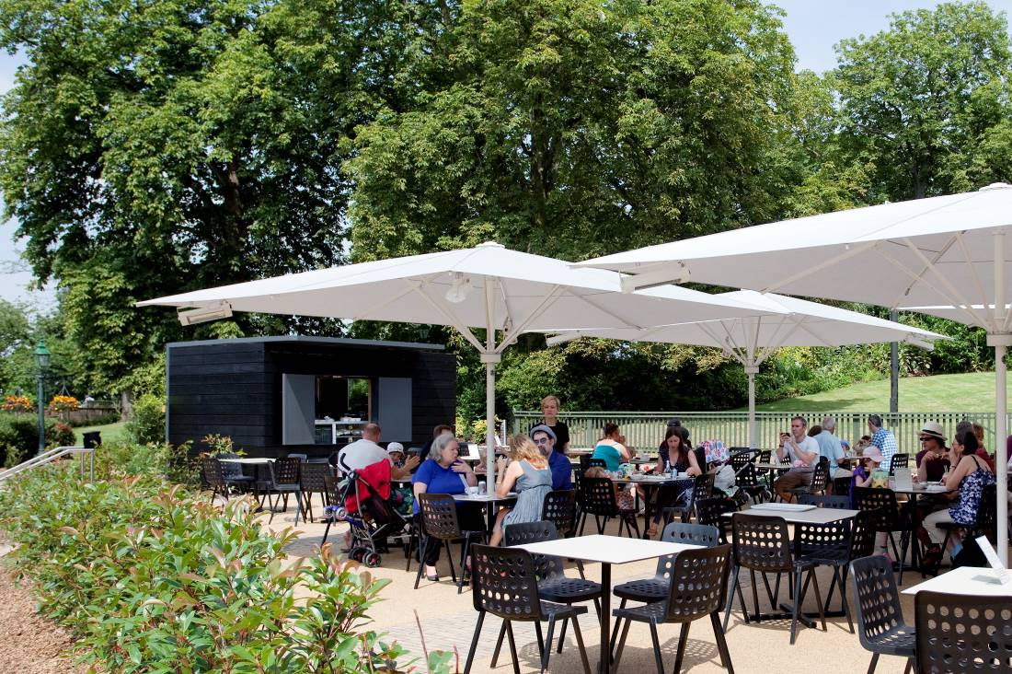

### Additional opportunities

The Horniman Museum and Gardens presents many opportunities for additional catering activity around its public programme.

* The Sunday Market attracts many traders including groceries, arts & crafts, and street food vendors.
* Seasonal bar and ice cream stalls add animation to the Gardens and provide revenue.
* Certain seasonal events (avg. 2500 capacity) require additional bar services (currently independent bar suppliers contracted as and when).

#### Commercial events and activity

The Conservatory is a beautiful setting for a range of events and is particularly popular for weddings. The Pavilion provides a great space for informal events such children’s parties or corporate away days and has the benefit of a small kitchen, cloakroom, and dedicated toilet facilities. The Bandstand is also a popular venue for weddings.

All three venues are licensed for weddings. The estate is also a popular location for filming and photography.

|  |  |  |  |  |
| --- | --- | --- | --- | --- |
| Venue Capacities | Standing | Dinner | Theatre Style | Boardroom |
| Conservatory | 150 | 120 | 120 | N/A |
| Pavilion | 80 | 60 | 60 | 30 |
| Bandstand | 60 | N/A | 50 | N/A |

The Conservatory. Photo Credit: Damian Griffiths

#### Number of Events by Type per Year

|  |  |  |  |  |  |
| --- | --- | --- | --- | --- | --- |
| FY | Corporate | Weddings | Functions | Children’s Parties | Filming |
| 2016/17 | 11 | 13 | 1 | 0 | 5 |
| 2017/18 | 18 | 42 | 4 | 6 | 9 |
| 2018/19 | 15 | 40 | 16 | 22 | 19 |
| 2019/20 | 22 | 30 | 7 | 35 | 25 |
| 2020/21 | 4 | 0 | 0 | 0 | 6 |
| 2021/22 | 14 | 17 | 14 | 32 | 11 |
| 2022/23 | 11 | 27 | 25 | 36 | 16 |

The Bandstand overlooking the meadow field. Photo Credit: Sophia Spring

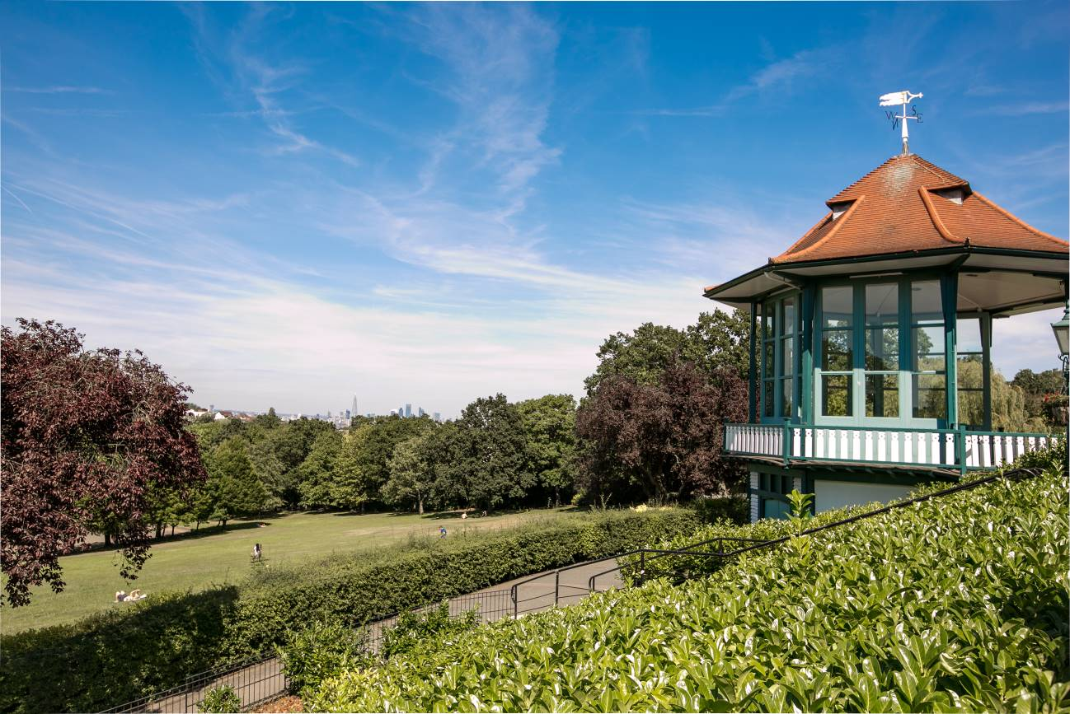

# Historic trading information

## Café Turnover (Museum café and kiosks)

Please note year turnovers are net, whereas monthly is gross

|  |  |  |
| --- | --- | --- |
| **Year** | **Café Turnover (Net)** | **Increase % Net Turnover Year on Year** |
| 2019/20 | £ 1,231,347 | 2.60% |
| 2020/21 | £ 604,901 | -50.90% |
| 2021/22 | £ 1,237,921 | 104.60% |
| 2022/23 | £ 1,584,585 | 28.00% |

|  |  |  |  |
| --- | --- | --- | --- |
| **2023/2024** | **Turnover (Gross)** | **Number of Transactions** | **ATV (Gross)** |
| April | £ 184,236 | 16780 | £ 10.98 |
| May | £ 162,903 | 15031 | £ 10.84 |
| June | £ 129,575 | 13686 | £ 9.47 |
| Quarter 1 | £ 476,714 | 45497 | £ 10.43 |
| July | £ 182,668 | 17103 | £ 10.68 |
| August | £ 207,054 | 19149 | £ 10.81 |

*Chart: Turnover (Gross) per month*

## Historic Museum Visitor Numbers

The Horniman’s post-pandemic recovery has been strong in terms of visitor numbers and complemented by a focus on increasing diversity so that the audience is more representative of the London population. In support of this, the Nature + Love project will be delivered over the next few years and introduce two new outdoor destinations on the site that will appeal to diverse audiences, better distribute footfall across the entire estate and embed new income generating opportunities. The commercial strategy takes its cue from these organisational priorities.

*Chart: Visitor numbers per month.*

Please note that during the Nature + Love project period (2024/2025) we are projecting a slight drop off in overall visitors to circa 850,000, post project completion rising to 950,000 and then upwards of 1 million.

|  |  |  |  |  |  |  |  |  |  |
| --- | --- | --- | --- | --- | --- | --- | --- | --- | --- |
|  | 2019/20 |  | 2020/21 |  | 2021/22 |  | 2022/23 |  | 2023/24 |
| April | 107,409 |  | 0 |  | 68,445 |  | 80,066 |  | 96,223 |
| May | 89,597 |  | 0 |  | 53,127 |  | 71,142 |  | 80,522 |
| June | 71,057 |  | 0 |  | 47,644 |  | 71,360 |  | 71,048 |
| July | 94,875 |  | 0 |  | 47,568 |  | 76,903 |  | 98,513 |
| August | 107,440 |  | 0 |  | 68,612 |  | 98,130 |  | 111,408 |
| September | 67,996 |  | 857 |  | 46,719 |  | 60,176 |  | 0 |
| October | 93,278 |  | 19,777 |  | 54,551 |  | 85,023 |  | 0 |
| November | 52,084 |  | 19,671 |  | 42,641 |  | 53,169 |  | 0 |
| December | 42,371 |  | 29,402 |  | 29,585 |  | 44,936 |  | 0 |
| January | 55,680 |  | 3,597 |  | 42,620 |  | 62,183 |  | 0 |
| February | 73,119 |  | 8,721 |  | 46,981 |  | 82,048 |  | 0 |
| March | 53,306 |  | 0 |  | 59,561 |  | 76,879 |  | 0 |

# The selection process:

|  |  |
| --- | --- |
| Tender opens | 07/11/2023 |
| Tender submission deadline | 08/12/2023 |
| Operators interviews w/c | 08/01/2024 |
| Visits to operators/tastings (2 weeks) | 02/01/2024 |
| Operator selection and appointment w/c | 22/01/2024 |

The Grasslands Garden

# Appendix I – Asset Register

The asset register will be available shortly after an independent audit has been completed.

# Appendix II – Division of Responsibilities

## Café Operator

Energy usage will be recharged quarterly to the café operator calculated from meter readings. Discussions will need to take place during contract stage on the usage of gas versus electric related to our commitment to sustainability practices.

The removal of waste from site will be recharged to the café operator quarterly by the Horniman.

Front of house cafe areas will be cleaned by the Horniman in-house cleaning team. This is to reduce the number of independent contractors on site daily. Specifics can be discussed during contract stage. Cleaning will be recharged quarterly.

Marketing and signage will be the responsibility and at the cost of the café operator but must follow all Horniman brand and style guidelines and be approved by the Horniman.

Pest control will be charged back to the café operator and policies must be adhered to. Due to the nature of the building and the priority of safeguarding the museum’s collections, a fair and transparent cost will be recharged.

Any other costs incurred by the Horniman as a result of the café operations and as notified to the café operator.

The café operator will be responsible for:

* Electrical works including all safety checks i.e. PAT testing, inspections etc.
* Extraction
* Maintenance of equipment owned by the Horniman but used by the contractor
* Complying with all relevant regulations including (without limitation) any food hygiene, public liability, health & safety, safeguarding, GDPR regulations.
* Providing fire risk assessments and other H&S documentation on a regular basis to our estates team.

## Events

Events venues/spaces will be provided in a clean and operational state by the Horniman. The caterer is responsible for returning the venue to a reasonable state of cleanliness prior to vacating the space and on the same day as the events. Preferably waste is to be removed from site but if part of a joint tender then can be recharged to the operator.

Event administration, marketing and management is the responsibility of the caterer through close liaison and approval by the Horniman team.

Event security is the responsibility of the caterer and must be sufficient for the event and with security staff holding the relevant qualifications. The Horniman has general guidance for contractor behavior which will be shared.