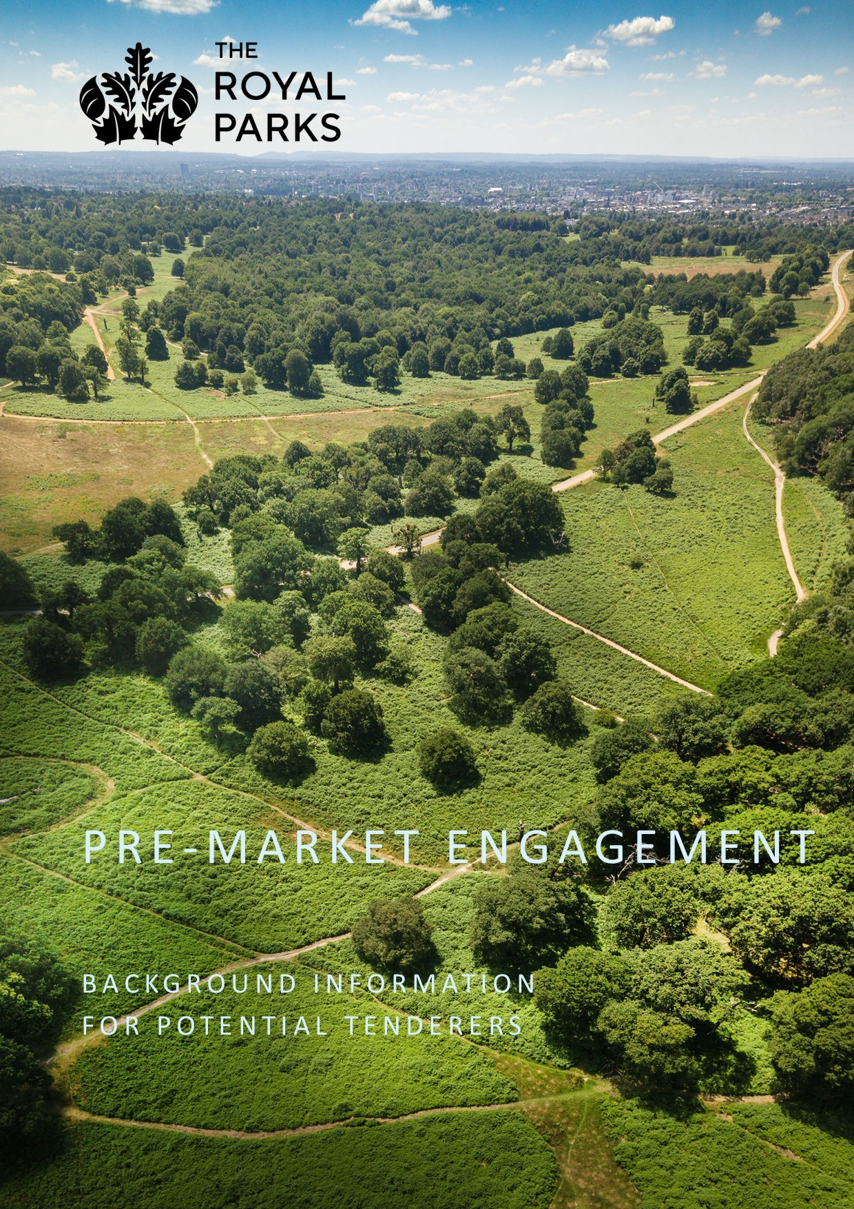
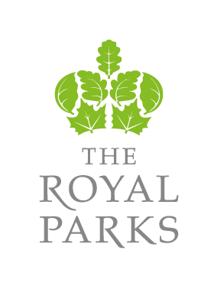

PROCUREMENT OF

SIGNAGE.

PRE-MARKET ENGAGEMENT DOCUMENT.

December 2021

1.0 THE ROYAL PARKS BACKGROUND

The Royal Parks is the charity dedicated to caring for the most famous collection of urban parks in the world.
The charity was created 2017, bringing together the park management, fundraising and education functions of The Royal Parks Agency and the Royal Parks Foundation.
We provide free access to London's beautiful, natural and historic green spaces, to help improve everyone's quality of life and well-being every day.
We protect, and sustainably manage 5,000 acres of diverse parkland, from the funds we raise.
We welcome everyone, and care about delivering diverse, excellent and unforgettable experiences to everyone who visits the timeless green spaces we manage.
TRP manages eight of London's Royal Parks - St James's Park, The Green Park, Hyde Park, Kensington Gardens, The Regent's Park (& Primrose Hill), Greenwich Park, Richmond Park and Bushy Park.
We are also responsible for several other areas including Brompton Cemetery, Victoria Tower Gardens, and associated infrastructure including roads and properties, both within the parks and wider estate, which includes property outside the boundaries of the parks themselves e.g., the Longford River, various monuments and water bodies in addition to playgrounds and other water bodies such as the Serpentine. TRP runs several events over the year at some of the parks including Concerts and Hyde Park Winter Wonderland which attract large numbers of visitors.
The Royal Parks are timeless green spaces are where life flourishes. They are a living history comprised of Grade 1 listed landscapes on the English Register of Historic Parks and Gardens, and home to numerous Grade i and ii listed buildings, artefacts and monuments. In addition, Greenwich Park lies within a UNESCO World Heritage Site, Bushy Park has recently been designated as a Site of Special Scientific Interest (SSSI), and Richmond Park is a National Nature Reserve, London's largest Site of Special Scientific Interest and a European Special Area of Conservation. Further information on TRP is available from www.royalparks.org.uk

2.0 signage background

In 2021 TRP launched its first Interpretation and Wayfinding Strategy to improve the way we present information in and about the Royal Parks. A primary focus of this work is improving signage across the estate, from interpretive information panels to park regulations. The suite of signage also includes map boards to aid in wayfinding, and noticeboards to inform visitors of important events, services and park rules.
Across the estate we have almost 250 noticeboards and map boards, which were installed in the 1990s. Many of these boards are now in a poor state of repair and require refurbishment. The map boards and noticeboards are primarily placed at entrances/exits to the parks, and thus offer visitors a first impression of The Royal Parks as an organisation. Therefore, it is vital that both the information and the infrastructure that displays it are of a high quality and convey the care with which TRP maintains the parks.
The focus of this brief is repair work to map boards and noticeboards in Richmond Park and Kensington Gardens, and finding a solution for neatly and efficiently displaying notices in noticeboards.
The map boards and noticeboards consist of cast iron frames supported on upright posts. Almost all of these frames contain a lockable glass-fronted cabinet that encases the map or notices. The boards come in a range of sizes and orientations, and some are double-sided. Some of the boards are abutted or affixed to each other, creating panels in a diptych or triptych formation. Please see Appendix A for examples in Richmond Park and Kensington Gardens.
Over time, many of the cabinets – including their locks and keys – have become damaged, making them difficult to open. The metal frames are worn, with flaking paint and scratches. Therefore, we would like to replace the cabinets and repaint the metal frames.
The map boards contain large maps in a landscape orientation, with practical information about the park. The noticeboards contain a wide variety of notices and posters ranging from regulatory/instructional messages to promotional materials about activities in the parks; the notices are mainly produced by TRP, but also include collateral produced by third parties. The noticeboards are usually slim and vertical, but in Richmond Park the noticeboards are very large and have a landscape orientation.
The notices are often haphazardly arranged and out-of-date, partly because it is difficult to open the damaged cabinets and partly because the backing boards currently only allow for affixing notices with drawing pins tape. We would like a more aesthetically pleasing solution for the noticeboards that will enable us to display the notices in a tidier, more uniform manner, and will make the notices easier to replace.

3.0 PRE-MARKET ENGAGEMENT (PME) PURPOSE

The purpose of the PME is as follows –
- Allows the market to better understand our requirements by issuing a draft version of the Tender in advance.
- Give the market an opportunity to seek clarification from TRP regarding elements of our requirements.
- Allows TRP to gather information on how the market is structured and how it operates.
- Allows the market to better understand TRP from an organisational perspective (in particular, an early understanding of TRP core values, as detailed in the documents we have made available via the Delta portal).
- Allows TRP to obtain feedback regarding our requirements (e.g. possible changes to the draft specification).
- Allows TRP to test the feasibility of our needs against what is available in the market.
- Allows suppliers/ providers time to plan and prepare to respond to a contract opportunity.
- An opportunity for suppliers / providers to partner with others to provide better solutions (e.g. technology partners).
- Generates interest in TRP as a buyer.
- Stimulates competition and innovation.
- Informs TRP of any risks and issues.
- Helps TRP plan the optimal approach-to-market.

4.0 NEXT STAGES

The following key provisional dates have been identified; these will be confirmed within the tender documents. Please note that TRP reserves the right to change these provisional dates.

Task | Date / Comments:
Pre-Market Questionnaire issued, complete with draft ITT | 20 December
Return / informal evaluation of questionnaire / alterations to specification | (12 noon) 4 January
Tender issued | 10 January
Tender return | 24 January
Evaluation | 31 January
Award | 7 February
Installation | To be completed by 31 March at the latest.

5.0 RESPONDING TO OUR PRE-MARKET ENGAGEMENT

Please respond via email to mabrahams@royalparks.org.uk

May I take this opportunity to thank you for your interest in this exercise.

With best wishes.

Mark Abrahams.

Head of Contract Management & Procurement.

APPENDIX A

PRE-MARKET ENGAGEMENT QUESTIONS

Organisation name:
……………………………………………………………………………………….

Main point of contact name:
……………………………………………………………………………………….

Main point of contact email address:
……………………………………………………………………………………….

Main point of contact mobile number:
……………………………………………………………………………………….

Q1 – Do you envisage submitting a bid?
……………………………………………………………………………………….

Q2 - Are you able to meet the timescales outlined within our timetable above (please identify typical lead time)?
……………………………………………………………………………………….

Q3 - Will you bid as a stand-alone bidder, or with a partner (e.g., to install the signage)? If the latter, please briefly clarify your role and the partner’s role:
……………………………………………………………………………………….

Q4 – Are you able to deliver against our specification as detailed / appended?
……………………………………………………………………………………….

Q5 – Please highlight any areas of our specification that you would not be able to comply with, or where you require clarification (add additional lines below if necessary).
……………………………………………………………………………………….
……………………………………………………………………………………….
……………………………………………………………………………………….

Q6 – Do you envisage any other challenges, e.g., availability of materials?
……………………………………………………………………………………….
……………………………………………………………………………………….

Q7 – Please specify the type of coating you would use (attach spec sheet if possible)
……………………………………………………………………………………….
……………………………………………………………………………………….

Q8 – Please specify the type of rust-proofing treatment you would use (attach spec sheet if possible)
……………………………………………………………………………………….
……………………………………………………………………………………….

Q9 – Please identify the type / thickness of glass (or similar) (attach spec sheet if possible)
……………………………………………………………………………………….
……………………………………………………………………………………….

Q10 – Please identify the types of materials to be used (attach spec sheet if possible)
……………………………………………………………………………………….
……………………………………………………………………………………….

Q11 – Please identify the types of locks (attach spec sheet if possible)
……………………………………………………………………………………….
……………………………………………………………………………………….

Q12 – Please identify any reference sites (attach spec sheet if possible)
……………………………………………………………………………………….
……………………………………………………………………………………….

Q13 – Please state the length of guarantee period (attach spec sheet if possible)
……………………………………………………………………………………….
……………………………………………………………………………………….

