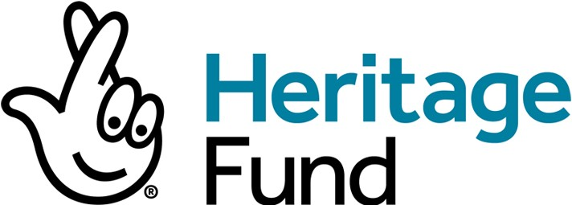

Invitation to Tender

Board Paper Solution

Ref: NHMF 0322

Schedule 2: Specification

BACKGROUND

The National Lottery Heritage Fund, formerly the Heritage Lottery Fund (HLF), is an operating name for the Trustees of the National Heritage Memorial Fund (NHMF). In 1994 the NHMF was given authority under the National Lottery Act to distribute money raised by the National Lottery to support projects involving the national, regional and local heritage of the United Kingdom.

The Heritage Fund is looking to appoint a provider of a Board Paper digital solution provider to provide a digital portal option that will change the way in which we send out Board and Committee papers reflecting a degree of ambition by the Heritage Fund to operate digitally and in a more modern way. It should be fully accessible and inclusive and will enable greater and more effective collaboration and communication. A streamlined solution that has the capabilities to allow the Fund to prepare and administer a range of meetings and communications more efficiently, that can be aligned with Microsoft Teams.

REQUIREMENT

The platform should be user-friendly and intuitive that would reduce the need for multiple apps, emails and papers. A secure document library to ensure all Board processes are located on the same interface is considered essential and would address cyber security risks/concerns.

The application must provide 100 fully supported licences per annum, with the option to increase the number of licences as required.

The solution should:

- Consider how project administrators would have overall control to commission and decommission licences
- Allow for design preferences to customise graphic profile and menu structures
- Provide a digital APP solution, compatible with Android
- Improve user experience with the option to annotate papers and create new document versions, both on and offline.
- Be fully accessible and inclusive to increase collaboration and communication
- Provide unlimited administrative training and 24/7 end-user support.
- Ensure setup of Single Sign On (SSO) registration/access
- Provide secure data hosting and auto wiping of data for lost devices
- Support Board Effectiveness with analytics reporting tools
- Provide unlimited document storage
- Allow intime voting
- Support ongoing management and maintenance; and
- Options to split screen to view video/documents side-by-side

DURATION AND TIMELINE

The Duration of the Contract will be four (4) years with the option to extend for a further one (1) year period at the discretion of the heritage Fund.

The appointed provider will need to be able to produce, train internal staff and roll the solution out to the organisation within 6 months of award of Contract.

CONTRACT MANAGER

The Contract Manager will be Claire Franklin Senior Governance Manager and the winning provider will be expected to work closely with the Contract Manager during the implementation and ongoing provision of the solution

