Conversion of MAN 15T HX77
Support Vehicles to EPLS Mk3 Variant
OSVP/0032

Article Acceptance Standard

Annex J

V1

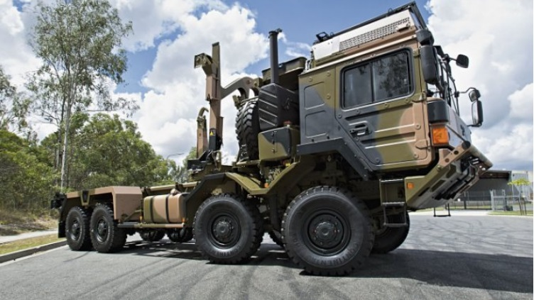

Version History

Issue: V1

Author:

Date: 29 September 2017.
Authorised by:

Signature:

Date: 29 September 2017
Checked for The Authority by:

Signature:

Date:

 | Version | Amendment |  |  | Date
 | V1 | First Submission Document for ITN |  |  | 29/09/17

Contents

1. Introduction 4
2. Objective 4
3. Conversion, Inspection and Testing Process 4
4. Assumptions 5
5. Appendices 7

Table 1: Table of Abbreviations

Abbreviation | Interpretation for this Document
CES | Complete Equipment Supplies
ILHS | Integrated Load Handling System
EPLS | Enhanced Palletised Loading System
MTBUK | MAN Truck and Bus UK Limited
RMMV | Rheinmetall MAN Military Vehicles
SI | Service Information
EnSIR | Entry Standard Inspection Report
ExSIR | Exit Standard Inspection Report
FOT | First of Type
QA | Quality Assurance
CoC | Certificate of Conformity
SRD | System Requirement Document

- Introduction
This document sets out the Article Acceptance Standard for Contract OSVP/0032.
- Objective
The conversion of the HX77 Cargo vehicles to EPLS Mk3 variants is to be undertaken at the Convertor’s premises in Manchester. Conversion is in accordance with a Conversion Manual compiled and supplied by (Rheinmetall MAN Military Vehicles) RMMV Ö in Austria based on the (First of Type) FOT conversion.
The Article Acceptance Standard sets out the standard that the finished converted vehicle will meet in accordance with the specification as described by the Authority and stated by the Contractor in Appendix E to Annex A. Each stage of the Conversion Process is fundamental in achieving the overall Acceptance Criteria.
Compliance, therefore, is achieved by ensuring that each element of the Conversion Process is documented and adhered to, the components of which are set out below:
- Quality Control;
- ILHS Functional Test;
- Conformity of Production;
- Compliance with UK Roadworthiness Legislation;
- Vehicle Handover to Babcock/DSG.
- Conversion, Inspection and Testing Process
A simplified chart outlining the Article Acceptance Standard is shown in Appendix A.
During the conversion of each vehicle, specific areas of the work that have a Safety Aspect will be quality checked in accordance with the Conversion Manual provided by RMMV Ö. This Manual forms the basis of the Quality Book which is the document that identifies and records all the key elements of the conversion. Each vehicle will be issued with its own Quality Book. An example of this can be found in Appendix B.
If at any time during the conversion any element fails to meet the Quality Criteria, it will be reworked and rechecked to the fully compliant standard. Only when the processes set out in the Vehicle Quality Book are complete will the vehicle proceed to the next stage of the conversion.
Should any Emergent Work be identified once the Contractor accepts a vehicle into the Conversion Programme; then the cost and time required to complete the work will be estimated and communicated to the Authority Project Manager in accordance with Annex L of the Contract.
Upon the vehicle reaching a point where it can be driven under its own power, it will undergo a Functional Test of the ILHS using:
- a fully loaded Flatrack with a maximum mass not exceeding 15,5t;
- an empty ISO Container.
All tests performed by the ILHS will be in accordance with the ILHS Test Sheet shown at Appendix C. Should any test fail the required standard, the equipment will be reworked and retested to the point that the conditions are met.
All vehicles will be supplied with a hard copy of a (Certificate of Conformity) CoC as shown in Appendix D. This document will detail the serial numbers of the major component parts of the vehicle so that the Authority can update JAMES for the respective chassis. A soft copy will also be provided to the Authority’s Project Manager as part of the monthly progress reporting structure.
As a final check, all vehicles will undergo an (Exit Standard Inspection Report) ExSIR as shown at Appendix E. Hard copies of all the Quality and Functional Tests Sheets detailed within the Appendices will be compiled and placed in the vehicle. Soft copies will be deliverd to the Authority’s Project Manager as part of the monthly progress reporting structure.
Any Rectification Work identified at any stage of the Conversion will be implemented before release of the vehicle back to the customer.
Once a vehicle has undergone and passed all Quality and functional checks, it will be handed over to the collection and delivery personnel for movement back to the Handover Facility at Ashchurch.
On arrival at Ashchurch, each vehicle will have the fuel tank filled to maximum. This may be at the MoD UIN Fuel Bunkering Point or at a local fuel filling station dependant on availability.
Each vehicle will be given a cursory inspection by the Contractor’s personnel/agent to ensure that it is not suffering from any leaks or loss of fluids. Any minor adjustments and repairs deemed necessary will be carried out on site and any paperwork amended accordingly.
The Contractor will complete a Handover Form for release to the Authority’s representative as shown in Appendix F.
The Authority’s representative will inspect the vehicle within 5 working days and advise the Contractor/Handover Facility Staff of the result.
Should a vehicle be rejected for Acceptance,it will be returned to the Handover Facility Staff with details of the rejection criteria.
If the reason for rejection is deemed valid, the defect(s) will be rectified and resubmitted for Acceptance. However, should the reason for rejection be considered unjustified, the Authority’s Project Manager will be informed and will determine which party is correct, based on the information requested and supplied. This decision will take place within 2 working days.
If the decision is made in favour of the Contractor, the vehicle will be judged as being Accepted.
If the decision is made in favour of the Authority’s representative, the defect(s) shall be recitifed and the vehicle presented back to the Authority’s representative who within 2 working days shall inspect the said vehicle solely against the defects initially identified.The Authority’s Project Team will advise the Contractor of the Acceptance Status without delay.
- Assumptions
It is expected that the standard to which the Authority’s representative will accept the vehicle Back into Service will be that set out in FMT 932(W2) and FMT 933.
Each vehicle will be returned in a Roadworthy Condition appropriate to the standard in which it was accepted.
Each vehicle will be handed over to the Authority’s representative who will carry out their own inspection according to FMT 932(W2) and FMT 933. The Authority will have a maximum of 5 working days to inform the Contractor of the Acceptance Status of each vehicle handed over. If the Contractor has not received formal notification of status within 5 working days, it will be deemed as Accepted by the Authority.
A vehicle can only be rejected on the basis that the Top Hamper does not perform satisfactorily in line with the criteria as set out in the (System Requirement Document) SRD and according to Item 9.3.2 in the (Statement of Requirement) SOR. The vehicle will undergo an ExSIR at Manchester prior to leaving the Conversion Facility.
Each vehicle will be returned with a full tank of fuel (refilled at fuel point on camp using MoD UIN).
Each vehicle will be supplied with a Document Pack in a clear plastic A4 wallet.
Each Document Pack will include a copy of:
- Entry Standard Inspection Report;
- ILHS Test Sheet;
- Certificate of Conformity;
- Final Quality Check Sheet;
- Exit Standard Inspection Report.
Therefore the original FMT 932(W2) must be available for comparison together with the original EnSIR.
Any valid minor adjustments and repairs will be carried out on site and all relevant documentation amended accordingly prior to the vehicle being re-presented.

- Appendices
Appendix A
Reject
Reject
Vehicle
stock in
Manchester
Conversion
-
QA
incl. Final
Inspection
ILHS
-
Functional
Test
Repair/Rework
ExSIR
Delivery to
Ashchurch
Handover to
The Authority’s
representative
Acceptance
Repair/Rework
Appendix B

Quality Book to follow

Appendix C

Appendix D

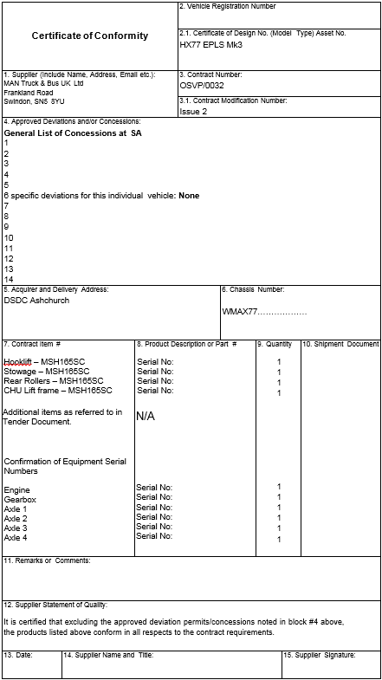

Appendix E
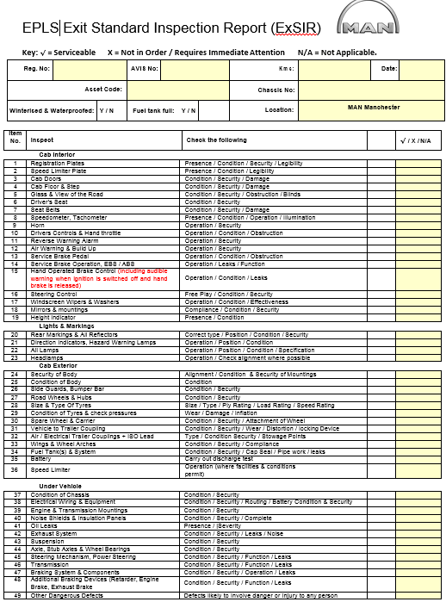

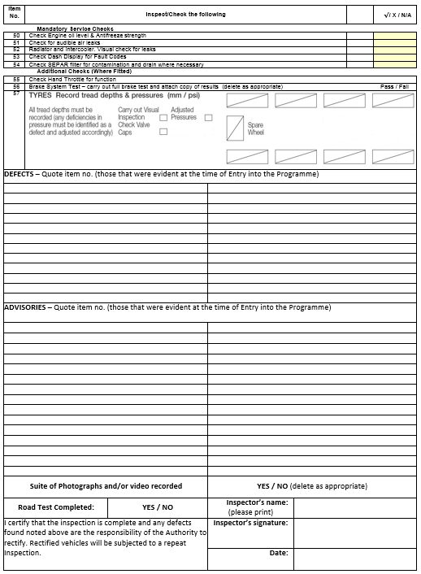

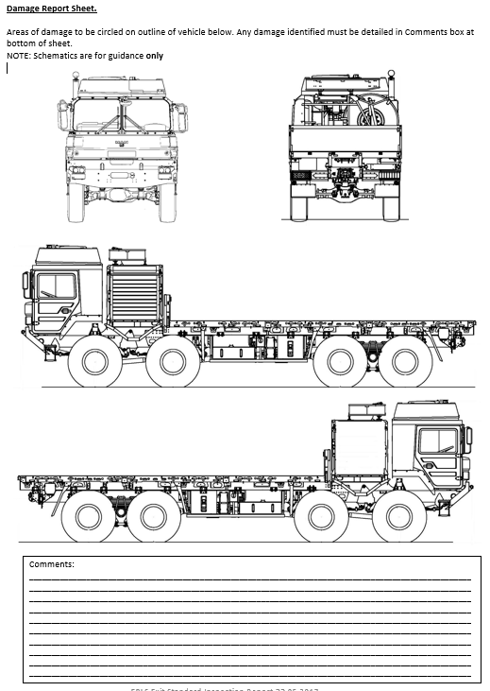

Appendix F
