

www.gov.uk/naturalengland
Request for Quotation

Request for Quotation
Cavenham Heath NNR Fencing Task

You are invited, to submit a quotation for the requirement described in the specification below.

Please confirm, by email, receipt of these documents and whether you intend to submit a quote.

Your response should be returned to the following email address by: 17:00 on 13-1-2023

Email: chris.hainsworth@naturalengland.org.uk
Date: 20-12-2022

Ensure you state the reference number and ‘Final Submission’ in the subject field to make it clear that it is your response.

Contact Details and Timeline

Chris Hainsworth will be your contact for any questions linked to the content of the quote pack or the process. Please submit any questions by email and note that, unless commercially sensitive, both the question and the response will be circulated to all tenderers.

Action | Date
Date of issue of RFQ | 23-12-2022 at 17:00 BST / GMT
Deadline for clarifications questions | 10-01-2023 at 17:00 BST / GMT
Deadline for receipt of Quotation | 13-01-2023 at 17:00 BST / GMT
Intended date of Contract Award | 18-01-2023
Intended Contract Start Date | 20-01-2023
Intended Delivery Date / Contract Duration | 20-01-2023 to 28-02-2023

Glossary

Unless the context otherwise requires the following words and expressions used within this Request for Quotation shall have the following meanings (to be interpreted in the singular or plural as the context requires):

“Authority” | Means the Department for Environment, Food and Rural Affairs acting as part of Natural England
“RFQ” | Means this Request for Quotation and all related documents published by the Authority and made available to suppliers
“Contract” | Means the contract to be entered into by the Authority and the successful supplier.

Conditions applying to the RFQ

You should examine your response to the RFQ and related documents ensuring it is complete prior to submitting your completed quotation.

Your quotation must contain sufficient information to enable the Authority to evaluate it fairly and effectively. You should ensure that you have prepared your quotation fully and accurately and that prices quoted are arithmetically correct for the units stated.

The supplier by submitting a quotation is deemed to accept the terms and conditions in the RFQ. Failure to comply with the instructions set out in the RTQ may result in the supplier’s exclusion from this procurement.

Acceptance of Quotations

By issuing this RFQ the Authority does not bind itself to accept any quotation and reserves the right not to award a contract to any supplier who submits a quotation.

Costs

The Authority will not reimburse you for any costs and expenses which you incur preparing and submitting your quotation, even if the Authority amends or terminates the procurement process.

Mandatory Requirements

The RFQ includes mandatory requirements and, if you do not comply with them, your quotation will not be evaluated.

Clarifications

The Authority reserves the right to discuss, confidentially, any aspect of your quotation with you prior to any award of Contract to clarify matters.

Amendments

The Authority may amend the RFQ at any time prior to the deadline for receipt. If it amends the RFQ the Authority will notify you in writing and may extend the deadline for receipt in order to give you a reasonable time in which to take the amendment into account.

Conditions of Contract

The terms and conditions attached Condensed Terms and Conditions will be included in any contract awarded as a result of this RFQ process. The Authority will not accept any material changes to these terms and conditions proposed by a supplier.

Specification

The Authority is Natural England. The Authority’s priorities are to secure a healthy natural environment; a sustainable, low-carbon economy; a thriving farming sector and a sustainable, healthy and secure food supply. Further information about the Authority can be found at: Defra. Natural England MMO

Construction of stockproof fencing on Cavenham Heath NNR 2022-3
The works will be carried out on Cavenham Heath National Nature Reserve, between the villages of Tuddenham St Mary and Icklingham, near Bury St Edmunds. Cavenham Heath is managed by Natural Englands Breckland NNR Team.

The works consist of supplying all materials, all labour and equipment for all the works as set out in this specification and drawings.

Site visit
Before submission of a quotation the contractor is advised to visit the site and satisfy himself as to the full extent and character of the works and conditions affecting the contract and quote for the whole works necessary to complete it to satisfy the specification and drawings.
Contractors should take their own site measurements.
Please contact Chris Hainsworth on 07799657428 to arrange a site visit.

Survey of site

The areas shown on the attached plans are only as accurate as the scale of drawing allows, therefore it is essential that contractors visit the site prior to submitting the quotation in order to fully ascertain:

- the extent of the work involved;
- check the proposed design and specification details;
- check vehicular access and where machinery and materials may be delivered
and stored.

It is emphasised that claims arising out of non-compliance with this clause will not be accepted.

Access
Access to Cavenham Heath is from Tuddenham village (see attached map).

Variations or extra works

The contractor shall not execute any variations that may affect the contract. These will either be

executed on an agreed price or on day works agreed at the start of the contract. Variation

orders will only be valid if issued and confirmed in writing by Natural England’s nominated

officer.

The contract is a fixed price contract with work to be completed by 15 March 2023.
Invoices are to be submitted by 20 March 2023.

Scope of work - general details

- The contractor is to supply all labour, plant and equipment for the proper execution of the work.
- The contractor should supply netting, barbed wire, staples, nails and other wire fixings as necessary.
- No existing trees, straining or intermediate posts are to be utilized in the fence construction.
- Rubbish removal – on completion of the work the contractor must clear from the site all old fence posts, netting and wire and off-cuts of wire etc.
- A small amount of line clearance may be necessary.

Description of work required

The work consists of complete replacement of several sections of fencing and disposal of the old fence materials. In addition the erection of 2 new field gates on section B-C including gateposts and side rails. The replacement fencing should be joined onto existing fences at either end to provide a continuous stock-proof barrier. There should be minimal line clearance required. See attached maps for details of fence location.

Description of work required (cont)
All the fence sections should be stock proof fencing consisting of high tensile stock netting, and above the netting either two strands of high tensile barbed wire with 5cm spacings, or two strands of high tensile plain wire with 5cm spacings.

For all fences any gaps in the fence, eg between straining posts or between new straining posts and existing fencing should be made stockproof with horizontal wooden rails. Rails should also be used to block any gaps under the fence where ground undulations prevent the wire exactly following the ground surface. This will especially necessary at one point where the fence line crosses a ditch.

Specific work required at each point on the map is as follows:

A-B
- Line clearance – overhanging willows at several points
- Removal of approx. 300m existing fence
- Replacement with approx. 300m of new fencing (barbed wire top strands)
B-C
- Line clearance
- Removal of approx. 730m of existing fence
- Replacement with approx.. 730m of new fencing (barbed wire top strands)
- Erection of 2 new galvanized metal field gates with gateposts and rails
C-D
- Removal of approx. 636m of existing fence (minimal line clearance)
- Replacement with approx. 636m new fencing (barbed wire top strands)

E-F
- Line clearance – minimal
- Removal of approx. 510m existing fence
- Replacement with approx. 510m of new fencing (plain wire top strands)

10. Specification of materials to be used

Line clearance
The fence sections will require minimal line clearance. Vegetation from line clearance should be piled neatly adjacent to the fence line, on the outside of the fence.

Rubbish Removal
Contractors to ensure that all old fence materials, off-cuts of wire etc are removed and properly disposed of off-site in their entirety.

Timber
Ideally all strainer and intermediate posts will be of chestnut, with approximate dimensions as for softwood below. If chestnut is not available, then specification for timber is as follows.

All timber to be softwood pressure treated to British Standard with Tanalith treatment code HT1/F1 and HT1/F2, conforming to BS5502 and BS5589. Any cut surface to be treated with timber preservative. All posts to be driven into the ground, but may be dug in if necessary. No post tops to be cut; all round posts to be peeled and pointed; diameter measurements are a minimum along the entire length of the post. All timber should be from a sustainable British source (FSC accredited).

Strainers: Box assembly, vertical posts 1 x 2.4m x 15-20cm Ø, 1 x 2.4m x 15-20cm Ø, with 90cm x 12.5cm x 7.5cm breast plates, horizontal bar 2.4m x 12.5-15cm Ø. Strainers to be a maximum of 4.00m apart and a minimum of 1.3m into the ground; multiple boxed junctions to be used as ground conditions dictate, at the contractor’s discretion. Horizontal bars to be rebated max 10mm, fixed by galvanised 12mm Ø, 30cm steel pins, at a height that brings it between the two top wires; pins should be driven into a pre-drilled hole of 10mm to prevent moisture from entering the timber; the 12mm Ø pin on the strutting post should be left with 25mm showing to put the diagonal wire over. 3.15mm HT plain wire is to be used to strain the box assembly and joined with crimp sleeves.

Turning posts: 2.4m x 15-20cm Ø with 90cm x 12.5cm x 7.5cm breast plates, at every change of direction less than 30°; strainer assembly to be used at turns exceeding 30° and as ground conditions dictate, at the contractor’s discretion; posts to be a minimum of 1.3m into the ground.

Intermediate posts: 1.85m x 10cm Ø, maximum of 5m apart and 0.75m into the ground.

Tie downs to be used on all types of post as necessary. A 1.85m x 10cm Ø post should be installed at 45º to the vertical post to a depth of at least 0.9m. The tie down post should be fixed with a 12mm galvanised pin using a pre-drilled 10mm hole, between 100mm and 200mm above ground level.

Stock netting
Stock netting to be HT 8/80/15. The netting to closely follow the ground contours so that no gaps of more than 7.5cm exist, but the netting should not be in contact with the ground surface. Wiring should consist of either two high-tensile barbed top wires or two high-tensile plain wires (see below), with the top wire at 5cm above the top of the stock netting. Barbed wire should be 2 ply 16.5g high tensile barbed wire.

Wiring

Staples to be 4cm x 3.15mm galvanised, barbed, and angled across the grain of the timber. Staples to be driven to a depth that does not crush the galvanizing, allows the wire to more as it expands or contracts (or is pressured by stock), but does not allow it to rattle in the wind which can damage the galvanizing. Wires are to be joined by tying to the manufacturer’s specification, or by using a crimp sleeve designed for the task (‘gripples’ are not appropriate). All steel to be galvanised to British standard (BS443: 1982). Nails should be galvanized if possible and of sufficient dimensions to securely fix rails.

Gates and gateposts
In section B-C two galvanised metal field gates are to be erected in positions to be agreed with the contractor. The gateposts can be either round chestnut or pressure treated softwood. Gaps on either side of the gate, between the strainer posts and the gateposts should be filled with stockproof post and rails.

Timescale

It is anticipated that work will be carried out between 19 January 2023 and 28 February 2023 with invoices to be received by 20 March 2023.

A timetable for the works, showing the approximate starting and finishing dates should be submitted with your tender.

13. Other points

i) Contractors are asked to quote for all the elements of work detailed in this specification. Please indicate in your quote the price per section. However, Natural England reserves the right to exclude some of the elements from the final work schedule.

ii) There are sheep and cattle grazing on the reserve most of the year. Contractors should liaise closely with the project officer and should ensure access gates are kept closed where necessary.

iii) The successful contractor will be expected to complete a risk assessment before starting work.

iv) The successful contractor should be able to supply Natural England with a valid Public Liability Insurance certificate and a valid Employers Liability insurance certificate before starting work.

13. Nominated officer

Natural England’s nominated officer is Chris Hainsworth, telephone 01638 721329 or 07799657428 (mobile).

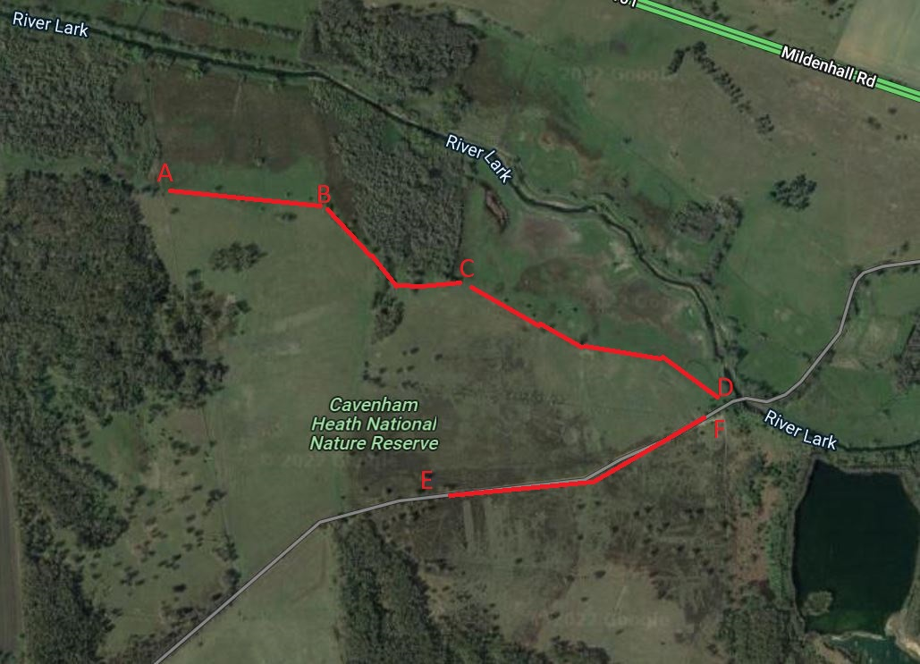
Site
The works will be carried out on Cavenham Heath National Nature Reserve, between the villages of Tuddenham St Mary and Icklingham, near Bury St Edmunds. Cavenham Heath is managed by Natural England’s Breckland NNR Team.

The works consist of supplying all materials, all labour and equipment for all the works as set out in this specification and drawings.

Prices
Prices must be submitted in £ sterling, and show the prices excluding and inclusive of VAT.

Quotation Submission
We will award this contract in line with the most economically advantageous tender (MEAT) as set out in the following award criteria:

Price – 80%

Quality – 20%

Criteria | weighting | To include:
Price | 80 | - Price for whole job and report
H&S | 10 | - Please detail how you will manage any H&S risks.
Previous Works | 10 | - Please indicate local projects that you have been involved with so that the NE officer may visit to look at the finished product.

Score | Justification
For a score of hundred (100): | Excellent - Response is completely relevant and excellent overall. The response is comprehensive, unambiguous and demonstrates a thorough understanding of the requirement and provides details of how the requirement will be met in full.
For a score of seventy (70): | Good - Response is relevant and good. The response demonstrates a good understanding and provides details on how the requirements will be fulfilled.
For a score of fifty (50): | Acceptable - Response is relevant and acceptable. The response provides sufficient evidence to fulfil basic requirements.
For a score of twenty (20): | Poor - Response is partially relevant and/or poor. The response addresses some elements of the requirements but contains insufficient / limited detail or explanation to demonstrate how the requirement will be fulfilled.
For a score of zero (0): | Unacceptable - Nil or inadequate response. Fails to demonstrate an ability to meet the requirement.

Contract Management

This contract shall be managed on behalf of the Authority by: Chris Hainsworth email:chris.hainsworth@naturalengland.org.uk. Telephone: 07799657428

We will raise purchase orders to cover the cost of the services and will issue to the awarded supplier following contract award. Invoice to be given on completion of all work.

Disclosure

All Central Government Departments, their Executive Agencies and Non Departmental Public Bodies are subject to control and reporting within Government. In particular, they report to the Cabinet Office and HM Treasury for all expenditure. Further the Cabinet Office has a cross-Government role delivering overall Government policy on public procurement, including ensuring value for money and related aspects of good procurement practice.

For these purposes, the Authority may disclose within Government any details contained in your quotation. The information will not be disclosed outside Government during the procurement.

In addition, the Authority is subject to the Freedom of Information Act 2000 and the Environmental Information Regulations 2004, which provide a public right of access to information held by public bodies. In accordance with these two statutes, the Authority may be required to disclose information contained in your quotation to any person who submits a request for information pursuant to those statutes.

By submitting a quotation you consent to these terms as part of the procurement.

Disclaimers

Whilst the information in this RFQ and any supporting information referred to herein or provided to you by the Authority have been prepared in good faith the Authority does not warrant that this information is comprehensive or that it has been independently verified.

The Authority does not:

- make any representation or warranty (express or implied) as to the accuracy, reasonableness or completeness of the RFQ;

- accept any liability for the information contained in the RFQ or for the fairness, accuracy or completeness of that information; or

- accept any liability for any loss or damage (other than in respect of fraudulent misrepresentation or any other liability which cannot lawfully be excluded) arising as a result of reliance on such information or any subsequent communication.

Any supplier considering entering into contractual relationships with the Authority following receipt of the RFQ should make its own investigations and independent assessment of the Authority and its requirements for the goods and/or services and should seek its own professional financial and legal advice.

Protection of Personal Data

In order to comply with the General Data Protection Regulations 2018 the contractor must agree to the following:

- You must only process any personal data in strict accordance with instructions from the Authority
- You must ensure that all the personal data that we disclose to you or you collect on our behalf under this agreement are kept confidential.
- You must take reasonable steps to ensure the reliability of employees who have access to personal data.
- Only employees who may be required to assist in meeting the obligations under this agreement may have access to the personal data.
- Any disclosure of personal data must be made in confidence and extend only so far as that which is specifically necessary for the purposes of this agreement.
- You must ensure that there are appropriate security measures in place to safeguard against any unauthorised access or unlawful processing or accidental loss, destruction or damage or disclosure of the personal data.
- On termination of this agreement, for whatever reason, the personal data must be returned to us promptly and safely, together with all copies in your possession or control.

General Data Protection Regulations 2018
For the purposes of the Regulations the Authority is the data processor.

The personal information that we have asked you provide on individuals (data subjects) that will be working for you on this contract will be used in compiling the tender list and in assessing your offer. If you are unsuccessful the information will be held and destroyed within two years of the award of contracts. If you are awarded a contract it will be retained for the duration of the contract and destroyed within seven years of the contract’s expiry.

We may monitor the performance of the individuals during the execution of the contract, and the results of our monitoring, together with the information that you have provided, will be used in determining what work is allocated under the contract, and in any renewal of the contract or in the award of future contracts of a similar nature. The information will not be disclosed to anyone outside the Authority without the consent of the data subject, unless the Authority is required by law to make such disclosures.

Cavenham Heath fencing 2022-3 Schedule

 | Element of Work | Price per metre | Total price (ex VAT)
A-B | Line clearance  300 metres old fence removed  300 metres new fence erected | ……………………  …………………….  ……………………. | ……………………  ..............................  …………………….
B-C | Line clearance  730 metres old fence removed  730 metres new fence erected  2 galvanised field gates, gateposts and rails erected | ……………………..  ………………………  ………………………  ……………………… | ……………………..
C-D | Line clearance  636 metres old fence removed  636 metres new fence erected | ……………………..  ……………………..  …………………….. | …………………….  ……………………..  ……………………...
E-F | Line clearance  510 metres old fence removed  510 metres new fence erected | ……………………..  ……………………..  …………………….. | …………………….  ……………………..  ……………………...

TOTAL PRICE (ex VAT) …………………..

