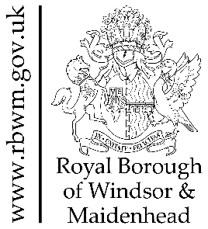
MARKET ENGAGEMENT BRIEF* - RBWM

“Building a borough for everyone – where residents and businesses grow, with opportunities for all”.

The Royal Borough of Windsor and Maidenhead (RBWM) is committed to ensuring that we deliver the most effective services for residents which improve outcomes, whilst ensuring best value for money.

The current contracts for Drug and Alcohol Services reach an end in March 2022 and prior to recommissioning, we wish to undertake a Market Engagement event, to discuss our proposed model and gain thoughts and insights about possible opportunities, challenges, and risks.

This document provides a broad overview of RBWM’s current position and our emerging model.

*Please note that this Brief is not a Tender Specification nor is it an exhaustive list of service requirements and this market engagement is focusing on services defined as Lot 2 and Lot 3.

Part 1

DRUG AND ALCOHOL SERVICE – TIME FOR A CHANGE - BROAD OUTLINE

BACKGROUND

The Royal Borough of Windsor and Maidenhead has an affluent and economically active population, ranking 304 out of 317 local authorities in England in the Indices of Multiple Deprivation (IMD) - where a ranking of 1 is the most deprived area.

The traditional model of delivering Drug and Alcohol Services hasn’t met the needs of the 61,554 (51%) adult residents, that Public Health England’s Predictive Analysis suggests may have unmet alcohol needs, or the 180 clients with multiple disadvantages and complex needs, including entrenched drug and alcohol issues, that are engaged with multiple local services. Nationally and locally, only around 6% of Heroin and Crack Cocaine users successfully complete a course of treatment and don’t return to the service within 6 months.

For residents wanting general information about drugs and alcohol, there have been successful national websites running for many years, such as Talk to Frank, and an active local charitable sector including Alcoholics Anonymous and Narcotics Anonymous, who operate Mutual Aid and Peer Support networks.

As the current Prescribing and Psychosocial Contracts reach a natural end in 2022, and
services have been required to deliver in different ways due to SARS Covid-19 pandemic restrictions, there is an opportunity to consider a different model of delivering Drug and Alcohol Services, that supports our direction of travel as a Borough and specifically considers the assessed needs of residents.

In the Royal Borough, we are developing a Place Based approach to service delivery, and have clear ambitions to build on existing partnerships to bring system change, by reducing duplication and overlap of services and scaling up support to tackle key themes linked multiple disadvantages. For clients with significant drug and alcohol issues, this will include an integrated, person centered approach of medication, support, and challenge.

Key Findings from the Drug and Alcohol Health Needs Assessment (2021)

Alcohol
- Based on the estimated prevalence calculations, there are potentially in the region of 46,709 to 77,607 (38.7% to 64.3%) adults in RBWM regularly drinking at the increased level of risk (more than 14 units alcohol a week).
- A relatively small number of people in RBWM attend the drug and alcohol treatment service solely for support with reducing alcohol consumption (about 125 people in the last year: 219 attended for alcohol, 94 of whom were for drug and alcohol). Instead, support for harmful drinking is more commonly accessed alongside treatment for opiate drugs and/or crack cocaine.
- There is no data available on the number of RBWM adults accessing self-help resources or mutual aid (such as Alcoholics Anonymous) for drinking, nor on the outcomes of these interventions.
- Based on the prevalence estimates alongside the known number of people attending the drug and alcohol treatment services, it is likely that there are a significant number of adults in RBWM who need support with reducing alcohol consumption, who don’t access the existing service. Providing an appropriate and accessible service for the majority of residents will reduce the long-term risk of harm to health and the wider associated costs to the health system and society.

Drugs
- RBWM commission a drug and alcohol treatment service that provides support with treatment and recovery to a relatively small cohort of the population who use drugs at the most harmful level (primarily people taking opiates and/or crack cocaine), sometimes alongside consuming harmful amounts of alcohol.
- Within this well-established drug and alcohol treatment service, staff have strong local knowledge about the cohort of the population using and/or seeking treatment for opiate and/or crack cocaine use. The service regularly provides robust data on clients and their outcomes to the National Drug Treatment Monitoring System.
- Based on the national prevalence figures for drug use, there are likely to be a significant number of adults, particularly young adults aged 16 to 24, regularly taking recreational drugs in RBWM. Very few people using recreational drugs are accessing the commissioned treatment service.
- There is a lack of available data on the number of adults in RBWM who are in need of support with reducing use of recreational drugs.

Alcohol and Drugs
- Clients with multiple disadvantages and complex needs, invariably have significant, chronic, and enduring issues with both alcohol and drugs
- Parental drug and alcohol use is a key concern for Children’s Social Care staff and there is currently no dedicated Substance Misuse worker within the service.

Hierarchy of Need
Drug and Alcohol Treatment, Recovery and Prevention

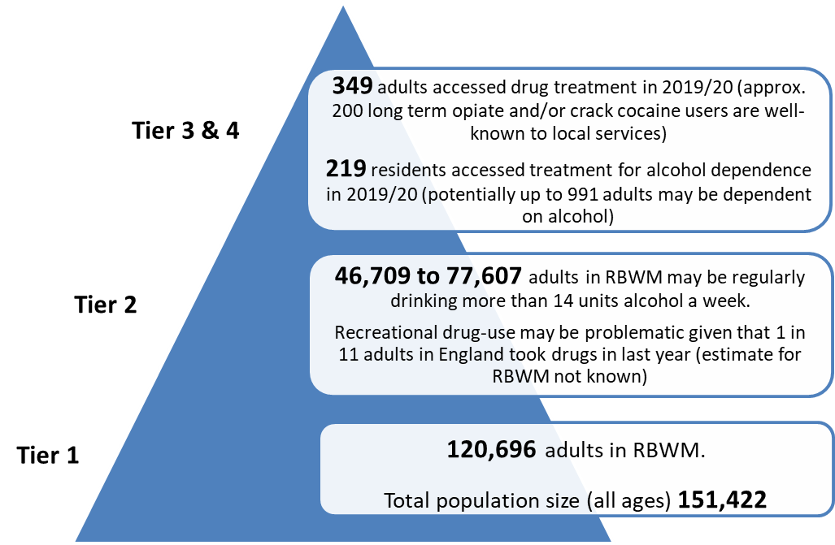

The overwhelming majority of the service users with complex needs are not long-term residents who grew up within RBWM, but have migrated here with existing long-standing issues, attracted by the tourism industry and night-time economy in Windsor. Although the number of adults with severe drug and alcohol issues is small compared to the population size, their multiple and enduring needs consume the majority of the Drug and Alcohol Grant and cause a constant drain across multiple service areas.

Along with Drug and Alcohol Services, clients with multiple disadvantages are either engaged with, or impact upon, a number of other local services, including: -
- Adult Social Care
- Children’s Social Care
- Community Mental Health Team
- Community Wardens and Street Scene
- Criminal Justice System
- GP Service and Counselling for Rough Sleepers
- Homelessness, Making Every Adult Matter and Rough Sleeper Pathway
- Police and Police Community Support Officers
- Probation Service
- Tourism
- Voluntary and Community Sector

Future Service Requirements from April 2022

The vision for the Royal Borough of Windsor and Maidenhead is that

Everyone in the borough lives a healthy, safe and independent life, supported by thriving and connected communities

This vision has shaped our commissioning plans for the future and is intrinsic to the Drug and Alcohol service model being proposed.

Early Intervention and Prevention (please note that this is not in the scope of this market engagement exercise. If required, we may hold specific market engagement for this area of service later on)

We are looking to a digital offer for residents with emerging needs or requiring intervention at an early stage for drug and/or alcohol issues alone. The clinical and medical interventions will come together in one contract, and psychosocial interventions to support residents with multiple disadvantages, will be based within broader RBWM services to support a person centred, trauma informed approach

Treatment and Recovery Services

Clinical Prescribing and Medical Service

We want to promote and invest in recovery and want this to be the focus of the Clinical Prescribing and Medical Service. We know that this is about changing hearts and minds, not just the Service Specification, and want the services we commission, and the residents we commission them for, to be empowered to improve.

We know that some clients have unstable addictions and behaviours, and continually ‘fall off script’, leading to rounds of titration and starting over again. Approximately half of the service users are known to take street drugs on top of their prescription, leading to Supervised Consumption and Needle Exchange costs, or take the offer of medication and sell it on. Some clients may be on the smallest amount of medication, and yet feel unable to make that final push to abstinence.

We’re looking for a service provider willing to embrace and pioneer the latest in pharmaceutical and technological innovation to enhance and improve service delivery. With inclusive person centred support, we believe that recovery from severe and enduring drug and/or alcohol abuse is possible, and have seen evidence from developing the Making Every Adult Matter (MEAM) approach in RBWM, that when a trusting but challenging relationship is developed between the client and all of the services involved, in a partnership network of care and support, full recovery is achievable.

Psychosocial Support

People with multiple needs face a combination of problems, and often fall through the gaps between services and systems, making it harder for them to address their problems and lead fulfilling lives. Invariably services are designed to support single issues, so that those experiencing a complex interplay of disadvantages make repeated demands on local services without any of their issues being fully resolved, and an increasing reliance on crisis and emergency services, rather than planned community interventions.

We propose to develop a model of Key Worker Psychosocial Support that is integrated within other RBWM services, for example:–
- Housing and Homelessness Services
- Children’s and Adult’s Social Care
- Community Wardens Service

We also want more intensive and solution focused Key Work that provides both support and challenge and includes a focus on the client’s mental health, as most suffer from some form of mental illness, from generalised anxiety through to depression, however most don’t reach the Community Mental Health Team threshold for support, but are above the threshold for the NHS Talking Therapies programme.

Proposed Contractual Lots

Based on our current vision and emerging thinking, we are considering contracting for three Lots:-

Lot 1 - Digital Offer for Early Intervention (please note that this lot is not included in the scope of this market engagement )
Lot 2 – Clinical Prescribing and Medical Service
Lot 3 - Psychosocial Key Worker Support Service and Needle Exchange

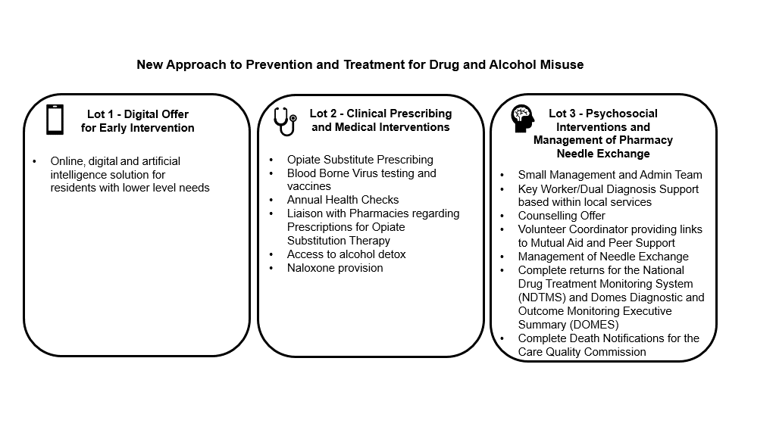

Lot 1 - Digital Offer for Early Intervention (please note that this is not in the scope of this market engagement exercise. If required, we may hold specific market engagement for this area of service later on)

Major technological advances have been made of late, including online, digital and artificial intelligence solutions. Such a service will be considered for residents with lower level needs, who often find it unacceptable to seek advice and support in person, due to the perceived stigma attached to Drug and Alcohol Services. This is particularly true of older adults with emerging needs in relation to alcohol, and the majority of non-opiate service users tend to be young adults using alcohol and/or Class A or B drugs for recreational purposes, such as Cocaine and Cannabis.

Lot 2 - Clinical Prescribing and Medical Interventions
- Opiate Substitute Prescribing.
- Blood Borne Virus testing and vaccines,
- Annual Health Checks,
- Liaison with Pharmacies regarding Prescriptions for Opiate Substitution Therapy
- Community Alcohol Detoxification and Medication.
- Naloxone provision

Lot 3 - Psychosocial Key Worker Support Service and Needle Exchange
- Key Worker inc Mental Health Support integrated within local services
- Counselling Offer
- Volunteer Coordinator providing links to Mutual Aid and Peer Support
- Management of Pharmacy Needle Exchange
- Complete Returns for the National Drug Treatment Monitoring System (NDTMS) and Domes Diagnostic and Outcome Monitoring Executive Summary (DOMES)
- omplete Death Notifications for the Care Quality Commission

Other Initiatives and Commissioned Services

We hope that whenever possible, services within our Borough and more widely across East Berkshire, will work together to support clients on their journey. Below are just some recent examples of innovative services commissioned or planned by RBWM in collaboration with our partners.

From 1st April 2021, the Local Authority and CCG Commissioned Friends in Need, and Support Time and Recovery (STaR) Services will start. This includes a 6-month support plan based on the Recovery Star outcomes, and access to online self-help programmes and peer support networks. Although initially available to clients of the Community Mental Health Team, Adult Social Care, the Wellbeing Service and Mental Health in Community Settings, we’d like to broaden the offer in future.

RBWM has a joint Community Learning and Skills Service with Slough Borough Council, which has access to community learning and development opportunities.

Homelessness and Rough Sleeper strategy, programme and pathways have been developed which includes increased Mental Health support and a Making Every Adult Matter
Coordinator. A bid has been submitted for the ‘Changing Futures’ funding, to tackle the challenges faced by adults with multiple disadvantages, including homelessness, addiction and mental illness to take a trauma informed, flexible and socially inclusive service.

Part 2
MARKET ENGAGEMENT -SUPPLIER’S INPUT
Thank you for the interest that you have shown in Drug and Alcohol Services in the Royal Borough of Windsor and Maidenhead, we very much appreciate your participation in this process to inform our commissioning model.
In order to gain the broad understanding of your organisation, we would like you to provide a written response to a few questions please - as listed below . Once we have collected and collated the information, we’d like to engage further with some or all of the respondents to gain further insight. Due to continued Covid-19 restrictions, all meetings will be held virtually.
- Name of your organisation
- Contact details
- How long have you been providing drug and alcohol services?
- Which of the services (based on our Lot classification) are you currently providing, and could you indicate the number of contracts you have?
- Which of the services (based on our Lot classification) are you likely to be interested in?
- Do you have knowledge, experience, or a proven approach to fulfil our vision for any of the future services (based on our Lot classification) and could you give an overview of this?
- What do you consider as the optimum length of a contract for your organisation and why?

Please note that this is a market engagement exercise not a formal tender, please be assured that all the information you provide will be treated in the strictest confidence.
The deadline for your response is 1st of April 2021 (2pm).
Supplier’s Answers:

1)

2)

3)

4)

5)

6)

7)

