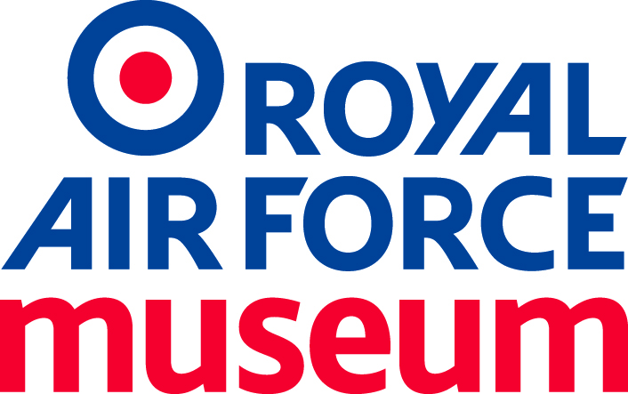

4 – Tender Specification

Battle of Britain Anniversary Programme
Phase 1 (BoB_001)

Index

1.0 Introduction ………………………………………………………………………………….…3

2.0 Background …………………………………………………………………………………..…3

2.1 Royal Air Force Museum History and Purpose ……..…………………….…….…3

2.2 Our Purpose ……………………………………………………………………….…..3

2.3 The Battle of Britain Anniversary ………………………………………………..…..4

3.0 BoB Anniversary Programme ……………………………………………………….………..4

3.1 Approach …………………………………………………………………….…………4

3.2 Scope ………………………………………………………………….…………….….4

4.0 Discovery Phase …………………………………………………………………………….…5

4.1 Discovery Phase – Context ……………………………………………………….…5

4.1.1. Content Partnership Platform ……………………………………….…...5

4.1.2. Digital Interpretation Technologies ……………..……………………….6

5.0 Challenges …………………………………………………………………….……………….6

5.1 RAF Centenary – Lessons Learned ……………………………….……………….6

5.2 Impact ……………………………………………………………….…………………6

6.0 Outcomes ……………………………………………………………………….……….…….6

7.0 Behaviours……………………………………………………………………..………………7

8.0 Risk …………………………………………………………………….………………………7

9.0 Budget ………………………………………………………………………………………….7

10.0 Schedule ……………………………………………………………………..………………7

Appendix 1 – Access for All ………………………………………………………………………8

Appendix 2 – Existing Content, Platforms and Channels ……………………………………..8

Appendix 3 – Audience ………………………………………………………………………….10

Appendix 4 – Inspiration …………………………………………………………………………12

Appendix 5 – Project Team ……………………………………………………………………..12

1.0 Introduction
The RAF Museum (RAFM) is seeking to appoint an agency to deliver aspects of our Battle of Britain (BoB) Anniversary Programme. This new programme will open in June 2020 as part of marking of the BoB 80th anniversary. The BoB display element of the programme will take place both at our London and Cosford Museums and online.

2.0 Background

2.1 The Royal Air Force Museum – History and Purpose
The Royal Air Force has shaped our nation and our society. It has influenced how we live our lives today through its impact on world events, society and technology.

The Royal Air Force (RAF) Museum was established as a legacy of the RAF’s fiftieth anniversary, opening our London (Hendon) site in 1972. From 1979, the Museum also managed the Cosford Aerospace Museum for the MOD, which had also been in operation since 1972. This was renamed the RAF Museum Cosford in 1998 when it formally became part of the Museum portfolio. The Museum also has two external stores, one in Stafford and another within RAF Cosford.

The Royal Air Force Museum is a National Museum, a Government non-departmental public body (NDPB) and a registered charity.

During the course of its last strategic plan, the Museum concentrated its efforts on being outward-focused and people-centred, exploring the history of the RAF over its hundred-year history through its incredible people and ensuring that our collection is relevant, shared and well cared for.

2018 marked the Centenary of the Royal Air Force and the Museum was privileged to support it across the year as one of the partners in a formal Joint Venture with our sister charities the RAF Association, RAF Benevolent Fund and RAF Charitable Trust. In June 2018, we opened the major transformation at our London site and, across both Cosford and London, had our most successful year since the Museum’s formation, welcoming a total of
990,000 visitors, an increase of 39% on the previous financial year.
Equally importantly, our visitor profile has broadened and diversified significantly, and the partnerships – and friendships – that have developed over the period give us a firm and inspiring foundation to build on for this next chapter of the Museum’s history.
In March 2019, the Trustees of the Royal Air Force Museum signed off a new Strategic Plan 2019–2030 and an associated Development Plan for the Museum.

Our vision for the next ten years:
Inspiring everyone with the RAF story – the people who shape it and its place in our lives.

2.2 Our Purpose
To share the story of the Royal Air Force, past, present and future – using the stories of its people and our collections in order to engage, inspire and encourage learning.

At the Royal Air Force Museum, our work and our behaviour are underpinned by six guiding values:

INtegrity: we are open, transparent and ethical
Sharing: we work as a team to ensure our collections and expertise are accessible to all
Passion: we care deeply about sharing our collections and their stories
Innovation: we tell our stories and develop our business with creativity and imagination
Relevance: we ensure our legacy by linking our histories with today and tomorrow
Excellence: we are professional and strive for excellence in all we do

We will achieve our vision and purpose through five strategic priorities that focus outwards with our collections at our heart:

- Inspiring innovative engagement, debate and reflection
- Inspiring our people within a dynamic, diverse and collaborative culture
- Embedding an entrepreneurial, agile and sustainable approach
- Leading the way with brilliant basics
- Connecting with communities and partners

2.3 The Battle of Britain Anniversary

The Royal Air Force and the nation will celebrate and commemorate the 80th anniversary of the Battle of Britain in 2020.The Museum will use this opportunity to develop and explore audience engagement through the BoB Anniversary Programme, with a view towards the next stages of our Master Planning in Cosford and London. This master plan includes the delivery of a significant permanent Second World War chapter/gallery at each of our public sites which are not due to be developed/open until after the BoB anniversary in 2020.

The time period between the BoB anniversary in 2020 and the delivery of our new galleries provides an exciting opportunity for the RAFM to explore different approaches to public engagement with the BoB story, with a view to integrating the learnings from this process in the development of our permanent galleries.

3.0 BoB Anniversary Programme

3.1 Approach
The RAFM will adopt an agile, audience centered approach to developing the BoB Anniversary Programme. The programme provides an opportunity for the RAFM to work collaboratively with an agency skilled in the delivery of multi-channel, experiential work within the heritage and cultural sector.

3.2 Scope

The final design solution for the BoB Anniversary Programme will include both physical and digital visitor experiences at both our Museum sites, as well as physical and/or digital experiences beyond those locations. These experiences will be defined through a collaboration between the RAFM and appointed agency. We will soft open in May 2020 with a full opening in June 2020.

Development of the BoB programme will conform to the following phases:

- Discovery
It will enable the RAFM, led by the agency, to explore engagement methods across a range of expert and general user journeys. Based on this work indicative costings are produced to test against fit and affordability.
(For physical displays - RIBA Stage 1 Preparation and Brief)

- Definition
The Definition stage involves translating what’s been learnt from the Discovery Phase into the product architecture. This should lead to a specification document illustrating how the product will be architected. If appropriate UX testing begins at this stage. Content strategy is defined and technical approach is agreed.
(For physical displays - RIBA Stage 2 Concept Design)

- Design and Development
The design & development stage involves bringing the specification document to life. The agreed approach is applied to key wireframe templates. Reviews are scheduled and each round of feedback is integrated for further review. Once approved the tenderer will build the product, content is uploaded/ migrated to the product, and we prepare for delivery.
(For physical displays - RIBA Stage 3 Developed Design and RIBA Stage 4 Technical Design)

- Delivery
The delivery stage occurs only after a series of internal technical and design evaluations. The delivery process is coordinated in collaboration with each of the key project stakeholders. Upon installation, the work is thoroughly tested, internally and externally.
(For physical displays - RIBA Stage 5 Construction)

- Support
The product will be tested and extensively quality assured by the tenderer before launch. Upon the successful completion of the testing period the product will be delivered to the Museum, launched and formally signed off by the Museum. From this point on the product will be managed internally.
(For physical displays - RIBA Stage 6 Handover and Close and Stage 7 In Use)

While this tender document details the delivery of the complete programme, we are, in the first instance, only asking agencies for detailed responses to the discovery phase (see the Instructions to Tenderers document).

Once the discovery phase is complete, it is the expectation of the RAFM that it will work with the tenderer to deliver all subsequent phases of the BoB programme, as an extension of their original tender appointment.

4.0 Discovery Phase
The discovery phase will enable the RAFM to embark upon a process, led by the agency, that explores aspects of the BoB Anniversary Programme, including:

- Creative responses that use of a mixture of resources and channels to deliver a rich experience of the BoB story
- Creative responses that engage the complete visitor journey, in gallery and online, pre and post visit
- Creative responses that provide Access For All, see Appendix 1.

In arriving at an audience-centered solution we are looking to work with a mixture of existing and new elements; what this means in practical terms is that we will, where appropriate:

- Make use of our existing public-facing digital platforms, in gallery and online, to deliver content to a particular experience
- Use our collection objects and artefacts
- Work collaboratively with the selected agency to deliver new interpretations of our collection and the narratives that animate these artefacts, in gallery and online
- Develop activities that explore the BoB story through public events and our online communities as well as our wider museum partnerships and community.

What we are not trying to do is:
- Design a brand-new stand-alone exhibition for the 2020 anniversary. We are looking for interventions, rather than exhibitions
- Create new technical solutions that emulate existing resources listed in Appendix 2 Existing Digital Content Platforms and Channels.

The RAFM have adopted this approach because we want to see what works for our audience, and what does not, via a rigorous evaluation/feedback process. The output of this process will inform both the delivery of the BoB programme and our future galleries and exhibitions.

4.1 Discovery Phase – Context

Although we do not want to constrain the discovery phase, set out below are some thoughts on various concepts, challenges, outcomes, risks and behaviours that we think are particularly relevant. This is not a fixed list, and we would look to the appointed agency to lead the RAFM team (see Appendix: 5 Project Team) on exploring each, as part of the development process. A list of projects/approaches by other organisations that we particularly liked is at Appendix 4.

4.1.1 Content Partnership Platform

One of the major drivers informing this project is the fact that the RAFM does not own BoB heritage outright. During the anniversary period the RAFM will be one of many formal and informal partners to share the task of celebrating the BoB anniversary. With this in mind the RAFM would look to develop our formal and informal partnerships, with relevant BoB heritage organisations and individuals. We want to explore a solution that provides the visitor with a coherent overview of the BoB heritage offer.

4.1.2 Digital Interpretation Technologies

We want to explore use of new digital technologies in the delivery of the BoB programme. The RAFM will work with the appointed agency to explore the best technological fit for the project against parameters such as appropriateness for audience and RAFM, operational costs, uniqueness of experience and legacy for future use/ development by RAFM.

5.0 Challenges

5.1 RAF Centenary – Lessons Learned
The RAFM recently delivered our RAF Centenary Programme. This involved the creation of three new galleries, significant capital works and the delivery of a digital layer that runs across our new galleries, hosting a set of public-facing digital platforms, online and in- gallery. One of the significant learnings from the Centenary Programme was the need to consider digital, physical and participatory experiences in a holistic manner, to ensure the coherence of the visitor journey across these channels.

5.2 Impact.

One of the major design challenges is the requirement that visitors are able to adopt the learning/engagement style that is appropriate to them, specifically:

- They may choose to only engage with the physical, in-gallery interpretation
- They may engage online only
- They may engage in-gallery via physical and digital platforms.

In addition, the BoB Anniversary Programme will be measured against the RAFM’s principle of Access for All (Appendix 1) and build on our understanding of the differing needs of audiences across both sites (See Appendix 3.2).

6.0 Outcomes.

The BoB Anniversary Programme will be delivered against core learning outcomes for both visitor and museum.

For visitors, to:
- Understand the role of the RAF in the Battle of Britain
- Understand the importance of the Battle of Britain, locally, nationally and internationally
- Understand the contemporary legacy of the Battle of Britain
- Understand the BoB heritage offer from a range of content partners.

For the Museum, to:
- Clearly communicate to our visitors (on and off site) that the project is the first stage in the redevelopment of Hangars 2 and 3 in Cosford and Hangars 3, 4 and 5 in London, giving us an opportunity to build engagement and trust, gain support, gather stories and test new interpretation techniques
- Encourage staff/volunteers to learn and use new and existing story sharing techniques that resonate most with different sectors of our audiences.

7.0 Behaviours
Through the BoB programme we are looking to encourage the following behaviours for both visitors and RAFM staff/ volunteers.

For visitors, to:
- Share stories through new digital experiences
- Volunteer (for example in transcribing artifacts)
For Museum staff/volunteers, to:
- Share content and knowledge through our public facing platforms, in-gallery and online
- Share content and knowledge through third party public facing platforms (for example Wikipedia’s BoB pages)
- Explore the possibilities of co-curation with other groups and organisations.

8.0 Risks
The RAFM is an organisation currently undergoing substantial cultural change, based upon its five strategic priorities that focus upon the sharing of the RAF story. This includes a significant expansion of its retail, physical and technological operations.

Through this expansion, typified by the RAF Centenary Programme, we recognise that the RAFM is strong across some aspects of delivery, and less so in other areas. Our approach to the BoB Anniversary programme is indicative of this culture change, and therefore shares some of the risks encountered in delivering the Centenary Programme, specifically:

- Communication of and engagement with the organisational change by staff, volunteers and visitors
- Variance of digital literacy across departments
- The need, for some of our audience, for a particular form of memorialisation in regard to the BoB anniversary
- The communication, to our public, of the programme as a chance to explore new approaches to public engagement
- The adoption internally and externally of different project management methodologies (for example agile) in delivering the solutions in-gallery and online
- The appetite, for both public and staff/volunteers, to test ideas in public as a considered part of a Museum programme.

9.0 Budget

As detailed in the Instructions to Tenderers document, this tender relates only to the delivery of the discovery phase of the programme. Tenderers should be aware that budget for the total programme is £250,000 (including all fees).

10.0 Schedule
We expect the discovery phase to run between September to October 2019. Soft opening of the experiences will be in May 2020, with an official opening in June 2020 and project conclusion December 2020.

11.0 Location
Project meetings will take place at Royal Air Force Museum, Grahame Park Way, London NW9 5LL or at RAF Museum Cosford, Shifnal, Shropshire TF11 8UP.
Appendices.

Appendix 1– Access For All

1.1 Intellectual access
- To enable all our audiences to feel welcome at our sites and connected to our stories
- To enable our audiences to discover, not to be instructed
- To deliver interpretation that engages and includes all visitors at different levels, from casual to specialist
- To incorporate activities that engage all the senses into the galleries, understanding that visitors have different preferred learning styles.
1.2 Social access
- To ensure that all visitors are welcomed, regardless of background or current social situation
- To provide free access to all main galleries and permanent exhibition spaces
- To monitor price points for additional activities including temporary exhibitions to ensure a wide range are accessible to low-income households.
1.3 Physical access
- To ensure that there is a clarity of communication from routing, signage to content
- To ensure that all galleries, displays and online content are designed to be physically accessible to the widest range of visitors
- To ensure that developments are renewable and sustainable.
1.4 Emotional access
- To enable our visitors to experience personal and emotional reactions
- To deliver key ‘wow’ factors supported by high quality displays and interpretation making use of modern technology.
1.5 Aesthetic Access
- To ensure that all visitors are offered opportunities to enjoy a purely aesthetic experience whether through encounters with our site or our collections.

Appendix 2 – Existing Digital Content Platforms and Channels

  - Content Infrastructure.

As part of our RAF Centenary Programme the Museum commissioned an extensive gallery infrastructure that enables content to be distributed to our in gallery and online digital platforms (listed below). If appropriate our content infrastructure will be used to deliver content to any new technological solution proposed.

All these platforms have analytics, which can be used to test deliverables against use, and to contribute these findings to post-delivery documentation.
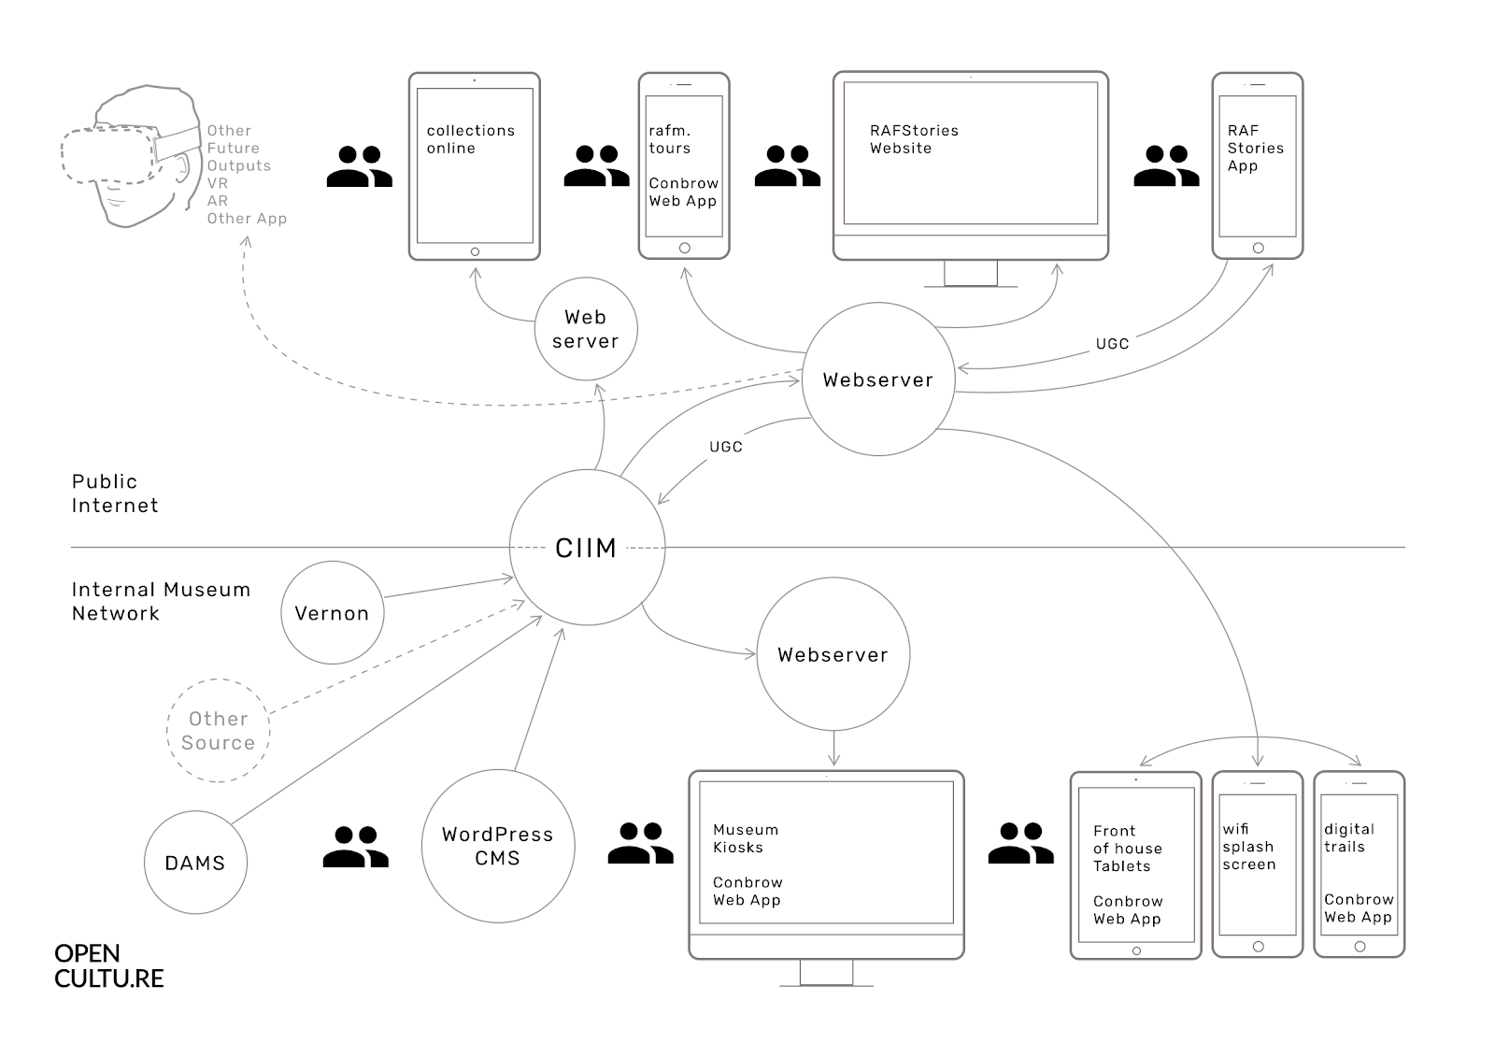
Schema 1 Showing overview of digital infrastructure

  - RAF Stories (www.rafstories.org)

RAF Stories is an NLHF funded story collecting platform that was delivered as part of our RAF Centenary Programme in 2018. The aim of the project is to collect the tangible and intangible heritage that animates the RAF story via a publicly accessible online platform. To achieve this the RAF Stories platform has an app that enables public users to submit stories, this is complimented by an in-house CMS (WordPress) that enables our staff and volunteers to easily push stories to the RAF Stories website.

2.3 Content Browser

Across our Centenary exhibitions we have 40 touchscreens that provide our team, using a central CMS (WordPress), to publish content to location specific kiosk. This in-gallery content is replicated for mobile devices at www.rafm.tours.

2.4 Digital Trails

Using the same CMS that publishes to the kiosk and RAF Stories, our teams are able to easily publish digital trails, providing different interpretations of our in-gallery collection, for example our 601 trail (https://rafm.tours/601-trail)

2.5 Collections Online

We are currently scoping our Collections Online platform. The project will be delivered using the same infrastructure that delivers RAF Stories, Content Browser and the digital trails. We will be looking to integrate this platform both in-gallery and online with a remit to provide open access to our content across all levels of visitor engagement.

2.6 RAFM Social Media

Our social platforms will be used to promote and market the BoB programme and engage our online community in discussion around pertinent BoB subjects and themes.

2.7 Casualty Forms/Volunteering Platform.
The RAFM has developed several volunteer driven projects, most recently Casualty Forms (https://www.casualtyforms.org/). Typically, this process involves the transcription of digitised material from our archive, by our volunteers, the content is then made available online. As part of the BoB Anniversary Programme we would use our experience in developing these volunteer driven projects, identifying and using previously unavailable BoB relevant content.

2.8 Wikipedia https://en.wikipedia.org/wiki/Battle_of_Britain

As part of the BoB Anniversary proposal the RAFM would also look to engage a Wikipedian in residence to assist staff in the sharing of RAFM content knowledge to Wikipedia. This is particularity relevant as Wikipedia is the go to data source for domestic mobile search products such as Google Lens.

2.9 Analytics Platform.

Analytics are integrated into all public facing digital platforms, both in-gallery and online. We would look to use the data generated from these, and any new digital platform to inform the development of the BoB Anniversary Programme.

Appendix 3 – Audience
The RAF Museum divides its audience into three levels:
- Paddlers – first time visitors, day-out visitors, visitors with no prior knowledge of the collection. These represent 69% of our audience
- Swimmers – repeat visitors, visitors with some prior knowledge or a particular interest in the collection driving their visit. These represent 24% of our audience
- Divers – specialist and expert visitors, visitors with a good knowledge of the collection and/or historical periods, often making full use of the Museum’s opportunities as researchers, volunteers, donors and supporters. These represent 7% of our audience.
The Museum’s intention is to offer interpretation to cater for all levels of learning and engagement.

3.1 Audience Models and Focus
The division of our audience into three engagement levels is put into context by research
that shows visitors at our two public sites are quite different. As a result at Cosford we are
developing our offer against a Fun Focused Families model and at London we use Leisure
Magpies).

These offers are delivered against our overarching drive to expand audiences in line with Access for All principles, with particular focus on women, BAME and 13 to 19 year olds.

3.2 Audience Models and Focus
Leisure Magpies (London)
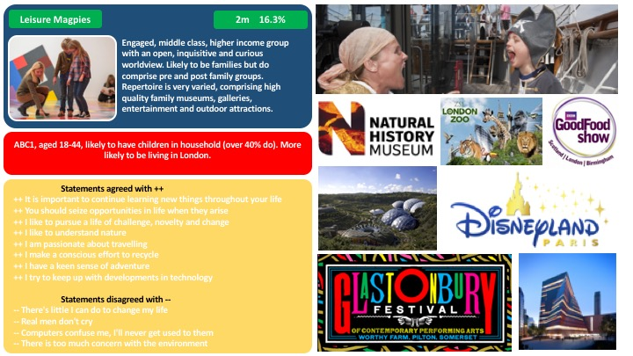

Fun Focused Families (Cosford)
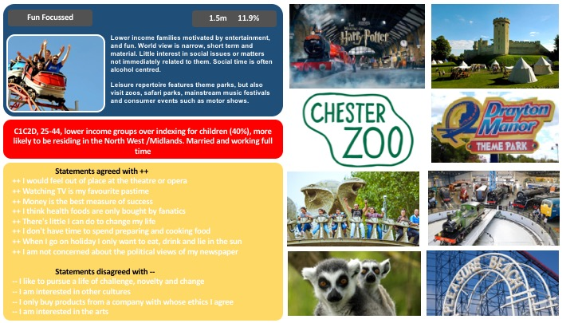

Appendix 4 Inspiration

Below is a list of projects and approaches that the team have found inspiring when considering the delivery of the BoB programme.

Marshmallow Laser Feast – Ocean of air.
Fully immersive piece of VR - it uses breath, smell and movement to enhance engagement.
https://www.marshmallowlaserfeast.com/experiences/ocean-of-air/

Ancient Lives - British Museum – AllOfUs
Making full use of digital to tell stories in a manner that would not be possible otherwise.
https://youtu.be/mvqs_ACIYHo

Sensorium – Tate – Flying Object
Using digital to step into and engage visitors in a manner not possible before.

Appendix 5 Project Team.
The BoB Anniversary programme team consists of:

- Director of Content & Programmes
- Head of Exhibitions and Interpretation
- Head of Digital Experience
- Gallery Network Manager
- Lead Curator
- Assistant Curators
- Digital content producer
- Audience Development Team
- Learning Officer
- Public Events Team
- Communications Team
- PR & Marketing Team
- Volunteer Team

