Invitation to Tender: University Shuttle Bus 2024

Tender reference: TRA007 LTU

6. Specification and Service Level Agreement

Preamble
The university seeks to appoint a contractor that will provide a Shuttle Bus service, inclusive of vehicle and driver, for the transportation of passengers via predetermined routes that connect the university’s Horsforth Campus to Horsforth Rail Station and local community.

The passenger profile will be a mix university students, staff, and visitors.

The Shuttle Bus service:
- is a key element of the university’s travel strategy to enhance the accessibility of Leeds Trinity University.
- supports the university’s sustainability strategy to encourage more of our staff and students to travel by public transport instead of driving to campus.
- will be fundamental to mitigating impacts of current and planned developments on campus.
- will take advantage of recent improvements in the local public transport network.
- Enables the university to enhance it’s contribution to the collective objectives of the Leeds Anchor Institutions promoting sustainability and the local economy.

The contract will be held between the university and the operator. Third party intermediary, or sub-contract arrangements will not be considered.

The University will operate the service as a private hire arrangement using a coach/private hire operator. This is to ensure the service can be adjusted where required to meet the changing needs of passengers and to allow a modest degree of flexibility in the service timetable to better align to exact train arrival and departure times.

Specification

The vehicle will:
- be fully DDA compliant to the Diversity and Equality Act 2010.
- have a minimum passenger capacity of 30 persons, plus space for a wheelchair.
- be modern, and as a minimum, Euro 6 compliant.
- display externally visible signage clearly identifying it to the university shuttle service.
- be of a high standard in:
  - appearance
  - cleanliness
  - well maintained interior
  - fully operational fittings
  - etc.

The service will:
- operate daily, Monday to Friday inclusive, during term times only.
- commence each day at 0730h.
- end each day at 1800h.
- not operate on bank holidays, or on days designated as non-working days at the discretion of the university.
- traverse XX.X miles per day.
- provide three routes, in rotation:
  - Route A: 0730h to 0925h
  - Route B: 1000h to 1050h
  - Route C: 1100h to 1335h
  - Route B: 1500h to 1550h.
  - Route A: 1600h to 1800h.

Appendix A provides route descriptions, maps, and indicative timetables.

The university envisages that any additional capacity, or new routes and services that may be required to support the university’s new City Campus at 1 Trevelyan Square, LS1 6AE which opens in September 2024 will also be provided for by this contract.

The contractor will:
- at all times provide a professional and customer focused service (drivers in particular will be smart and polite to members of the public).
- provide and adhere to a Health and Safety Policy specifically relating to the operation of the service, including any restrictions, rules and regulations relating to passenger behaviour.
- Provide and adhere to a mechanism in place to notify LTU should the service become unavailable for any reason.
- promote a customer service point of contact.
- accurately monitor all passenger movements.
- provide a weekly management report which as a minimum, details:
  - patronage by day and passenger type.
  - All customer issues and complaints including response times, remedial actions taken.

Service Levels:

- Reliability:
95% of services to operate no more than 1 minute early or 5 minutes late of the scheduled time.
- Complaints:
The contractor will respond to all issues within two working days.
Corrective and remedial actions will be implemented within five working days.
- Vehicle Standard:
Mutual and evolving agreement to a high standard of vehicle provision
- Pricing:
Open book pricing will be maintained.

Tenderers are invited to propose other relevant service levels and key performance indicators in the tender questionnaire (Part 7 of this invitation to tender)

Signed __________________________ Date ______________________________

Name __________________________ Position ___________________________

Authorised to sign tenders for and on behalf of: Tenderer to enter company name here.

Appendix A

Route A Peak Period Loop service to station

Route Description Brownberrie Lane, Station Road, Troy Road, Low Lane, Lister Hill, Long Row, Brownberrie Lane.

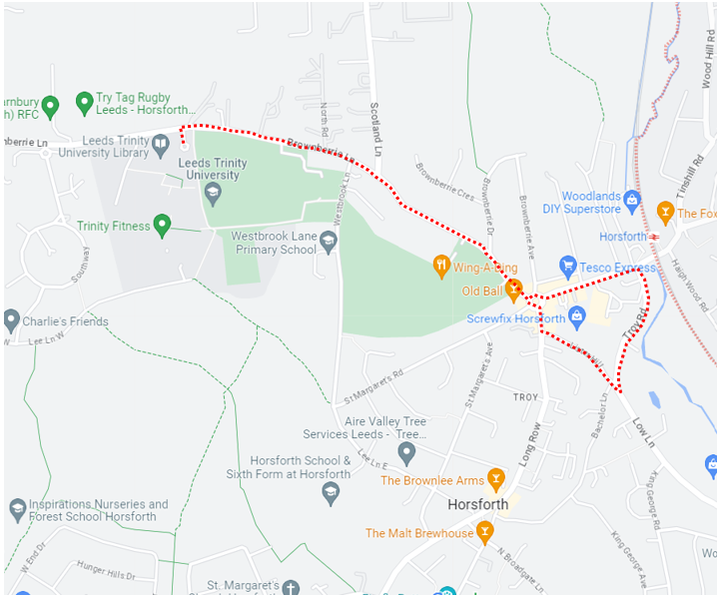

AM
Timing Point
Leeds Trinity University | 07:30 | 07:45 | 08:00 | 08:15 | 08:30 | 08:45 | 09:00 | 09:15
Horsforth Train Station | 07:35 | 07:50 | 08:05 | 08:20 | 08:35 | 08:50 | 09:05 | 09:20
Leeds Trinity University | 07:40 | 07:55 | 08:10 | 08:25 | 08:40 | 08:55 | 09:10 | 09:25

PM
Timing Point
Leeds Trinity University | 16:00 | 16:15 | 16:30 | 16:45 | 17:00 | 17:15 | 17:30 | 17:50
Horsforth Train Station | 16:05 | 16:20 | 16:35 | 16:50 | 17:05 | 17:20 | 17:35 | 17:55
Leeds Trinity University | 16:10 | 16:25 | 16:40 | 16:55 | 17:10 | 17:25 | 17:40 | 18:00

Route B Horsforth town centre and Morrisons

Route Description Brownberrie Lane, Station Road, Troy Road, Low Lane, King George Road, Broadgate Lane, Town Street, Church Road, Church Avenue, Long Row, Station Road, Troy Road, Lister Hill, Brownberrie Lane.

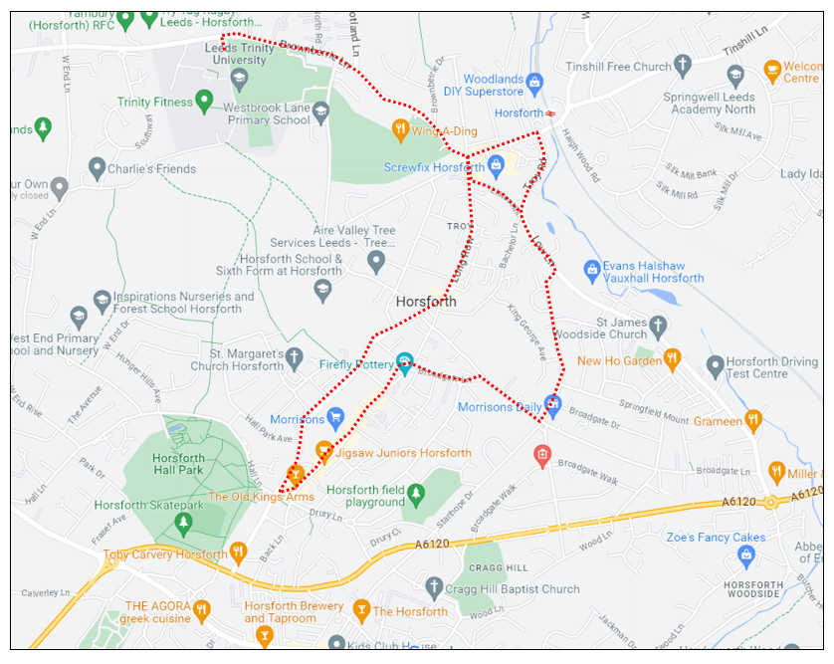

Timing Point
Leeds Trinity University | 10:00 | 10:30 | 15:00 | 15:30
Horsforth Train Station | 10:05 | 10:35 | 15:05 | 15:35
Broadgate Lane | 10:09 | 10:39 | 15:09 | 15:39
Town Street | 10:12 | 10:42 | 15:12 | 15:42
Morrisons | 10:14 | 10:44 | 15:14 | 15:44
Horsforth Train Station | 10:17 | 10:47 | 15:17 | 15:47
Leeds Trinity University | 10:20 | 10:50 | 15:20 | 15:50

Route C Kirkstall Bridge Shopping Loop

Route Description Brownberrie Lane, Station Road, Troy Road, Low Lane, Hawksworth Road, Abbey Road, [returning) Abbey Road, New Road Side, Ring Road, Fink Hill, Church Road, Church Avenue, Long Row, Brownberrie Lane.

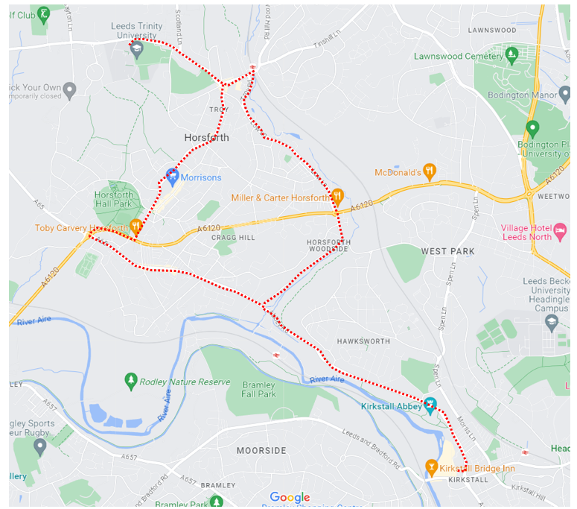

Timing Point
Leeds Trinity University | 11:00 | 13:00
Horsforth Train Station | 11:05 | 13:05
Kirkstall Bridge Shopping Park | 11:20 | 13:20
Morrisons | 11:30 | 13:30
Leeds Trinity University | 11:35 | 13:35

