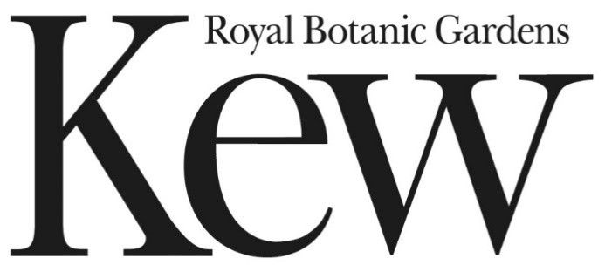

Part 2: Specification

Contract Reference: RBGKEW1131

Nature Heroes Badges Framework

(This document is for information)

1. **About RBG Kew**

Royal Botanic Gardens, Kew (‘RBG Kew’) is a world-famous centre for botanical and mycological knowledge. With two inspiring gardens at Kew in west London and Wakehurst in Sussex, we enchant our visitors with the wonder of plant diversity. The RBG Kew mission is to be a globally recognised resource for plant and fungal knowledge, building an understanding of the world’s plants and funghi upon which all our lives depend.

RBG Kew operates across two sites (‘Sites’): Kew Gardens in west London, founded in 1759 and now a UNESCO World Heritage Site, and at Wakehurst in Sussex, which is the home of the Millennium Seed Bank. RBG Kew also has a permanent research station in Madagascar. RBG Kew uses the power of science and the rich diversity of its gardens and collections to provide knowledge, inspiration and understanding of why plants and fungi matter to everyone.

RBG Kew was established under the National Heritage Act (1983) and is an Executive Non-Departmental Public Body (NDPB) with Exempt Charitable status. Its sponsor Department within government is the Department for Environment, Food and Rural Affairs (Defra), which also acts as its charitable regulator.

1. **Scope of the requirements**

We are looking to purchase custom made iron on badges. We are looking to contract a supplier that can provide multiple badge designs over a 4 year term.

The concept is that people buy a Wakehurst “Nature heroes” cape, then earn the different badges when they come to site and can add these to their cape (like guides / scouts).

The capes will be made of cotton.

We would like to see a sample iron badge as part of this process, and for each order, we would want to see a prototype before purchasing in bulk. (Please send sample for procurement purposes to; Wakehurst, Ardingly, Haywards Heath, RH17 6TN).

Each year we’ll be looking to purchase differing quantities of badges according to the event (see below). The badges ordered will differ in design and quantity. For year 1- 2023 it looks like this:

|  |  |  |  |  |
| --- | --- | --- | --- | --- |
| **Badge name** | **Date of event** | **Date of badges to delivered on site** | **Approximate quantity** | **Notes** |
| Bird Buddy | February half term  11th – 19th February | N/A | 2000 | Already ordered** |
| Superworm | Easter  30th March – 23rd April | N/A | 11000 | Already ordered** |
| Habitat hero | May Half term  27th May – 4th June | 17th May | 2000 | Name and design not finalised |
| Tree tracker | Summer 2023  7th July – 17th September | 26th June | 8000 | Name and design not finalised |
| Funghi Finder | October half term  19th Oct – 31st Oct | 9th October | 3000 | Procurement based on this design |

*\*\*Please note, due to timelines and contracts we have already purchased the first two badges.*

As the badge design ‘Funghi Finder’ is already finalised for October, we are asking you to tender based on that design but the initial order will be for the May half term badge ‘Habitat Hero’.

For years 2-4 of the contract we’ll build on the range and quanity of badges.

This specification is for tendering purposes; Fungi finder badge:

**Requirements:**

* Size 63mm diameter
* Supplied on an A7 backing card
* Iron on backing
* Embroidered, 100% Coverage

**Material:**

* embroidery thread made from 100% Rayon which has been certified as OEKO-Tex Standard 100
* backing fabric which the thread is sewn on to from 100% polyester, again OEKO-Tex Standard 100.

Both to be OEKO-Tex Standard 100 certified

**Artwork:**

Pantones: 381 / 298 / 185 / 2207 / Cool Grey 1 / Black / White

**Sustainability:**

Product should be:

* Ethically sourced
* Sustainably manufactured
* Use recyclable materials where possible
* minimise pollution and environmental risk
* have recyclable backing cards
* be delivered in recyclable packaging

It is desirable that suppliers have the following:

* own science based net zero targets
* whole life carbon footprint assessments for products

**Quantities**

* We expect to be ordering at the remaining 3 badges for 2023 and at least 5 badges per year in subsequent years.

1. **Equality, Diversity & Inclusion**

RBG Kew is committed to equality of opportunity for all in the delivery of a good, service or works and employment. We aim to ensure that our policies, strategies, procedures, services and all aspects of what we do incorporate equality objectives.

This is in line with equality key equality legislation that expects public authorities to eliminate unlawful discrimination and promote equality of opportunity in employment and in the provision of goods, facilities and services. Where functions and services are carried out by an external supplier, RBG Kew remains responsible for meeting equality duties. We will take equality issues into account at all stages of our procurement process and we expect organisations that deliver goods or provide services on our behalf to promote equal opportunities within their businesses.

We are committed to ensuring that suppliers delivering services on our behalf share our equality vision and adopt anti discriminatory practices. People, partners and businesses working or providing services on our behalf must adhere to our equality principles and demonstrate all necessary steps are taken to provide equal access in employment and service delivery in accordance with equality legislation.

1. **Contract Management**

Contract Review meetings and order specific KPI’s will be agreed for each requirement.

1. **Insurance**

The following insurance policies are required for this contract

1. Product liability insurance to the minimum value of £5 million per incident;
2. Public liability insurance to the minimum value of £5 million,
3. Employer’s Liability Insurance to the minimum value of £5million