University of Plymouth

New Engineering and Design Facility (NEDF)

**Prior Information Notice**

**WP7-2: Supply and Installation of an Integrated Visualisation System and Autonomous Vehicles Test Facility**

# Background

The new Engineering and Design facility (NEDF) will provide a new home for the specialist laboratories and teaching facilities of the School of Engineering, Computing and Mathematics.

The virtual reality enabled Visualisation System will support a diverse number of stakeholders from across the University and wider industrial community. This facility will comprise:

1. Hi-fidelity hybrid visualisation system for simultaneous 2D and 3D viewing using DX-LED display panels arranged for small groups of people to be immersed in the middle of the data.
2. Computing and tracking services to support free-roving VR and AR experiences.
3. Integration with other campus / remote facilities by the mutual exchange of live data.

The Autonomous Vehicles Test Facility that will support the operation and evaluation of individual robotic systems working under remote control or autonomously, or several robotic systems operating simultaneously as a single integrated autonomous system. The laboratory will enable the testing of robotic systems on land, air and water through the use of:

1. The permanently installed 1.0 m deep water tank with 500 kg jib crane
2. Two six-degree of freedom motion platforms
3. The 80 m2 land vehicle test area
4. The 500 m3 flying vehicle test space
5. A motion tracking system

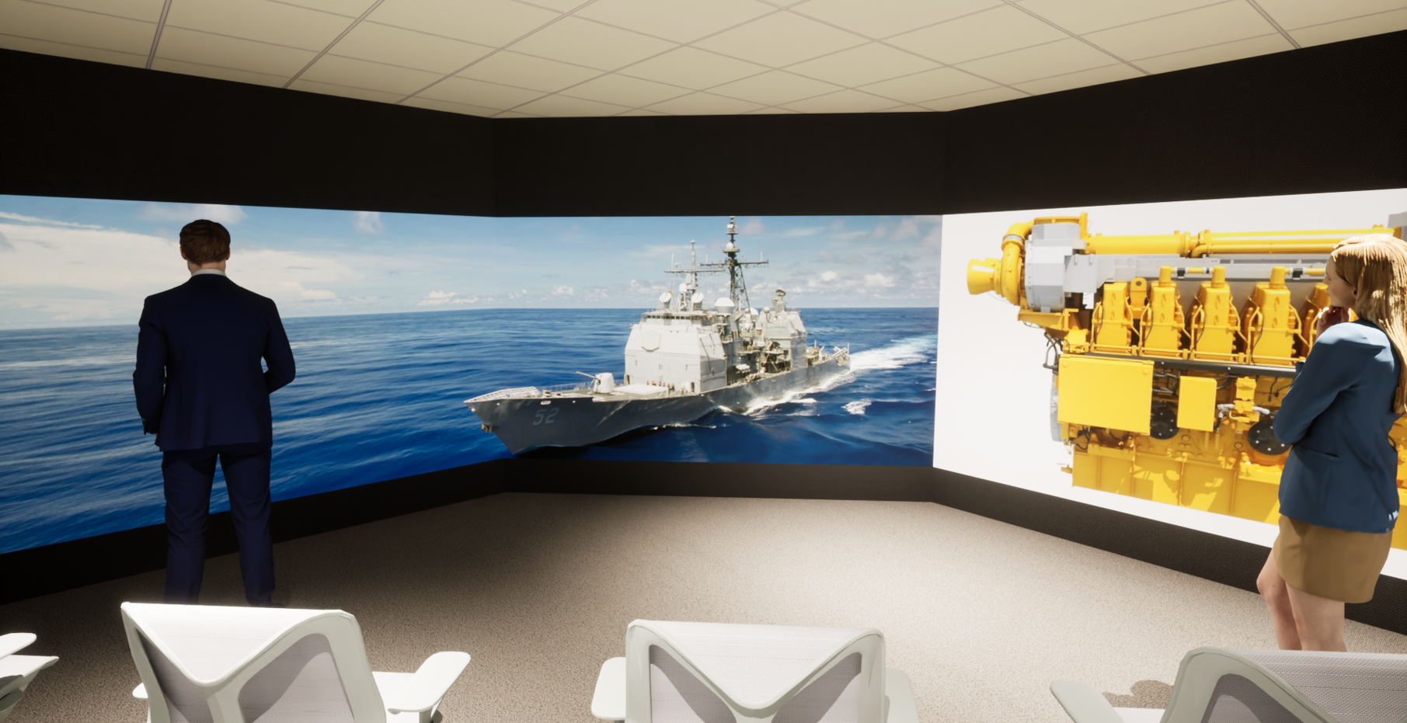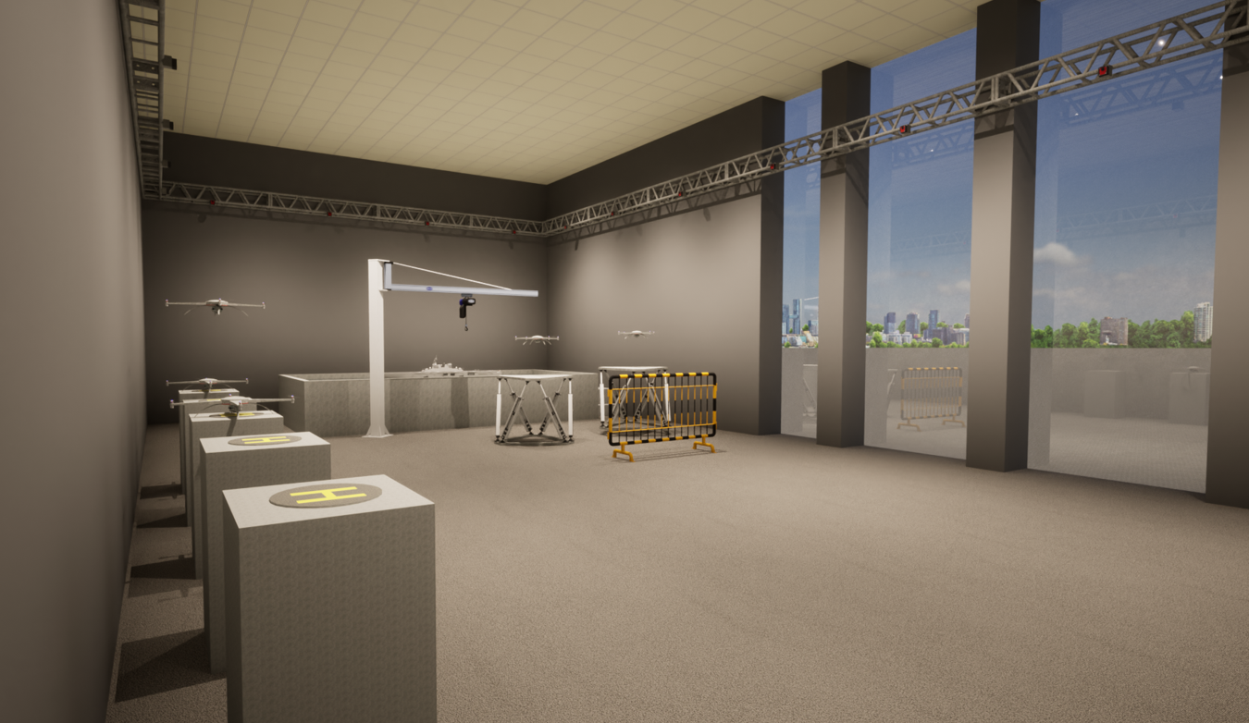

Figure 2: Initial proposals for the Visualisation System and Autonomous Vehicles Test Facility

To enable the integration of different on-campus or remote simulators and digital twins, we require a network topology and middleware architecture that will provide an integration framework for pseudo-real time event driven communication between multiple software and hardware. The integration framework will provide a middleware capable of choreographing multiple simulators, software, and hardware within a single simulation and or real environment.

# Requirements for a Supply and Installation Service

The supplier will provide an end-to-end engineering, procurement and installation service that will deliver turnkey solutions to the new facilities described in Section 1.

A fully detailed specification of the software and hardware requirements to fulfil the end-user requirements will be available to the selected supplier, which will include: Full mechanical design including facilities recommendations, power, and HVAC requirements; Complete bill of materials; Complete connectivity design; Compute architecture and specification; Data storage requirements; Network requirements; and Software requirements.

The supplier will:

* Provide end-to-end project management of the programme of work
* Engage a team of mechanical engineers, applications engineers, software engineers and solutions architects as appropriate
* Follow a stage-gate process with milestone meetings with the University
* Deliver a turnkey installation ready for operation by September 2023 that fulfils the detailed specification of the software and hardware requirements provided by the University.
* Provide on-going maintenance and support of the system solutions.

# Supplier Characteristics

The supplier will be a specialist systems integrator of large-scale, immersive visualisation systems with bespoke and off-the-shelf hardware and software system solutions that can fulfil the following requirements:

1. Demonstrate a track-record of world-leading innovation in the design and development of audio-visual systems, VR and AR systems, and fully integrated hardware and software solutions.
2. Demonstrate the depth of expertise within your organisation and network of suppliers and technology partners to ensure state-of-the-art solutions can be integrated into a tailored hardware and software solution that meets our specific needs.
3. Demonstrate a robust end-to-end engineering, procurement and installation process and the ability to liaise and work with the NEDF design and construction team.
4. Demonstrate the experience with projects of a similar scale and scope for installations in engineering industries and universities.

# Scope of Supply

The Supply and Installation Service is required for Q2 and Q3 of 2023 with delivery of a fully turnkey solution ready for operation by September 2023.

The University of Plymouth Standard T&Cs of supply can be found here:

[https://www.plymouth.ac.uk/about-us/university-structure/service-areas/procurement/terms-and-conditions](https://eur03.safelinks.protection.outlook.com/?url=https%3A%2F%2Fwww.plymouth.ac.uk%2Fabout-us%2Funiversity-structure%2Fservice-areas%2Fprocurement%2Fterms-and-conditions&data=04%7C01%7Cantony.robotham%40plymouth.ac.uk%7C805d4d2a42bc40559d3508d9b4bcfc96%7C5437e7eb83fb4d1abfd3bb247e061bf1%7C1%7C0%7C637739546043130629%7CUnknown%7CTWFpbGZsb3d8eyJWIjoiMC4wLjAwMDAiLCJQIjoiV2luMzIiLCJBTiI6Ik1haWwiLCJXVCI6Mn0%3D%7C3000&sdata=WVKcJnR3aVW8qyW5x3Pa51IXdZAF3N58GUuKT2i%2FZQc%3D&reserved=0)