Clarifications to Bidder’s Questions:

Accessibility Audit, Coast to Coast Path National Trail

**Q1) Can you confirm if there is a maximum budget for the project? We read thresholds of £12k but weren't clear if that was the budget.**

A1) The budget is set between £10k and £49,999.

**Q2) In terms of designing and scoping our approach, we noted " it may be necessary to carry out some site visits and carry out surveys in some locations" - is there any way to get some sense of how many sites it might be sensible to visit and survey? Do you have a view on particular locations that have issues or are representative?**

A2) In reality the number of site visits will be up to the successful organisation and will be dependent on findings from initial desk study although we appreciate that you need to make some assumptions in order to fully cost your bid. However we do not anticipate there would be a need for more than 3-5 site visits to cover (if necessary) the geography of the route and/or the partners/stakeholders in order to obtain further detailed information for the report.

**Q3) Where actions have been taken by the relevant highway authority, would this information be provided or would we have to discover this as part of the work?**

A3) NE are working closely with each of the 6 authorities and have an overview of each Project Plan for establishing the route. We would be able to make this information available along with contact details for any follow up questions.

**Q4) The brief is clear we are not auditing the route and we are in effect only surveying a sample of the route with a high-level approach.  But the outputs, in particular providing information that will "allow NE to provide accurate information to users about current state of the route", strike me as hard to do without a fairly detailed understanding of the accessibility throughout the trail...which would require more of a full survey.**

A4) At the very least we hope, when the new trail is open, to be in a position to give good information about accessibility.  This may include noting that some stretches have not been fully assessed etc.  However, what we need is to better understand where, having looked at the existing guidance, there are already stretches, already promoted by partners, which offer greater accessibility and how there may be links to and from these stretches.  We sought to set out in the tender brief that there has already been work done on this across the route but it needs bringing together with recommendations for priorities for more detailed assessment going forwards.

**Q5) As bi-monthly can mean both twice a month, and once every two months, for the avoidance of doubt please can you clarify how often there would be teleconferences**.

A5) Due to the tight timescales of the project, we will be looking to hold meetings twice a month to review progress, resolve issues and adjust targets.

**Q6) Are you able to be any more explicit about the geographic scope of the project? This image from the**[**Coast to Coast Wider Benefits Report**](https://eur03.safelinks.protection.outlook.com/?url=https%3A%2F%2Fwww.yorkshiredales.org.uk%2Fwp-content%2Fuploads%2Fsites%2F13%2F2022%2F12%2FWider-Benefits-Coast-to-Coast-report-FINAL.pdf&data=05%7C01%7Cneil.coles%40naturalengland.org.uk%7C39532bff5a524284471608dbf1b619e7%7C770a245002274c6290c74e38537f1102%7C0%7C0%7C638369537337730984%7CUnknown%7CTWFpbGZsb3d8eyJWIjoiMC4wLjAwMDAiLCJQIjoiV2luMzIiLCJBTiI6Ik1haWwiLCJXVCI6Mn0%3D%7C3000%7C%7C%7C&sdata=mD%2F7vNr1JnRgOIjWRq3Xi3GD2I6mrXRh1JGBW5myUi0%3D&reserved=0) **shows the number of variations of routes; is this project just looking at the red walking route and associated circular and link routes,  or does it include for part of any of the other routes to be considered?**

* 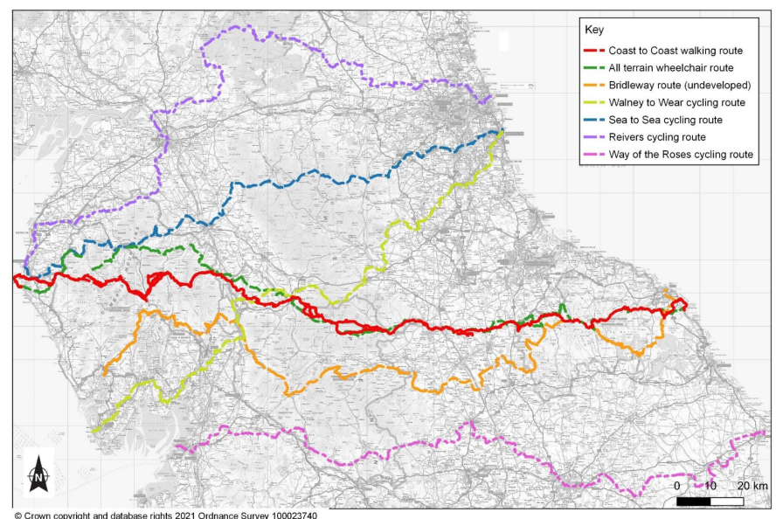

A6) The National Trail will mostly follow the line of the Alfred Wainwright route. The line of the approved Coast to Coast Path National Trail is represented here by the red line on the map. Our expectation is that the Audit will review the quality of accessibility on the main line of the route, and where the Path does not provide suitable access for Bikes, horses and people with limited mobility, make recommendations for improvements, link routes, improved information etc as specified in the tender brief.

**Q7) We note the outcome of "detail in a format which will allow NE to provide accurate information to users about current state of the route to allow them to make their own decisions about appropriate access". This implies more detail than a "high level" accessibility audit; please can you clarify the level of detail expected from a primarily desk-based high level audit? Is this considered adequate at this stage to satisfy the detail required for users to make decisions about access choices? Alternatively, are you looking for gap analysis to suggest what would be required to provide this detail? And what level of functionality are you hoping for at this stage?**

 A7) At the very least we hope, when the new trail is open, to be in a position to give good information about accessibility.  This may include noting that some stretches have not been fully assessed etc.  However what we need is to better understand where, having looked at the existing

 guidance,  there are already stretches, already promoted by partners, which offer greater accessibility and how there may be links to and from these stretches.  We sought to set out in the tender brief that there has already been work done on this across the route but it needs bringing together with recommendations for priorities for more detailed assessment going forwards.

**Q8) The programme says final report is due on 23rd March; which is a Saturday. For the avoidance of doubt, please can you confirm the final report deadline?**

A8) It will be Monday 25th

**Q9) Is the budget £10-49K inclusive of VAT?**

A10) Yes, ceiling of £49,999 is inclusive of VAT