

**East Wittering & Bracklesham Vision**

**Booker Green Project – invitation to tender**

Part of the

East Wittering & Bracklesham Village Centres

Improvements and Landscaping Project

East Wittering & Bracklesham (EWB) Parish Council is working on a Vision project to explore what East Wittering village and Bracklesham village centres could look like in future. Known as BREW-Vision, this is very much a collaborative process that involves all the local authorities, and will involve the local community. An important element of BREW-Vision will be the improvements to Booker Green located at the end of Shore Road, East Wittering, West Sussex.

**Brief:**

EWB inviting consultants, designers and contractors to submit fee proposals for the Booker Green Project.

The aim of the proposal is to address the issues outlined in the **CONSULTANTS BRIEF**

**and DELIVERABLES** section below.

Consultants are asked to include a proposal specifying design and costs for the total project including materials, time, labour **broken down for each element of the deliverables**, and demonstrating their intended approach.

The successful applicant will be expected to project manage the whole contract, including contractors.

The projected works are expected to begin in September 2021.

**Budget:**

The indicative budget is £45,000.

**Tendering process**

* Proposals are being sought from three parties in line with local government procurement procedures. The process of inviting tenders will be administered EWB. The decision on the successful candidate will be taken by EWB.

**Evaluation of tenders**

Evaluation of tenders will be undertaken using a mix of **35% price and 65% quality** of response.

**Submission**

The deadline for responses is 12.00 midday on **Thursday 25 Feb 2021** clearly marked:

**‘Confidential – Booker Green Project’**

Please send the **final submission** by email to:

Sam Tate [sam.tate@eastwitteringbrackleshampc.org.uk](mailto:sam.tate@eastwitteringbrackleshampc.org.uk)

The decision regarding the successful applicant will be made by EWB and applicants will be informed of the outcome.

**Questions** regarding this brief should be directed to either:

Sam Tate [sam.tate@eastwitteringbrackleshampc.org.uk](mailto:sam.tate@eastwitteringbrackleshampc.org.uk)

Fee proposals are to allow for the following meetings:

* One initial meeting/discussion with Council officers (allow 2 hours)
* Two review meetings with Council officers to review progress (allow 2 hours each)
* One final presentation meeting with Council officers
* Interim correspondence by email and telephone

The following programme is proposed. All dates below refer to 2021:

|  |  |
| --- | --- |
| Receipt of fee proposals | Deadline for receipt by EWB: Thurs 25 February 2021 |
| Selection process | Consultant interviews: w/c/ 01/3/21 |
| Appointment of consultant | By Thurs 11/03/21 |
| Initial meeting | w/c 22/03/21 |
| Review meeting 1 | w/c 12/04/21 |
| Review meeting 2 | w/c 26/04/21 |
| Final design | w/c 10/05/21 |
| Works commence | w/c/ 13/09/21 |
| Project completion | w/c 25/10/21 |

East Wittering & Bracklesham Parish Council reserve the right, in its absolute discretion, not to appoint a consultant following the selection process.

**The following supporting documentation must be provided with each fee proposal:**

* Completed ‘Company Health & Safety Questionnaire’ (as attached)
* Completed ‘Non-Collusive Tendering’ certificate (as attached)
* Proposed programme for delivery to comply with the requirements as above
* Examples of reference projects

**Setting the scene**

The Parish of East Wittering & Bracklesham is located on the Manhood Peninsula in the south western corner of Chichester District, West Sussex. The village of East Wittering is approximately 7 miles south of the city of Chichester and 17 miles east of Portsmouth, both of which represent the closest major centres of employment, shops and services.

A small parish in terms of land area, it contains two settlements; East Wittering and Bracklesham, with the vast majority of housing and development located in its southern third adjacent to the coast. This includes the Parish church, Primary school, and most of the shops and services.

Due to its location on the extremity of the Manhood peninsula, combined with a lack of an A road or rail line, the settlements of the parish are relatively isolated and this tends to make the area popular with retirees or those seeking quiet lifestyles, rather than commuters. Those seeking to commute out of the area or access shops and services in nearby settlements are largely forced to rely on their own means of transport.

The beaches of the Manhood Peninsula, particularly those adjacent to East Wittering and Bracklesham, are extremely popular amongst the surfing fraternity. Businesses servicing the needs of this group and others using the local coast and landscape are an essential part of the local economy in East Wittering. The Bracklesham Bay Site of Special Scientific Interest exists within the Parish, making up its full southern boundary adjacent to the English Channel.

The local population more than doubles during the holiday season due to the influx of visitors. The increase in the visitor population is essential to many local shops and businesses, but leads to increased pressure on the public open spaces within the parish.

There are likely to be increases in population in the area over the next decade. This will add an additional burden to facilities and open spaces, and means it is becoming increasingly necessary to consider place shaping and public realm activities.

Booker Green is located at the end of Shore Road. It faces the open coast and is subject to the effects of weather and overtopping by the sea during storms. It is used as a recreational space by all demographics of local and visitor populations. There is a footpath running along the back of the Green that allows access through the Green from Shore Road to the beach. Booker Green is immensely popular for picnics, people with prams, dog walkers and beach users passing through, and those who want to relax on a bench and look out over the sea.

Adjacent amenities include a small beach café, a fisherman’s hut selling locally caught fish, a car park on Marine Drive half way down Shore Road, and various eateries and take-away restaurants on Shore Road.

**CONSULTANTS BRIEF**

The area to be covered in the proposal is shown on the following map of the Booker Green area:

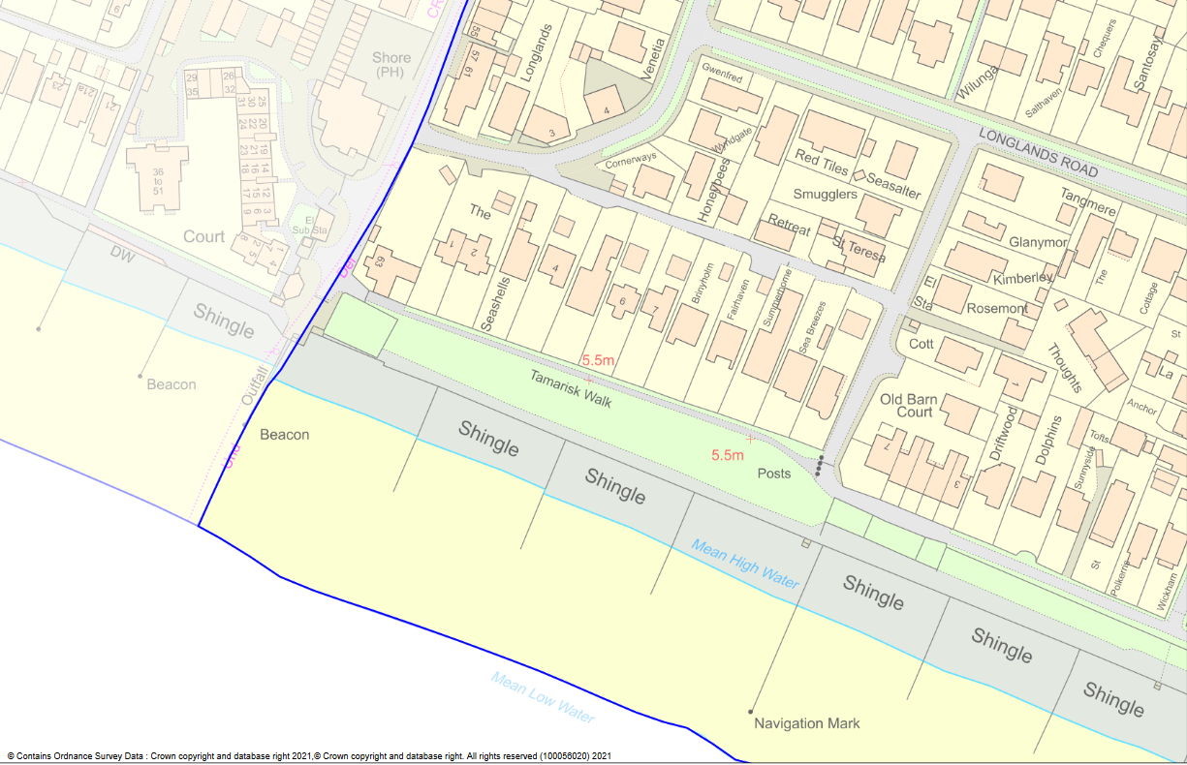

**Booker Green**

**DELIVERABLES**

**Landscaping, public realm and wayfinding deliverables**

The aim is to enhance Booker Green. The area is located at the end of Shore Road and belongs to East Wittering & Bracklesham Parish Council. Landscaping, public realm and wayfinding are a priority in this location and need to celebrate the surfing culture associated with the beach. The following approaches and costs are to be included within the proposal:

* Design and costs for improved landscaping and public realm at Booker Green reflecting a pebbled beach garden.
  + Designs and materials must allow ease for of access by all and require minimum maintenance.
  + To be achieved using gravel, decking, beach style planting and other materials as appropriate
  + Intended materials and third party suppliers of large items/quantities (eg seating; planters; gravel; other) to be stated and costed in the fee proposal
* Planters and trees to soften the area.
* Better seating to replace the existing unattractive mix of concrete and wooden benches.
* Consider garden and picnic areas
* Consider seating areas
* Relocate 16 existing memorial dedications to an alternative area that might be seating (eg long stone benches similar to Eastgate in Chichester) or might be a stand-alone area. This will need to accommodate an extra 300 memorial plaques to allow more requests for dedications to be accommodated (the dimensions of each plaque is approx. 15 x 8 cms)
* Costs for managing the project

**Critical issues to be either addressed or taken into consideration:**

The Booker Green Project proposal for street furniture, hard landscaping and planting must comply with the following and address any associated issues:

* To be compatible with the harsh marine environment, with minimal parts vulnerable to corrosion and requiring replacement.
* To be compatible with the needs of informal street sports such as parkour and skateboarding.
* The design, including wayfinding furniture, **must comply with planning requirements**.
* Seating adjacent to the seawall (sea defences) must leave enough space, i.e. 5 metres, behind the seawall to allow access.
* Project is a single element of a larger overarching Vision Masterplan and a modular approach must be taken with the design.
* Access to existing public rights of way to be maintained throughout the project.