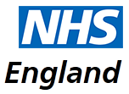

Special Allocation Scheme(SAS) Services

NHS England working with London Sustainability and Transformation Partnerships (STPs)

Engagement Event Information pack

Contents
1 London – Special Allocation Scheme (SAS) Commissioning Intentions 3
1.1 Introduction 3
1.2 Objectives of the Commissioners for the SAS scheme 3
1.3 Scope of services 4
1.4 Market Testing 4
1.5 Critical Success Factors (CSFs) 4
1.6 STP Overviews 5
1.6.1 South West London STP 5
1.6.2 South East London STP 6
1.6.3 North East London STP 7
1.6.4 North Central London STP 9
1.6.5 North West London STP 10
2 Engagement Event 13
2.1 Purpose of the event 13
2.2 Expressing an interest. 13

London – Special Allocation Scheme (SAS) Commissioning Intentions

Introduction

A Special Allocation Scheme (SAS) was introduced as a Directed Enhanced Service in 2004 to provide general primary care medical services in a secure environment to patients who meet the criteria for inclusion into the scheme. The SAS cannot be used in any other circumstances without express and prior agreement with NHS England

This SAS allows Commissioners to balance the rights of patients to receive services from GPs with the need to ensure that specified persons, including GPs, their staff, patients and others on the premises, deliver and receive those services without actual or threatened violence or other reasonable fear for their safety.

CCGs that have delegated authority for primary medical services are now responsible for ensuring that a SAS is set up for their area.

Historically there has been no detailed National guidance for the scheme made available centrally. This has led to variances and inconsistencies in the schemes across London as well as nationally.

In order to help address these concerns, NHS England has included guidance on the commissioning of a robust SAS in its most recent (November 2017) Primary Medical Care Policy and Guidance Manual (PGM). The guidance includes a detailed draft specimen specification

A London framework, based on the national guidance was agreed in the summer of 2018. Since then there have been ongoing discussions with STPs about the service requirements and commissioning options

SAS schemes in London are currently provided on an individual CCG basis. The detailed nature of the new national guidance would seem to lend itself to supra-CCG arrangements i.e. to commission services at STP level and this has now been agreed across London.
Based on the national requirements for this service, we currently expect to utilise the AMPS contractual route in order to ensure the service is commissioned in line with the national guidance. Each of the 5 London STPs therefore wishes to commission a single provider (i.e. one provider per STP) under an APMS contract to provide this service. However, given the nature of the service and the lack of comparable information available, London’s commissioners wish to engage with potential bidders/providers about their proposed arrangements and service model.

Objectives of the Commissioners for the SAS scheme

The key objectives of commissioning the SAS scheme are:

- Only patients who fit the criteria should be referred to a SAS and it should not be used for any other purpose.
- To provide patients on the scheme with full access to NHS primary medical care services within a reasonable distance to the patient’s home.
- To improve the quality of primary medical care available to patients in a controlled and safe environment.
- To deliver the service in line with the national guidelines which includes call handling and security arrangements.
- To ensure the service is underpinned by effective audit and best practice.
- To ensure that the provider has effective links with acute, mental health and community service providers within the locality.
- To ensure that GP practice staff in general can practice and provide services without concerns about their own safety and wellbeing.
- To ensure that prescriptions will be issued to the patient’s nominated pharmacy and the SAS will ensure that the pharmacy is informed that the patient is going to collect the prescription.
- To ensure patients on the scheme are managed appropriately and rehabilitated after 12 months so they can re-register with a GP practice of their choice.

Scope of services

The service is intended to provide primary medical care to adults who have been subject to immediate removal from their GP’s list as a result of violent or aggressive behaviour. A contractor will be expected to provide the full range of essential and additional services as contained in the current standard GMS contract.
A key objective or the service is that the contractor should, working with other agencies as appropriate, provide support for rehabilitation of Registered Patients in order to address the underlying causes of violent or aggressive behaviour and encourage and support facilitation of return to mainstream general practice, normally within 12 months of first registration with the SAS.
In addition, given the nature of the service the contractor will be required to complete a thorough risk assessment for each Registered Patient to determine the level of security and safety measures required and to employ professional security guards to be present on the premises where face to face consultations take place.
Further details are provided in the draft service specification attached as Annex 1
.

Market Testing

NHS England/Commissioners wish to enter into discussions about commissioning the SAS service with suitably qualified and experienced healthcare providers (including general practitioners, social enterprise / third sector organisations and other providers) with the necessary capacity and capability (or a demonstrable ability to provide the necessary capacity and capability) to provide the range of primary medical care services as set out in the published service specifications (see advert attachments) in a safe and effective manner and to meet the requirements of paragraph[ 1.5 ] below.

Critical Success Factors (CSFs)

- Access – The national requirements are to provide services from a location that is different from the normal work place of the GP practitioner. Travel distance / time should not normally exceed 10 miles or 1 hour.
- Capacity – The service requirements are to provider full primary care access (core and additional services) and “management of” patients on the scheme. This includes call handling services between 8.00am – 6.30pm Monday to Friday, and ability to access the service and appointments (face to face, skype, telephone) according to clinical need.
- Quality – Patient-centred primary medical care services, delivered in a safe and effective manner and regular assessment of patients to support their return to mainstream primary care.
- Safety – Safe environment for both, patients and practitioners
- Multidisciplinary working – The SAS provider will provide comprehensive and high quality primary medical services within reasonable distance to the patient’s home (where possible), including specifically: active management of long term and chronic conditions: patient referral, engagement and liaison with supplementary services where available routinely within the area, including specialist mental health services, drug and alcohol services and those available through secondary services.

STP Overviews

South West London STP

The South West London (SWL) STP comprise Croydon, Kingston, Merton, Richmond, Sutton and Wandsworth CCGs with a population approximately 1.585 million. In some areas a 5% rise has been projected in the next 5 years.

Across the six CCG areas there are 189 GP contracts and 212 sites where patient can access primary care services.

Historically there are two Special Allocations Schemes (previously Primary Care Extra or Safe Haven Schemes) have been commissioned in South West London. The arrangements mainly mirror the 2004 Violent Patient Scheme specifications with local variations. However, neither of these schemes meet the national criteria fully therefore, the services need to be recommissioned.

One of the SWL services is the Croydon Safe Haven scheme which provides services to patients registered with Croydon GP practices. The service is currently part of the Edridge Road APMS contract. However, this is under review. There are approximately 40 patients currently on the scheme and of those, 12 patients were registered in 2017-18.

The Primary Care Extra service runs from the Tudor Lodge Health Centre in Wandsworth. This scheme provides services for Sutton, Merton, Kingston, Richmond and Wandsworth patients. There are approximately 90 registered patients. Between 14-16 patients have been placed on the scheme in 2016-17 and 2017-18 from the five CCG areas.

The numbers reported by Primary Care Services England (PCSE) are lower than the actual number of people allocated to the Croydon and Wandsworth services as PCSE only records new registrations to the scheme and not those who have been on it longer than 12 months.

The new service provider will be required to manage the service for approximately 120 -140 patients per annum between the two sites. It is to be determent if the current sites will be used in future and if an additional site is needed across SWL.

Locations of the current SWL schemes
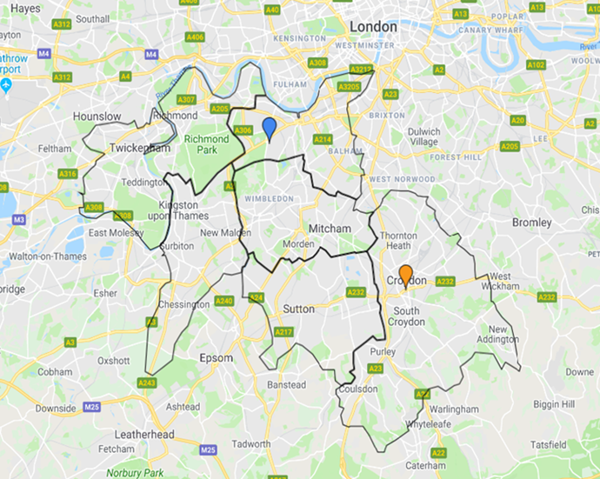

South East London STP
The South-East London STP comprises of Bexley, Bromley, Greenwich, Lambeth, Southwark and Lewisham CCGs with a combined registered population of 1.96m. (as of 1st October 2018)

The population is diverse and mobile with extremes of deprivation and wealth.
Premature death and differences in life expectancy are significant issues.
75% of over 55s have at least one LTC,
26% of children are classified as living in poverty
32% of children are overweight or obese.

There are 219 GP Practices across SEL
Single handed practices comprise 10.86% of all SEL practices
Latest GP patient survey results show on average across SEL 82% reported having a good experience of GP
100% practices are working in a networked or federated way

The current SAS providers care for approximately 120 patients across the 6 CCGs. There is considerable variation between the numbers of patients registered with each CCG’s scheme. The variation does not reflect the overall registered populations e.g the registered patient populations of Lewisham and Southwark are very similar but there are 27 SAS registered patients in Lewisham and only 9 in Southwark. The reasons for this variation are not known.

SAS schemes in Bexley, Bromley and Greenwich are provided from the hospital premises situated within the 3 CCG areas as shown on the map below. Lambeth, Southwark and Lewisham schemes operate from the providers’ own practices within the CCG areas

Under the scheme to be commissioned, where a face to face consultation is required, the service will be delivered from up to five sites across the STP area. It is proposed that each of the locations will be available on a specified day of the week and at a specified time. The provider will not be expected to attend more than one site on any particular day.

The locations, which may be on hospital premises will be specified by the commissioners but have not yet been agreed. The map below shows the locations of some possible sites but others are also under consideration. The numbers and locations of patients shown on the map are indicative only.
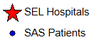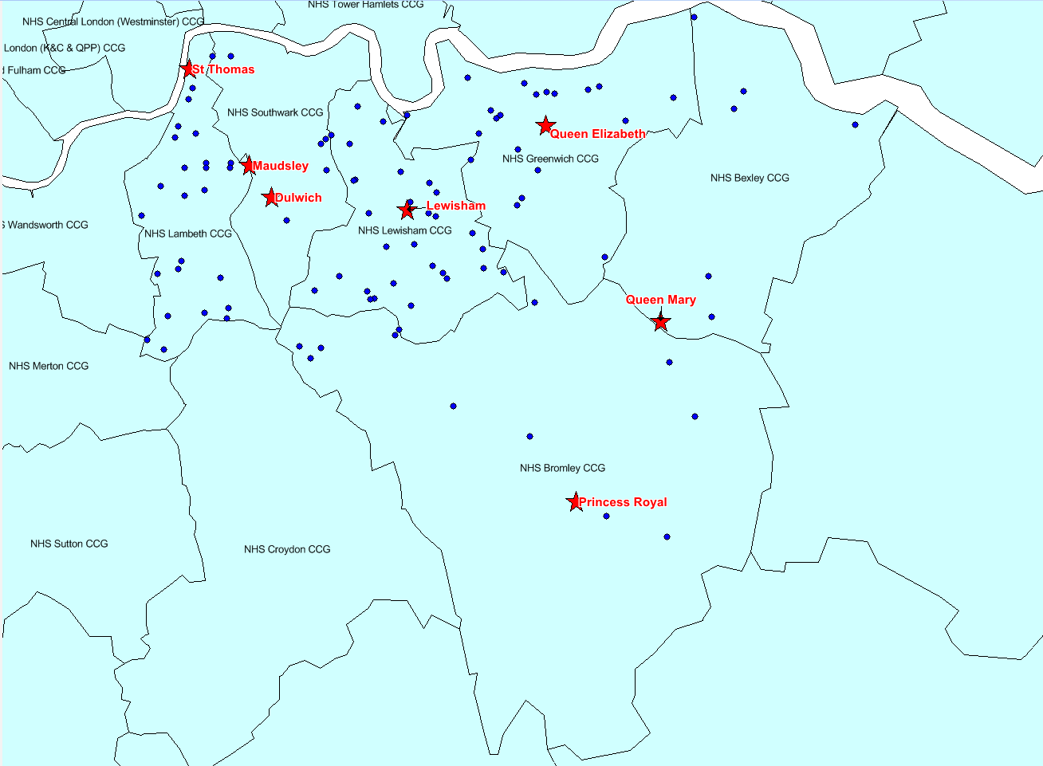

North East London STP

The North East London (NEL) STP comprises of 7 CCGs including City & Hackney, Tower Hamlets, Barking, Dagenham, Havering and Redbridge known as (BHR), Newham and Waltham Forest serving a population approximately 2 million.

There are currently 3 service providers in the STP as follows:

Waltham Forest and Newham CCG, service is currently provided by The Orient Practice, from Oliver Road Polyclinic in Leyton. Located in the North East of London, the London Borough of Waltham Forest is an urban area, with a young, multicultural community.

Waltham Forest is a rapidly growing borough; between the 2001 and 2011 censuses, the population grew by 18% from 218,300 to 258,200 (7th fastest growing borough in London). Newham now has the seventh highest population in London and covers an area of 3,622 hectares and has a resident population of approximately 400,000, in terms of age profile. Newham has one of the youngest populations in London with an average age of 31.3 years.

City & Hackney and Tower Hamlets service is currently provided by Stouts Place GP practice in Hackney.

City and Hackney are two separate but neighbouring local authorities with a total of 46 wards. Hackney is a relatively young borough with a quarter of its population under 20. Tower Hamlets remains the second most densely population local authority in the UK with rapid growth seen over the last 10 years. The population is projected to reach 365,200 by 2027.

BHR CCGs service is provided by Kings Park Surgery in Harold Wood.
There are 3 CCGs covering the boroughs of Barking and Dagenham, Havering and Redbridge. Barking and Dagenham has seen rapid population growth, the structure has changed significantly with particularly large increases in the numbers of younger people living in the borough. Redbridge has a growing and mobile population and is the largest of the three BHR boroughs. The proportion of younger people is higher than for London and England.

Across the seven CCG areas there are 215 GP practices where patient can access primary care services.

There is currently a total of 168 patients across NEL who are currently registerd on the SAS across the three sites.
It is intended that the SAS be delivered across three sites in NEL, location of sites to be confirmed.
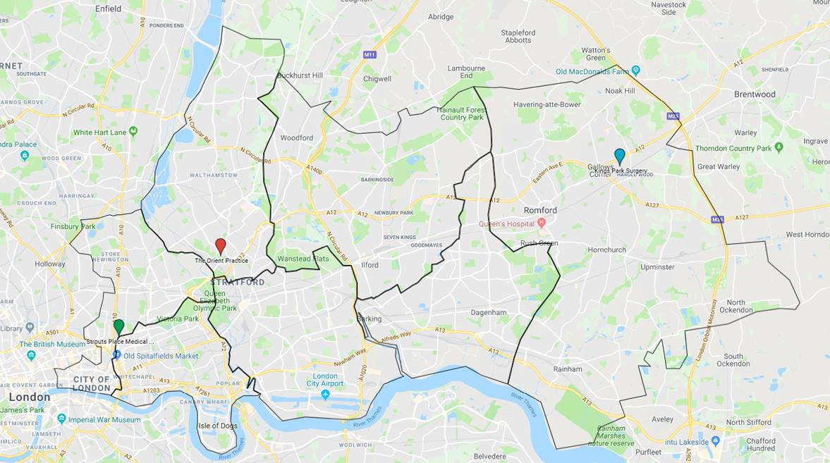

North Central London STP
The STP comprises Barnet, Camden, Enfield, Haringey and Islington CCGs with a population of approximately 1.44 million.

8% of local people move into or out of NCL each year, having an effect on GP registration, screening uptake and health service delivery. Four of the five boroughs in NCL are in the top 10% of areas in England for the number of homeless households with a priority need. There are stark health in-equalities in NCL with marked differences in life expectancy. The number of children living in poverty and with childhood obesity is high. There are also high rates of mental illness.

Across the five CCGs there are 207 GP practices. The number of GPs and practice nurses per person in parts of NCL is low, especially in Haringey.

Currently there is one provider of SAS services for Camden, Haringey and Islington patients, and a second provider for Barnet and Enfield patients.

There are 49 patients in the scheme for Camden, Haringey and Islington. The service is delivered from a health centre in South Camden.

In Barnet and Enfield there is a disparity of patient numbers on the scheme with the provider reporting 131 patients registered whereas Primary Care Services England (PCSE) state the number is lower. The service is delivered from a GP surgery site in Barnet.

A total of 180 patients are on the SAS in NCL with between 5 and 14 new referrals into the scheme each year. The location of patients currently on the SAS is shown on the map below

Locations of current NCL schemes

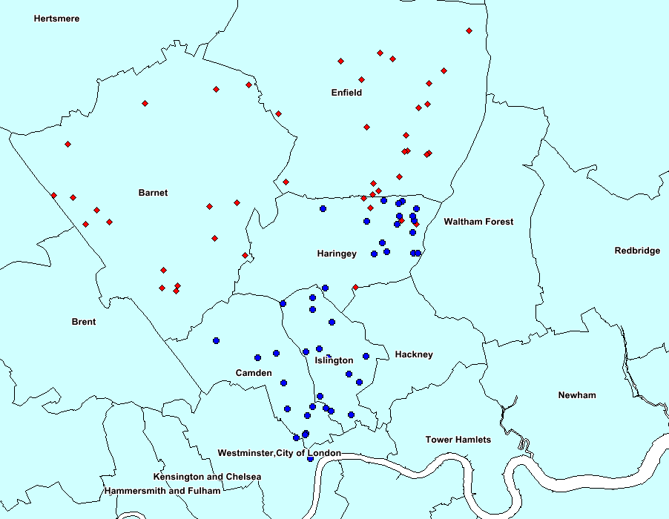
- Barnet and Enfield patients
- Camden, Haringey and Islington patients

It is intended that the SAS be delivered from three sites across NCL, confirmation pending. These sites would be in Camden, Barnet and Haringey.

North West London STP

The North West London (NWL) STP comprises of 8 CCGs including Central London, West London, Hammersmith and Fulham, Ealing, Brent, Harrow, Hounslow and Hillingdon serving a registered population of approximately 2.5 million.

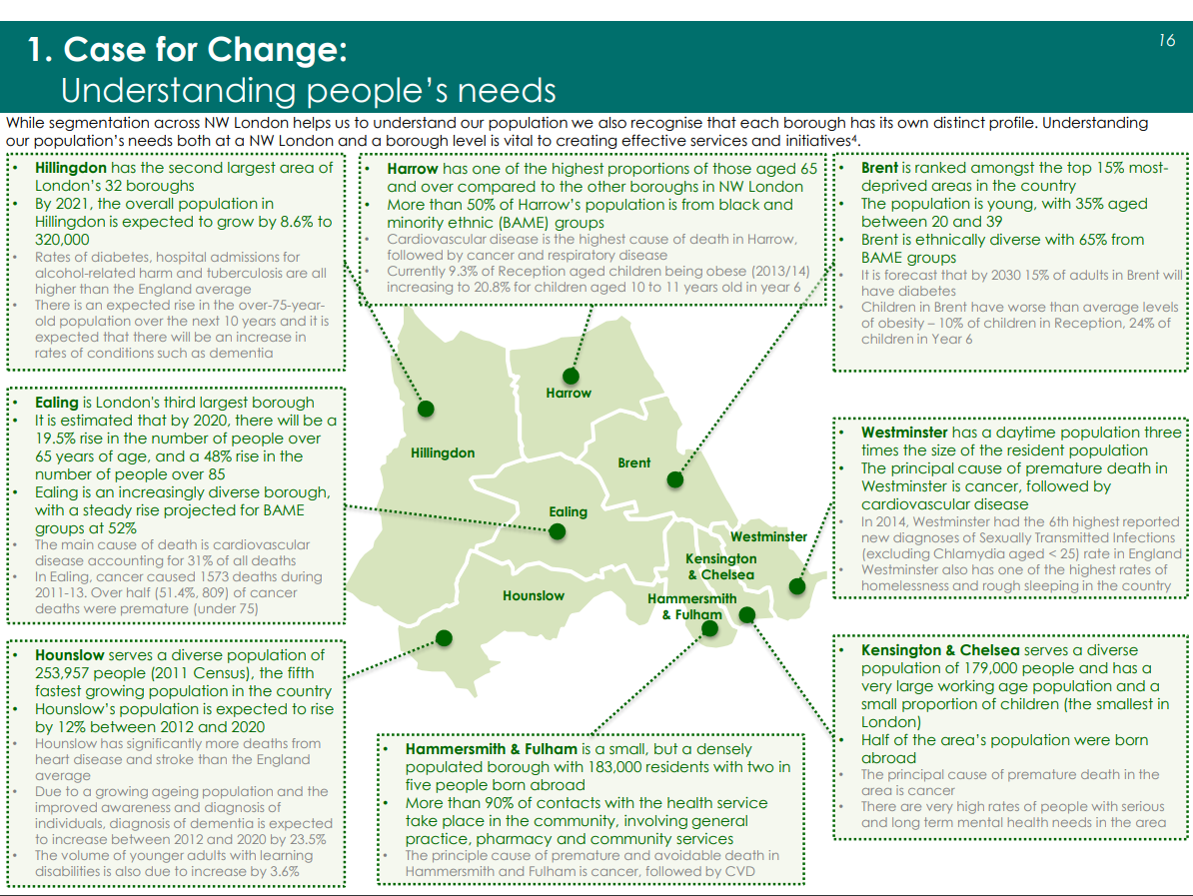

There are currently 5 service providers in the STP as follows:

- Central London, West London and Hammersmith and Fulham CCG, service is currently provided by Dr Jefferies and Partners - Munster Road. Located in the southern half of the London borough of Hammersmith and Fulham.

- Brent and Harrow CCG, service is currently provided by The Mountfield Surgery (Dr Keane). Located in the south east of the London borough of Barnet.

- Ealing CCG service is currently provided by The Waterside Medical Centre. Located in the south east corner of the London borough of Ealing.

- Hillingdon CCG service is currently provided by The Acorn Medical Centre. Located centrally in the London borough of Ealing.

- Hounslow CCG service is currently provided by Livingcare Heston (Great West). Located in the North West of the London borough of Hounslow.

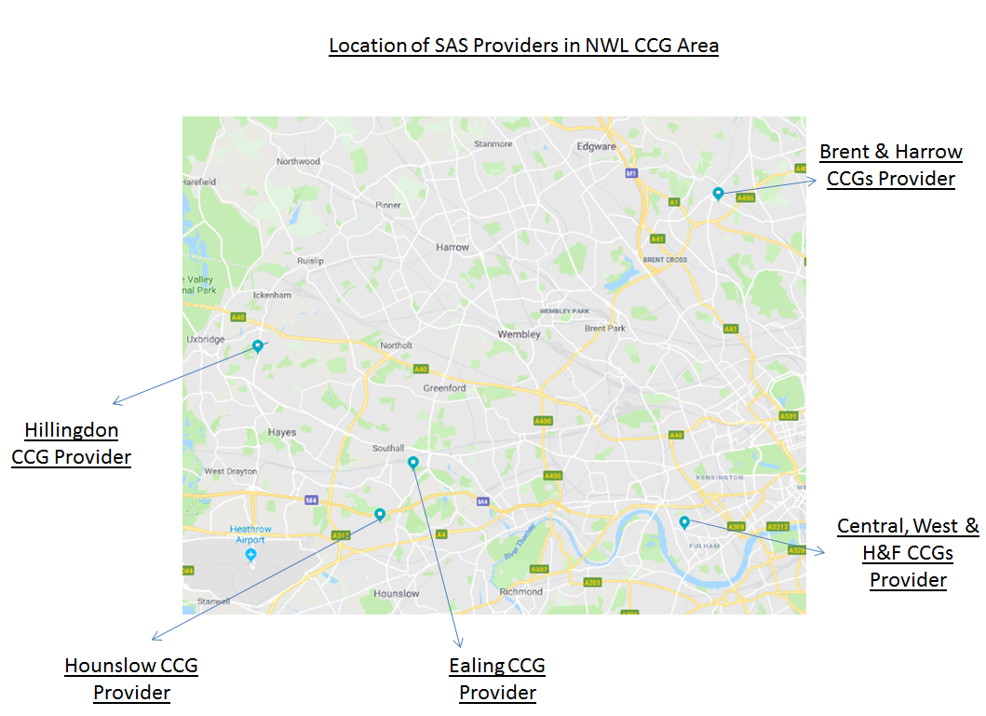

Across the eight CCG areas there are 360 GP practices where patients can access primary care services.

There are currently a total of 292 patients across NWL who are currently registerd on the SAS across the five sites.
In Brent CCG area the provider is showing a total of 103 patients which is at some variance with what the position is with the other seven CCG areas. This is currently undergoing a reconcilliation with the provider.
It is intended that the SAS be delivered across three sites in NWL, location of sites to be confirmed. However, flexible service delivery models that make use of all forms of consultation and technology are being considered.

For further information this link will take you to the NW London Sustainability and Transformation Plan - NW London Sustainability and Transformation Plan October 2016

Engagement Event

Purpose of the event

The outcomes of the engagement event will support discussions on the most appropriate commissioning route for this service within London. To facilitate these discussions we would like interested parties to attend 1:1 table discussions on 17th December at Euston tower, London. Exact timings are yet to be agreed and will be determined by the number of interested parties, i.e. if we have a large number of providers interested in the event we may hold an AM and PM session, however if the numbers are manageable in 1 session, we will hold an am session only.

The format of the sessions will be as follows. The venue will have a number of tables set up in a room and each interested organisation will be allocated a table where by they will discuss various subject areas relating to the commissioning of the SAS service in London. The discussions would be of a generic nature i.e. they will not be about specific practices or specific areas within London. The commissioners wish to discuss the general “How to” rather than the specifics. However representatives from each from each STP area will be in attendance and depending on numbers and time available there should be an opportunity to have discussions with those STP representatives. Please note any discussions with specific STP areas must be of a general nature as no decision to procure has been taken and STP representatives are unlikely to be able to offer further information above what has already been published.

To facilitate discussions we request that all attending organisations complete our survey and return it back to us via the portal by 11th December. Only those that have completed our very short survey will be guaranteed a place at the event. These surveys will help us gather some preliminary information and aid in discussions on the day.

If you have any questions please do not hesitate to contact us via the email address.

Expressing an interest.
Organisations who wish to attend the event on 17th December 2018 should register by 11th December via england.london-procurement@nhs.net returning the short survey attached to the advert. The advert contains The survey, The specification and background information that will outline the approach being taken and information about the SAS services in each of the STP areas.

