

DIGITAL BIRD TABLE

SUPPORT TO PROJECT CONVERGENCE 2022

STATEment of REQUIREMENT

|  |  |
| --- | --- |
| Project Name: | DIGITAL BIRD TABLE |
| Document Release: | Final |
| Version Number: | 1.0 |
| Date: | 21/11/2021 |

|  |  |
| --- | --- |
| Author: | REDACTED |
| Project Executive: | REDACTED |
| File Number: | DInfoC4ISTAR/0084 |
| SharePoint URL: |  |

SUBJECT TO CONTRACT

## OUTCOME

1. Head of Capability - Information Manoeuvre (HoC IM) is responsible for the delivery of the Land ISTAR Programme. The Land ISTAR programme is responsible for the acquisition and analysis of intelligence information and with that, representing this information in a clear and concise manner. Traditional methods of representing large amounts of geospatial data is through the use of what is referred to as the “Bird Table” (See Fig 1). Project HYDRA is a project within the Land ISTAR Programme which is responsible for the fusion of data for the purposes of analysis. Over the last year, a start-up successfully delivered a capability to digitise the Bird Table approach into a Mixed Reality (MR) environment (See Fig 2). The capability drew in information through HYDRA to provide the data orchestration component. By digitising this approach, efficiencies were made in managing knowledge in a formation headquarters. HoC IM now seeks to develop the capability further and deploy an OCD into the field on exercise. This will require the evolution of the capability to meet specific staff user requirements and the continuance of the capabilities delivered as part of the CCD, components of which include:
   1. **Microsoft HoloLens**. The Army will provide the HoloLens contract with up to 15 HoloLens 2 headsets as Government Furnished Equipment (GFE). The contractor will be responsible for the safety and security of the devices during their participation in the contract. On conclusion, the 15 HoloLens 2 will be returned to the Army project manager.
   2. **Agile Delivery**. In order to meet timings, the capability must be delivered according to an Agile delivery methodology. Two-week incremental improvements, in line with project HYDRA’s sprint cycles, in order to deliver on Project Convergence 2022 (PC22).
   3. **Virtual Server**. The HoloLens virtual server will be central to the processing of HYDRA data into visual representations through the HoloLens. This server will combine data sources relevant to the bird table and provide a mechanism to support the querying of data. Key to the continued success of the DBT will be the ability to work collaboratively with other staff members but will also pull in other data on users demand to enhance understanding of HYDRA datasets. The virtual server now needs to be integrated into the Mission Secret environment and therefore any capability needs to be accreditable to Secret in time for PC22 in Sep 22.
   4. **HYDRA interfacing**. Data critical to the successful delivery of the DBT is held predominantly on or through the HYDRA capability. It is therefore essential that the DBT capability connects to HYDRA. The ability to work with HYDRA contractors is therefore a key part of the requirement.
   5. **GIS Interface**. Whilst the DBT capability must be able to pull geospatial feeds from any Open Geospatial Compliant (OGC) service, the GIS interface will be with Esri’s ArcGIS. The ArcGIS platform will provide feature services in both OGC and Esri proprietary standards whether directly or indirectly through the HYDRA platform.
   6. **System engineering support**. This shall be provided to maintain the current configuration and respond to change requests to the system. Any dependencies on the HYDRA platform shall be clearly articulated in good time to the HYDRA contract.
   7. **Service Support**. The contract will provide technical support to respond to 1st and 2nd line issues such as login support, network connection and user experience etc. Service and support will also be required over PC22 which will be delivered in the US.

Figure 1. Brigade troops briefing on a “Bird Table”.

Figure 2. The evolution of the “Bird Table” into the Digital Bird Table (DBT).

1. The contracted team will need to possess the necessary skills to deliver ALL of the requirements and expertise detailed in Schedule 1 in order to maintain, support and change the DBT capabilities and infrastructure that make up the MR environment. **The contractor must demonstrate a proven deployment of MR which covers ALL of the use cases in Annex A.** **Any offer will be discounted if they are unable to provide proof of an ability to deliver all seven use cases as there is insufficient time to conduct re-development in these areas.**

### Purpose

1. The purpose of this document is to define the DBT requirement.
2. This document is split into 3 schedules:
   * 1. The technology used.
     2. The services required.
     3. The service levels required.

# Background

1. The project manager for Project HYDRA is responsible for the intelligence fusion and analysis of data in the Army. Project HYDRA has been working with 4 Military Intelligence Battalion (4 MI Bn) to deliver an analytical capability at the SECRET level, to develop and deliver project HYDRA into the deployed space. The deployed space, within the formation headquarters, requires a means to visualise understanding for both the intelligence analyst and the headquarters staff. The HoloLens DBT has been working broadly with 4 MI Bn to deliver against this requirement. The current capability delivers an interactive MR environment to replicate current Bird Table processes but enhance this with an ability to interact with data elements and exploit communication channels such as JChat (Open fire server-based chat). Project HYDRA has been successfully tested on exercise with the Legacy Blue System (LBS), the Land environment network of choice for Divisional operations. The HYDRA servers are connected to the LBS network through a code of connection which enables a connection to the Esri GIS server (DATAMAN), chat capability (JChat) and the LBS terminals in order to use the HYDRA User Interface (UI), figure 3 refers. Access to the UI was achieved through a web browser via an https connection between LBS and HYDRA. The UI, which is a google angular based UI, provides the user access to data through a mapping orientated visualisation (similar to Google Maps).

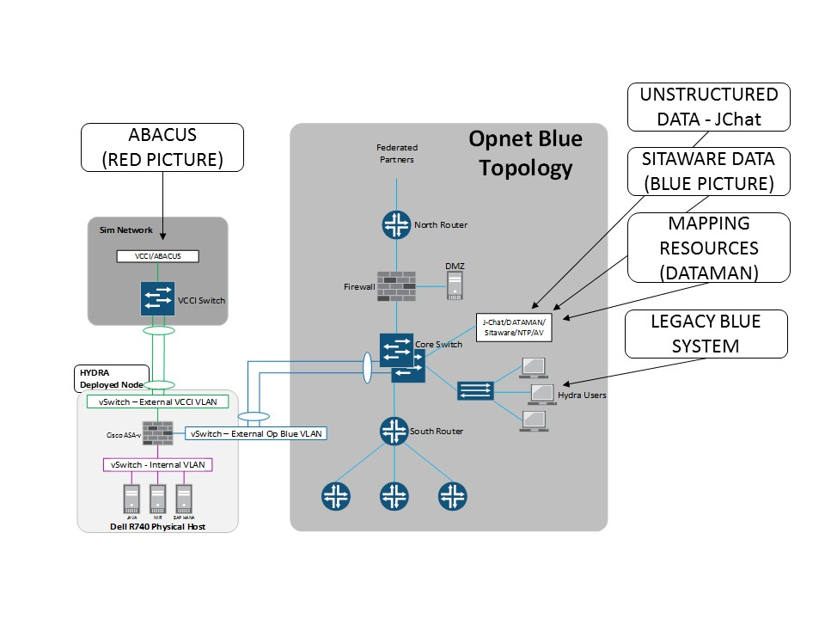

Figure 3. High Level Design for HYDRA connection to Legacy Blue System.

1. The CCD for the DBT demonstrated a need for such technology in the deployed spac. The ability to connect to HYDRA in line with the LBS High Level Design (HLD) and MOD Secret accreditation processes is something which was not achieved as part of the CCD and is now a priority area of focus. The DBT should now look to deliver a Digital Bird Table, on MODCloud Service Offering 2, in line with the HYDRA dev and test platform. The DBT should also deploy onto the HYDRA/ZODIAC Mission Secret node in time for PC22. This CCD was considered phase 1 and covered the delivery of Annex A use cases. Whilst phase 2 will focus on deploying the platform onto Mission Secret networks and therefore managing Mission Secret data. As a result, all contracted personnel shall hold, or shall have the necessary criteria to hold Security Clearance (SC) to meet phase 2 requirements. The HYDRA contract will provide the levels of support required to establish connection and integration with HYDRA. Any data and integration requirements for the HoloLens capability shall be clearly articulated prior to contract award. All other levels of service support for the DBT will need to be covered by the HoloLens DBT contract.

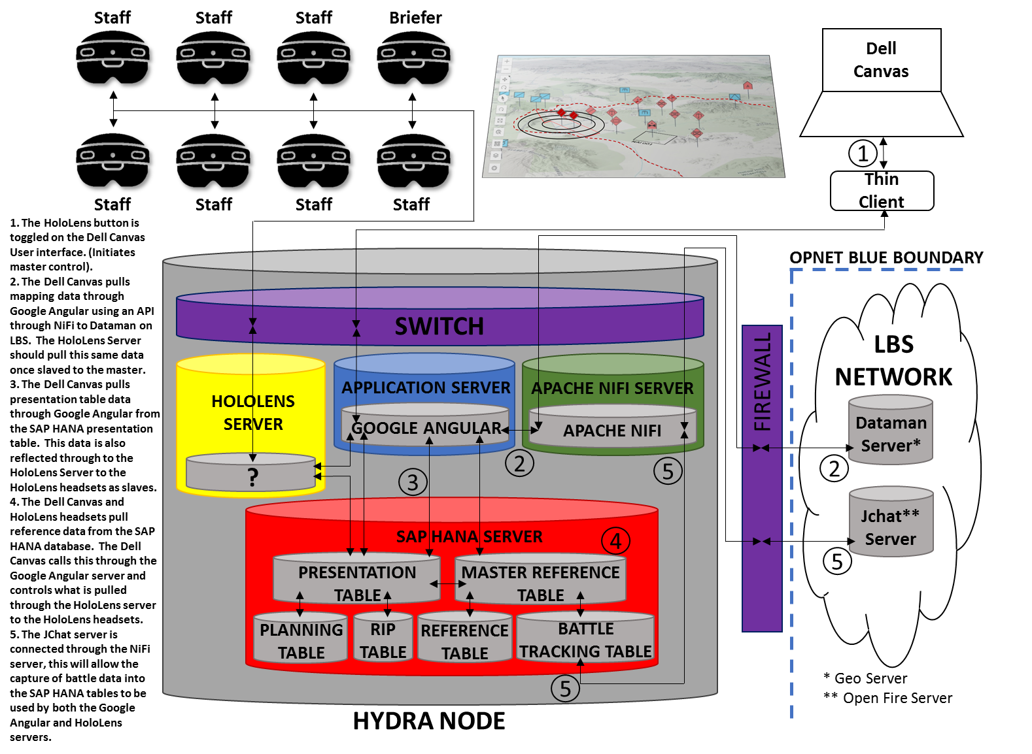

Figure 4. High Level design for HoloLens connection to the HYDRA node.

HoloLens Digital Bird Table Capability Concept Demonstrator.

1. As with Project HYDRA, the HoloLens DBT will migrate to a ‘private cloud’, therefore any resources from the internet will need to be onboarded to the capability as there will be no connection to the internet. All foreground intellectual property shall be retained by the MOD. Background IP remains the intellectual property of the contractor.
2. The HoloLens DBT will be comprised of four core component parts.
   1. Control surfaces and connection ancillaries. A physical touchscreen was chosen as the control surface to provide a more tactile interface with the digital bird table. This removed human interface challenges with the MR environment in the early stages of the CCD. The DBT contract shall provide thin clients or appropriate compute to connect the touchscreen and those 3rd party analysts, as described in Use Case 5 of Annex A. The DBT contract shall enable the connection to the HYDRA AWS dev and test environment. Costs for DBT integration onto the HYDRA AWS dev and test environment shall be borne by the DBT contract.
   2. HoloLens 2 Headset. The HoloLens 2 headset from Microsoft is the MR headset of choice, as it currently has the widest field of view on the market. The HoloLens 2 headset will be referred to as HoloLens throughout this Statement Of Requirement (SOR). The HoloLens will be connected via it’s USB-C port to remain accreditation compliant, as such it will not be using any Wi-Fi connections. The hardwired connection will require adaptation so as not to disrupt the user experience this shall be provisioned by the HoloLens contract. The USB-C connection will also be required to power the device and be required to enable a keyboard interface.
   3. HoloLens Server and hosting environment. Aligning with the principles of project HYDRA’s centralised processing and low bandwidth requirements, the DBT shall be delivered as a server-based capability on HYDRA AWS Dev and Test platform and also alongside the HYDRA Mission Secret node. The supplier must therefore be prepared to work with the HYDRA contract at mission secret, to ensure the HoloLens is appropriately connected. Interim accreditation of the capability will need to be achieved by no later than 1 Apr 22.
   4. Service provision to support the HoloLens components as above. The contract must support 1st, 2nd and 3rd lines of support for the capability. First line support for the DBT capability will be through the contract. The 2nd and 3rd line support for the capability will need to be supported by both the contract and the HYDRA contract. Training for the use of the DBT is also a service which must be delivered within the contract.
3. The HoloLens DBT will deploy on phase 2 to support Project Convergence 2022, in the US with our partners in Sep 22. There will be a number (no less than 3) integration exercises in the run up to PC22 which the contract will attend. A design architecture for the intended integration into the HYDRA deployed node at figure 2 shall be delivered by the contract.

# Operating Model

1. **Processes.**  The six use cases for the HoloLens DBT CCD are at Annex A. The phase 1 CCD must prove the utility of MR within the divisional headquarters environment. The CCD worked on the premise of low on bandwidth consumption and drew upon centrally processed data. The DBT capability must continue these principles, and be prepared to interface with the HYDRA deployed capability (at Figure 3) as part of phase 2. This architecture will contribute to work in the Defence space on the Digital Battlespace and seek to increase efficiencies within the headquarters.
2. **Organisation**. There are two contracted parties to enable the delivery of the DBT, the DBT contract and the HYDRA contract. Both parties must work together with the project management staff at Army HQ, Bde staff and 4 MI Bn staff.
3. **Location**. The team will be working predominantly in the UK for the contracted period and deploy the capability to the US in support of PC22.
4. **Information**. Data sources will be provided through the HYDRA AWS dev and test platform and node. Mapping services from the Esri ArcGIS platform, DATAMAN, will be managed through the HYDRA node via Apache NiFi and all operational data will also be pulled from the HYDRA node from the SAP HANA database. A JChat connection will also be established through Apache NiFi.
5. **Suppliers**. The contract will provide the virtual server to manage the data delivery to the HoloLens device. The HoloLens will be provided as GFE. All other ancillaries and compute shall be provided by the DBT contract.
6. **Management System**. The DBT capability will be supported by 1st, 2nd and 3rd lines of customer support as part of the contract. An arrangement will be secured with the HYDRA contract to establish codes of connection and data exchange arrangements. Training is also a service which shall be provisioned as part of the contract.

HOLOLENS DBT roles and responsibilities

1. **Data Acquisition.** Data Acquisition and its provision will be conducted by the HYDRA capability. The HYDRA contract will provide a means to interface the HoloLens virtual server into the HYDRA capability.
2. **HYDRA Fusion Manager and supporting intelligence staff**. The data feed for use by the DBT will be maintained and stored on HYDRA, this will be managed by the fusion manager and the intelligence staff within the Brigade Headquarters. These staff members will also support the HoloLens briefer to enable his or her delivery of intelligence through the DBT. As part of their role, the fusion manager and the intelligence staff will provide support through a third-party series of screens or HoloLens to conduct “over-the-shoulder” support to the briefer and the staff as the brief is conducted. Use Case 5 at Annex A refers to this as “man marking”. In the same way the HoloLens briefer can be informed of information in real time to assist in questions or clarity.
3. **HoloLens Briefer**. The briefer will orchestrate the delivery of a brief through the medium of the HoloLens, controlled through the touchscreen. The briefer will manage display layers, manipulate timelines, draw tactical graphics and call data points to be displayed on any layer, all in order to bring the briefers points to life. The briefer will be able to see other staff members interactions with the map however, other staff members will not be able to move data points on the map in the same way the briefer can. The HoloLens briefer will also have a private chat session available to him or her to allow the fusion manager and intelligence staff of the Brigade to provide support on questions from the staff as described in para 17.
4. **HoloLens Staff**. The HoloLens staff will be from the exercising Bde and largely be consumers of data layers and data points on those layers presented by the HoloLens Briefer. Bde Staff will have little to no ability to move datapoints so as not to disrupt the briefing however, the staff will be able to interact with data points to extract data from them, such as equipment weapon range. HoloLens Staff will also be able to communicate through JChat channels to enable non-verbal communication (Chat) during the briefing.
5. **Integration Team**. The integration team will be responsible for the integration of the DBT which will pull upon datasets up to Mission Secret. The integrators role will be to orchestrate data resources from SAP HANA, Esri ArcGIS and JChat so that the data is seamless for the user. The DBT shall be managed via a third-party application such as a Universal Windows Platform (UWP) application, which would make use of the data contained within the SAP HANA database. Whilst there will be technical support from the HYDRA contract, the integrator team will be provided by the contract and shall be sufficiently proficient to work with these resources. Any specific work done by the HYDRA contract to support the DBT shall be funded through the DBT contract.
6. **Data Management Team**. Broader data management will be conducted by the HYDRA contract. There will be a relationship with the HYDRA contract to ensure any amendments though the DBT interaction and passage of data to other systems such as JChat are well managed.
7. **Development Team.** The main provision of the DBT team will be a group of suitably experienced HoloLens developers who have previous experience on spatial MR projects. The toolsets will be supported by a development team to manage the services which deliver the required HoloLens visualisations. Expertise in this area will be provided through contract. All personnel on the project mush hold or have the ability to hold Security Clearances (SC).
8. **Enterprise Administration.** Enterprise administration will be provided through a mix of the HYDRA contract resources and the DBT contract resources to support deployment onto the HYDRA AWS dev and test platform and Mission Secret node. Responsibilities include but are not limited to support and maintenance of storage, processing, VMs, OS, together with supporting software and monitoring the health of HoloLens applications/services. All hosting matters shall be supported and guided by the HYDRA contract.
9. **Service Desk.** The contract will contribute support via the current Service Ticketing Desk arrangement for HYDRA, which is to be the single point of contact for all issues pertaining to the DBT. This service desk shall provide support to the HYDRA and DBT platform during the contracted period.

## Schedule 1 –Technology

### Key Technologies

1. These key technologies underpin the DBT.

**HYDRA Technology**

1. **SAP HANA environment**. SAP HANA is the relational database for the HYDRA capability. This will provide both the data tables and analytics for the HYDRA capability. Figure 4 below highlights SAP HANA’s ability to perform spatial analytics, graphing analytics, text analytics and predictive analytics.

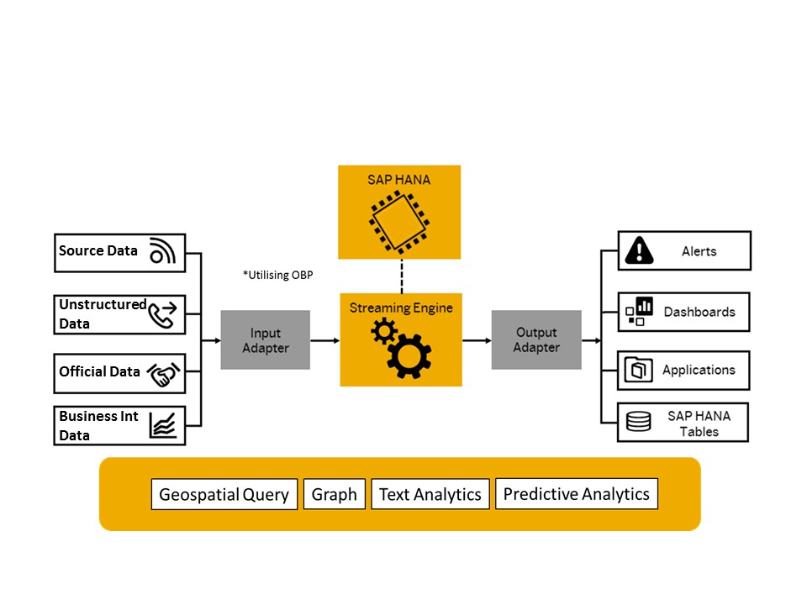

Figure 4.

1. **Apache NiFi**. Apache NiFi will be used as the Extract Transform and Load (ETL) function for the capability. This tool enables the management of structured and unstructured data into HANA, for storage and analysis, managing differing formats and standards.
2. **Google Angular**. Google angular currently provides the platform for the HYDRA web application to ensure a rapid evolution of the user interface. This user interface interacts with SAP HANA resources.

**Amazon Web Services (AWS) Dev and Test environment**

1. The Dev and Test environment for HYDRA is on MODCould ICE. Service Offering 2 of MODCloud ICE is now being used for the deployment of the HYDRA dev and test environment.

**HYDRA Deployed Node**

1. The HYDRA deployed node is the platform where the DBT will be deployed in time for PC22. Figure 3 details the high-level design for the deployed node indicating where the node sits alongside the OpNet Blue network for wider integration as part of phase 2. This node operates at Mission Secret and the DBT must be able to meet the accreditation standards for these networks.

**Geospatial CIS**

1. Geospatial support will be provided by ArcGIS linking into the HYDRA MODCloud ICE platform. This will deliver the mapping and feature services required to provide the visualisations required for the HoloLens platform. In the deployed space, ArcGIS services are natively on OpNET Blue.

**HoloLens 2**.

1. Up to fifteen HoloLens 2 will be provided by the project for development work and use on the CCD. For accreditation reasons, and in the short term, the HoloLens 2 must be hardwired to the network (through the USB-C connection with an ethernet adapter), not using Wi-Fi connections.

**Compute**

1. Additional compute and the ancillaries to connect and manage the capability should be provided by the HoloLens contract. These requirements shall be discussed prior to contract award.

**Operating Systems**.

1. The following platforms are available:
   1. RedHat Enterprise Linux
   2. AWS Linux

## Schedule 2 – Services

1. The DBT requires a capability that will consist of software and hardware, together with 1st, 2nd and 3rd Line Support with Systems Engineers, as detailed in the above requirement, this will provide the Products, Delivery, Support and on-going maintenance of the DBT. The team will need to possess the necessary skills and expertise to deploy the capability onto the Mission Secret node as detailed in Schedule 1 in order to maintain, support and adapt the DBT.
2. The high-level deliverables for the service are:
   1. Produce and review relevant technical documentation to support the Infrastructure, application platforms and services.
   2. Provide dedicated support to troubleshoot problems with infrastructure and platforms across relevant MOD owned and managed hosting environments.
   3. Ensure that all infrastructure platforms and services are delivered and align to the policies and standards that have been defined for the system.
   4. Implement solutions, formulate estimates and provide technical expertise for new, and enhancements to existing, infrastructure and application services, based on the prioritised capability requirements.
   5. Provide technical support for all designed and hosted capability and services, including fix bugs and changes to live application services.
   6. Design and develop automation scripts that deploy the required system software and bespoke application software to the environments.
   7. Provide 1st, 2nd and 3rd line support for the DBT.
   8. Deploy hardware and software capability (system software and applications) to pre-production and live environments.
3. The team may be required to work with other suppliers/strategic partner’s resources and internal staff to ensure a coherent delivery of service.
4. The supplier will also be required to provide a client interface to agree business prioritisations and deliverables.
5. Subject to demand and budget the DBT will require the ability to scale up and down the resource requirements. Due to budgetary constraints it is envisaged that the service would be on a capped T&M basis that would enable the supplier to confirm a maximum monthly cost for the core capability.

### Scaling

1. The DBT requires ROM estimates for the provision of capability and resources to support to the MOD in accordance with the above requirement.
2. The requirement for the provision of additional resources would take 2 forms:
   1. Additional server resource – Should there be a requirement for additional processing required over and above what is currently delivered by the HYDRA node.

Or

* 1. Additional hosting on MODCloud ICE (AWS) – In order to dev and test the DBT with HYDRA, the capability will need to be hosted on MODCloud within the HYDRA dev and test platform. Should there be additional resources required, the current MODCloud environment will need to be enhanced.

**Governance**

1. The authority in conjunction with the supplier will devise the bi-monthly Statement of Work against which the supplier’s outcomes will be tracked. The authority will be responsible for providing monthly feedback to the supplier and report performance to the DBT Business Manager. This supplier’s performance review will then be reviewed at the DBT governance board.

## Schedule 3 – Service Levels

### Provisioning

1. The service supplier will use their ‘best endeavours’ to provide resources to meet the priorities specified by the DBT. Specifically:
   1. Provision of further resources within 30 calendar days.
   2. Exit of current resources no longer required within 7 days.
2. The service supplier warrants that all staff used to supply the capability hold current, or be able to hold, MOD applicable security clearances at Security Clearance (SC) level or above and are willing and eligible to obtain higher clearance levels if the role requires it.

### Licencing and Support Agreements

1. The supplier must ensure that all software used by the DBT environment is fully licenced, with the provider of the hardware and software, and that support agreements are in place to allow Service Requests to be raised by the service supplier against the software. This will include but is not limited to:
   1. The HoloLens Server on the HYDRA MODCloud ICE (AWS) dev and test platform.
   2. Any provisioned compute or ancillaries.
   3. Any software to be installed on the HoloLens 2.
2. **Hardware.** The capability will be hosted on the HYDRA MODCloud ICE (AWS) dev and test platform. The capability will also be deployed on OpNET Blue through HYDRA;s code of connection. The contractor will be responsible for the provision of any hardware outside of the HoloLens, touchscreens or the hosting environment in its original configuration.
3. **Intellectual Property Rights (IPR).** The selected supplier shall not retain IPR relating to any foreground services delivered during the terms of the contract.
4. **Exit Plan.** The Authority and the Supplier will agree an exit plan during the Call-Off Contract period to enable the Supplier Deliverables to be transferred to the Authority ensuring that the Authority has all the documentation required to support and continuously develop the Service with Authority resource or any third party as the Authority requires. The Supplier will update this plan whenever there are material changes to the Services. A Statement of Work may be agreed between the Authority and the Supplier to specifically cover the exit plan.
5. **Duration.** The duration of the overall contract needed is assessed as starting from 1 Feb 22, with approval expiring on 18 Nov 22.

Annexes:

A. Digital Bird Table use cases for CCD development and for confirmation of user need (Complete).

B. Additional use cases for delivery in support of Project Convergence 2022 (PC22).

ANNEX A to

DIGITAL BIRD TABLE SOR

Dated 23 Nov 2021

**DIGITAL BIRD TABLE USE CASES FOR CCD DEVELOPMENT AND FOR CONFIRMATION OF USER NEED (COMPLETE)**

1. The following use cases articulate the requirement for mixed reality in portraying a digital bird table.

ANNEX B to

DIGITAL BIRD TABLE SOR

Dated 23 Nov 2021

**ADDITIONAL USE CASES FOR DELIVERY IN SUPPORT OF PROJECT CONVERGENCE 2022 (PC22).**

1. The following use cases articulate the requirement for mixed reality in support of Project Convergence 2022.

2. **Refinements**:

* 1. Migrate to Defence systems
  2. JChat interface enhancements
  3. Improve context specific responses in JChat
  4. Improve shape file ingest and broader utility
  5. Improve layer management
  6. User ability to upload briefing notes
  7. Improve feature properties layout
  8. Improve user interaction with data points

3. Use cases specific to Project Convergence 2022.

