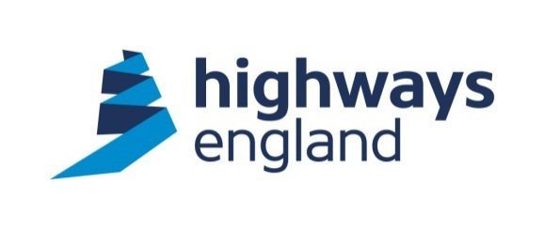 | Highways England  Commercial & Procurement Division  Lateral  8 City Walk  Leeds
6th March 2018
Softcat Ltd

Dear REDACTED
itt_3633 – Microsoft Surface Hubs – February 2018
Further to your recent submission of a Tender for the above Further Competition carried out under the Crown Commercial Service Technology Products 2 (RM3733) framework, I am writing to advise that the Further Competition is now complete.
We are exercising the option of a complete order incorporating the initial and the optional orders in the tender.
I am pleased to inform you that your company ranked first in our evaluation and therefore we would like to award the itt_3633 – Microsoft Surface Hubs – February 2018 to you.
As you may be aware there is some speed required in this matter, and as such please could you contact REDACTED on REDACTED to pre-empt arrangements prior to the end of the standstill period.
You are requested not to make any press announcements regarding the award of this Further Competition until the contract has been signed by both parties.

A copy of the completed Contract Order Form will be forwarded to you shortly for your signature and return.
For your information, please also find attached a Debrief Report which sets out the scores achieved by your company during the evaluation.
Yours sincerely

REDCACTED
Procurement Delivery Partner
Email: REDACTED

Annex A
Score | Rationale
Q3 Mandatory Questions (Pass/Fail)
 | REDACTED
Q4 Quality Question (30%)
 | REDACTED
Q5 Total Price (70%)
 | REDACTED
Total | REDACTED

