AHDB – Red meat reputation in foodservice
CCS – Research Market Place (RM6126)

- Summary
AHDB are a levy funded organisation that works on behalf of British agriculture. Sectors covered include beef and lamb, pork, dairy and cereals and oilseeds.

AHDB wish to understand how to improve consumer attitudes towards red meat (beef, lamb and pork) when dining out-of-home, and ultimately drive sales of these products within the foodservice sector. The research will be used to influence operators (and their supply chains) to better showcase British red meat on menus, to secure a long-term market for our sectors.

We wish to understand and test concepts in an environment that is as realistic as possible. The budget for this project is approx. £40k, with a final debrief which must take place before by the end of March 2023.

- Background

While retail volumes dominate, the out of home market remains an important area for red meat. According to our estimates, in 2019 eating out (dine-in and food-to-go) accounted for 11% of total beef volume, 13% of pork and 6% of lamb, with takeaways adding further to this.
The out-of-home market has faced its most challenging period in recent history and is just starting to recover from the loss of sales from the pandemic. We know that the market is different to how it was pre-pandemic; in addition to challenges such as rising costs and labour shortages, menus have been simplified and consumers are cutting back on out of home spend as the cost-of-living crisis deepens. This means that red meat will be competing for share of a smaller pot. In addition to this, over the longer-term, consumer attitudes towards red meat have been changing and vegetarian/vegan options have greater menu presence than they did previously.
Previous research from Lumina Intelligence has shown that some keywords are linked to a higher spend per meal. We know that getting the descriptions right is key.
AHDB’s focus for red meat is around the theme of ‘reputation’, which includes health, environment and welfare. This research will explore whether terms related to these themes resonate with consumers and ultimately encourage them to opt for red meat and/or trade up. AHDB aim to secure markets for British meat and the British foodservice industry is one of these.
- Service Requirement

Business objective | Protect the reputation of beef, lamb and pork  Protect sales of red meat by driving a longer-term shift in positive attitudes towards red meat
Research Objectives | Do reputational keywords, logos/accreditation and imagery on menus improve attitudes towards:  - The red meat industry/farming  - The food  - The restaurant  Does it improve sales?  - Does it convert people to red meat?  - Do people choose red meat more often?  - Does it encourage trade up?  Will people pay more for the item?  - How much more?
Suggested approach | We envisage a two-stage approach to this research, as suggested below. However, we welcome all methodologies that agencies feel suitable and will score responses based on your recommended route, in line with the scoring criteria in Section 4.  Stage 1 – Understanding the market  The focus of this stage is to understand where factors related to farming and red meat feature within consumers’ decision drivers:  - When choosing a pub/restaurant (to go out for a meat-based meal)  - Once in a pub/restaurant, when choosing a meat-based meal  This will also allow us to prioritise keyword/image/logo testing in Stage 2.  Examples of these factors are detailed in Figure 1, in Stage 2 (below).  This is likely to be an online survey (but open to other qual/quant methodologies) and should focus on our sectors rather than total foodservice.  At a topline level, we know the top 10 consumer needs when consumers choose a premise to eat at, with familiarity, proximity and value for money being top drivers (according to Lumina). However, the out-of-home market is incredibly complex (with variations by channel and consumption occasion) and we are not looking to try and understand these complexities within this research.  NB. We have previously undertaken a Meat Shopper Journey project within retail, which identified a decision hierarchy and highlighted claimed vs actual importance of factors when shopping for meat. This is shared for reference, as the most similar piece of research we have undertaken in retail.  Instead, we want to know how meat can fit into the broader picture. For example, when people think about the quality of the food at a pub/restaurant, does the quality of the meat factor in here? If they think about variety, does this include having all proteins present? We would ideally like to understand how these factors might vary based on type of occasion (i.e. dinner with friends, romantic dinner, special occasion).  Additionally, when considering which keywords, images and logos to take forward to Stage 2, which ones should we prioritise? This stage will allow us to better understand what types of images are likely to work.  Stage 2 – Menu testing  This stage is the core of this project. The aim of this stage is to test whether keywords/images/logos on menu will affect consumer attitudes and choices.  In this stage, we want to get as close as possible to actual behaviour (choosing a dish whilst in a pub/restaurant), rather than claimed (such as via an omnibus survey).  Therefore, we imagine a methodology such as A/B menu testing to be suitable (but are open to other methodologies).  We wish to test how consumers respond to keywords, images and icons that may encourage people to choose red meat and improve perceptions of our industry.  Examples of what may be included are detailed below, but Stage 1 will allow us to refine what goes into Stage 2:  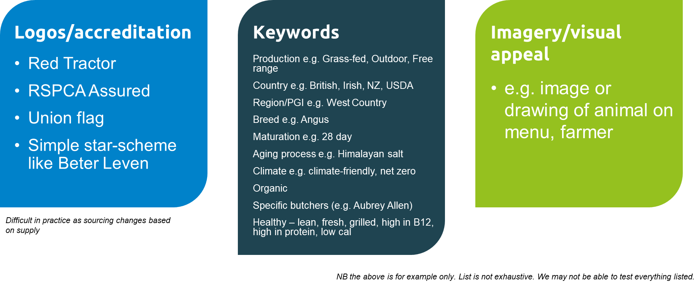  Figure 1 Keywords, images, logos related to red meat  While there is increased digitisation within foodservice, we intend to just test a static (pdf) menu only, as the main objective is to show how words/imagery can affect behaviour and therefore this can be applied to digital platforms.  We intend to use a mid-range pub-style menu as the base for this research as this will ensure good coverage across all proteins.  We know that price is a key consideration and therefore we intend to include prices on a baseline menu and then explore possible trade-up due to the test menu descriptors.  Finally, the recent addition of calorie labelling, for larger operators, is impacting what people choose on menus. We therefore believe it’s important to include this but perhaps explore whether other health labelling (such as high in vitamin B12, high in protein) counteracts this at all.  NB. We have previously looked at how to better engage shoppers with the meat aisle. As part of this we tested communication territories related to ‘reputation’ (health, environment, welfare). This is shared for reference, as the most similar piece of research we have undertaken in retail.  Please note that our preference is for the winning agency to provide the concepts and design elements, within the maximum budget, and this will be considered within the scoring as per Section 4. We are able to source designs/concepts elsewhere but this should be reflected within the timelines and budget. Please detail the feasibility of this in your response.
Target Market / Audience | - Eat out at pub/restaurant once a month.  - Eat red meat (and will choose it out of home)  - Otherwise nat rep (GB Adults)
Requirements | The proposal must clearly demonstrate that the research objectives listed above will be met.  The methodologies used to achieve the research objectives must clearly be identified in the proposal with clear demonstration of how the approach achieves the objectives.  The quality of the methodologies will be scored in line with the scoring criteria and the agency must clearly show how they are relevant and link to achieving the research objectives.  Any research tools e.g. recruitment screeners, questionnaires etc. used by the successful tenderer must be approved by AHDB prior to any fieldwork taking place. These need to be detailed into the timing plan.  Details of relevant previous work by the agency must be demonstrated.  The proposal must also include the following details for each of the projects:  - Name and full contact details of the project manager that would be leading each project.  - Details of relevant experience and projects of project managers  - Key targets and dates of achievement (timetable).  - A breakdown of costs for all stages of the project including VAT  - Details and experience of any 3rd party agencies that will be used to deliver the research project. Cleary indicating the stage in which they would be involved and the percentage of works that would go to a third party.  Agencies must clearly mark their recommended route to achieve objectives and final lump cost in delivering the project.  Your proposal must demonstrate how a process for quality control will be followed along with adherence to MRS code of conduct.  Terms of use  This research would be bespoke to AHDB with the ability for AHDB to use findings with wider stakeholders/industry and publish results in a report, which will be publicly available on the AHDB website. The information from this project shall be deemed Confidential Information and to be used as deemed fit by AHDB. Agencies can be given prior sight of content for media/PR usage. All designs created within the project are the property of AHDB and all pictures used must have the correct licenses to be published. Agencies are required to share in the proposal any sharing restriction or use of data/assets that would come from this research.
Budget | A budget in the region of £40,000 including VAT is available for this project.
Outputs | A detailed PowerPoint of final results with a presentation (on Microsoft Teams)
Timings | Research timings can be stipulated by the research agency but we would like to avoid the majority of fieldwork taking place in the run up to Christmas and during Veganuary as these are likely to sway consumer perceptions of meat.  The full project must be completed by March 2022 so that it can be billed within this financial year.  Mini competition brief circulated 14th September 2022  Deadline for the submission of clarification questions 27th September 2022 (EOD)  Deadline for AHDB response to clarification questions 29th September 2022 (EOD)  Deadline for receipt of responses 12pm on 7th October 2022  Winning tender awarded By 14th October 2022  Kick off meeting via Microsoft Teams w/c 7th Nov 2022  Final debrief via Microsoft Teams By end of March 2022

- Structure of submissions and evaluation methodology

80% of the evaluation weighting will be based on the quality of the proposal. This will entail:
- Demonstrate a clear understanding of the brief and research objectives in the proposal (10%)
- Outline a clear approach and highlight any proposed techniques to be used in the methodology and/or analysis used – clearly showing how they are relevant and link to achieving the research objectives (40%)
- Ability to provide designs and concepts for stimulus across both stages (5%)
- An objective and well-structured proposal which clearly lays out the required information and includes a detailed breakdown of costs and a project plan with a timeline, identification of any risks/key dates (10%)
- Ability to meet the required deadlines of final debrief prior to the end of the financial year, and the avoidance of Dec/Jan fieldwork. With clear timings to allow Stage 1 to feed into Stage 2 (5%)
- Demonstrate how a process for quality control will be followed for recruitment, moderation and interpretation/presentation of findings (5%)
- Relevant experience of project manager and supporting team (5%)

Please note: a minimum score of 40 out of 60 is required in this section to be appointed by AHDB on this project.

20% of the evaluation weighting will be based on the cost of the proposal.
- To enable comparability of proposals, provide a full lump sum cost per project with a breakdown of costs.

Your proposal must illustrate how you will meet the service requirements set out above and describe how you plan to deliver this service to AHDB.

Your written proposal should be submitted no later than noon on Friday 7th October 2022.

Please send your proposal to: Strategic.Insight@ahdb.org.uk
Any questions on the project should be directed to Rebecca Gladman and Kim Heath.
Rebecca.Gladman@ahdb.org.uk and Kim.Heath@ahdb.org.uk

Title for email submission: AHDB Red Meat Reputation in Foodservice
Submissions will remain unopened until after the closing date and time has passed.

AHDB will review tenders following the closing date and may consult with interested parties as part of the selection process.

AHDB reserve the right to seek alteration of individual tenders to meet the exact requirements and to decline all tenders should the requirements not be met.

